1. What is Redux?

Redux is a state management library commonly used with JavaScript frameworks like React. It helps manage the state of an application in a predictable way by providing a central store where the state is maintained.

Key Concepts:

***Store***: The single source of truth where the application's state is stored.

***Action***: An object that describes a change or an event that has occurred. It has a type property and sometimes a payload with additional data.

***Reducer***: A pure function that takes the current state and an action as arguments and returns a new state.

1. What is Redux Thunk used for?

Redux Thunk is a middleware for Redux that allows you to write action creators that return a function instead of an action. This is useful for handling asynchronous operations (such as API calls) within Redux.

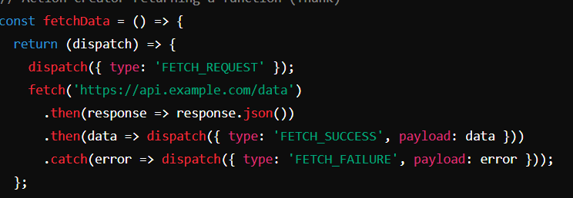

1. What is Pure Component? When to use Pure Component over Component?

A Pure Component in React is a component that performs a shallow comparison of props and state to determine whether it should re-render. It is an optimized version of the React.Component class…

1. What is the second argument that can optionally be passed to setState and what is its purpose?

The second argument to setState is a callback function that is executed after the state has been updated and the component has been re-rendered.