***MODULE: 1 SE –***

***Overview of IT Industry***

1. **What is Software? What is Software Engineering?**

* Software refers to a collection of instructions, data, or programs used to operate computers and execute specific tasks. It is a general term that describes computer programs.
* Software can be divided into two major categories: system software and application software.

1. **Explain types of Software.**

1. ***System Software***

* ***Operating Systems***: Manage computer hardware and software resources (e.g., Windows, macOS, Linux)..
* ***Device Driver***s: Control hardware components.
* Utilities: Perform maintenance tasks (e.g., antivirus software, file management tools).

***2.Application Software:***

***Productivity Software:*** Assist users in performing tasks (e.g., word processors, spreadsheets).

***Business Software:*** Manage business functions (e.g., CRM, ERP systems).

**3.Development Software**:

***> Programming Languages***: Used to create software (e.g., Python, Java).

> **IDEs (Integrated Development Environments)**: Tools that provide comprehensive facilities to programmers (e.g., Visual Studio, Eclipse)

1. ***Embedded Software***:

Software written to control machines or devices that are not typically considered computers (e.g., software in cars, medical devices).

1. **Web-Based Software:**

Software that runs on a web server and can be accessed through a web browser (e.g., web applications like Gmail, online banking systems).

**3. What is SDLC? Explain each phase of SDLC ?**

> SDLC (Software Development Life Cycle) is a process used by software industry professionals to design, develop, and test high-quality software. The SDLC aims to produce software that meets or exceeds customer expectations, is completed within time and cost estimates, and works efficiently and effectively in the current and planned IT infrastructure.

The SDLC typically consists of the following phases:

**1**. ***Planning***:

> Define the project scope and objectives.

> Conduct feasibility studies to determine the project's technical, operational, and financial viability.

**2. Requirements Analysis:**

> Gather and analyze user requirements.

> Document the functional and non-functional requirements.

**3. Design:**

> Translate requirements into detailed design specifications.

> Create system architecture and design diagrams.

**4. Implementation (or Coding)**:

> Write the actual code based on the design specifications.

> Use appropriate programming languages and development tools.

**5. Testing:**

> Test the software to identify and fix defects.

> Conduct various types of testing (unit testing, integration testing, system testing, acceptance testing).

**6. Deployment:**

> Install the software in the production environment.

> Perform necessary configurations and integrations.

**7. Maintenance:**

> Monitor the software for issues and performance.

> Provide ongoing support and maintenance.

**4. What is DFD? Create a DFD diagram on Flipkart**

> A Data Flow Diagram (DFD) is a graphical representation that depicts the flow of data within a system.

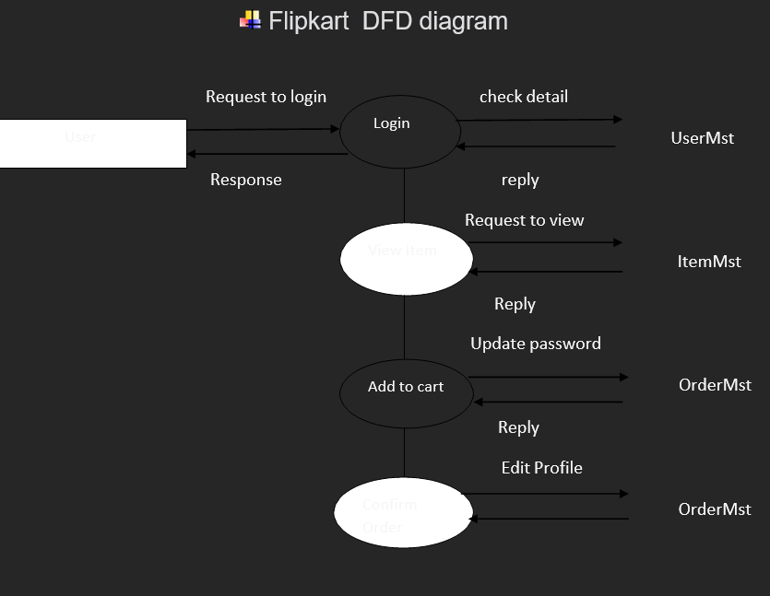

1. **What is Flow chart? Create a flowchart to make addition of two numbers?**

* A flowchart is a graphical representation of a process or algorithm.
* A diagram of a program

  Description automatically generated

1. **What is Use case Diagram? Create a use-case on bill payment on paytm ?**

* A use case diagram is a graphical representation that depicts the interactions between the users (actors) and the system to capture the system's functional requirements.

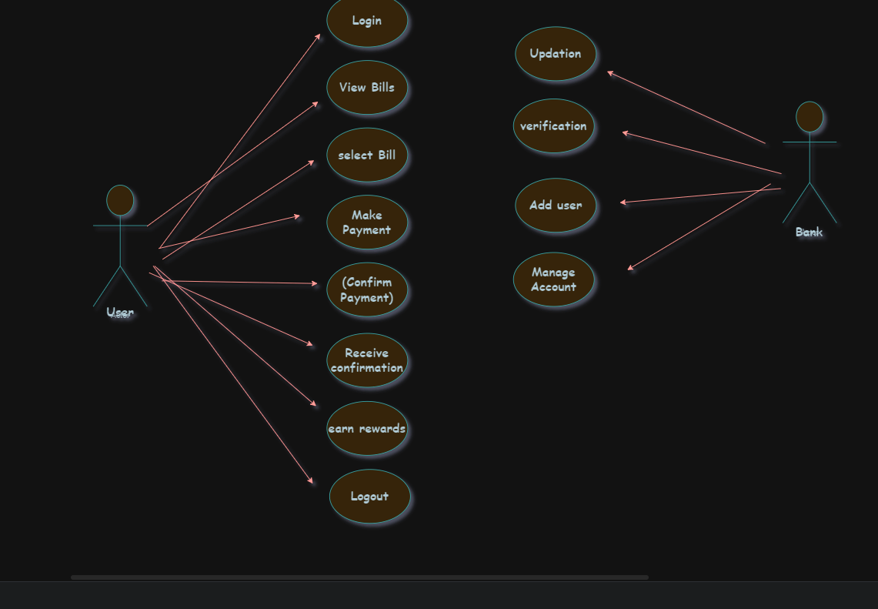

----------------------------------------------Completed--------------------------------------------------