WD - HTML
1.Are the HTML tags and elements the same thing?
No, The HTML tags and elements are not the same. HTML elements consist of opening tags, content, and closing tags.
- HTML Tags:
HTML tags are used to define elements in an HTML document.
Tags are composed of opening and closing tags, and they surround and define content.
Example: <p> is an opening tag, and </p> is a closing tag. Together, they define a paragraph element.
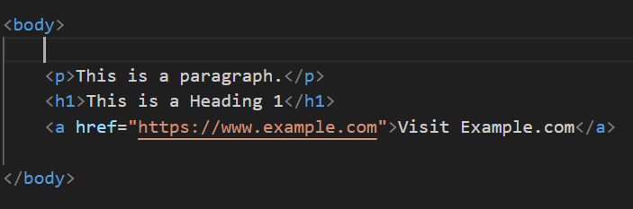
- HTML Elements:
An HTML element consists of an opening tag, content, and a closing tag. The content is the information you want to display on the web page.
Here are examples of four HTML tags and elements:
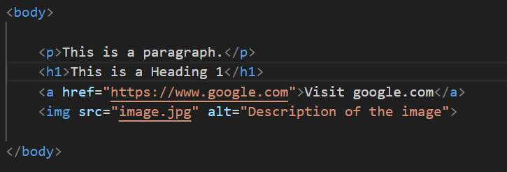
2. What are tags and attributes in HTML?
- HTML Tags:
Tags are use to define elements in HTML.
The consist of an opening tag, content, and a closing tag.
Tags are enclosed in angle brackets (< >).
- Example:-- <p> [opening tag] and </p> [closing tag]define a paragraph element.
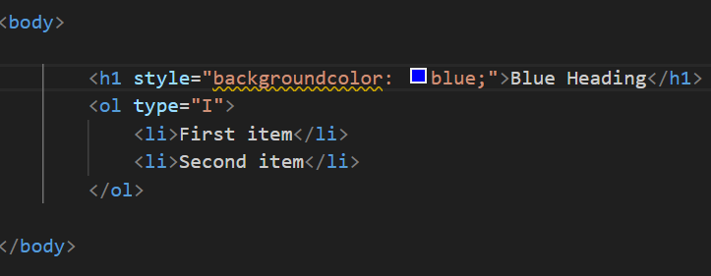
- HTML Attributes:
The Attributes provide additional information about HTML elements.
The are always included in the opening tag.

EX:--
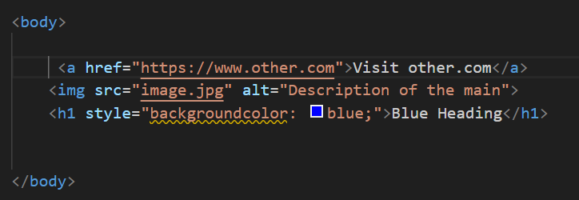

3. What are void elements in HTML?
Void elements in HTML are self-closing tags that don't require a closing tag and represent elements like images or line breaks.
- Ex:-
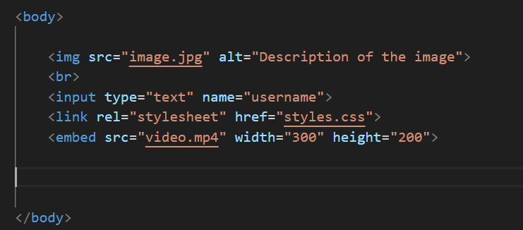
4. What are HTML Entities?
The HTML entities are special codes used to represent by tool reserved content code characters different tools and symbols in HTML, ensuring proper in web browsers.
- EX:-
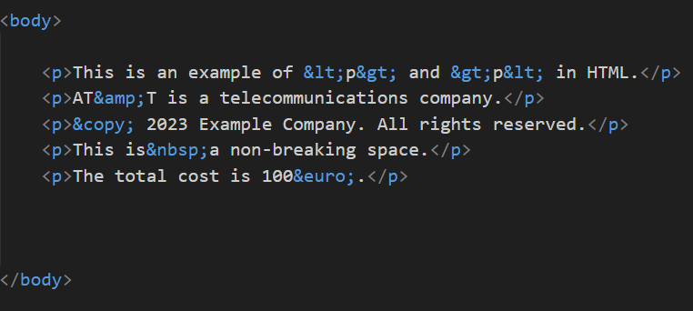
5. What are different types of lists in HTML?
In HTML, there are three main types of lists: ordered lists, unordered lists, and definition lists
Different types of lists in HTML include ordered lists (<ol>), unordered lists (<ul>), and definition lists (<dl>).

- Ordered List (<ol>):
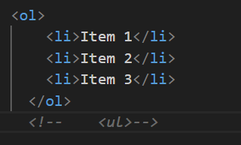
- Unordered List (<ul>):
An unordered list is used to represent a list of items without a specific order, typically bulleted.
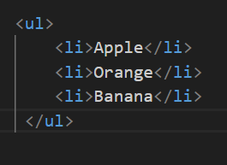
- Nested Lists:
Lists can be nested inside other lists to create hierarchical structures.
EX:-
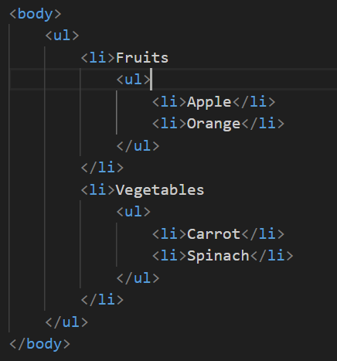
- Description List (<dl>):
A description list is used to define terms and their corresponding descriptions.
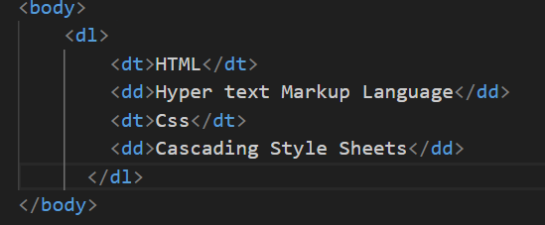
6.What is the ‘class’ attribute in HTML?
The 'class' attribute in HTML is used to assign one or more class names to an element, allowing it to be styled or targeted with CSS and JavaScript.
EX:-
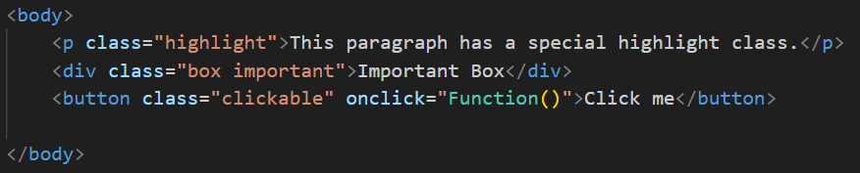7.What is the difference between the ‘id’ attribute and the ‘class’ attribute of HTML elements?
The 'id' attribute is used to uniquely identify a single HTML element, while the 'class' attribute can be used to apply one or more class html element.

- EX:-
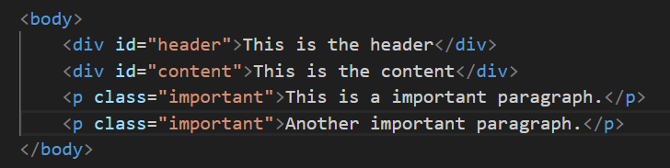8. What are the various formatting tags in HTML?
The Various formatting tags in HTML include
style your content. <b> (bold), <i> (italic), <u> (underline), <strike> (strikethrough), and <sup> (superscript), among others.
- EX:-
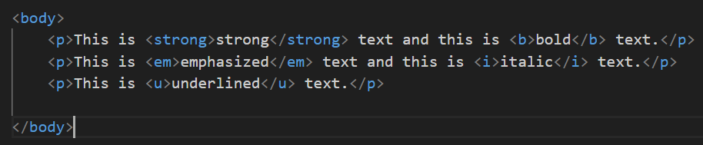9.How is Cell Padding different from Cell Spacing?
- Cell padding is the space between the content of a table cell and its border, while cell spacing is the space between adjacent table cells.
Cell Padding:
- The cellpadding attribute is used to define the space (padding) inside the content of a table cell.
- It sets the system distance between the cell content and the cell border.
- EX:-
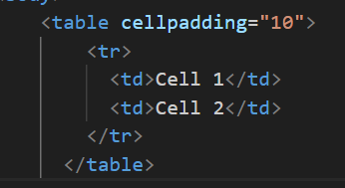
Cell Spacing:
The cellspacing attribute is used to define the space between the cells in a table.
It sets the distance between adjacent cells.
EX:-
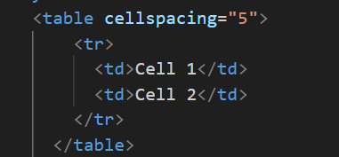
10. How can we club two or more rows or columns into a single row or column in an HTML table?
You can use the rowspan attribute to merge rows and the colspan attribute to merge columns in an HTML table.
- Rowspan (Merging Rows):
To merge cells column content make them span multiple rows, use the rowspan attribute.
- EX:-
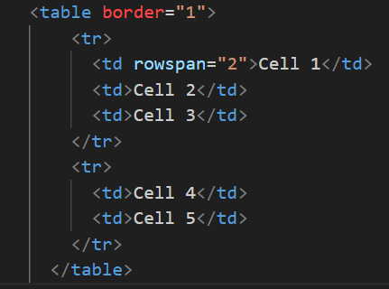
- Colspan (Merging Columns):

To merge cells row and make them span multiple columns, use the content colspan attribute.
<table border="1">
EX:-
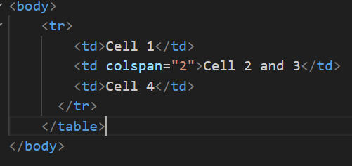
11. What is the difference between a block-level element and an inline element?
- Block-level elements create a new block formatting context and typically start on a new line, while inline elements do not create new lines and flow within the content of block-level elements.
EX:-
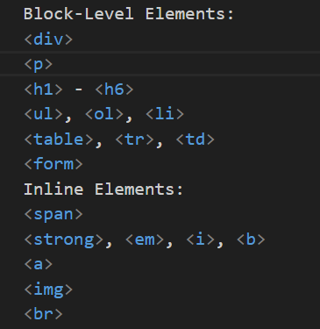
12. How to create a Hyperlink in HTML?
To create a hyperlink in HTML, use the <a> (anchor) element with the href attribute to specify the URL you want to link to.
EX:-
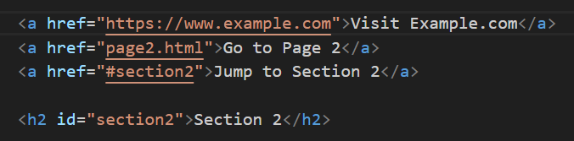
13. What is the use of an iframe tag?
The <iframe> tag in HTML is used to embed another web page or content within the current web page.
The <iframe> (inline frame) tag in HTML is used to embed an external resource or document within an HTML document. It allows you to display content from another source, such as a web page, video, or interactive application, within the current document.
EX:-
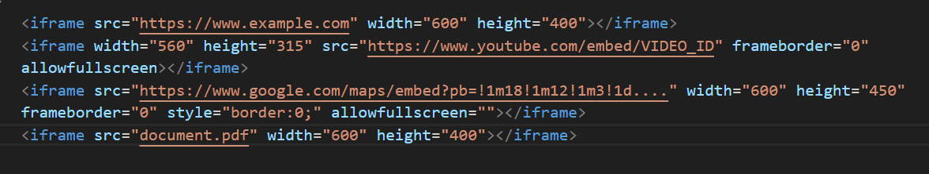14.What is the use of a span tag? Explain with example?
The <span> tag in HTML is used to apply inline styles or to group inline elements for styling or scripting purposes without affecting the document's structure. Here's an example
<p>This is a <span style="color: red;">red</span> word.</p>
- Styling Text:

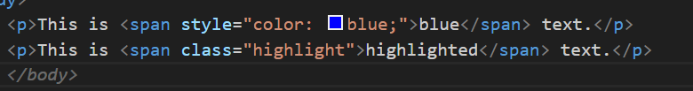
- Applying Classes for Styling:
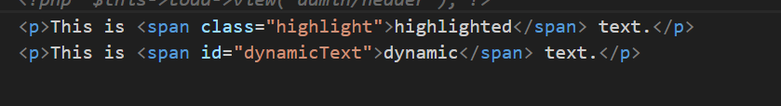15.How to insert a picture into a background image of a web page?
You cannot directly insert a picture into the background image of a web page. Instead, you can set the background image of an HTML element, such as the <body> or a <div>, using CSS.
To insert a picture into the background of a web page, you can use the CSS background-image property
EX:-
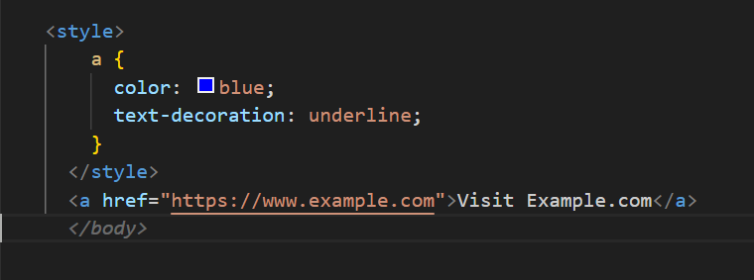
16.How are active links different from normal links?
Active links are different from normal links in that they represent the current or active page the user is on and are often styled differently to indicate their status.
- Normal Links:
State: A normal link represents the default state of a hyperli
- Styling:
You can define the default styles for links using CSS, specifying properties like color,
EX:-
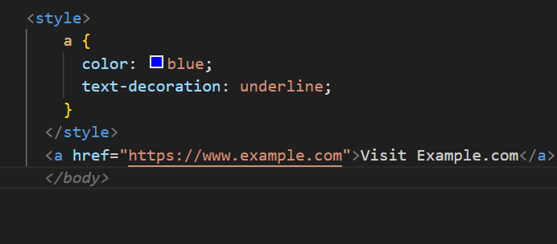
- Active Links:
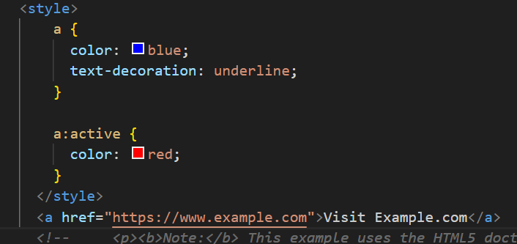
State: An active link represents the state of a hyperlink while it is being clicked or activated.
Styling: You can define separate styles for the active state using the :active pseudo-class in CSS.

17. What are the different tags to separate sections of text?
In HTML, there are several tags used to separate and structure sections of text. These tags help in creating well-organized and semantically meaningful content. Here are some common tags for separating sections of text:
Different HTML tags to separate sections of text include <div>, <p>, <h1> to <h6>, <section>, and <article>.
EX:-
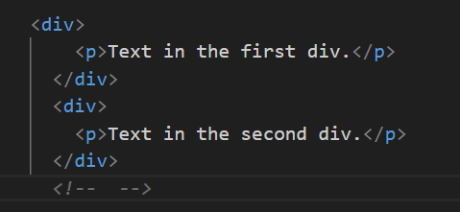
18. What is SVG?
SVG stands for Scalable Vector Graphics, a format for describing two-dimensional vector graphics that can be scaled and rendered at various sizes without loss of quality.
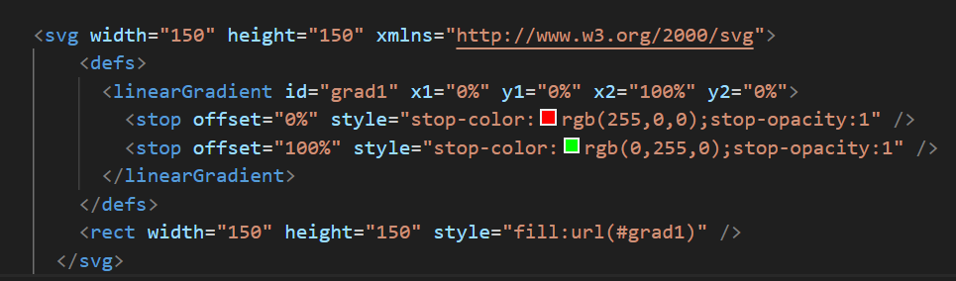
19.What is difference between HTML and XHTML?
- The XHTML is a stricter and more XML-like version of HTML, enforcing well-formedness rules and using lowercase tag names, while HTML is more lenient and forgiving of syntax errors.

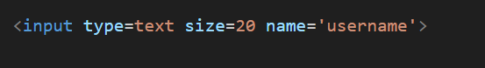

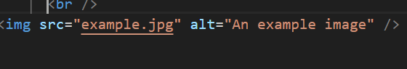
20. What are logical and physical tags in HTML?
Logical tags in HTML emphasize the purpose and structure of elements, while physical tags focus on their presentation or appearance.
Logical Tags:

Definition: Logical tags are used to define the structure and semantics of the content without implying any specific visual presentation.

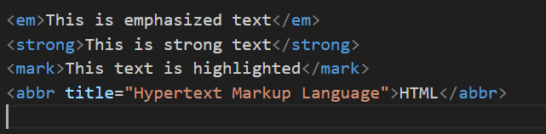

Physical Tags:

Definition: Physical tags, on the other hand, are used to define the appearance or presentation of the content on the page.

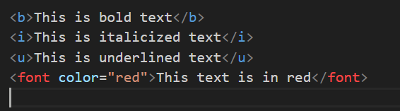

-------------------complete----------------------

