B. TECH (DATA SCIENCE) (DIVISION 4)
Machine Learning CA 4
PROJECT REPORT ON
MUMBAI HOUSING
VALUE ENGINE
A Random Forest-Based Housing Value Prediction System
SUBMITTED BY
NAME OF STUDENT | ROLL NO.
Krishna Vijaykumar Ghute | 2407023
Quadri Rushan Alam | 2207002
UNDER THE GUIDANCE OF
Ms. Priyanka Hajare Mam
Project Guide
Institute of Information and Communication Technology (IICT)
MGM University (MGMU), Chh. Sambhajinagar
Academic Year 2026–2027

CERTIFICATE
Institute of Information and Communication Technology (IICT)
MGM University (MGMU), Chh. Sambhajinagar

This is to certify that Krishna Vijaykumar Ghute (Roll No. 2407023) and Quadri Rushan Alam (Roll No. 2207002), students of B.Tech (Data Science), Institute of Information and Communication Technology (IICT), MGM University (MGMU), have completed the Machine Learning CA4 project titled “Mumbai Housing Value Engine: A Random Forest-Based Housing Value Prediction System” under the guidance of Ms. Priyanka during the academic year 2026–2027. The project report is submitted towards the partial fulfilment of the academic requirements prescribed for the course.
The work described in this report is an academic prototype. Its conclusions are limited to the dataset and evaluation procedure described in the report.

____________________________ | ____________________________
Ms. Priyanka  Project Guide | Department / Institute Authority

Date of Submission: 13 October 2026
Place: Chh. Sambhajinagar

ACKNOWLEDGEMENT
We express our sincere gratitude to our project guide, Ms. Priyanka, for her guidance, encouragement, and feedback throughout the development of this Machine Learning CA4 project.
We thank the Director, Head of Department, and faculty members of the Institute of Information and Communication Technology (IICT), MGM University, for providing the academic environment and learning resources required to complete this work.
We also acknowledge the developers of the open-source tools and libraries used in this project, including Python, pandas, NumPy, scikit-learn, Flask, Bootstrap, and Leaflet, along with the authors of the dataset repository and technical documentation referenced in this report.
Finally, we thank everyone who supported us during model development, testing, interface design, and preparation of the report.

Student Team Members
- Krishna Vijaykumar Ghute (Roll No. 2407023) – IICT, Data Science, MGMU
- Quadri Rushan Alam (Roll No. 2207002) – IICT, Data Science, MGMU

ABSTRACT
This project presents the Mumbai Housing Value Engine, an academic web application that demonstrates regression-based housing-value estimation through an interactive geographic interface. A housing dataset obtained from the public Mumbai-Housing-Prices repository was explored, cleaned and analysed. Correlation analysis and univariate feature screening were used to study the relationship between candidate inputs and the target variable, median_house_value. A compact Random Forest Regressor using median_income, latitude and longitude was selected after comparison with several regression algorithms. The saved model was integrated into a Flask application. Users enter monthly household income and select a location on a Leaflet map; the application transforms the income using the project’s documented reference convention, prepares the three model features and returns a prediction. The interface supports click-based location selection and throttled live cursor tracking. On the reported held-out evaluation of 4,000 records, the saved model achieved an R² score of 0.9782, MAE of 189,313.50 dataset units, RMSE of 374,405.08 dataset units and a reported MAPE of 8.80%. These values describe performance on the evaluated dataset, not a verified probability of correctness for an individual estimate. Because dataset scale and feature semantics require independent validation, the system is presented as a research and demonstration prototype rather than an authoritative real-estate valuation service.
Keywords: Machine Learning, Random Forest Regression, Housing Value Prediction, Feature Selection, Flask, Geospatial Visualization

1. INTRODUCTION
Housing-value estimation is a regression problem in which a model learns associations between observed property or neighbourhood attributes and a numerical target. Location is important because market conditions vary spatially, while income-related variables can reflect differences in neighbourhood affordability. A web interface can make the model easier to explore by allowing users to vary inputs and observe how the prediction changes.
The Mumbai Housing Value Engine combines a saved machine-learning model with a lightweight web application. The model was trained and evaluated outside the live interface. During use, the Flask server loads the saved model, validates user inputs, prepares the required features and returns the predicted target value as JSON. The browser updates the displayed result, while Leaflet provides an interactive map for location selection [4, 5].
The current deployed model uses three features: median_income, latitude and longitude. Other columns were considered during analysis, but the reduced model produced stronger reported results in the recorded feature-set comparison. The final interface therefore exposes only the inputs actually used by the model.

1.1 Problem Statement
To develop an interactive and reproducible web prototype that estimates a housing-value target from income and geographic coordinates using a trained regression model, while presenting the result clearly and responding smoothly to location changes.
Traditional static model outputs are not convenient for exploring spatial variation. Furthermore, adding input fields that are not used by the trained model can mislead users. The project addresses these interface and integration issues by aligning the form with the model’s three trained features and by updating predictions automatically.

1.2 Objectives
- Explore the dataset and analyse relationships between candidate features and the target variable.
- Select a compact feature set and compare regression models using a held-out test set and cross-validation.
- Save the selected Random Forest model and integrate it into a Flask web application.
- Build an interactive Leaflet map supporting click-based location selection and live cursor tracking.
- Evaluate performance with R², MAE, RMSE and MAPE while documenting data and deployment limitations.

1.3 Scope
The project covers exploratory data analysis, feature screening, supervised regression, model comparison, model persistence and local web deployment. The live interface accepts monthly household income and coordinates. Income is transformed using the project-level convention documented in Section 3.3. The present version does not accept individual-flat attributes such as BHK, carpet area, furnishing or amenities because these are not inputs to the saved model. It does not establish a legally or commercially reliable valuation, and it has not been evaluated using a spatially separated test set or verified live transaction prices.

2. LITERATURE SURVEY
The project draws on established ensemble-learning research, prior housing-prediction work, model-evaluation guidance, and documentation for the application and mapping technologies.
Reference / Author | Methodology Used | Key Findings / Relevance | Limitations / Gap
Deng & Zhang (2025) |  | Explains generalization and feature importance. | Does not validate the project's dataset.
  Random Forest and
  ensemble learning
House Price Prediction using Random Forest Machine Learning Technique (2022) | Random Forest regression | Demonstrates housing-value prediction using ensemble learning. | Uses a different dataset.
Scikit-learn Documentation | R², MAE, RMSE and MAPE metrics | Supports systematic model evaluation. | Technical documentation, not a Mumbai housing study.
hindav — Mumbai-Housing-Prices | Geographic and housing-related dataset | Used for exploratory analysis and model development. | Dataset provenance and units require validation.
Proposed Work | Feature selection, model comparison, Random Forest, Flask and Leaflet | Integrates model prediction with an interactive map. | Requires verified market data and spatial validation.

2.1 Research Gap
The reviewed work establishes that ensemble models can be used for tabular regression and that regression metrics should be selected to match the prediction task [1–3]. For this project, the practical gap is the integration of a selected model with an interactive location-driven interface. A second gap concerns data validation: a strong random-split score alone does not demonstrate that predictions generalize to new neighbourhoods or represent current transaction prices. The proposed application is consequently presented as a prototype whose next stage should include dataset auditing and spatially robust evaluation.

3. METHODOLOGY
The methodology includes dataset inspection, exploratory analysis, feature screening, comparative model evaluation, persistence of the selected estimator and integration with the web interface. The development workflow is summarized in Figure 1.
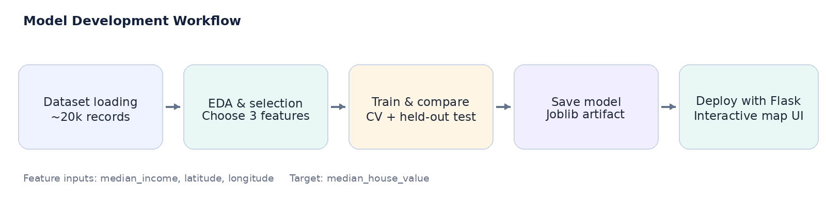
Figure 1. Model development and deployment workflow.

3.1 System Architecture and Design
The system has a browser layer, a Flask prediction endpoint, a feature-preparation step, a saved Random Forest model and a response-rendering step. The browser sends the current income and coordinates as JSON. The backend validates the input, applies the income conversion rule and creates a one-row DataFrame with the expected feature names and order. The estimator returns a numerical prediction, which is sent to the browser as JSON. The page updates the result display without requiring a full reload.
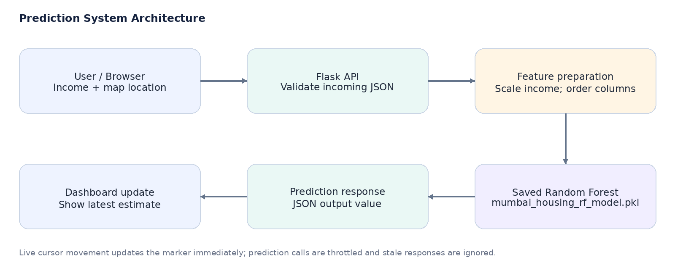
Figure 2. Runtime architecture of the deployed prediction application.

3.2 System Specifications
Category | Details / Tools / Technologies
Hardware requirements | Standard Windows laptop or desktop. A GPU is not required for inference. Exact processor and RAM specifications were not recorded.
Operating system | Windows development environment.
Programming language | Python for data analysis, model evaluation and the backend; JavaScript, HTML and CSS for the frontend.
Machine-learning libraries | scikit-learn, NumPy, pandas and joblib.
Backend framework | Flask provides the home page and the /predict JSON endpoint [5].
Frontend and styling | HTML5, CSS3, JavaScript and Bootstrap 5.3.3.
Geospatial interface | Leaflet 1.9.4 with OpenStreetMap map tiles and required attribution [6].
Model artifact | mumbai_housing_rf_model.pkl
Evaluation metadata | model_metrics.json; maintained as project output, not required to serve predictions.

3.3 Dataset and Preprocessing
The project uses the public CSV linked from the Mumbai-Housing-Prices GitHub repository [4]. The repository describes the dataset as having approximately 20,000 records and lists columns including longitude, latitude, housing_median_age, total_rooms, total_bedrooms, population, households, median_income, median_house_value and ocean_proximity. The target variable used for training is median_house_value.
Initial analysis included inspection of data types and distributions, correlation analysis, and univariate feature screening. In the recorded correlation analysis, median_income showed the strongest positive linear association with the target (approximately +0.7714), latitude showed a negative association (approximately −0.3834), and longitude had a comparatively small negative correlation (approximately −0.0829). Room, bedroom, household and population counts had weak univariate correlations in the supplied analysis. These results supported testing a smaller set of predictors, but correlation alone does not prove causation and does not capture every nonlinear relationship.
The final deployed model uses exactly three input columns: median_income, latitude and longitude. The application accepts monthly household income for usability and converts it to the model’s input scale using the project convention:
median_income = (monthly_income / 30,000) × 0.815520
The resulting value is clipped to the training-data range [0.027715, 3.613535].
This mapping is a project-level reference convention, not a calibrated economic conversion established by a separate statistical study. It is kept for compatibility with the saved model and must be validated against the dataset’s documented definition of median_income before practical deployment. Latitude and longitude are checked against the application’s supported map bounds (latitude 18.80–19.35; longitude 72.70–73.10).

3.4 Model Selection and Evaluation
Candidate regressors were compared using a held-out test set and five-fold cross-validation. The recorded model-selection experiment ranked models by mean cross-validated R². The Random Forest baseline achieved the strongest mean cross-validation score among the evaluated candidates. A RandomizedSearchCV experiment was also conducted, but the tuned model did not outperform the original baseline on the recorded evaluation; therefore the baseline estimator was retained for deployment.
R² measures the fraction of target variance explained relative to a mean-only baseline. MAE is the mean absolute difference between actual and predicted target values; RMSE is the square root of mean squared error and penalizes larger residuals more strongly. MAPE is the mean absolute percentage error calculated over non-zero actual target values in the project evaluation. These are regression measures, not classification accuracy or a probability that an individual prediction is correct [3].

4. RESULTS AND ANALYSIS
The final saved Random Forest artifact was loaded and checked against the feature names expected by the application. Its recorded verification metrics are shown in Table 3. The evaluation contains 4,000 held-out records.
Evaluation metric | Final saved model result | Interpretation
Test records | 4,000 | Number of held-out records used in the reported verification.
R² score | 0.978211 (97.82%) | Strong fit on this held-out dataset; not a literal prediction accuracy or confidence percentage.
MAE | 189,313.50 dataset units | Average absolute difference between actual and predicted target values.
RMSE | 374,405.08 dataset units | Error measure that gives greater weight to larger residuals.
MAPE | 8.80% (reported) | Average absolute percentage error across non-zero actual values, according to the project calculation.

Table 3. Final saved model metrics reported by the project evaluation script.
Unit caution: The GitHub dataset README describes median_house_value as a rupee-denominated target. However, its aggregate-style feature definitions and project-level income transformation require independent validation. MAE and RMSE are therefore stated in dataset units in this report, and the application is not presented as a verified market-price service.

4.1 Model Comparison
The model-selection experiment evaluated multiple regressors using the same three-feature approach. Table 4 lists the recorded mean cross-validation R² values. Values are taken from the project’s saved experiment output and are rounded to four decimal places.
Rank | Model | Mean CV R²
1 | Random Forest Regressor | 0.9749
2 | Extra Trees Regressor | 0.9691
3 | XGBoost Regressor | 0.9682
4 | K-Nearest Neighbours Regressor | 0.9540
5 | Decision Tree Regressor | 0.9529
6 | Gradient Boosting Regressor | 0.8718
7 | Linear / Ridge / Lasso / ElasticNet family | 0.6199
8 | Support Vector Regressor (SVR) | −0.1143

Table 4. Recorded five-fold cross-validation results for candidate regressors.
For a direct test-set comparison, the saved experiment output reported the following baseline figures for Linear Regression and the Random Forest approach. Because evaluation values can vary slightly with data filtering and split configuration, these comparison figures are distinguished from the final model-metrics file reported in Table 3.

Metric | Linear Regression baseline | Random Forest proposal | Change
Test R² | 0.6373 | 0.9781 | +0.3408 absolute R² (34.08 percentage points)
Test MAE | 1,198,193.45 | 189,313.50 | Approximately 84.20% lower
Test RMSE | 1,527,612.07 | 374,405.08 | Approximately 75.49% lower

Table 5. Recorded baseline-to-proposed model comparison; errors are in dataset units.

4.2 Feature-Set Analysis
The recorded feature-set experiment compared a wider 11-column input design with the reduced three-feature design. The reduced model achieved a higher held-out R² and lower recorded MAE and RMSE in that experiment. Cross-validation also favoured the smaller set: mean CV R² was approximately 0.9749 for the three-feature model and 0.9601 for the wider feature set. This result motivated aligning the web form with the saved three-feature estimator rather than retaining input fields that did not affect predictions.

4.3 Web Application Behaviour
- The Flask server loads the serialized Random Forest model at startup and checks that the trained feature names are present.
- The browser requests a new estimate automatically when monthly income changes or a location is selected on the map.
- Double-clicking the map toggles live cursor tracking; the marker follows the cursor while prediction requests are throttled.
- A latest-request queue avoids accumulating unnecessary requests and prevents older responses from replacing a newer result.
- The interface displays a dataset-unit estimate and an explanatory limitation note rather than presenting the output as a verified market quote.

5. CONCLUSION
The Mumbai Housing Value Engine demonstrates an end-to-end machine-learning workflow, from tabular data analysis and feature selection to regression model comparison, model persistence and web deployment. A Random Forest Regressor using median_income, latitude and longitude was selected for the deployed prototype. The saved model’s reported held-out evaluation produced an R² score of approximately 0.9782 over 4,000 records, with MAE of 189,313.50 dataset units, RMSE of 374,405.08 dataset units and a reported MAPE of 8.80%.
The project also highlights an important engineering principle: web inputs should match the inputs used during model training. Removing unused controls avoids giving users the impression that features influence the result when they are not passed to the estimator. The interactive map improves usability by allowing direct spatial exploration, while throttled API requests support smoother cursor tracking.
The reported scores indicate strong predictive performance on the evaluated dataset but do not establish reliability for unseen neighbourhoods or verified real-world prices. Before deployment beyond an academic demonstration, the dataset’s provenance, target units, feature semantics and income transformation must be validated, and the model should be tested using spatially separated evaluation data.

5.1 Applications
- Academic demonstration of supervised regression, feature selection and model evaluation.
- Interactive exploration of how a trained model responds to income and geographic-coordinate changes.
- Prototype foundation for a future housing analytics dashboard after independent dataset and unit validation.

5.2 Limitations
- The application uses only three trained features and does not model floor area, BHK, property condition, amenities, furnishing or recent transaction details.
- The mapping from a user-entered monthly income to median_income is a project convention and requires validation.
- Random train/test evaluation may overstate performance when nearby or similar records appear in both partitions; a geographic holdout evaluation is recommended.
- Dataset units and its relationship to current Mumbai transaction prices have not been independently verified.

5.3 Future Scope
- Validate and document the dataset source, target units, duplicates, location coverage and field definitions.
- Replace the reference income conversion with a statistically justified transformation based on the data dictionary and training distribution.
- Evaluate the model using spatial cross-validation or neighbourhood-based holdout sets and report confidence/uncertainty intervals where methodologically justified.
- Collect validated property-level features such as carpet area, BHK, building age, furnishing, amenities and recent sale/listing prices.
- Add model versioning, logging, unit tests, security settings and production deployment controls before any public deployment.

6. REFERENCES
[1] L. Breiman, “Random Forests,” Machine Learning, vol. 45, pp. 5–32, 2001. https://doi.org/10.1023/A:1010933404324
[2] A. B. Adetunji, O. N. Akande, F. A. Ajala, O. Oyewo, Y. F. Akande and G. Oluwadara, “House Price Prediction using Random Forest Machine Learning Technique,” Procedia Computer Science, vol. 199, pp. 806–813, 2022. https://doi.org/10.1016/j.procs.2022.01.100
[3] scikit-learn developers, “Metrics and scoring: quantifying the quality of predictions,” scikit-learn documentation. https://scikit-learn.org/stable/modules/model_evaluation.html
[4] hindav, “Mumbai-Housing-Prices: Mumbai Housing Prices 2025 – With Coordinates,” GitHub repository and dataset README. https://github.com/hindav/Mumbai-Housing-Prices (accessed 11 October 2026).
[5] Pallets Projects, “Flask Quickstart,” Flask documentation. https://flask.palletsprojects.com/en/stable/quickstart/
[6] Leaflet, “Quick Start Guide,” Leaflet documentation. https://leafletjs.com/examples/quick-start/
[7] Institute of Information and Communication Technology (IICT), MGM University, Machine Learning CA4 report template supplied for academic year 2026–2027.

APPENDIX A: REPRODUCIBILITY NOTES
The following project artifacts are associated with the current implementation:
- app.py — Flask application and prediction API.
- templates/index.html — interactive browser interface and prediction requests.
- static/style.css — responsive dashboard styles.
- mumbai_housing_rf_model.pkl — serialized Random Forest model used by the application.
- model_metrics.json — saved evaluation metadata used for verification and reporting.
- requirements.txt — Python package dependencies, to be maintained alongside the repository.
To run the application in the development environment, install the dependencies in a Python virtual environment and execute `python app.py` from the project directory. Open `http://127.0.0.1:5000` in a browser. Internet access is required for the third-party Bootstrap, Leaflet and OpenStreetMap resources currently referenced by the frontend.
Repository URL: To be inserted after the mandatory GitHub repository is created.

