MINIMUM BALANCE PENALTY PROCESSING SYSTEM

Mainframe Technology – COBOL, JCL & VSAM Assessment

Name : Krishna Kanth J

VSAM DATASET CREATION:
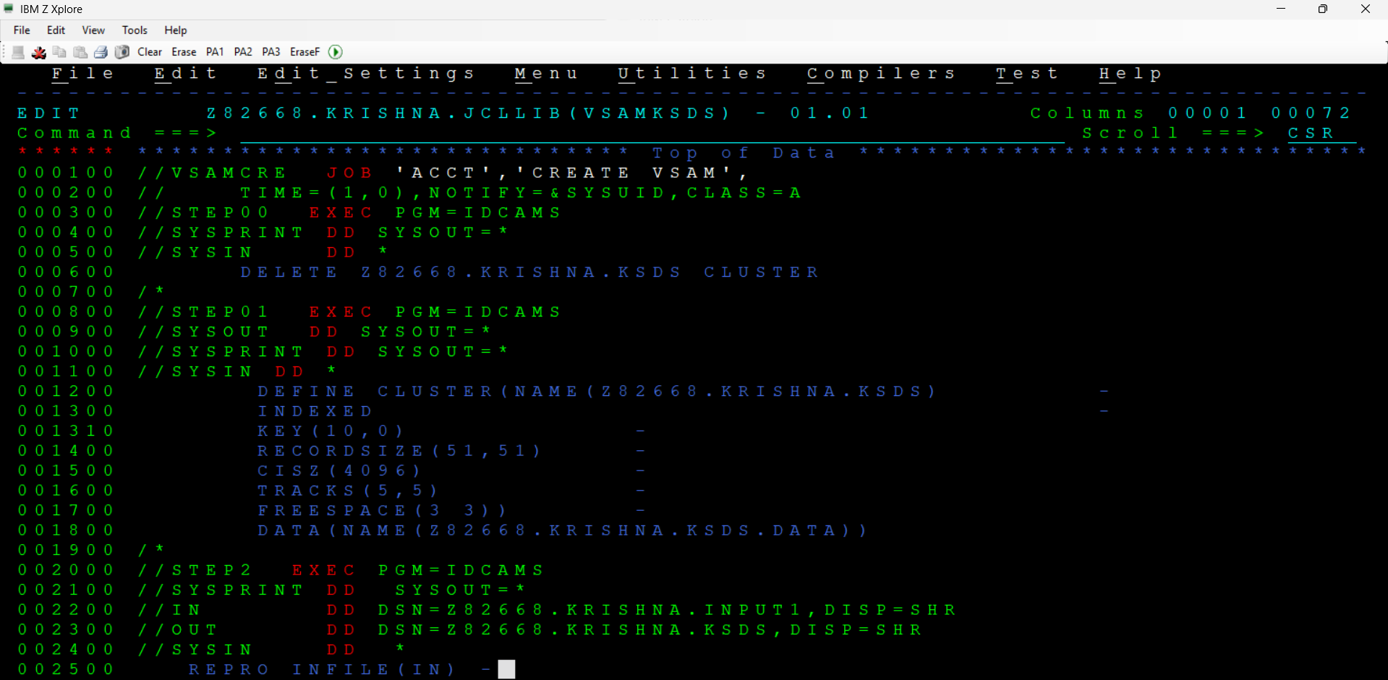

JCL PROGRAMS :
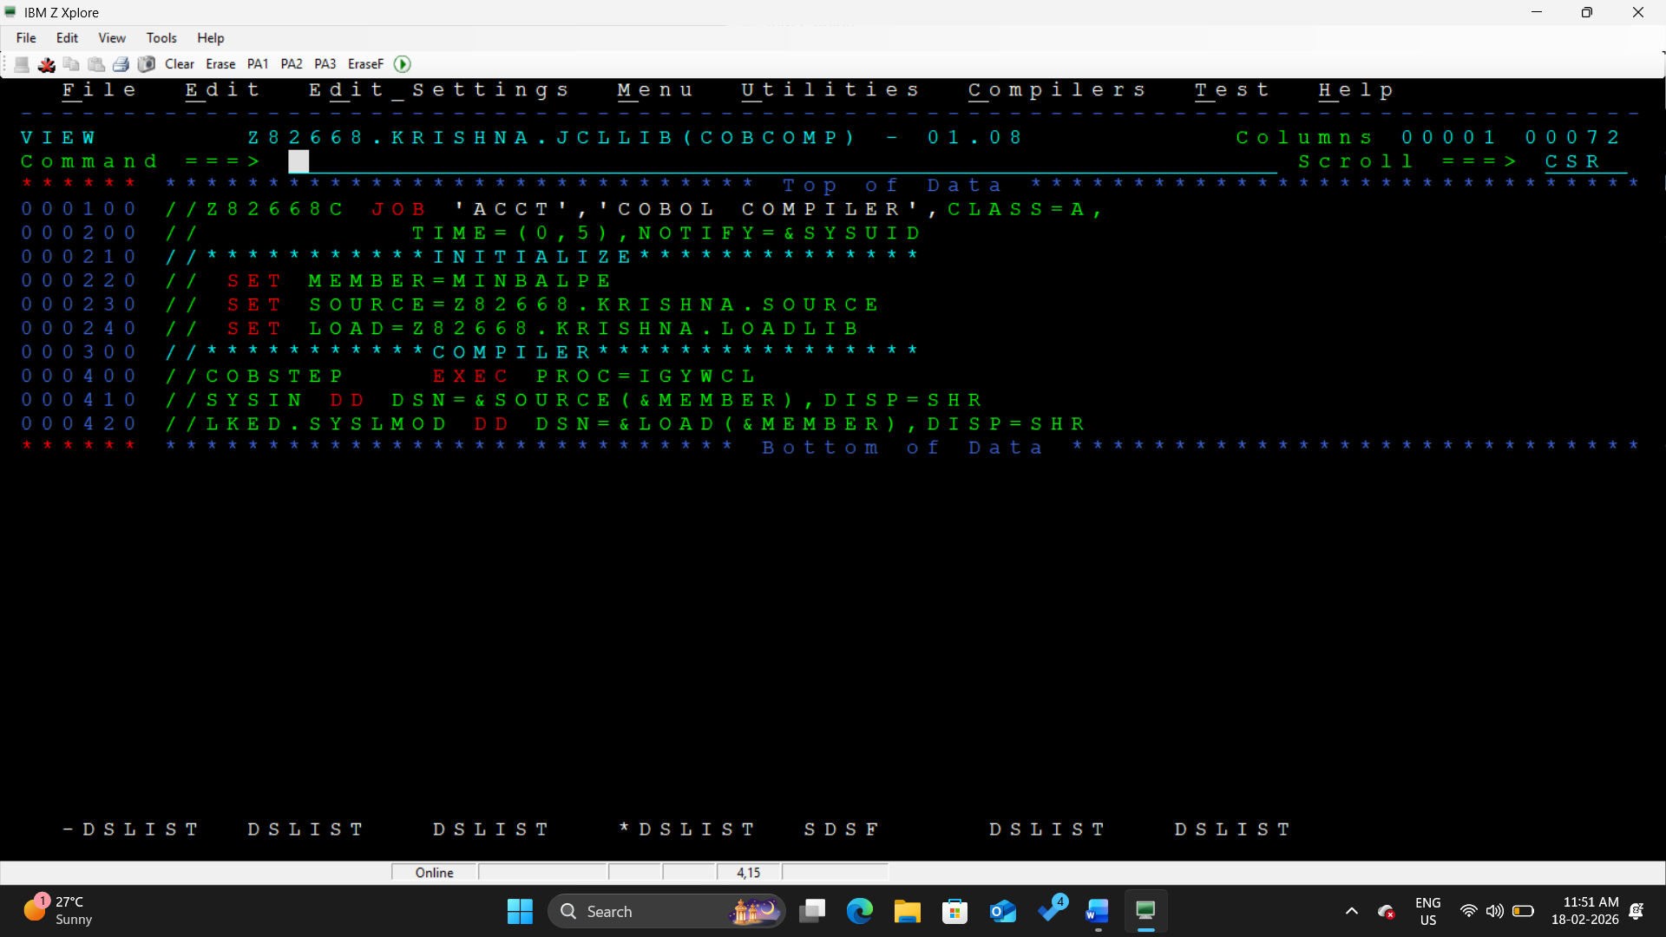

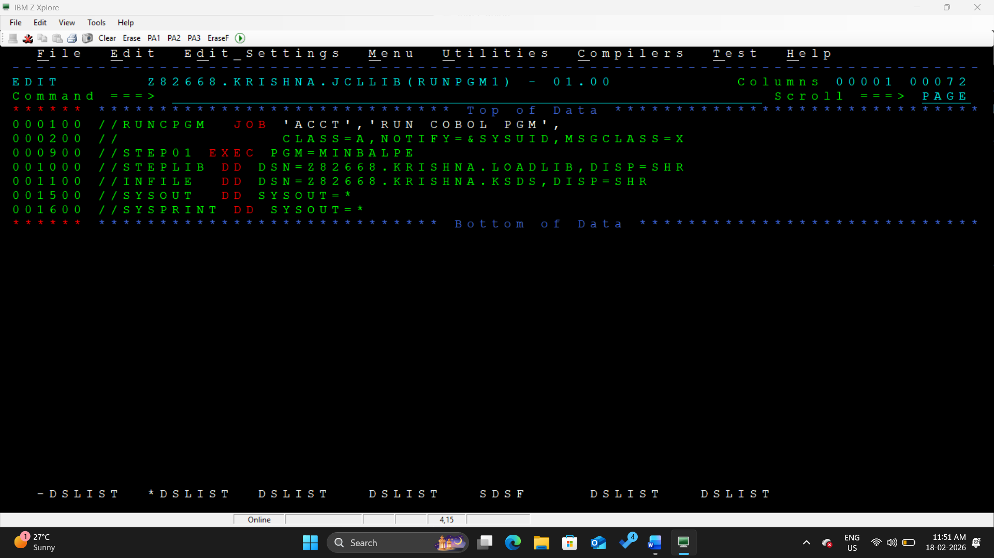

COBOL IMPLEMENTATION:
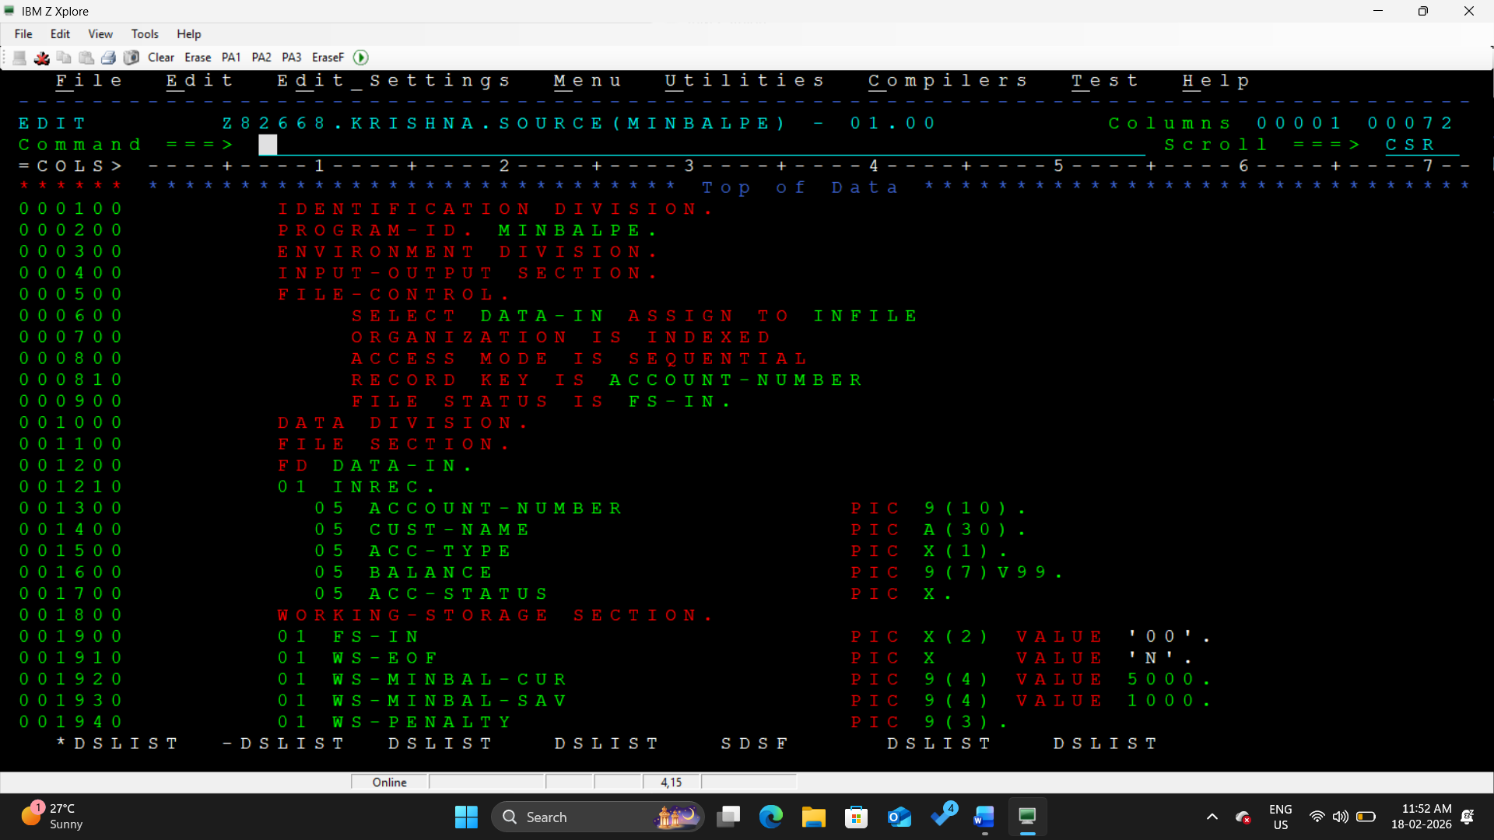

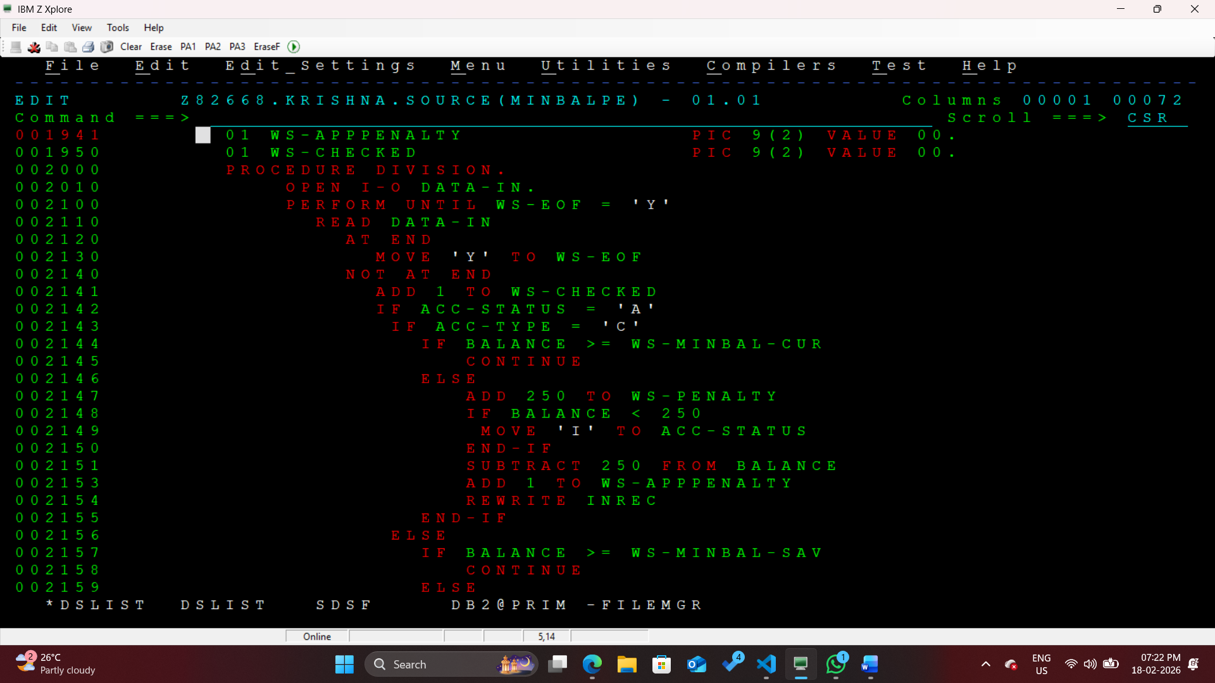

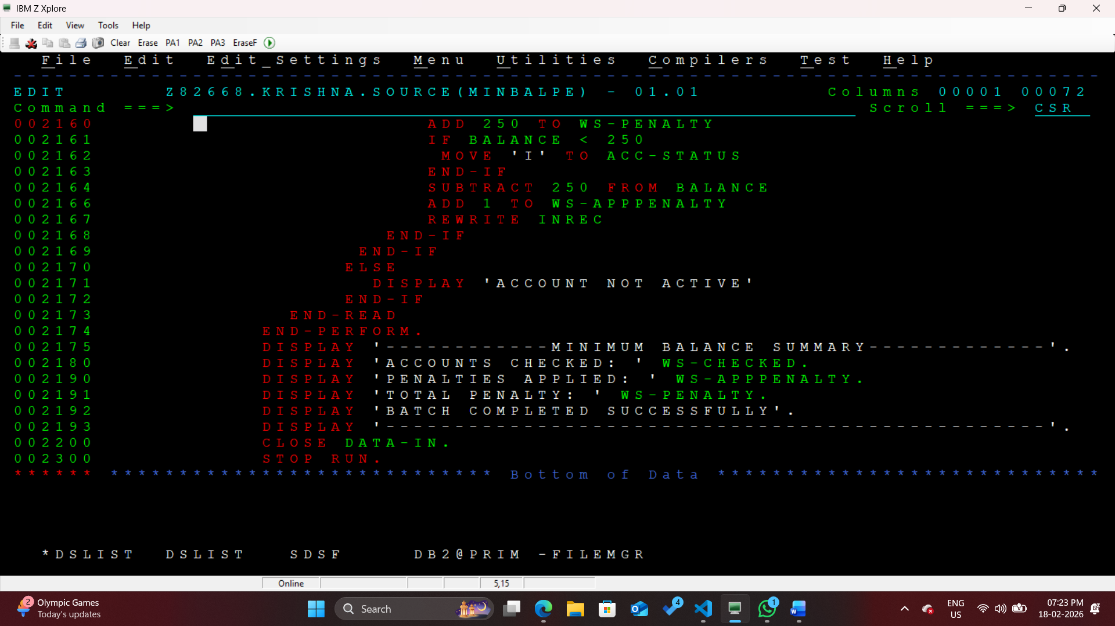

OUTPUT:

