**Implemented services**

1. Book-service
2. Subscription-service
3. API gateway
4. Eureka server

**DB Used**:

PostgresSQL

Book API

<http://localhost:8080/books>

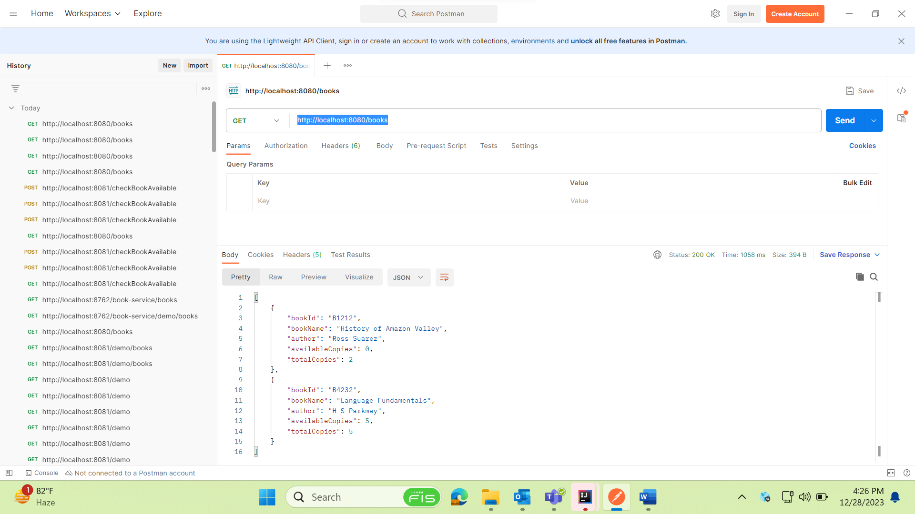

Subscription API

<http://localhost:8081/subscriptions>

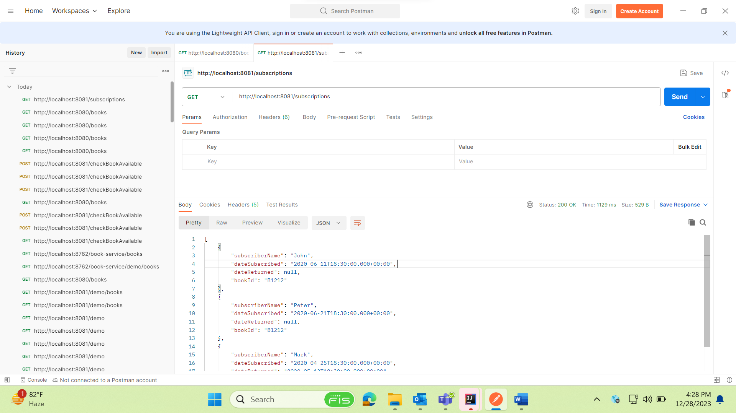

Subscription for particular user

<http://localhost:8081/subscriptions?subscriberName=Mark>

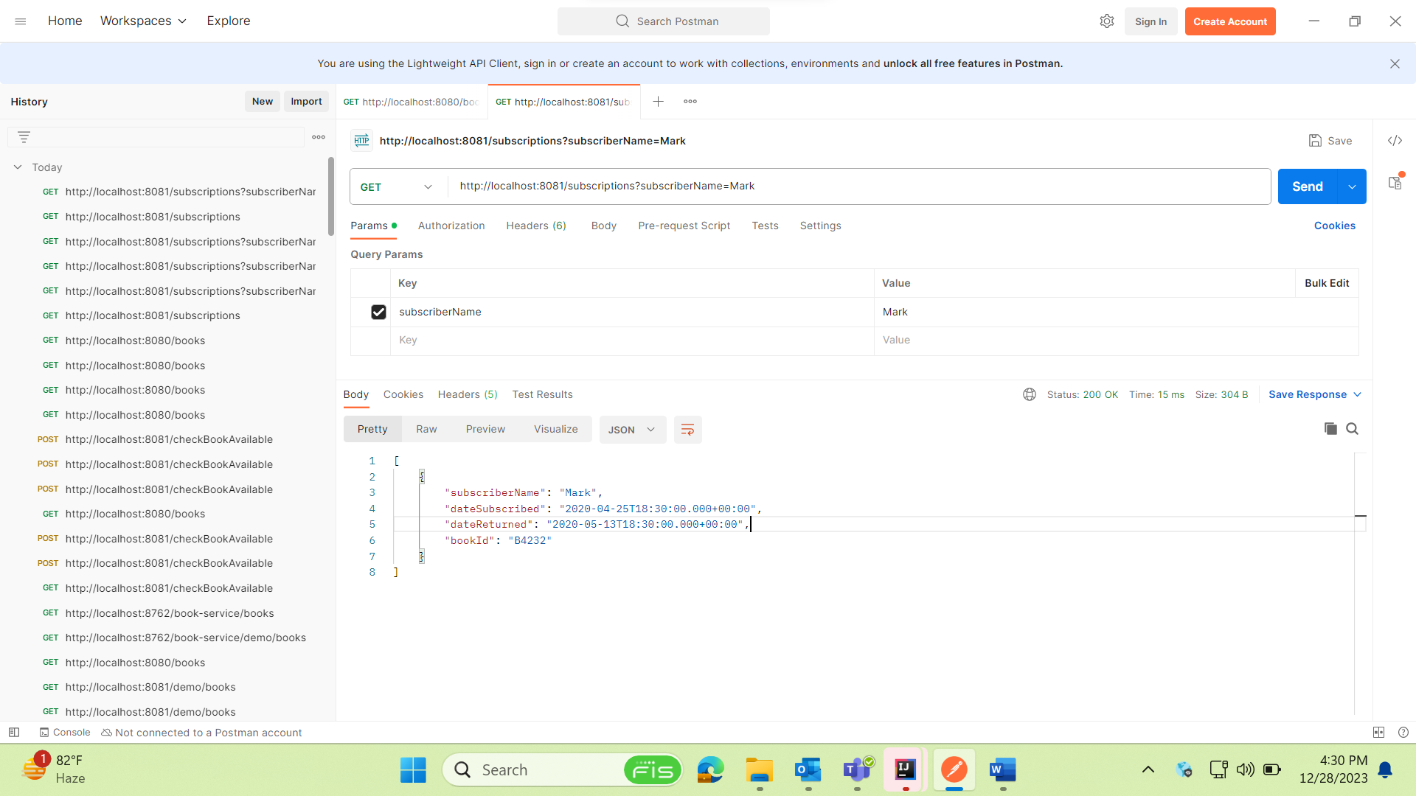

Save subscription for book not available(Calling book service from subscription service for availability of book)

<http://localhost:8081/saveSubscription>

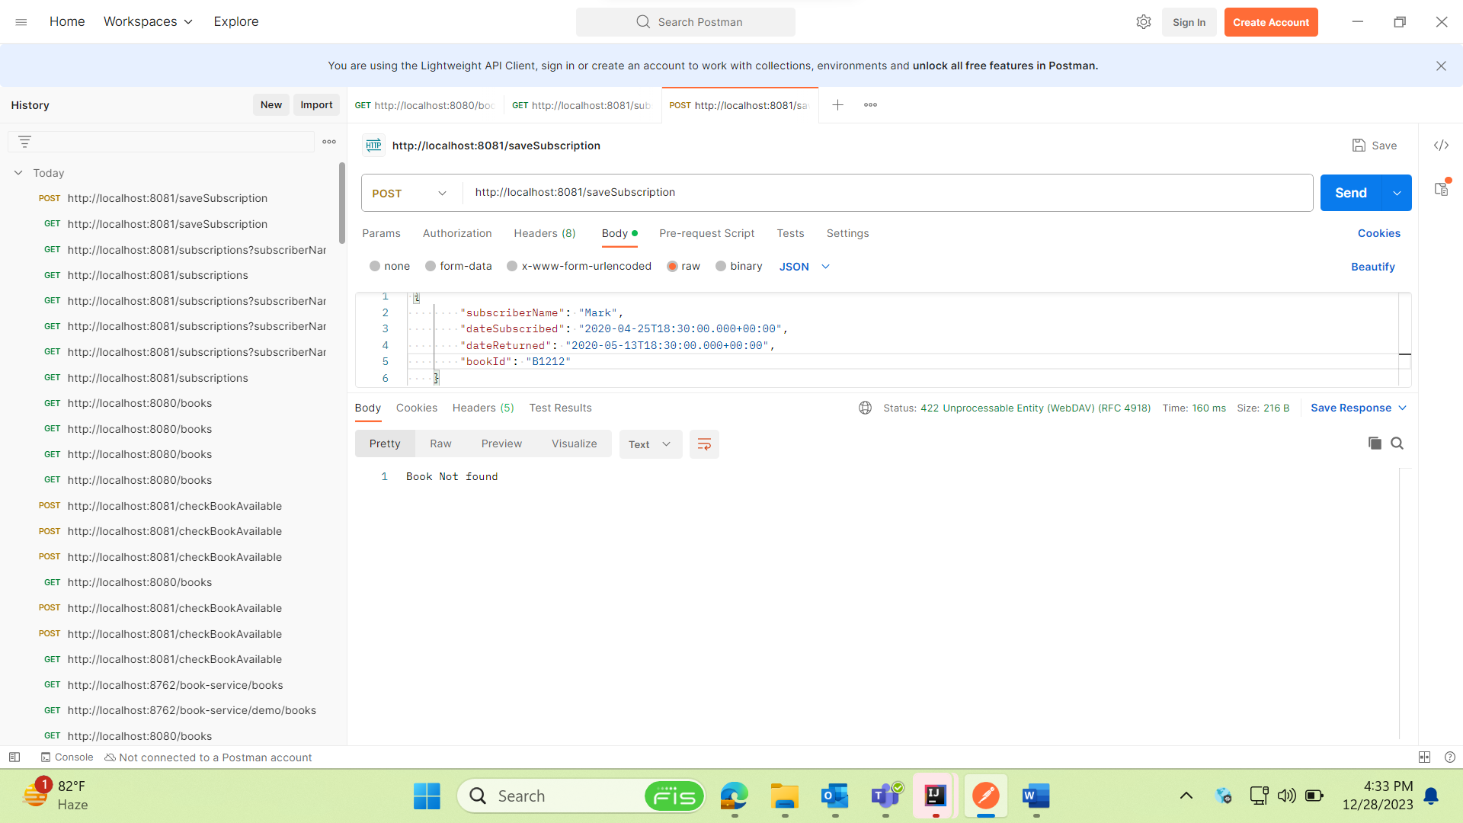

Save subscription for available record

DB record added

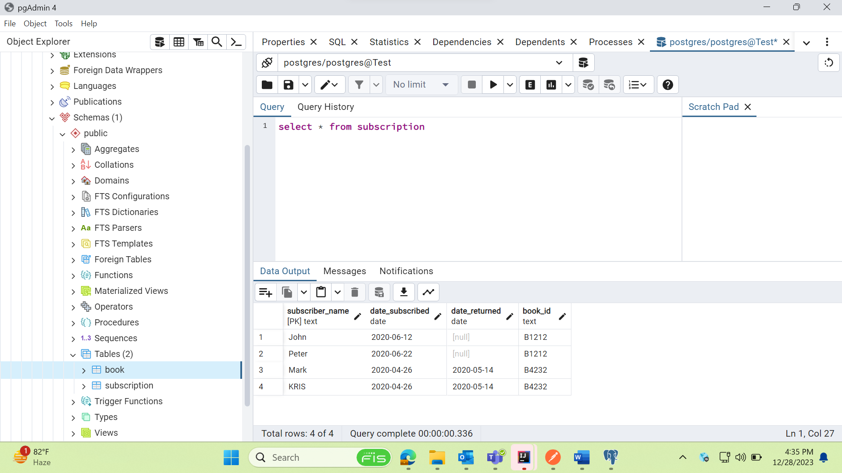

Eureka server

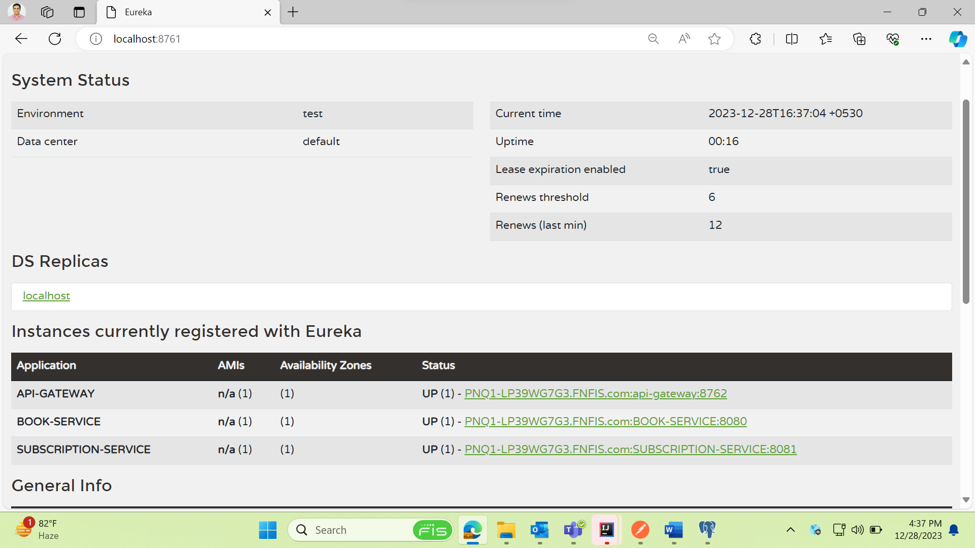

API gateway – Running book service through gateway port

http://localhost:8762/book-service/books

If book service is down implemented fall back mechanism

