NPC – CAPSTONE PROJECT ASSIGNMENT
Malware Analysis Sandbox Using Oracle VirtualBox
Submitted BY: KRISHNA KARLE
Class / Year: SY CYBER SECURITY
PRN: 2125UCSM1059
Subject: NPC

1. Aim
To understand malware analysis sandboxing using Oracle VirtualBox, observe process and network activity in an isolated Linux virtual machine, examine a harmless shell simulation, and verify recovery using a clean snapshot.
2. Software and Requirements
- Oracle VirtualBox
- Linux virtual machine
- Linux Terminal
- Windows host computer
- VirusTotal website for checking an existing report, if available
3. Introduction
A malware analysis sandbox is an isolated environment used to study the behavior of suspicious programs without affecting the main computer or other systems. Virtualization software such as Oracle VirtualBox allows users to create virtual machines for controlled experiments.
Snapshots save the state of a virtual machine at a particular time. Restoring a clean snapshot helps return the virtual machine to its earlier state after an experiment.
For safety, this assignment used a harmless shell script simulation instead of a real reverse shell or bind shell.
4. Procedure
Step 1: Create and isolate the Linux virtual machine
A Linux virtual machine was run using Oracle VirtualBox. The virtual network adapter was disabled to prevent network connectivity during the experiment.

Step 2: Create a clean snapshot
A snapshot named Clean_Baseline was created before the experiment. This snapshot preserved the initial state of the virtual machine.
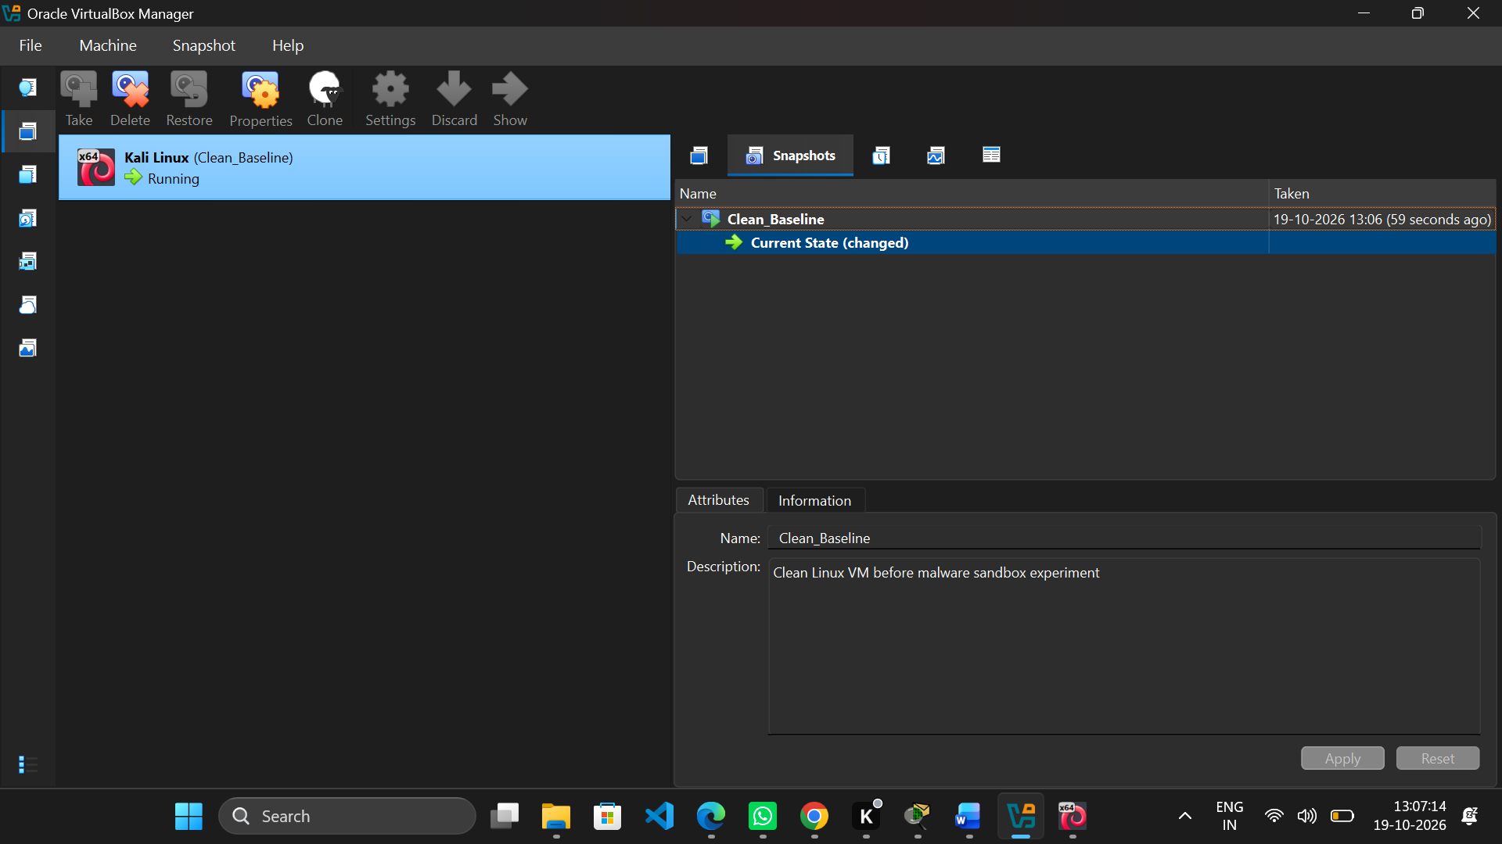Step 3: Record the initial process activity
The following command was used to observe running processes:
ps -eo pid,comm,args --sort=pid | head -20
This output provided a baseline for comparison.
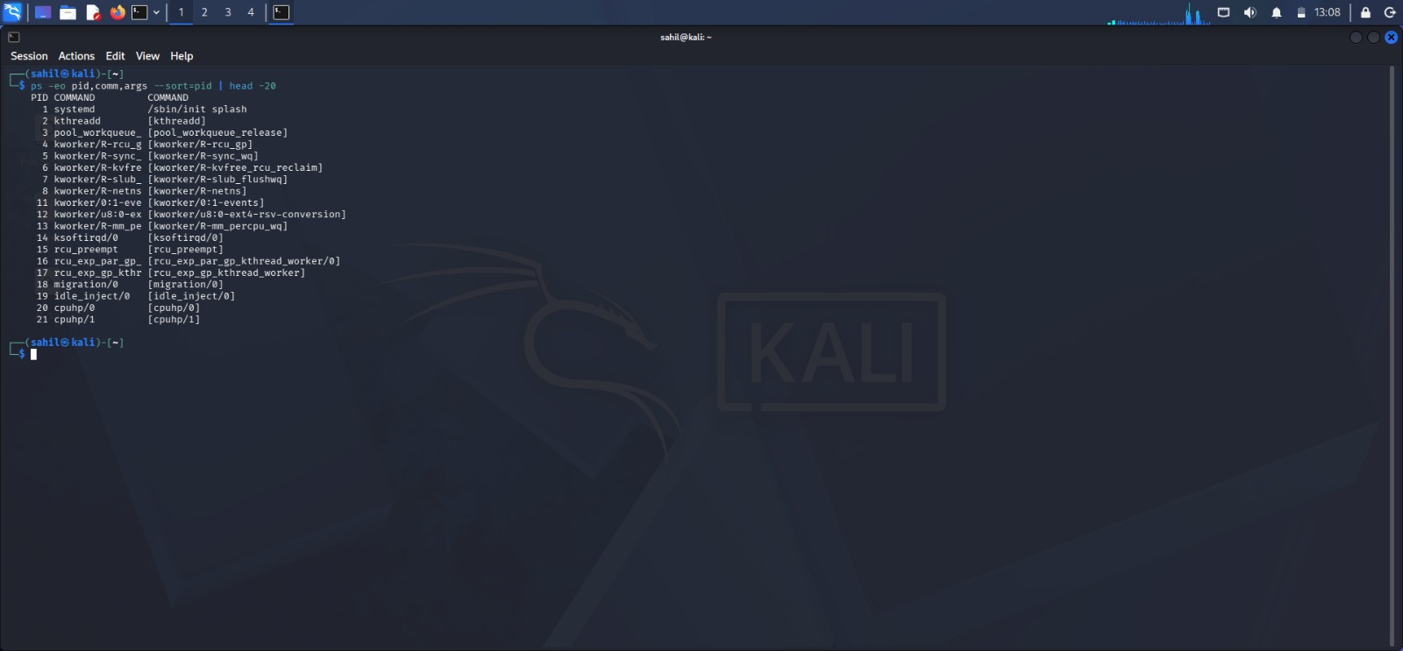

Step 4: Record the initial network activity
The following command was executed:
ss -tulnp
It displayed listening TCP and UDP sockets and associated process information when available.
Step 5: Create the shell simulation
A directory named sandbox_lab was created in the Linux home directory. A script named shell_simulation.sh was created to print a message, display the date and time, and indicate completion.
The script did not establish network connections or execute remote commands.

Step 6: Observe processes before execution
The following command was used:
ps -eo pid,comm,args --sort=pid | tail -15
This recorded process information immediately before running the script.
Step 7: Execute the simulation
The script was executed using:
./shell_simulation.sh
The output displayed a start message, the current date and time, and a completion message.

Step 8: Observe network activity after execution
The following commands were used:
ss -tulnp
ss -tnp
The results were compared with the initial network baseline. Since the script was designed only to print text and the date, it was not expected to create network connections.
Step 9: Observe system changes
The following commands were used:
find ~/sandbox_lab -maxdepth 1 -type f -printf '%f | %s bytes | %TY-%Tm-%Td %TH:%TM:%TS\n'
ls -l ~/sandbox_lab
These commands displayed the created script, its size, permissions, and modification time.
Step 10: Analyze the script
The script was examined using text-search commands and by displaying its complete contents. The review confirmed that the custom script was intended only to print messages and display the date.
This was a basic script inspection, not a complete malware analysis.
Step 11: Check VirusTotal
VirusTotal was checked for an existing report for the custom-created script. No detection score, first-seen date, or historical indicators should be reported unless an actual report provides those details.
If no report was found, the finding is: “No existing VirusTotal report was identified for the custom-created shell simulation.”
Step 12: Restore the clean snapshot
The virtual machine was shut down, and the Clean_Baseline snapshot was restored using Oracle VirtualBox.
After restoration, the presence of the experiment directory was checked using:
ls -la ~/sandbox_lab
The expected result was that the directory created after the snapshot would no longer exist.
Step 13: Verify isolation
The following commands were used:
ip -br addr
ip route
The VirtualBox network settings were also checked to confirm that the network adapter remained disabled.

SCREENSHOTS:
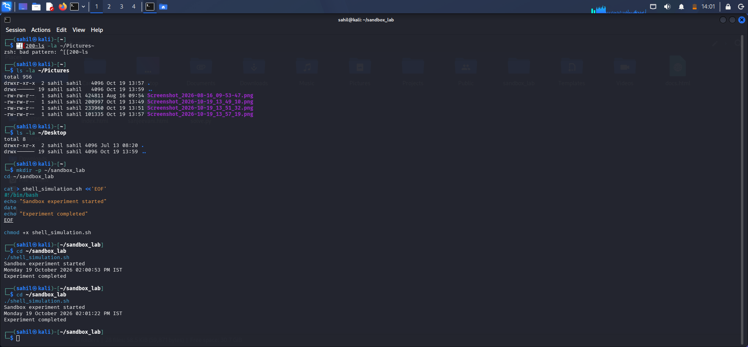
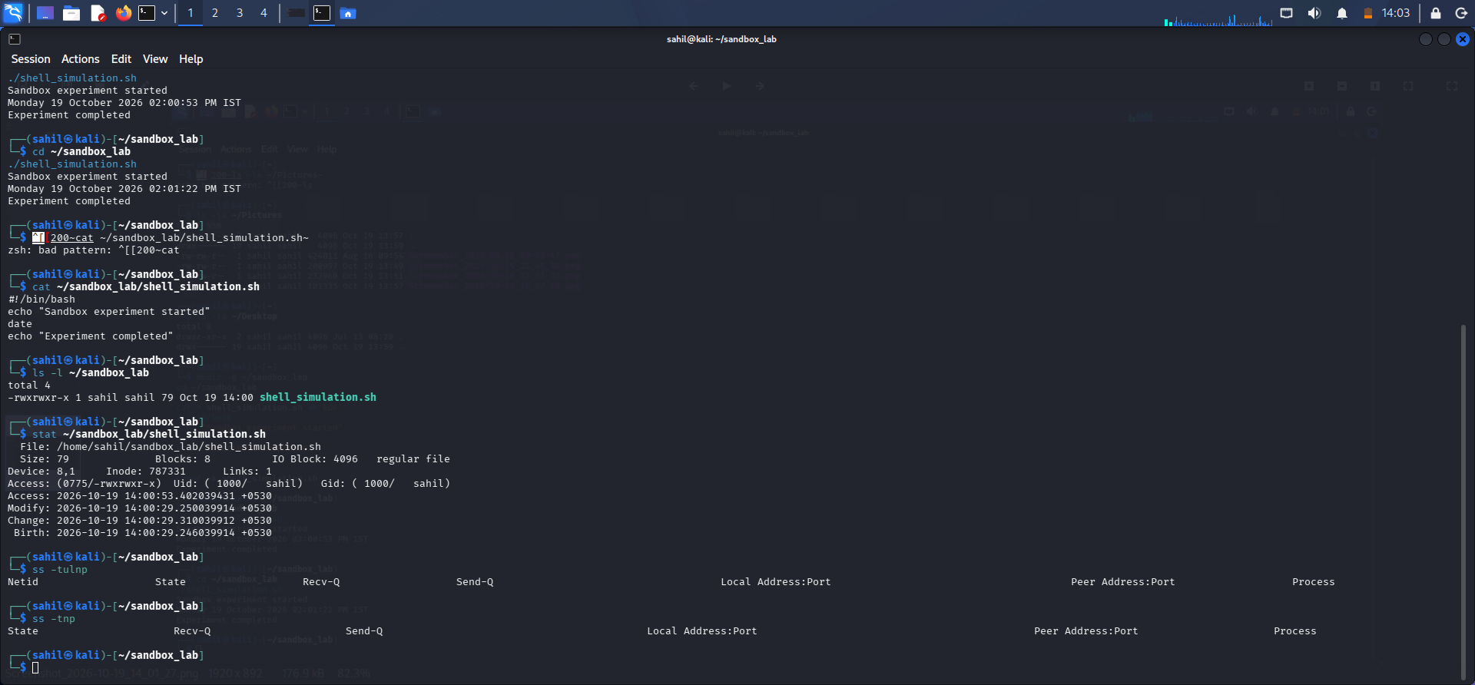
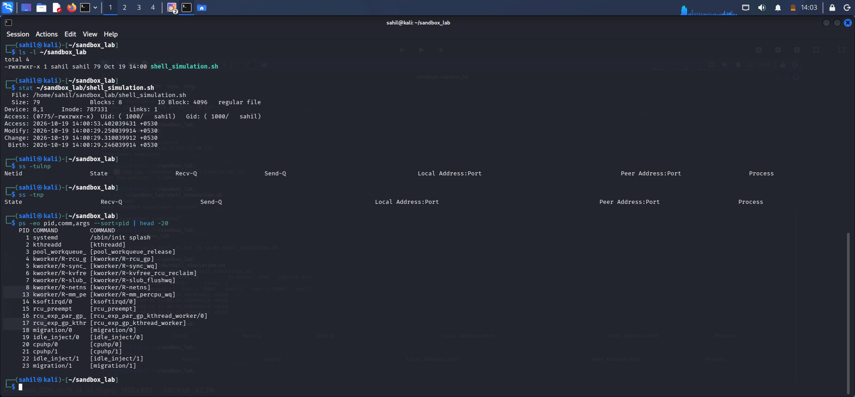
5. Observations
- The Linux virtual machine was used as an isolated experimental environment.
- A clean snapshot was created before the experiment.
- Initial process and network information was recorded.
- A harmless shell simulation was created and executed successfully.
- The script printed messages and the date without intentionally opening network connections.
- File and permission information was examined to identify changes made during the experiment.
- VirusTotal findings were dependent on whether an existing report was available.
- The clean snapshot was restored, and the experiment directory was checked afterward.
- The VM's network isolation was checked again after restoration.
6. Results
The controlled shell simulation was executed in the Linux virtual machine. Process information, network socket information, and file-system changes were examined. Snapshot restoration was performed to return the VM to its clean baseline.
This experiment demonstrated basic sandbox workflow and recovery. It did not test a real malware sample or a functional reverse shell or bind shell.
7. Importance of Sandboxing
- Isolation: Helps reduce the risk of experimental software affecting the host computer.
- Monitoring: Allows researchers to observe processes, network sockets, and file-system changes.
- Snapshot recovery: Makes it possible to return a virtual machine to a known clean state.
- Safety: Reduces risk when experiments are conducted with appropriate network restrictions and harmless test programs.
- Repeatability: A clean baseline helps make observations more consistent across repeated experiments.
8. Precautions
- Keep the virtual machine disconnected from the internet during the experiment.
- Do not use real credentials or confidential files.
- Do not expose a reverse shell or bind shell to external networks.
- Use snapshots before experiments and verify restoration afterward.
- Do not claim VirusTotal detection results without a verified report.
- Use only authorized samples and controlled lab environments.
9. Conclusion
This assignment provided practical experience with Oracle VirtualBox, Linux process monitoring, network socket inspection, basic script examination, and snapshot recovery. The harmless shell simulation demonstrated how a controlled program can be observed in an isolated environment. The experiment also highlighted the importance of network isolation, clean baselines, and snapshot restoration in safer malware-analysis workflows.
Note: The experiment used a harmless shell simulation rather than actual malware or a real reverse shell/bind shell. The report therefore describes the results as a basic sandbox demonstration.

