DRUG REVIEW CLASSIFICATION BY USING SENTIMENT ANALYSIS
Dasari Krishna kumar1,Nuthanakanti Bhaskar2,Bagam Laxmaiah³, Gurram Pavan Reddy⁴,
Santhuja Pandu⁵, Avala Raji Reddy⁶.
1,2,3,4,5.6 Dept. of Computer Science and Engineering, CMR Technical Campus,
Hyderabad,India.
{dkrishnakumar.002,bhaskar4n,blaxmanphd, pavangurram.reddy,
santhuja.pandu,avala.rajireddy}@gmail.com

Abstract. The drugs sentiment analysis has grown significantly in importance in the modern day since categorizing medications based on their efficacy by examining user evaluations can help possible future customers in learning more and making better selections about a certain drugs. Using social media, blogs, and other sources, sentiment analysis is a popular approach for obtaining opinions from a large number of people. In addition to a lack of accessibility, many people started using medications on their own without the necessary consultations it increased the severity of the health issue. Numerous fields have found application for machine learning, and creative work for automation is increasing. The information intends to show a medication recommendation method that could significantly decrease the need for specialists. Implementing machine learning methods, such as light gradient boosting machine (LGBM) K-nearest neighbours (KNN), CAT(computer-aided translation) boost, decision tree (DT), and, in order to assess the information and create a model that conducts sentiment classification. Measurements for precision, accuracy, recall, and f1score were utilized to evaluate the attitudes that were shown. As a consequence, the outcomes demonstrate that the classifier outperforms other approaches.

Keywords: Natural Language Processing (NLP), Drug Rating, ML-Algorithms, Drugs Sentiment Analysis.

1.INTRODUCTION

In the field of machine learning, NLP(natural language processing) is extremely important. It contributes significantly to the study of medical reviews and texts, especially in the area of healthcare. An method for machine learning that is perfect and produces predictions with zero errors is constantly in demand. They intended to evaluate the application of NLP algorithms (in particular Sentiment Analysis) in this study, as a result, they chose a data collection that is more consisting of those of the medical and healthcare industries.

Sentiment analysis (SA), a research that examines into people's sentiments and suggestions regarding various topics is known as opinion mining, including people, organizations, products, and services. The study of each remark to determine whether it is favourable, negative, or neutral is subjective in the context of sentiment analysis. Indicates that [1] SA- sentiment analysis is frequently used in the fields of items, movies, services, restaurants, etc. This method isn't commonly utilised in the medical field, though, which may be because of concerns about privacy and ethical [3].

SA is divided into three levels: sentence, document, and feature. The goal of this study has been to discover characteristics that are either positive, negative, or neutrally contained in customer remarks [4]. This investigation has also uncovered earlier research on the medical field that was mainly involved with medication reviews. Reviews of drugs have been the exclusive focus of this study, or the opinions of users regarding the effectiveness, risks, side effects, symptoms, availability, and cost of the drugs. The fundamental issue with sentiment categorization is that user comment attributes frequently contain irrelevant, unimportant, or even misleading data [15].

Drug development at pharmaceutical corporations often follows a similar pattern. The effectiveness of a drug in treating a patient's disease and any potential adverse effects are important factors when evaluating a drug. The word used in medicine to describe the negative effects produced on by prescription medications is called an adverse drug reaction (ADR). For the pharmaceutical company, it is crucial to assess the adverse effects of the drug whether it is used repeatedly or by people from other cultures. The continuous evaluation would protect the populace from dangerous situations. We need to determine the most effective method so that we can assess the effects of the medications on a wide range of people. Once such a method has been developed, a sentiment analysis tool that understands medical terminology and polarises patient review material from various online sources, including social media and blogs, will be available. When a medicine is being created, it often has to be tested on a large number of people throughout the world taking into consideration various characteristics including weather, eating habits, ethnicity, and so on. To have the medicine approved by the relevant authority, the results must be compromised. Let's use the COVID immunisation as an example. Before the vaccine was made available to the general public, pharmaceutical firms undertook a special procedure. The J&J COVID-19 vaccine is stopped due to neurological dangers according to this journal [1], and we are hearing about several occurrences that are having an adverse effect on vaccinations that have previously been studied and put on the market. There is no established process available to pharmaceutical corporations for receiving direct patient input. Sentiment analysis enters the frame in this case, where it may be able to use data from several sources like social media content, blogs, and more. The information that was gathered could aid pharmaceutical companies in resolving the issue that patients are having.

The medical sentiment is used as a research study for a number of elements, including "medical condition," "treatment procedure," and others that have a direct impact on the health of the users. Periodic patient status analysis can be used to identify any type of improvement or deterioration.

The internet's rapid growth and the online company sector's expansion have enhanced the significance of product reviews. Before making a purchase, consumers have become accustomed to accessing websites and viewing evaluations all across the world. Because they are worried about their health, more individuals are using internet diagnostic tools. 35% of users, according to a 2013 Pew American Research Centre survey, searched online for medical condition diagnosis, whereas 60% of adults searched for information on topics associated with health. In order to help patients as well as doctors learn more about medications for different health issues, a medication recommendation architecture is very necessary.

According to the user's benefit and requirements, a popular mechanism that suggests items is called a suggestion network. Developing algorithms to recognize and separating emotional content from text, such as opinions and attitudes, is known as sentiment analysis [17]. In contrast, "featuring engineering" deals with the enhancing model performance by including additional features in addition to those already present.
2.LITERATURE SURVEY
K. Denecke [1] and Y. Deng, et.al [14] Drug reviews, as defined, are opinions on medications that discuss their efficacy, adverse effects, practicality, and cost. By expressing concepts and ratings on these medications, user comments might assist other users in finding the best establishments, locations, or services.

N. Griese- Mammen et al [6] indicates that a medication review is an organised assessment of a patient's medications according to the Pharmaceutical Care Network Europe (PCNE), with an eye on optimizing the use of medications and improving wellness, concerning drug-related issues and recommended remedies. Basiri M. E., Nemati S., Abdar M., Cifci M. A., and Acharya U. R., et.al [1] Described as a patient's written assessment of various medications depending on their experiences and preferences. This type of evaluation offers a wide range of data that can help with accurate medication safety and public health choices.

D. Cavalcanti and R. Prudêncio, et.al [8] says that SA might also be advantageous to medication producers, particularly in pharmacovigilance because specific side effects of a medicine could be more quickly discovered through public archives or posts on social media. The analysis of medications could include a significant amount of emotional terms derived from the author's own experiences and emotions. As a result, SA may be utilised to gather relevant information that will help in making better decisions about medication safety and public health.

Leilei Sun, Hui Xiong, Chonghui Guo, Chuanren Liu, and Yanming Xie, et.al to find the optimal therapy recommendation for patients, the results of detailed treatment records evaluation. Using an efficient semantic clustering approach, [11] it was aimed at evaluating the similarity of the treatment data were to one another.
the best treatment strategies may be offered using this approach. Patients from several clinics are combined into one electronic medical record (EMR) for examination. As a result, the cure rate is improved by this approach.

Goel V., Gupta A. K. and Kumar N., et.al The Recurrent Neural Network (RNN) and Naive Bayes were used to achieve multilingual sentiment analysis. Implementing the Google Translator API, tweets from a wide range of languages were converted into English. [7] The results demonstrate that Naive Bayes outperformed RNN with 77.21% in comparison to 95.34%.

Y. Bao and X. Jiang et al. [12] compared the performance of three different algorithms using treatment data: the support vector machine (SVM), the back propagation neural network, and the decision tree approach. Considering SVM performed exceptionally well in all three of the model-specific limitations (exactness, competency, and adaptability), it was chosen for the medication suggestion module. A mechanism of error-checking was also provided in order to ensure the correctness of the administration, analysis, and quality.
S.M. Rezaeinia, R. Rahmani, A. Ghodsi, and Veisi, H., et.al By using the Improved Word Vectors (IWV), the sentiment analysis model's accuracy might be increased. Lexicons were combined with word vectors in the study to increase the text's potential to be read emotionally. Additionally, the Improved Word Vectors concept may be utilised by the Word2Vec pre-trained model, which enhances the system performance by 2%. Due to its rapid expansion, the author argues that it is essential to improve Natural language processing (NLP) [5] and text categorization algorithms. This paper highlights a method called part-of-speech (POS) tagging that can help an application do sentiment analysis while taking the context into considerations[6].

Habimana, O., Gu, X. Li, R., Li, Y., and Yu, G., et.al [2] showed that the amount of data produced by the use of online technologies on platforms like social media, blogs, etc. has greatly expanded. Our understanding of the list of tasks required to construct a model for executing the sentiment analysis work has been helped by the deep learning technique that is provided in the study attempt. This analysis also discussed related issues, such as the way to perform natural language processing using models that have already been trained, including the Bidirectional encoder representations from Transformers (BERT)[7].

3.FRAMEWORK OF DRUG REVIEW CLASSIFICATION BY USING SENTIMENT ANALYSIS

In this section framework of drug review classification by using sentiment analysis is seen in Fig.1. Drug Review Dataset (Drugs.com), a dataset utilized in this study, was initially the input. It was acquired from the UCI ML repository. Included are the name of the medication (in writing), the patient's health status, review, and helpful amount (in numbers), as well as the period (an examination entry date),and One of the six elements of this dataset is a numerical 10-star patient rating that represents the patient's overall level of satisfaction. A total of about 2,15,063 occurrences in every one of them. Considering noise and missing values are common in real-world data, and data could be in a useless format, but data can't be utilized to directly train ML systems. Data preparation improves a machine learning model's precision and effectiveness, in order to clean the data and get it ready for the model to operate.
In this analysis, they used standard data preparation techniques including deleting unnecessary items,examining rows for text, duplicate rows, and values that are empty. After that, all 1200 rows in the conditions column have empty values removed. To prevent redundancy, the unique id must be different. The review text was included to the condition and medication column since the condition and medication terms also have predictive potential.

It is crucial to organize up the review texts. It is essential to vectorize the review text before moving on to the feature extraction section. The term "text preprocessing" also applies to this procedure. Prior to cleaning the reviews, HTML(hyper text markup language) tags, punctuation, quotations, URLs(uniform resource locator), etc. were removed. The eliminated reviews were lowercased to avoid duplication. Tokenization, which divides words into small components called tokens, was also conducted on the reviews. Stop words such "a, to, all, we, with, etc.," as well as other similar phrases, were also removed from the corpus. Each token was reduced to its core components by lemmatization. Based on user ratings, every piece of feedback has been classified as either favorable or unfavorable for sentiment analysis purposes. Reviews are positive if the reviewer's grade falls between 6 and 10; otherwise, they are unfavorable. The necessary information is then selected once the undesired data has been deleted. After picking features, sufficient data is required to develop classifiers for sentiment analysis. Because words cannot be processed directly by machine learning algorithms, they must be converted to numerical format. Especially vectors of integers.

This study used three well-known and publicly available approaches for extracting features from text data: the TF-IDF, Word2Vec, and the bag of words (Bow). A framework known as manual feature was produced in Bow, TF-IDF, and Word2Vec by manually extracting elements from the review column using a range of feature engineering techniques. Each token's frequency in a text or review is counted by a machine learning tool called bag of words.A sentence or unit can be represented in terms of several words (n-grams) or only a single phrase (a unigram). The TF-IDF weighting approach assigns weight to words rather than counting them. [17].

In considering the fact that TF-IDF evaluates relevance rather than repetition, it was to place less emphasis on phrases that frequently occur in the information collected.The probability of discovering a word in a document is known as term frequency (TF). Despite being well-known vectorization techniques, A lot of applications utilize TF and TF-IDF types of applications for natural language processing, they neglect as closely related words are in semantics and structure. For instance, TF and TF-IDF vectorization methods relate to the almost equivalence phrases amazing and delicious as two separate words, respectively, despite the fact that they are extracted using different strategies depending on the type of data. To develop word embedding, the Word2Vec models will be used. Using a wide range of deep learning methods, word embeddings were replicated from enormous datasets. The Word2Vec generates a vector space with typically one hundred dimensions from a massive corpus of text as its input.

The basic idea was to organize word vectors in vector space according to their semantic meanings, with the eventual goal of locating words in the dataset that make sense in the same way close. It's a well-known idea that feature engineering can boost the model's accuracy.15 features are employed, including meaningful counts, each day, every month, and every calendar year attributes obtained via an event column by employing a Date & Time function in Pandas, as well as a condition column label encoded using the Sickest package's label encoder function. Eight features were generated from each text review; utilize the Textblob toolbox to extract the polarity of the discarded and uncleaned reviews.

The dataset is finalised and then separated into two sets: testing and training. To train the machine learning model, 70% of the data was still available. Following model training, the remaining 30% of the data were used to evaluate the final model. Among the most frequently utilised oversampling techniques for resolving the imbalance issue is called Synthetic minority oversampling technique (SMOTE). By randomly increasing the number of minority class samples and duplicating them, it is aimed at balancing class distribution. New minority instances are synthesised by SMOTE by combining minority examples that already exist. For categorising and estimating the possibility of an incident, naive bayes is used. Every Naive Bayes classifier makes the assumption that a certain feature's value is different from all other feature values provided in the class variables. For example, if a fruit is red, round, and has a diameter of about 10 cm, a machine may classify it as an apple. Since it makes use of each of these characteristics to accurately identify whether the fruit is an apple, the colour, roundness, and size criteria are not closely correlated by the Naive Bayes classifier. Utilizing the Bayes theorem, the classifier was created.

One of the most basic ML Classifications, K-Nearest Neighbours (KNN), is used for both classification and regression procedures. Utilising the data, KNN algorithms generate new data points based on a measurement of similarity (for example, distance function). Basically, we may state The KNN computation recognises that similar objects may be compared. In KNN, classification takes place by taking into consideration its neighbour’s majorities. The group with the closest neighbours receives the data points. With more nearest neighbours, both the accuracy and the k estimate could increase. The dependent or target variable is predicted by the predictor variables. Our goal variable in this case is the possibility of developing coronary illnesses, and using the KNN method, our model will predict the outcome. Decision trees are the foundation of the Light GBM gradient-boosting architecture, it reduces memory use while improving model performances. It uses two advanced techniques: exclusive feature bundling (EFB) and gradient-based one-side sampling (GOSS).

The histogram-based method, which is the main component of all GBDT (Gradient Boosting Decision Tree) systems, has constraints that these solutions address. The Light GBM Algorithm's features are formed by the two GOSS and EFB approaches that are discussed below. They combine to make the model operate well and provide it a competitive advantage over alternative GBDT frameworks. Yandex created the open-source Cat Boost or Categorical Boosting library.

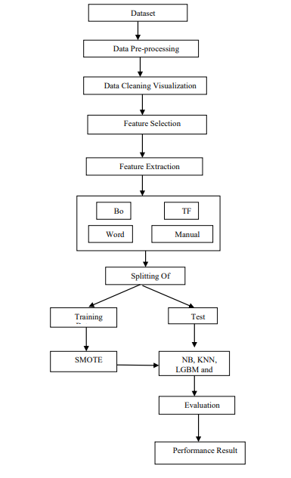

Fig 1: Framework of Drug Review Classification by Using Sentiment Analysis

It was developed to be used with issues like regression and classification that include a significant number of independent features. In my proposed system, the dataset may be manually collected using multiple digital cameras, enhanced, segmented as needed, and saved in distinct folders to distinguish between different photos used for training and validation. Both categorical and numerical characteristics may be handled by the gradient boosting variation known as catboost. Reducing the image's size and cropping it to a certain size and area of interest are both examples of preprocessing. The image is processed and improved to the necessary color scale. To transform categorical data into numerical features, feature-input algorithms like Immediately Converter or Labeling Converter are not necessary. The biases and weights of different feature maps are utilized to capture and select relevant information in a specific process, as opposed to generally designed feature extractors. Additionally, The dataset's value gaps are handled efficiently by a technique known as symmetric weighted quantile sketch (SWQS), which also helps to prevent overfitting and enhance overall dataset performance. It implies that once a network masters class comparison, the capability to identify new image classes even when provided with only a limited number of labelled examples, Precision, recall, F1score, and accuracy were the five measures used to evaluate projected sentiment. The performance results achieved better results.

4.RESULT ANALYSIS
In this section result analysis for framework of drug review classification by using sentiment analysis is seen in Table 1.This method achieved better results. In this system Navie Bayes and KNN, LGBM and Catboost are the classifiers are used.

The classifications of FN- False Negative, FP- False Positive , TN- True Negative , and TP- True Positive , which are defined as follows, are used to evaluate performance:

Real Positive: Whenever an example is correctly predicted to be optimistic and is in fact optimistic.

Real Negative: When the outcome of a sample is exactly as predicted negative.

False positive: Whether an inaccurately predicted negative sample turns out to be a positive sample.

False Negative: While a sample is mistakenly expected to be positive but really turns out to be positive. These parameters are used to calculate performance measures for the provided system, such as precision, accuracy, recall, and F1 score classification errors.

Accuracy: This is referred to be a measure of performance that evaluates the system's capacity for making accurate predictions

Precision: The precision measures a system's ability to provide only usable results.

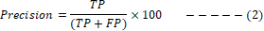
True positive rate (TPR), often called recall, is the proportion of data examples that correctly match a machine learning algorithm's classification of a certain class, or "positive class," when it comes to this group.
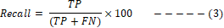

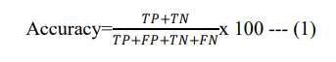
F1 Score: The evaluation metric for machine learning called the F1 score combines accuracy and recall ratings. To efficiently test model correctness, learn how to utilise it and when to utilize

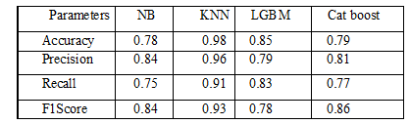
Table 1: Performance Analysis

In Fig.2, accuracy comparison graph of drug review classification by using sentiment analysis is observed. The accuracy of KNN is higher.

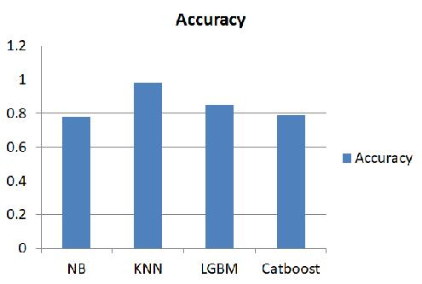

Accuracy

classifier
Fig.2: Accuracy Comparison Graph

Precision comparison graphical representation is seen in Fig.3 between NB, KNN, LGBM and Cat boost. The KNN shows higher precision value.
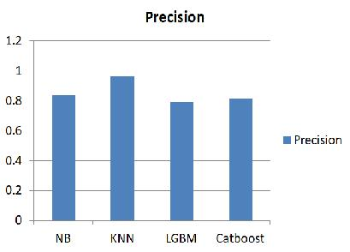

accuracy

classifier
Fig 3: Precision Comparison Graph

The classifiers such as NB, KNN, LGBM and Cat boost compared for recall of drug review classification by using sentiment analysis in Fig.4.

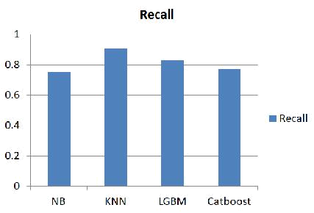

Accuracy

classifier

Fig 4: Recall Comparison Graph

In Fig.5, F1 score comparison graph of drug review classification by using sentiment analysis is observed. The F1 Score of KNN is higher in this graphical representation.

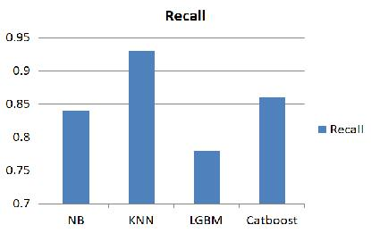

accuracy

Classifier

Fig 5: F1-Score Comparison Graph

5.Conclusion
The content aims to show a medication recommendation method that can significantly minimize the number of specialists. By processing the data with machine learning approaches,Decision trees (DT), K-Nearest Neighbors (KNN), and CAT enhance light gradient boosting machine (LGBM) were used to create models for sentiment classification. Evaluation of the predicted feelings using accuracy, precision, recall, and f1score. Consequently, the best results were obtained with regard to the F1 score, recall, accuracy, and precision.
References

- M. E. Basiri, M. Abdar, M. A. Cifci, S. Nemati, and U. R. Acharya, “A novel method for sentiment classification of drug reviews using fusion of deep and machine learning techniques,” Knowledge-Based Syst., vol. 198, 2020, doi: 10.1016/j.knosys.2020.105949

- Habimana, O., Li, Y., Li, R., Gu, X. and Yu, G., 2020. Sentiment analysis using deep learning approaches: an overview. Science China Information Sciences, 63(1), pp.1-36, https://doi.org/10.1007/s11432-018-9941-6

- T. Chen, P. Su, C. Shang, R. Hill, H. Zhang, and Q. Shen, “Sentiment Classification of Drug Reviews Using Fuzzy-rough Feature Selection,” IEEE Int. Conf. Fuzzy Syst., vol. 2019-June, pp. 1–6, 2019, doi: 10.1109/FUZZ-IEEE.2019.8858916.

- S. R. Ahmad, A. A. Bakar, and M. R. Yaakub, “Ant colony optimization for text feature selection in sentiment analysis,” Intell. Data Anal., vol. 23, no. 1, pp. 133–158, 2019, doi: 10.3233/IDA-173740

- Rezaeinia, S.M., Rahmani, R., Ghodsi, A. and Veisi, H., 2019. Sentiment analysis based on improved pre-trained word embeddings. Expert Systems with Applications, 117, pp.139-147, https://doi.org/10.1016/j.eswa.2018.08.044

- N. Griese-Mammen., “PCNE definition of medication review: reaching agreement,” Int. J.
Clin. Pharm., vol. 40, no. 5, 2018, doi: 10.1007/s11096-018-0696-7.

- V. Goel, A. K. Gupta and N. Kumar, ”Sentiment Analysis of Multilingual Twitter Data using Natural Language Processing,” 2018 8th International Conference on

Communication Systems and Network Technologies (CSNT), Bhopal, India, 2018, pp. 208-212, doi: 10.1109/CSNT.2018.8820254

- D. Cavalcanti and R. Prudêncio, “Aspect-based opinion mining in drug reviews,” Lect.

Notes Comput. Sci. (including Subser. Lect. Notes Artif. Intell. Lect. Notes Bioinformatics), vol. 10423 LNAI, no. August, pp. 815–827, 2017, doi:10.1007/978-3-319-65340-2_66

- Hadi, M.A., Neoh, C.F., Zin, R.M., Elrggal, M.E. and Cheema, E., 2017.
Pharmacovigilance: pharmacists’ perspective on spontaneous adverse drug reaction
reporting. Integrated pharmacy research & practice, 6, p.91, doi: 10.2147/IPRP.S105881

- Beppu, H., Minaguchi, M.A.S.U.M.I., Uchide, K.I.Y.O.S.H.I., Kumamoto, K.U.N.I.H.I.K.O., Sekiguchi, M.A.S.A.T.O. and Yaju, Y., 2017. Lessons learnt in Japan from adverse reactions to the HPV vaccine: a medical ethics perspective. Indian J Med Ethics, 2(2), pp.82-8, doi: https://doi.org/10.20529/IJME.2017.021.

- Leilei Sun, Chuanren Liu, Chonghui Guo, Hui Xiong, and Yanming Xie. 2016. Data-driven Automatic Treatment Regimen Development and Recommendation. In Proceedings of the 22nd ACM SIGKDD International Conference on Knowledge Discovery and Data

Mining (KDD ’16). Association for Computing Machinery, New York, NY, USA, 1865–
1874. DOI:https://doi.org/10.1145/2939672.2939866.
- Y. Bao and X. Jiang, ”An intelligent medicine recommender system framework,” 2016

IEEE 11th Conference on Industrial Electronics and Applications (ICIEA), Hefei, 2016, pp. 1383-1388, doi: 10.1109/ICIEA.2016.7603801.

- J. Li, H. Xu, X. He, J. Deng and X. Sun,” Tweet modeling with LSTM recurrent neural networks for hashtag recommendation,” 2016 International Joint Conference on Neural

Networks (IJCNN), Vancouver, BC, 2016, pp. 1570-1577, doi: 10.1109/IJCNN.2016.7727385.

- K. Denecke and Y. Deng, “Sentiment analysis in medical settings: New opportunities and challenges,” Artif. Intell. Med., vol. 64, no. 1, pp. 17–27, 2015, DOI: 10.1016/j.artmed.2015.03.006.

- H. Arafat, R. M.Elawady, S. Barakat, and N. M.Elrashidy, “Different Feature Selection for Sentiment Classification,” Int. J. Inf. Sci. Intell. Syst., vol. 1, no. 3, pp. 137–150, 2014.
- Zhang, Yin & Zhang, Dafang & Hassan, Mohammad & Alamri, Atif & Peng, Limei. (2014). CADRE: Cloud-Assisted Drug Recommendation Service for Online Pharmacies. Mobile Networks and Applications. 20. 348-355. 10.1007/s11036-014-0537-4.

- Fox, Susannah & Duggan, Maeve. (2012). Health Online 2013. Pew Research Internet Project Report.

- Doulaverakis, C., Nikolaidis, G., Kleontas, A. GalenOWL: Ontology-based drug recommendations discovery. J Biomed Semant 3, 14 (2012). https://doi.org/10.1186/2041-1480-3-14.

- Shimada K, Takada H, Mitsuyama S, Drug-recommendation system for patients with infectious diseases. AMIA Annu Symp Proc. 2005;2005:1112, PMID: 16779399; PMCID: PMC1560833.

- K. Yanagisawa et al., "Convolutional Neural Network Can Recognize Drug Resistance of Single Cancer Cells," International Journal of Molecular Sciences, vol. 21, no. 9, May 2020, Art. no. 3166.

- K. Y. Chang, T. P. Lin, L. Y. Shih, and C. K. Wang, "Analysis and Prediction of the Critical Regions of Antimicrobial Peptides Based on Conditional Random Fields," Plos One, vol. 10, no. 3, Mar 2015, Art. no. e0119490.

- Archive.ics.uci.edu. S. Kallumadi and F. Gräßer 2018. UCI Machine Learning Repository: Drug Review Dataset (Druglib.com) Data Set. [online] Available at: [Accessed 24 October 2021]

