* **Summary of the Project**
  + Project is all about creating automation test suit for the application that is web based for the influents server.
  + It’s having unit test cases that is created for the each part of the project.
  + It covers all the functional test cases for the things also it give the result for the thing.
* **Project Planning and Project management**
  + Created road map for the testing and created priority test cases.
  + Tested most of the functional test cases first and then created all the black box testing.
  + Create selenium test suite using testing framework.
* **Project coding.**
  + Used eclipse into the tool for the coding and used selenium RC for the creation of first level test case.
* **Project Screenshot with the details of the coding.**
  + Project Login screenshot.

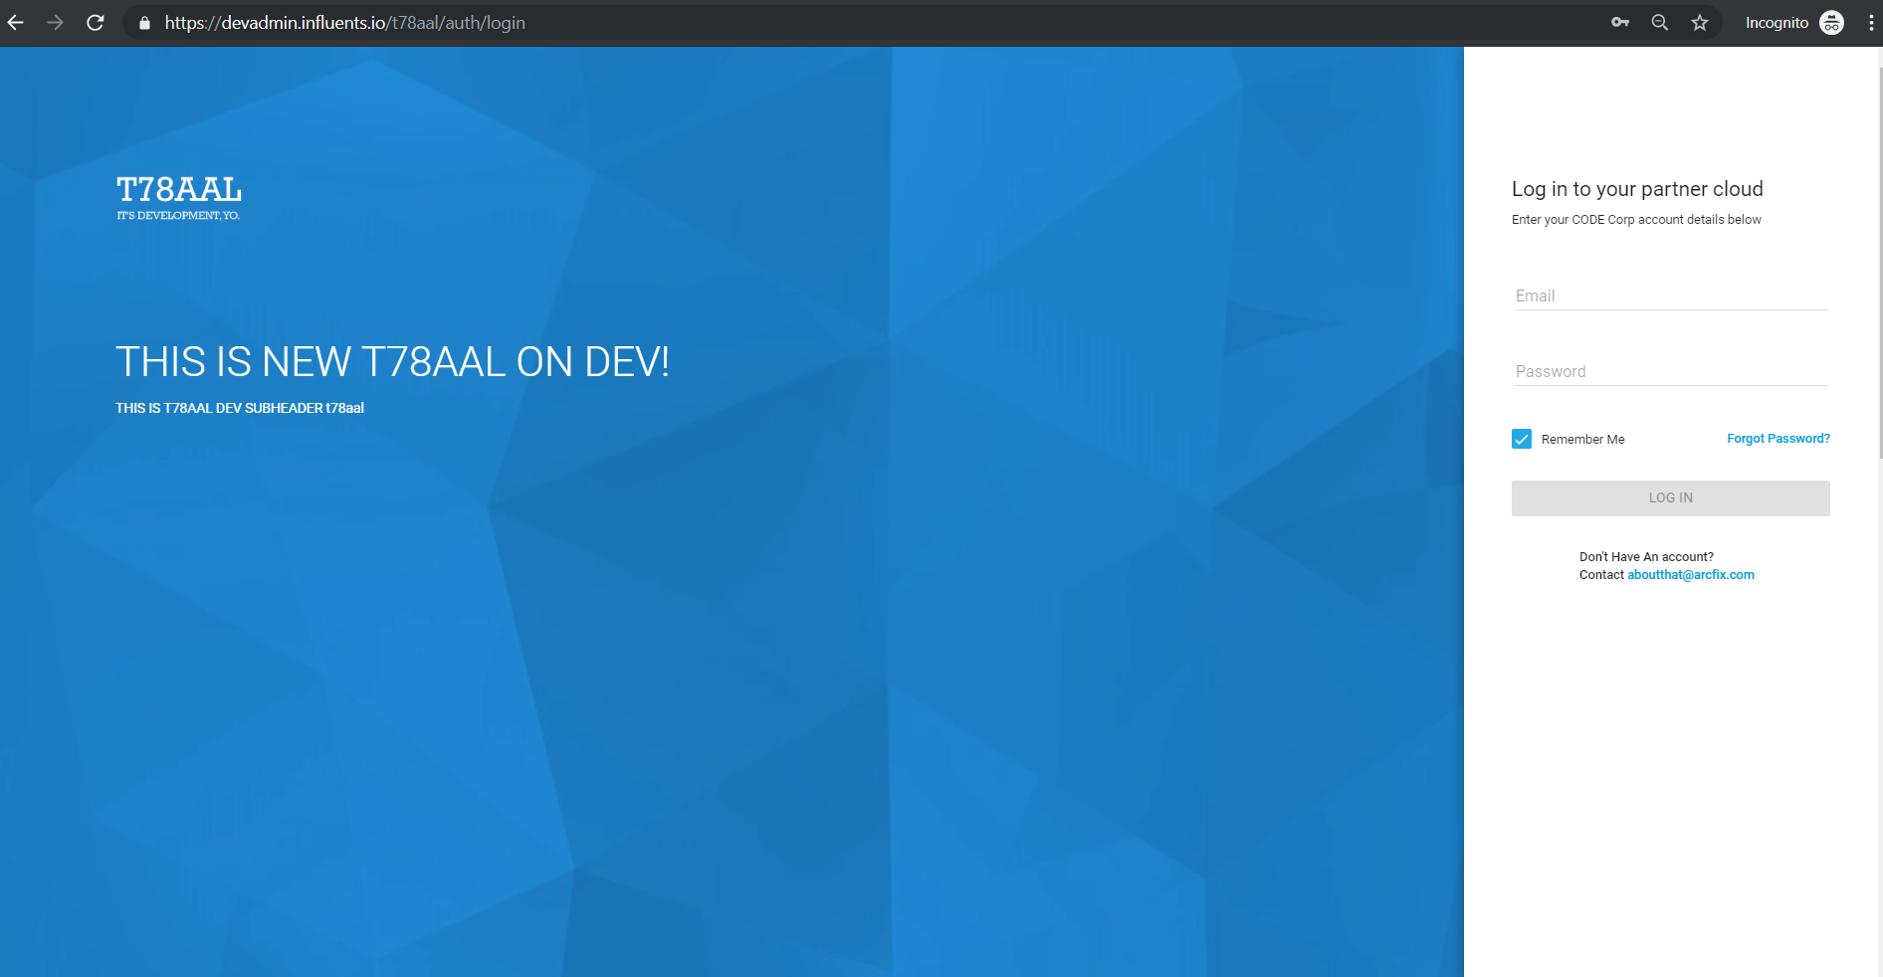

* + Home screen for the influents that is designed

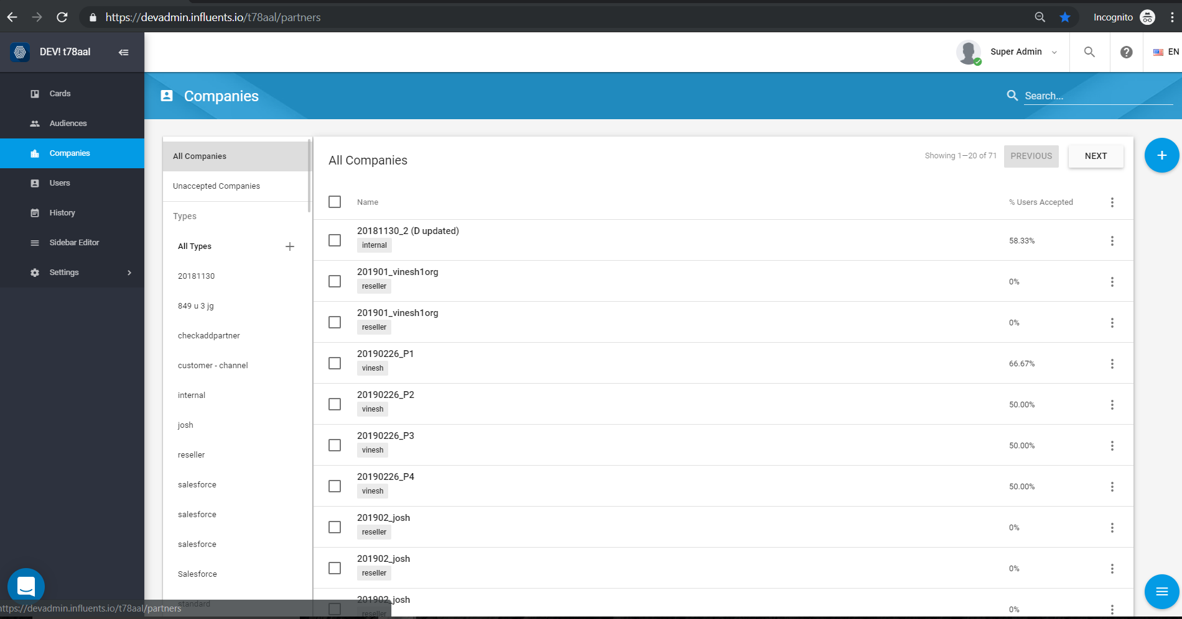

* + Creating new card with the automation suite. It covers main functions for the test suit.

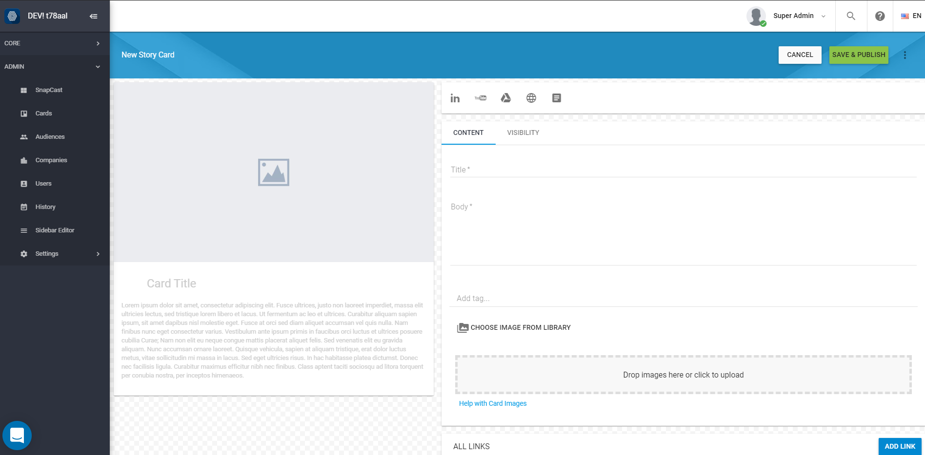

* + Creation of test cases using eclipse.

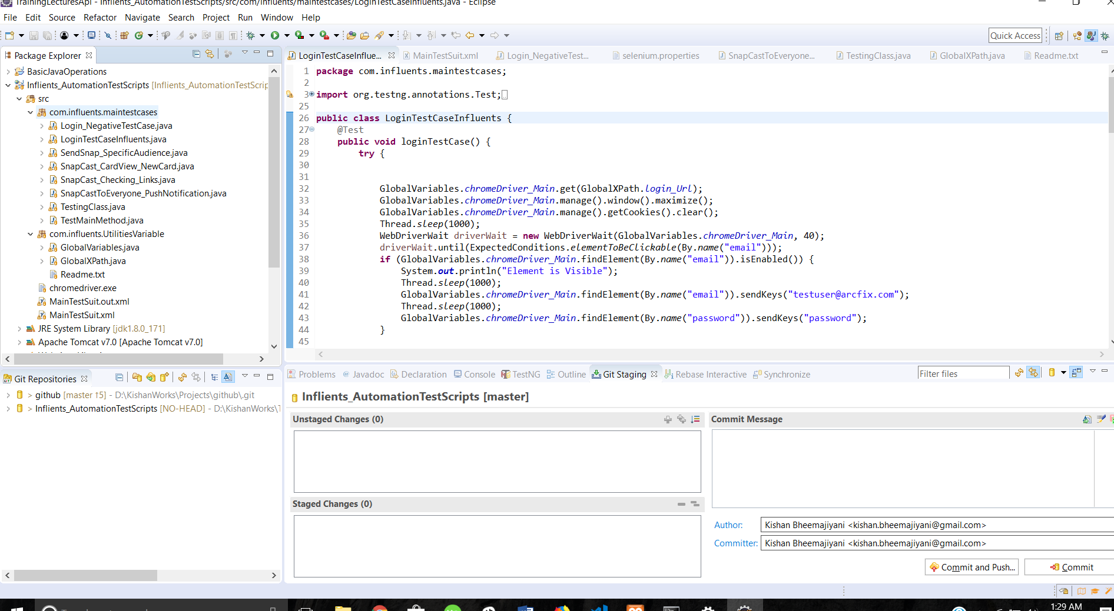

* + **Test Planning and Test case descriptions**
    - Login logout test case
      1. Login with the login details user name and password
      2. Check if user should login with proper details.
      3. Expected output: User should login properly without issue.
    - Login negative test case.
      1. Login with incorrect username and password of user.
      2. Expected output: It should not allow user to login user.
    - Login and Push card to everyone.
      1. Login with correct username and password.
      2. Go to Card section and create card for all user and push it to everyone.
      3. Exception Output: User should get notification on android and iOS device.
    - Push card to the specific audience
      1. Login with the correct credential
      2. Go to the cards view and create new card and push it to specific audience.
      3. Expected Output: user should receive card on the mobile device.
* **Pushing code to the git hub.**
  + Using architecture of team using centralized repository as git and putting one as team copy and sharing amongst the team members. Also committing final code by the repository owner.
  + Having one staging and one production infrastructure for the same and pushing code after testing into production.
* **Code deployment into the Production**
  + Using Jenkins for the production release of the code into the git hub. Everyday job is running for the deploy code on staging and then Jenkins job set for the production to deploy.
  + This continues for the each sprint of the cycle and after some time duration this happens all the times. So pipe line works on that way.

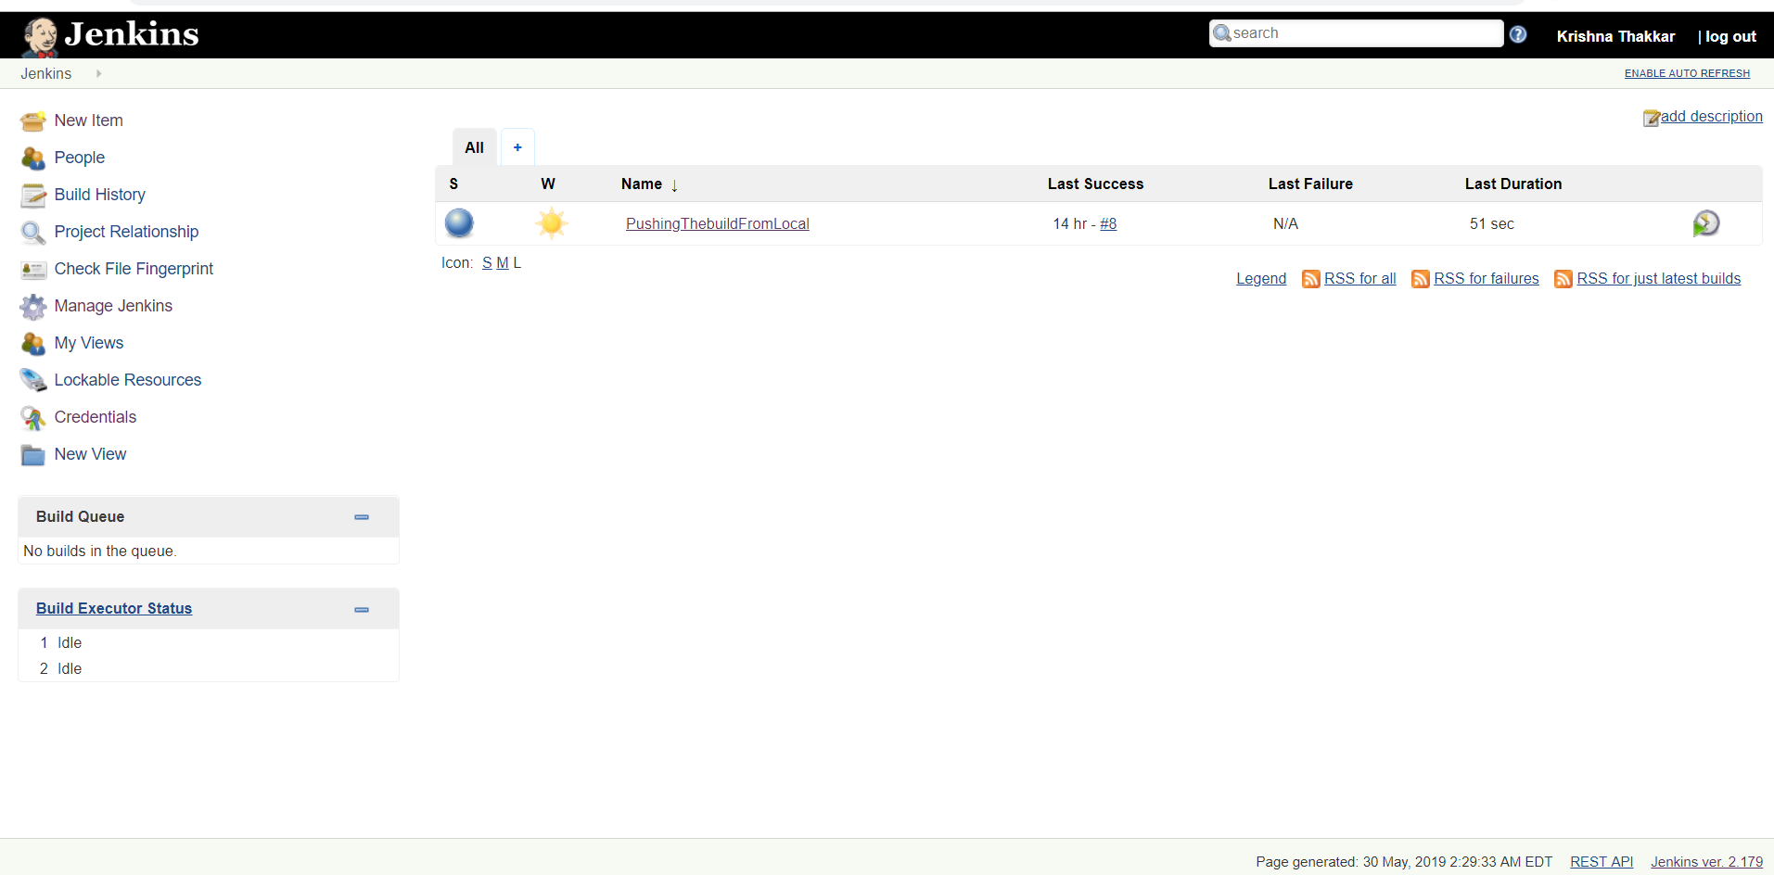

* **Jenkins Pipeline.**
  + There is Jenkins jobs that is run after every interval that push build to the production and builds the project.
  + Since right now same thing is happening on local, since have not bought the Jenkins server yet.
* **Reporting after test run** 
  + It will create one report by default and it will send it to the concern person after every test run.
  + Every bug identified will be having Jira ticket created.