**Background**

Web pages are written in Hypertext Markup Language (HTML). An HTML file is composed of text surrounded by tags, where the tags “mark up*”*the text by specifying its format, layout, or other information. Tags can be nested as well.

Here is a simple example, with the tags highlighted in bold:

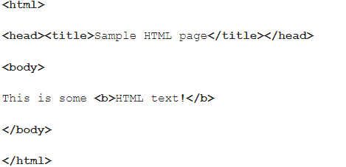

In theory (though not often in practice), well formatted HTML requires that the tags are “balanced,” i.e. that open tags are matched by their corresponding close tag in the correct order.

For instance, if we ignore whitespace and the text between the tags, we end up with this:

**<html><head><title></title></head><body><b></b></body></html>**

Note that there is some symmetry in the HTML tags, in that whenever we close a tag, it matches the most recent (unclosed) open tag.

For instance, if we highlight the “title” tags, we see that a close tag matches the last open tag:

<html><head>**<title></title>**</head><body><b></b></body></html>

And in this case, the close “body” tag matches the open “body” tag, which is the most recently opened tag that has not yet been closed (since the “b” tag is already closed):

<html><head><title></title></head>**<body>**<b></b>**</body>**</html>

Some HTML tags are “self-closing” and do not rely on a matching closing tag. For instance, here the “br” tag closes itself:

<html><head>head><body><b>**<br/>**</b></body></html>

A self-closing tag is one that ends with the forward slash character, as opposed to a closing tag, which starts with one.

It is easy to make mistakes in HTML code! Most commonly, people forget to close tags or close nested tags in the wrong order, e.g. something like this:

<html><head><title></title><body><b></body></b></html>

In this case, there is no close “head” tag, and the “body” tag is closed in the wrong order: it should come after the close “b” tag.

In this project, I have created a method that determines whether an HTML file is well formatted using a stack. Every time code encounters an open tag, it pushes it onto the stack; when it encounters a close tag, it pops the tag off the top of the stack, and if they don’t match, then the file is marked as not well formatted.