**Architecture Style: Pipes and Filters**

**Introduction:**

Pipe and Filter style each component has a set of inputs and set of outputs.

A component reads streams of data on its inputs and produces streams of data on its outputs, delivering a complete instance of the result in a standard order.

Filter are the independent entities and pipes carry the stream of inputs from one filter to another.

**Project Description:**

The current build system is avionics system where the stream of data is provided as input and the compute functionality is implemented according to the requirements.

Implementations:

System A and System B

Design Diagrams:

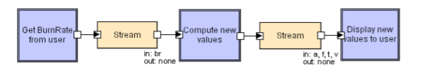

Source Filter 🡪 stream 🡪 MiddleFilter 🡪 stream 🡪 Sink Filter

References:

<https://www.cs.cmu.edu/afs/cs/project/vit/ftp/pdf/intro_softarch.pdf>

<http://csw.jlu.edu.cn/__local/D/7E/93/42957E37BCEAE3BFE85E0C21385_F61A27C5_B7C243.pdf>