**NAME:-Krishna Gokul Nagare**

**PRN NO:-2124UCSM1032**

**ASSIGNMENT NO.1**

**1. Introduction**

Install the Android SDK and developer tools and build a test project to confirm that those tools are properly installed and configured.

**2. Tools & Technologies Used**

* Android Studio
* Java/Kotlin (Specify the language used)
* Emulator or Physical Device ()

**3. Procedure & Steps**

**Step 1: Create a New Project (helloworldAPK)**

* Open Android Studio and create a new project.
* Select an second page activity by app-activity-page you selected
* Set the project name and package name.
* Select the programming language (Java/Kotlin).

**Screenshot:-**

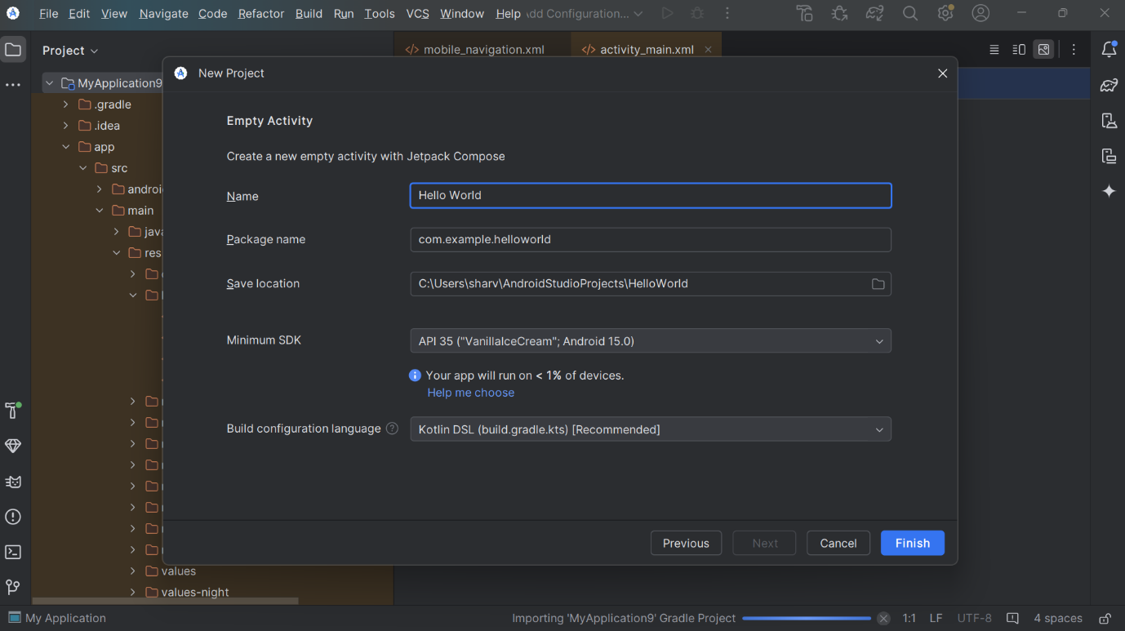

**Step 2: Writing the Code:**

**Screenshot:-**

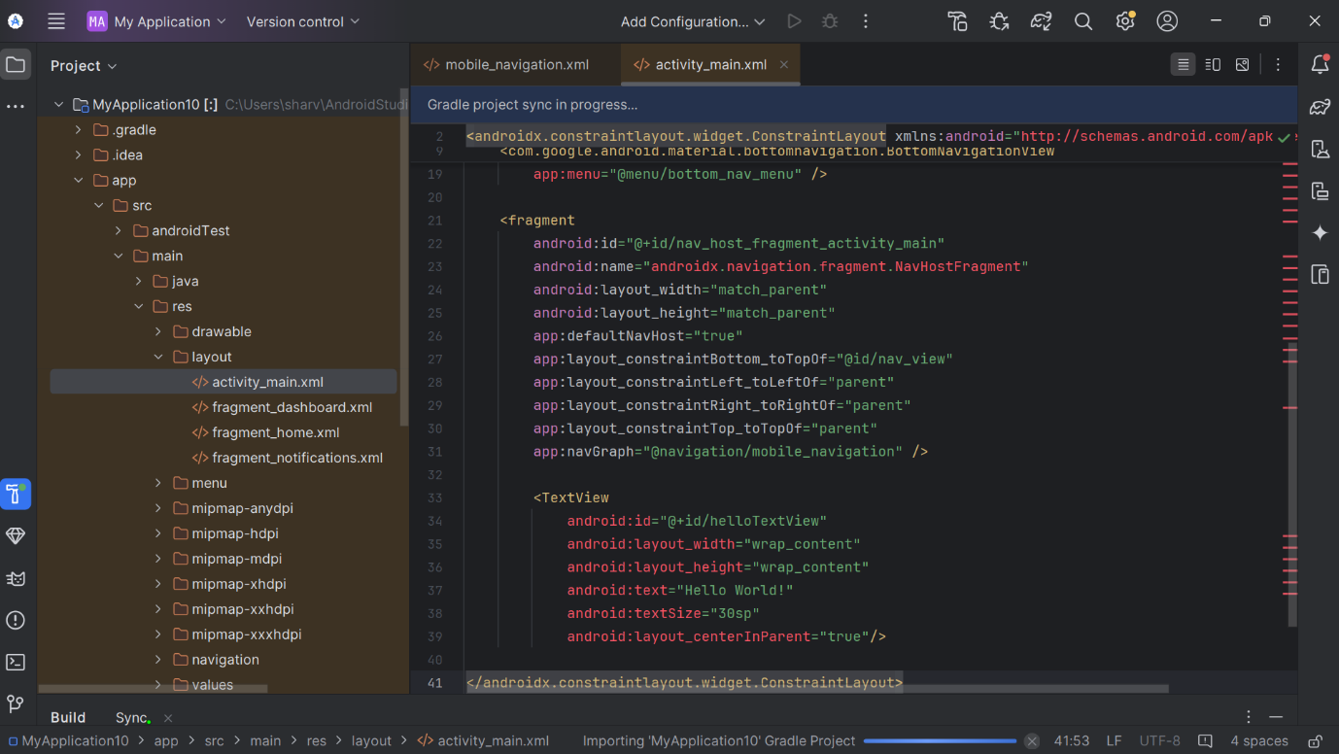

**Step 3: Running the Application on Emulator**

* Click on the **Run** button in Android Studio.

**Screenshot:**

**Sep 4: Testing & Output**

* Test different functionalities of the app.
* Capture the output results.

**Screenshot:-**

