**NAME:-Krishna Nagare**

**PRN:-2124UCSM1032**

# Assignment_02

**Table Layout for Restaurant Data Entry Form: Write a program that uses a table layout to create a restaurant**

**data entry form. Include fields like "Restaurant Name,"**

**"Location," and "Cuisine Type." Add a set of radio buttons to let the user select the type of restaurant**

**(e.g., "Fast Food," "Fine Dining," or "Cafe"). Use this to design a user-friendly interface for restaurant owners to input their data.**

1. **Introduction** 
   * Install the Android SDK and developer tools and build a test project to confirm that those tools are properly installed and configured.
   * Assignment_02 Encounters the layout of the restaurant data entry form where users can choose their preferences for there dining
2. **Tools & Technologies Used** 
   * Android Studio
   * Java/Kotlin (Specify the language used)
   * Emulator or Physical Device (Android version 15)
3. **Procedure & Steps**

Step 1: Create a New Project

* + Open Android Studio and create a new project.
  + Choose an Bottom Navigation Activity.
  + Set the project name and package name.
  + Select the programming language (Kotlin).

Screenshot:

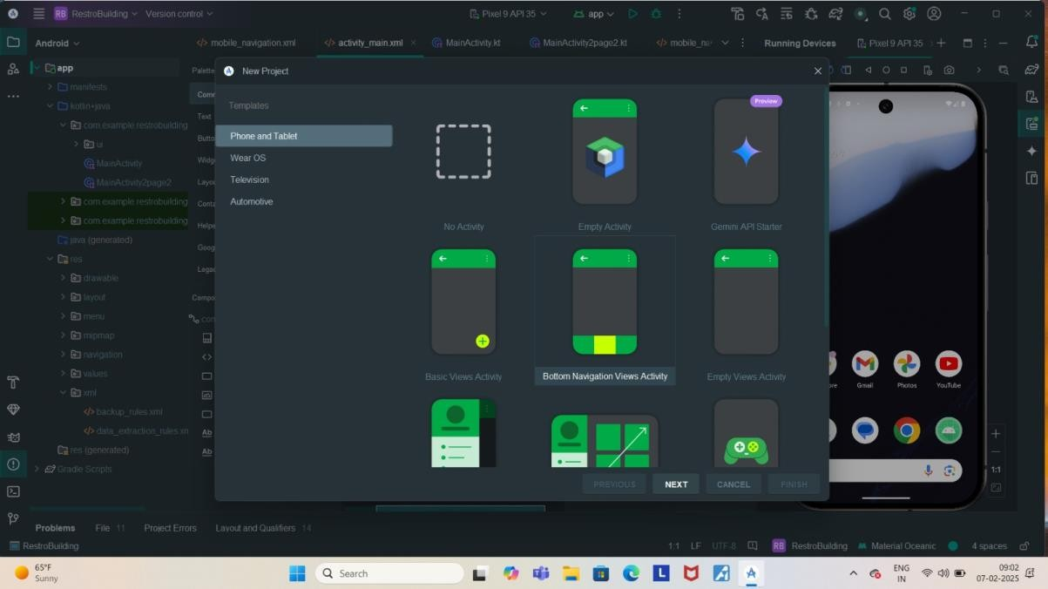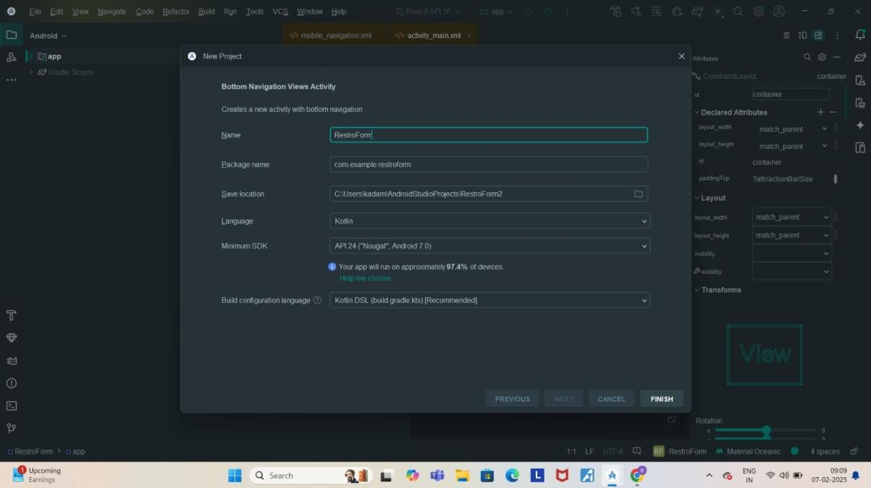

**Step 2: Designing the UI**

* + Open activity_main.xml and design the layout using XML.
  + Add UI components such as TextView , EditText, Button, etc.

**Screenshot:**

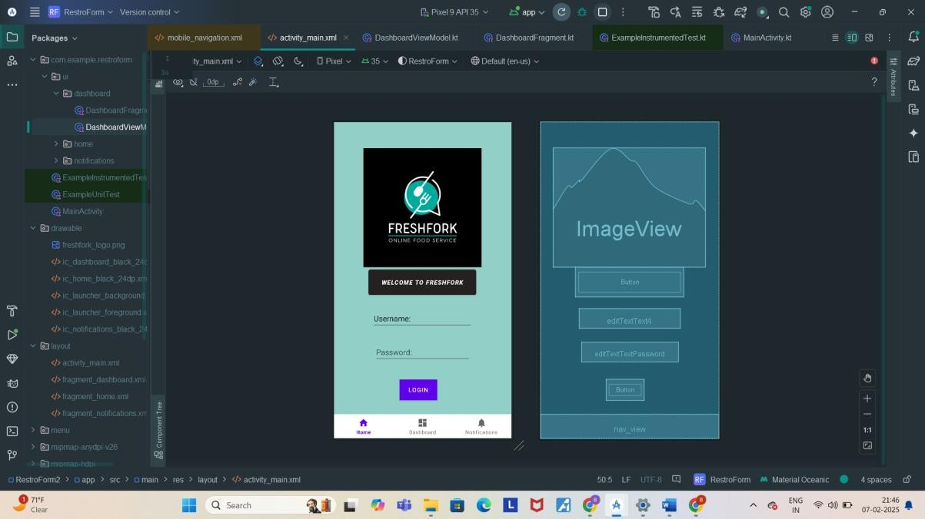

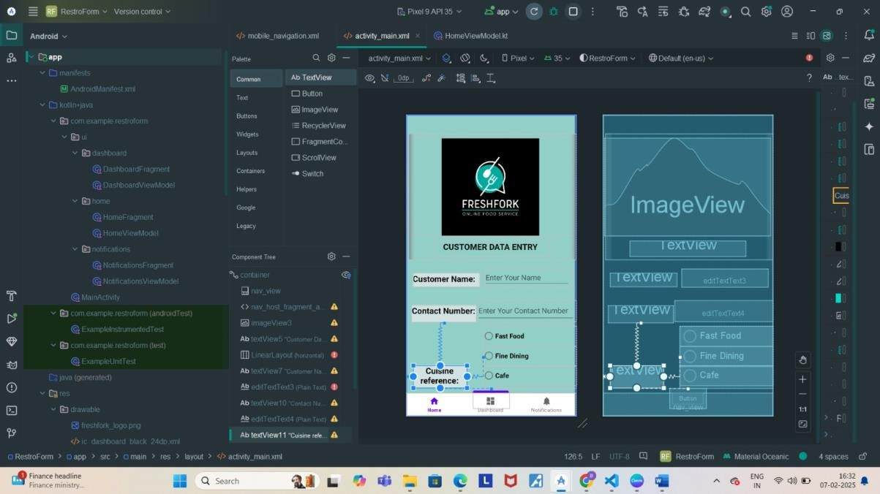

**Step 3: Writing the Code**

**Page_01**

<androidx.constraintlayout.widget.ConstraintLayout xmlns:android="http://schemas.android.com/apk/res/android" xmlns:app="http://schemas.android.com/apk/res-auto" xmlns:tools="http://schemas.android.com/tools" android:id="@+id/container" android:layout_width="match_parent" android:layout_height="match_parent" android:background="#91CFC7" android:paddingTop="?attr/actionBarSize">

<com.google.android.material.bottomnavigation.BottomNavigationView android:id="@+id/nav_view" android:layout_width="0dp" android:layout_height="wrap_content" android:layout_marginStart="0dp" android:layout_marginEnd="0dp" android:background="?android:attr/windowBackground" app:layout_constraintBottom_toBottomOf="parent" app:layout_constraintLeft_toLeftOf="parent" app:layout_constraintRight_toRightOf="parent" app:menu="@menu/bottom_nav_menu" />

<fragment android:id="@+id/nav_host_fragment_activity_main" android:name="androidx.navigation.fragment.NavHostFragment" android:layout_width="match_parent" android:layout_height="match_parent" app:defaultNavHost="true" app:layout_constraintBottom_toTopOf="@id/nav_view" app:layout_constraintLeft_toLeftOf="parent" app:layout_constraintRight_toRightOf="parent" app:layout_constraintTop_toTopOf="parent" app:navGraph="@navigation/mobile_navigation" />

<Button android:id="@+id/button3" android:layout_width="250dp" android:layout_height="70dp" android:layout_marginBottom="308dp" android:backgroundTint="#252121" android:text="Welcome to FreshFork" android:textAlignment="center" android:textStyle="bold|italic" app:layout_constraintBottom_toTopOf="@+id/nav_view" app:layout_constraintEnd_toEndOf="parent" app:layout_constraintHorizontal_bias="0.496" app:layout_constraintStart_toStartOf="parent" app:layout_constraintTop_toBottomOf="@+id/imageView3"

app:layout_constraintVertical_bias="0.0" />

<ImageView android:id="@+id/imageView3" android:layout_width="352dp" android:layout_height="275dp" android:layout_marginTop="4dp" app:layout_constraintEnd_toEndOf="parent" app:layout_constraintHorizontal_bias="0.491" app:layout_constraintStart_toStartOf="parent" app:layout_constraintTop_toTopOf="parent" app:srcCompat="@drawable/freshfork_logo" />

<Button android:id="@+id/button4" android:layout_width="wrap_content" android:layout_height="wrap_content" android:layout_marginBottom="16dp" android:background="#171616" android:backgroundTint="#1B1515" android:text="Login" app:layout_constraintBottom_toBottomOf="parent" app:layout_constraintEnd_toEndOf="parent" app:layout_constraintHorizontal_bias="0.47" app:layout_constraintStart_toStartOf="parent" app:layout_constraintTop_toBottomOf="@+id/button3" app:layout_constraintVertical_bias="0.722" />

<EditText android:id="@+id/editTextText4" android:layout_width="233dp" android:layout_height="46dp" android:layout_marginBottom="68dp" android:ems="10" android:inputType="text" android:text="Username:" app:layout_constraintBottom_toTopOf="@+id/button4" app:layout_constraintEnd_toEndOf="parent" app:layout_constraintHorizontal_bias="0.497" app:layout_constraintStart_toStartOf="parent" app:layout_constraintTop_toBottomOf="@+id/button3" app:layout_constraintVertical_bias="0.343" />

<EditText android:id="@+id/editTextTextPassword" android:layout_width="223dp" android:layout_height="46dp" android:layout_marginTop="32dp" android:ems="10" android:hint="Password:" android:inputType="textPassword" app:layout_constraintEnd_toEndOf="parent" app:layout_constraintHorizontal_bias="0.497" app:layout_constraintStart_toStartOf="parent"

app:layout_constraintTop_toBottomOf="@+id/editTextText4" />

</androidx.constraintlayout.widget.ConstraintLayout>

Page_02

?xml version="1.0" encoding="utf-8"?>

<androidx.constraintlayout.widget.ConstraintLayout xmlns:android="http://schemas.android.com/apk/res/android" xmlns:app="http://schemas.android.com/apk/res-auto" xmlns:tools="http://schemas.android.com/tools" android:id="@+id/container" android:layout_width="match_parent" android:layout_height="match_parent" android:background="#91CFC7" android:paddingTop="?attr/actionBarSize" tools:visibility="visible">

<com.google.android.material.bottomnavigation.BottomNavigationView android:id="@+id/nav_view" android:layout_width="0dp" android:layout_height="wrap_content" android:layout_marginStart="0dp" android:layout_marginEnd="0dp" android:background="?android:attr/windowBackground" app:layout_constraintBottom_toBottomOf="parent" app:layout_constraintLeft_toLeftOf="parent" app:layout_constraintRight_toRightOf="parent" app:menu="@menu/bottom_nav_menu" />

<fragment android:id="@+id/nav_host_fragment_activity_main" android:name="androidx.navigation.fragment.NavHostFragment" android:layout_width="match_parent" android:layout_height="match_parent" app:defaultNavHost="true" app:layout_constraintBottom_toTopOf="@id/nav_view" app:layout_constraintLeft_toLeftOf="parent" app:layout_constraintRight_toRightOf="parent" app:layout_constraintTop_toTopOf="parent" app:navGraph="@navigation/mobile_navigation" />

<ImageView android:id="@+id/imageView3" android:layout_width="402dp" android:layout_height="238dp" app:layout_constraintEnd_toEndOf="parent" app:layout_constraintHorizontal_bias="0.444" app:layout_constraintStart_toStartOf="parent" app:layout_constraintTop_toTopOf="parent" app:srcCompat="@drawable/freshfork_logo" />

<TextView android:id="@+id/textView5" android:layout_width="280dp" android:layout_height="38dp" android:layout_marginTop="12dp" android:text="Customer Data Entry" android:textAlignment="center" android:textAllCaps="true" android:textColor="#0C0C0C" android:textSize="20sp" android:textStyle="bold" app:layout_constraintEnd_toEndOf="parent" app:layout_constraintHorizontal_bias="0.496" app:layout_constraintStart_toStartOf="parent"

app:layout_constraintTop_toBottomOf="@+id/imageView3" /> <LinearLayout android:layout_width="406dp" android:layout_height="305dp" android:orientation="horizontal" tools:layout_editor_absoluteX="6dp" tools:layout_editor_absoluteY="-11dp">

</LinearLayout>

<TextView android:id="@+id/textView7" android:layout_width="163dp" android:layout_height="33dp" android:layout_marginTop="40dp" android:background="#D2E1E1" android:text="Customer Name:" android:textColor="#070707" android:textSize="20sp" android:textStyle="bold" app:layout_constraintEnd_toStartOf="@+id/editTextText3" app:layout_constraintHorizontal_bias="0.592" app:layout_constraintStart_toStartOf="parent" app:layout_constraintTop_toBottomOf="@+id/textView5" />

<EditText android:id="@+id/editTextText3" android:layout_width="wrap_content" android:layout_height="wrap_content" android:layout_marginTop="28dp" android:layout_marginEnd="12dp" android:ems="10" android:hint="Enter Your Name" android:inputType="text" app:layout_constraintEnd_toEndOf="parent"

app:layout_constraintTop_toBottomOf="@+id/textView5" />

<TextView android:id="@+id/textView10" android:layout_width="158dp" android:layout_height="41dp" android:layout_marginStart="12dp" android:layout_marginTop="44dp" android:background="#D2E1E1"

android:text="Contact Number:" android:textAlignment="center" android:textColor="#070707" android:textSize="20sp" android:textStyle="bold" app:layout_constraintStart_toStartOf="parent" app:layout_constraintTop_toBottomOf="@+id/textView7" />

<EditText android:id="@+id/editTextText4" android:layout_width="239dp" android:layout_height="52dp" android:layout_marginTop="32dp" android:ems="10" android:hint="Enter Your Contact Number" android:inputType="text" app:layout_constraintEnd_toEndOf="parent" app:layout_constraintHorizontal_bias="1.0" app:layout_constraintStart_toEndOf="@+id/textView10" app:layout_constraintTop_toBottomOf="@+id/editTextText3" />

<TextView android:id="@+id/textView11" android:layout_width="131dp" android:layout_height="54dp" android:layout_marginTop="104dp" android:background="#D2E1E1" android:text="Cuisine reference:" android:textAlignment="center" android:textColor="#020202" android:textSize="20sp" android:textStyle="bold" app:layout_constraintBottom_toTopOf="@+id/button2" app:layout_constraintEnd_toStartOf="@+id/radioGroup" app:layout_constraintHorizontal_bias="0.29" app:layout_constraintStart_toStartOf="parent" app:layout_constraintTop_toBottomOf="@+id/textView10" app:layout_constraintVertical_bias="0.25" />

<RadioGroup android:id="@+id/radioGroup" android:layout_width="226dp" android:layout_height="151dp" app:layout_constraintBottom_toTopOf="@+id/nav_view" app:layout_constraintEnd_toEndOf="parent"

app:layout_constraintTop_toBottomOf="@+id/editTextText4">

<RadioButton android:id="@+id/radioButton" android:layout_width="match_parent" android:layout_height="wrap_content" android:text="Fast Food" android:textAlignment="viewStart" android:textSize="16sp" android:textStyle="bold" />

<RadioButton android:id="@+id/radioButton2" android:layout_width="match_parent" android:layout_height="wrap_content" android:text="Fine Dining" android:textSize="16sp" android:textStyle="bold" />

<RadioButton android:id="@+id/radioButton3" android:layout_width="match_parent" android:layout_height="wrap_content" android:text="Cafe" android:textSize="16sp" android:textStyle="bold" />

</RadioGroup>

<Button android:id="@+id/button2" android:layout_width="wrap_content" android:layout_height="wrap_content" android:text="Submit" app:layout_constraintEnd_toEndOf="parent" app:layout_constraintStart_toStartOf="parent"

app:layout_constraintTop_toBottomOf="@+id/radioGroup" />

</androidx.constraintlayout.widget.ConstraintLayout>

**Step 4: Running the Application on Emulator** • Click on the Run button in Android Studio.

• Select the emulator and launch the app.

**Screenshot:**

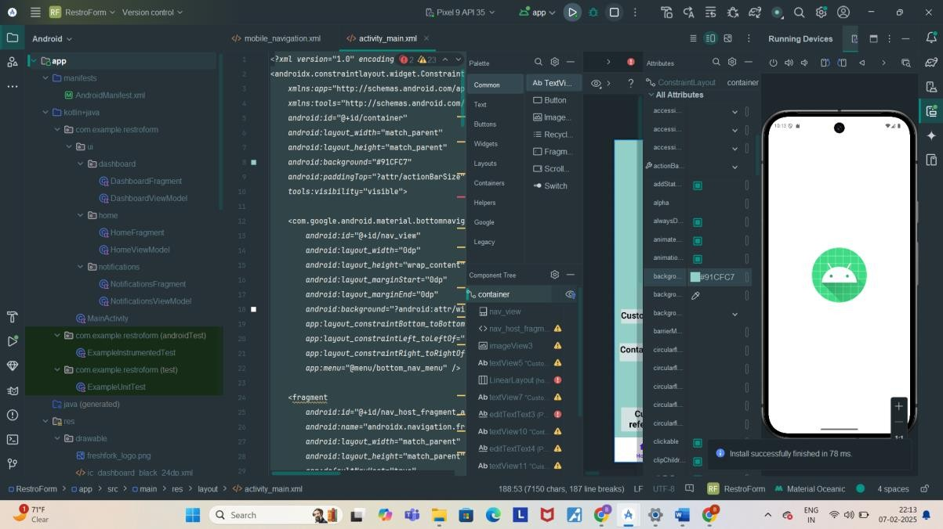

**Step 5: Testing & Output**

Test different functionalities of the app.

Capture the output results.

Page_01

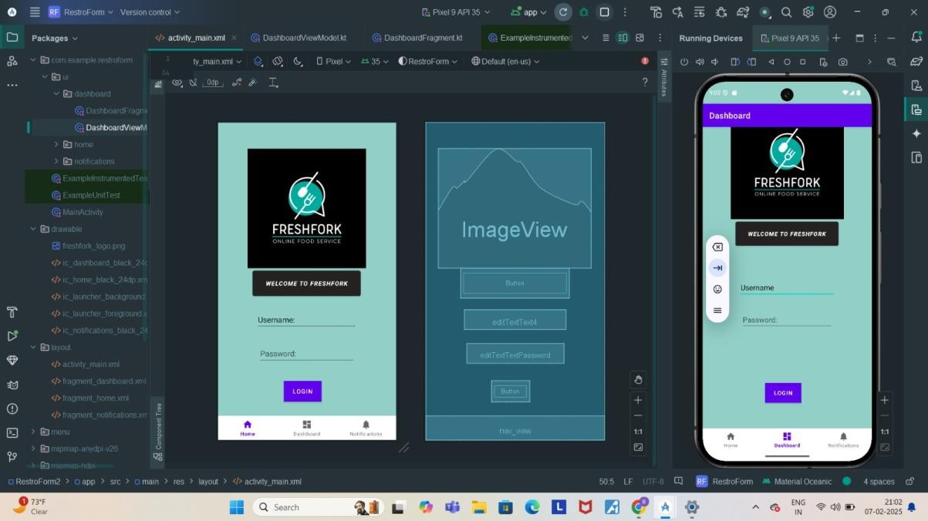

Page_02

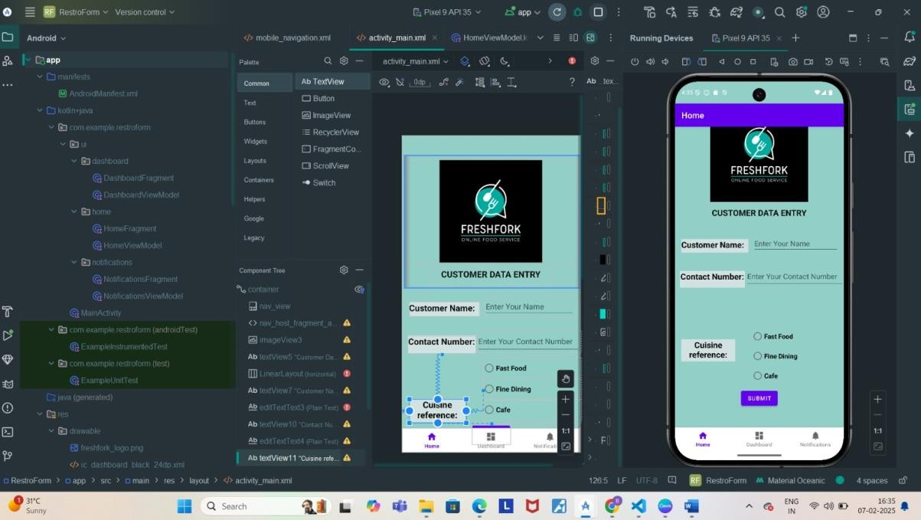

**4 .Conclusion:**

**Learning Outcomes:**

**From this current assignment I learned basic and various elements from the design palette and their arrangements ,one of them was the arrangement of radio buttons in radio group. Challenges Faced:**

**In Some arrangements it was giving error as well as connection of two different pages with button configuration .**

**Resolved it:**

**My teachers helped and by some video references I figured out codes changes .**