# **Assignment Name: Phone Call Application**

PRN : 2124UCSM1032

## **1. Introduction**

## Phone Call Program: Write a program to make phone calls. For instance, develop a contact app that allows users to select a contact and press a "Call" button to initiate a **call to the selected number.**

## **2. Tools & Technologies Used**

* Android Studio
* Java/Kotlin (Specify the language used)
* Emulator or Physical Device (Mention the Android version)

## **3. Procedure & Steps**

### **Step 1: Create a New Project**

* Open Android Studio and create a new project.
* Choose an Empty Activity template.
* Set the project name and package name.
* Select the programming language (Java/Kotlin).

**Screenshot:**

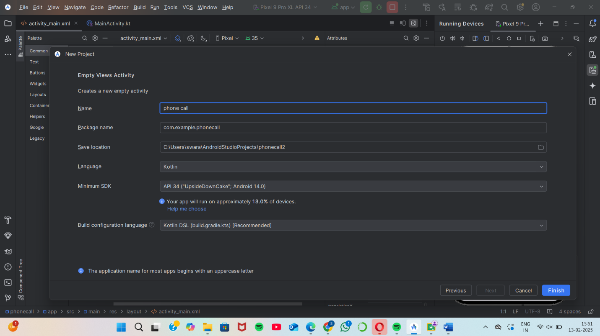

### **Step 2: Designing the UI**

* Open activity_main.xml and design the layout using XML.
* Add UI components such as TextView, EditText, Button, etc.

**Screenshot:**

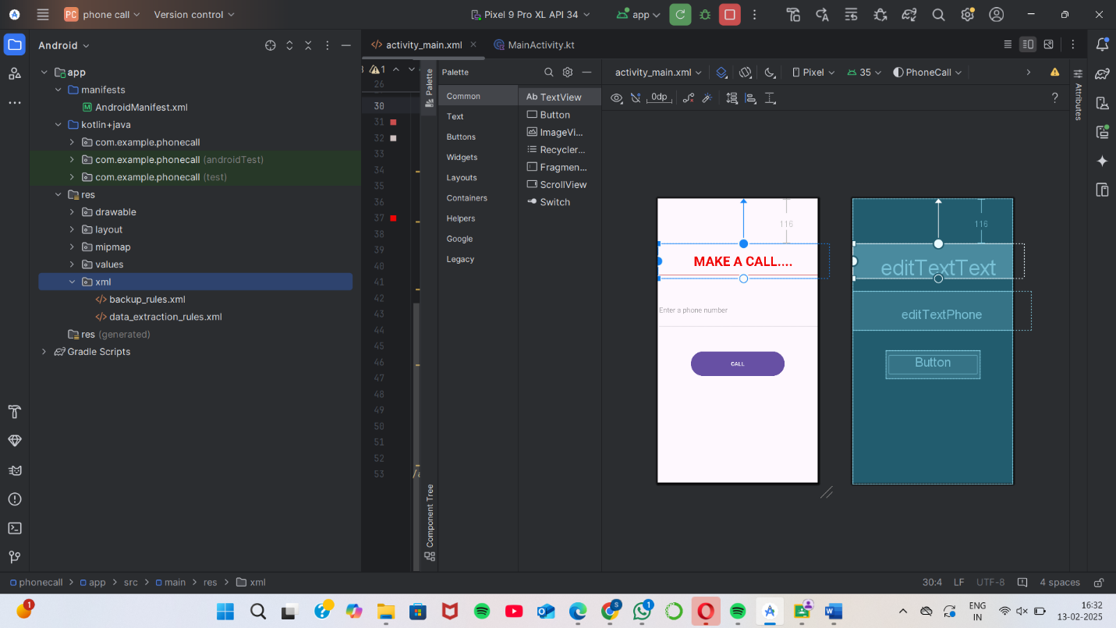

### **Step 3: Writing the Code**

* Open MainActivity.java or MainActivity.kt.
* Implement functionality such as button clicks, form validation, etc.
* Use necessary Android components like Intents, RecyclerView, Fragments, etc.

java

CopyEdit  
  
class MainActivity : AppCompatActivity() {  
  
 override fun onCreate(savedInstanceState: Bundle?) {  
 super.onCreate(savedInstanceState)  
 *enableEdgeToEdge*()  
 setContentView(R.layout.*activity_main*)  
  
 ViewCompat.setOnApplyWindowInsetsListener(findViewById(R.id.*main*)) { v, insets ->  
 val systemBars = insets.getInsets(WindowInsetsCompat.Type.systemBars())  
 v.setPadding(systemBars.left, systemBars.top, systemBars.right, systemBars.bottom)  
 insets  
 }  
  
 val phoneNumberInput = findViewById<EditText>(R.id.*editTextPhone*)  
 val callButton = findViewById<Button>(R.id.*button*)  
  
 callButton.setOnClickListener {  
 val phoneNumber = phoneNumberInput.*text*.toString().*trim*()  
 if (phoneNumber.*isNotEmpty*()) {  
 dialPhoneNumber(phoneNumber)  
 } else {  
 Toast.makeText(this, "Enter a valid phone number", Toast.*LENGTH_SHORT*).show()  
 }  
 }  
 }  
  
 **private fun dialPhoneNumber(phoneNumber: String) {  
 val dialIntent = Intent(Intent.*ACTION_DIAL*)  
 dialIntent.*data* = Uri.parse("tel:$phoneNumber")  
 startActivity(dialIntent)  
 }  
}**

**Screenshot:**

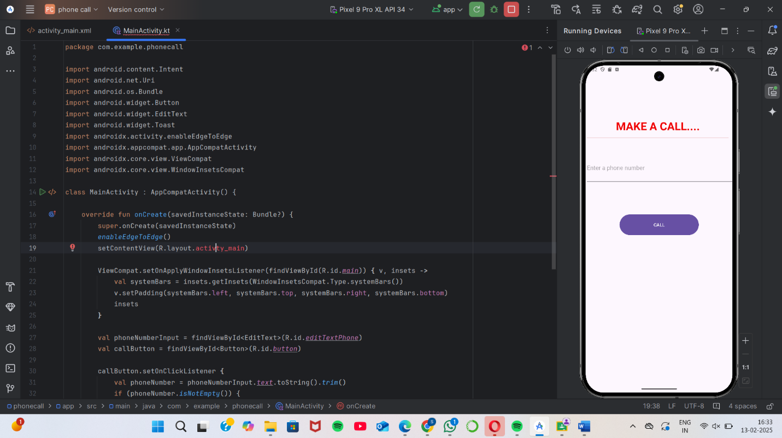

### **Step 4: Running the Application on Emulator**

* Click on the **Run** button in Android Studio.
* Select the emulator and launch the app.

**Screenshot:**

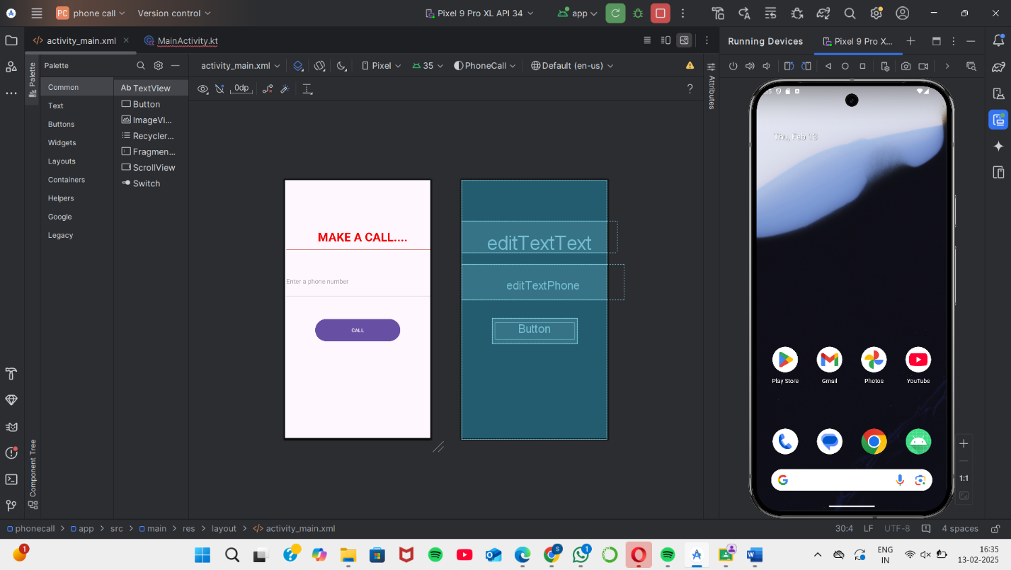

### **Step 5: Testing & Output**

* Test different functionalities of the app.
* Capture the output results.

**Screenshot: \**

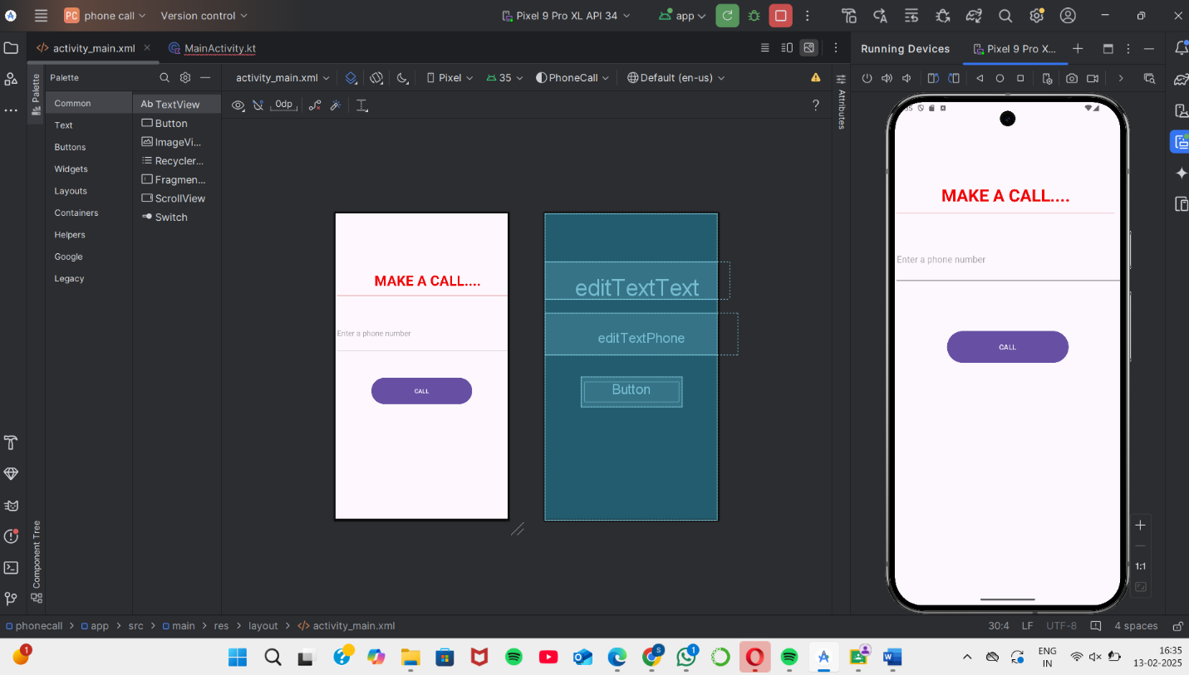

## **4. Conclusion**

