- Task Description
Develop a "Chess" board game with redux when one with white other is black color of squre while clicking on white one color change to yellow and black to red

- Task Output Screenshot
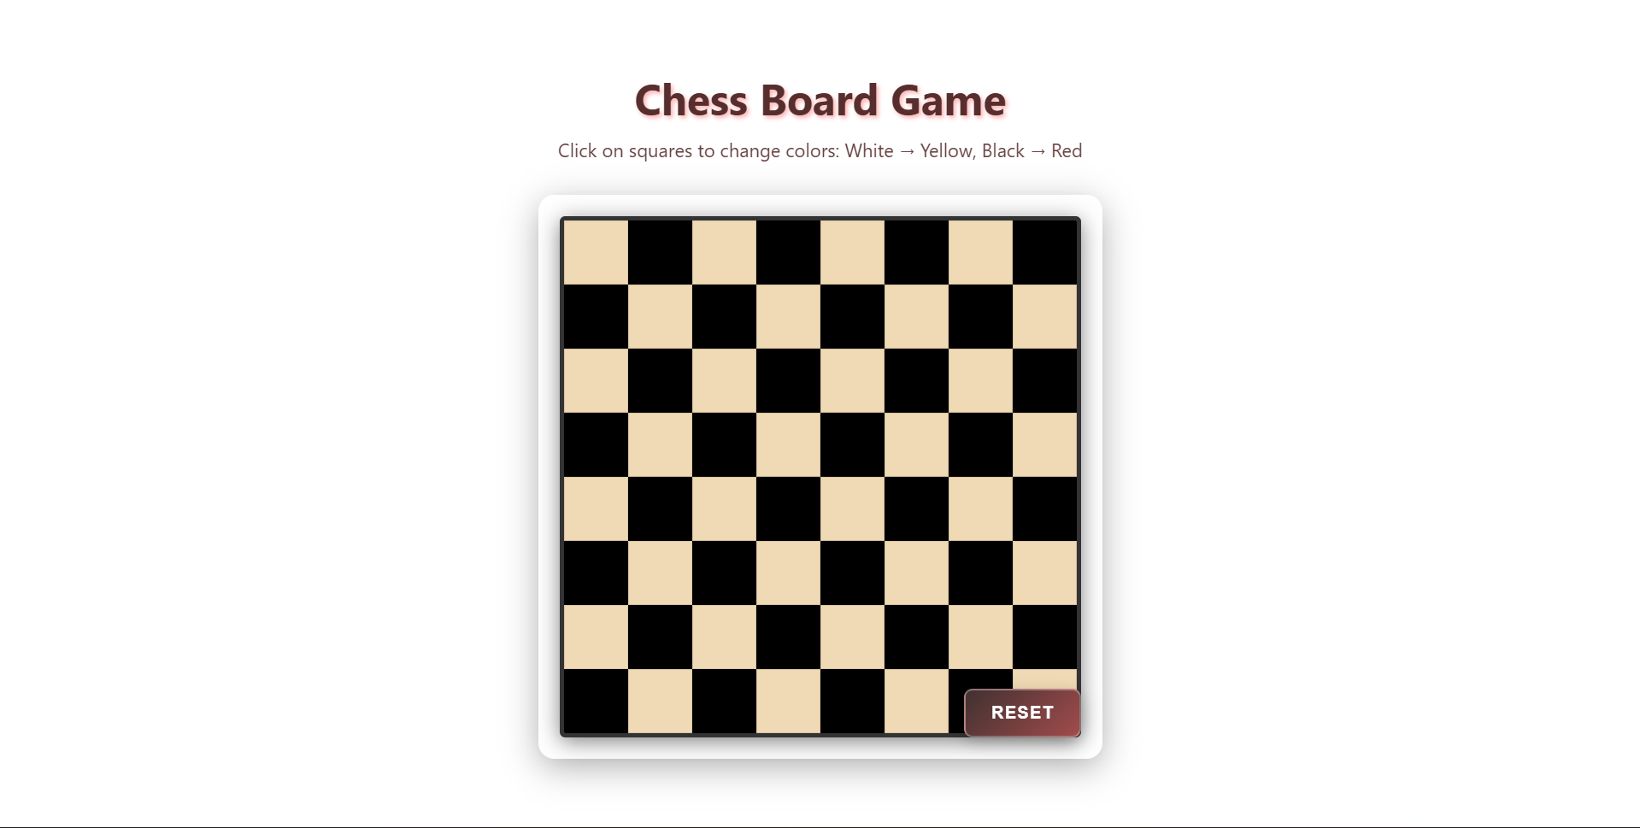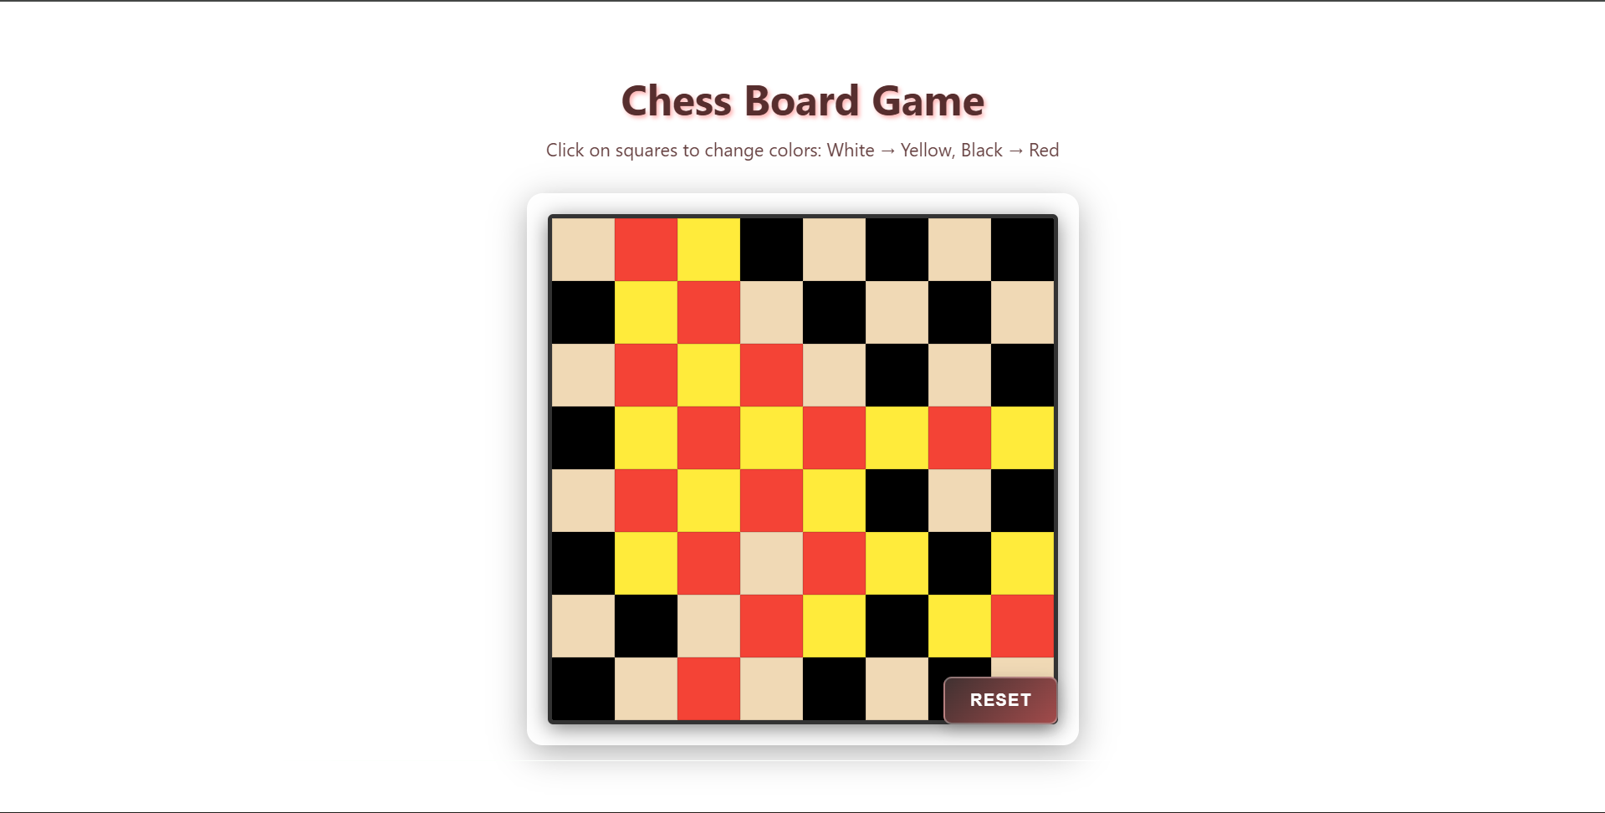

- Widget/Algorithm Used In Task
  - Renders an 8X8 grid of a chess board.
  - Each square is assigned Base color: White and Black.
  - On click, a Redux action updates the color of the clicked square.
  - Color change on click:
    - White turns Yellow
    - Black turns Red
  - Redux is storing all 64 square states in an array and update square color immutably using reducer.
  - React Hooks used:
    - useSelector → fetch board data from Redux store
    - useDispatch → trigger color-change actions
  - UI is renders using CSS Grid for ensuring equal size of square boxes

