- Task Description
Develop a role-based authorization system to control access to specific routes or components.

- Task Output Screenshot
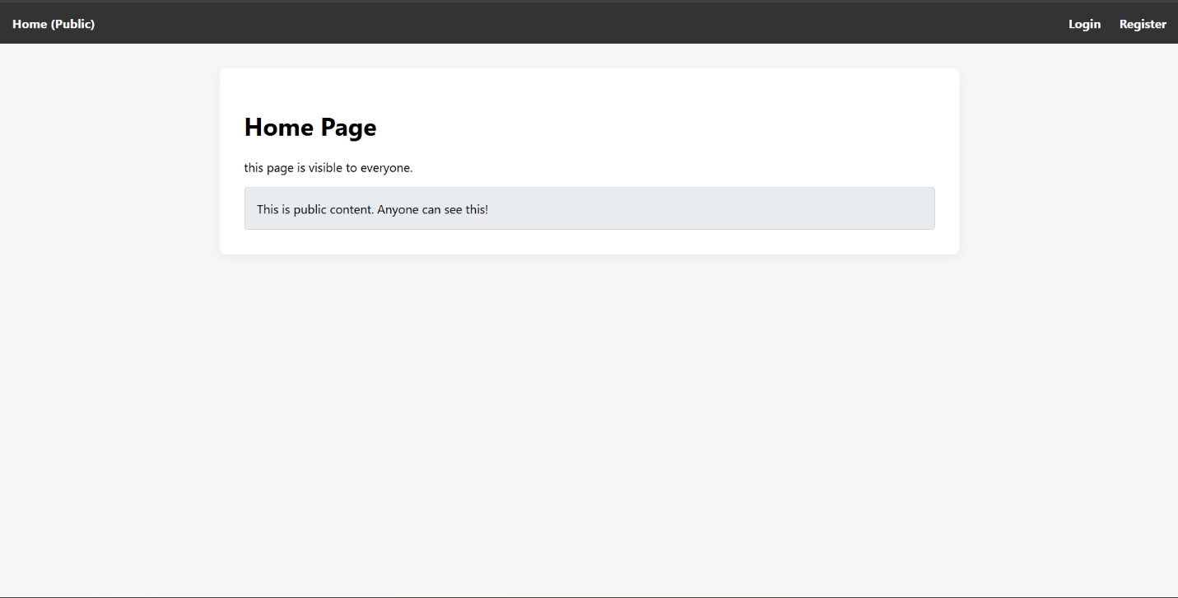
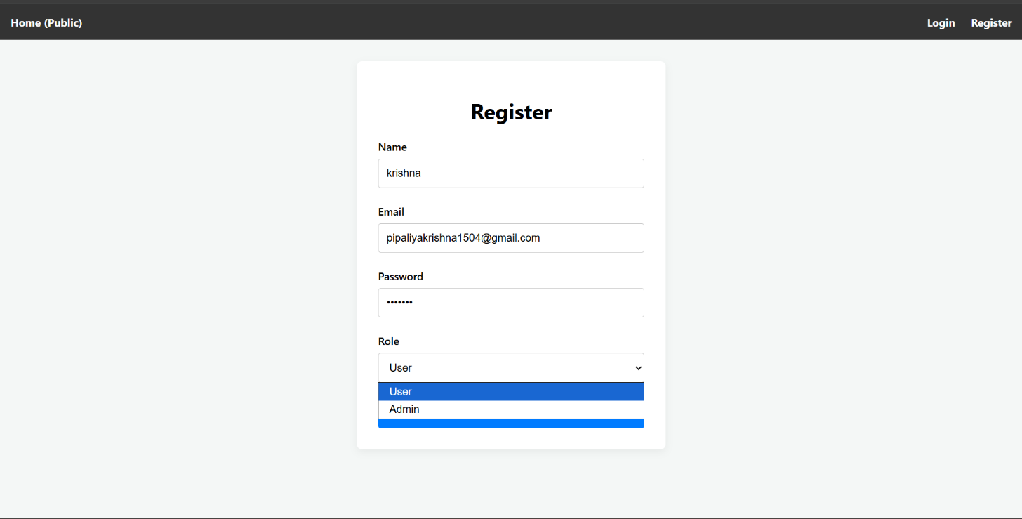
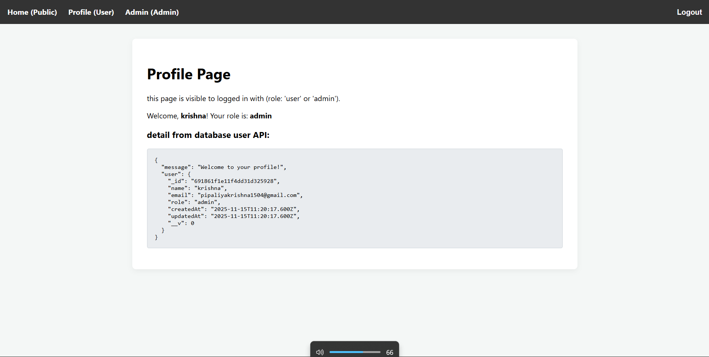
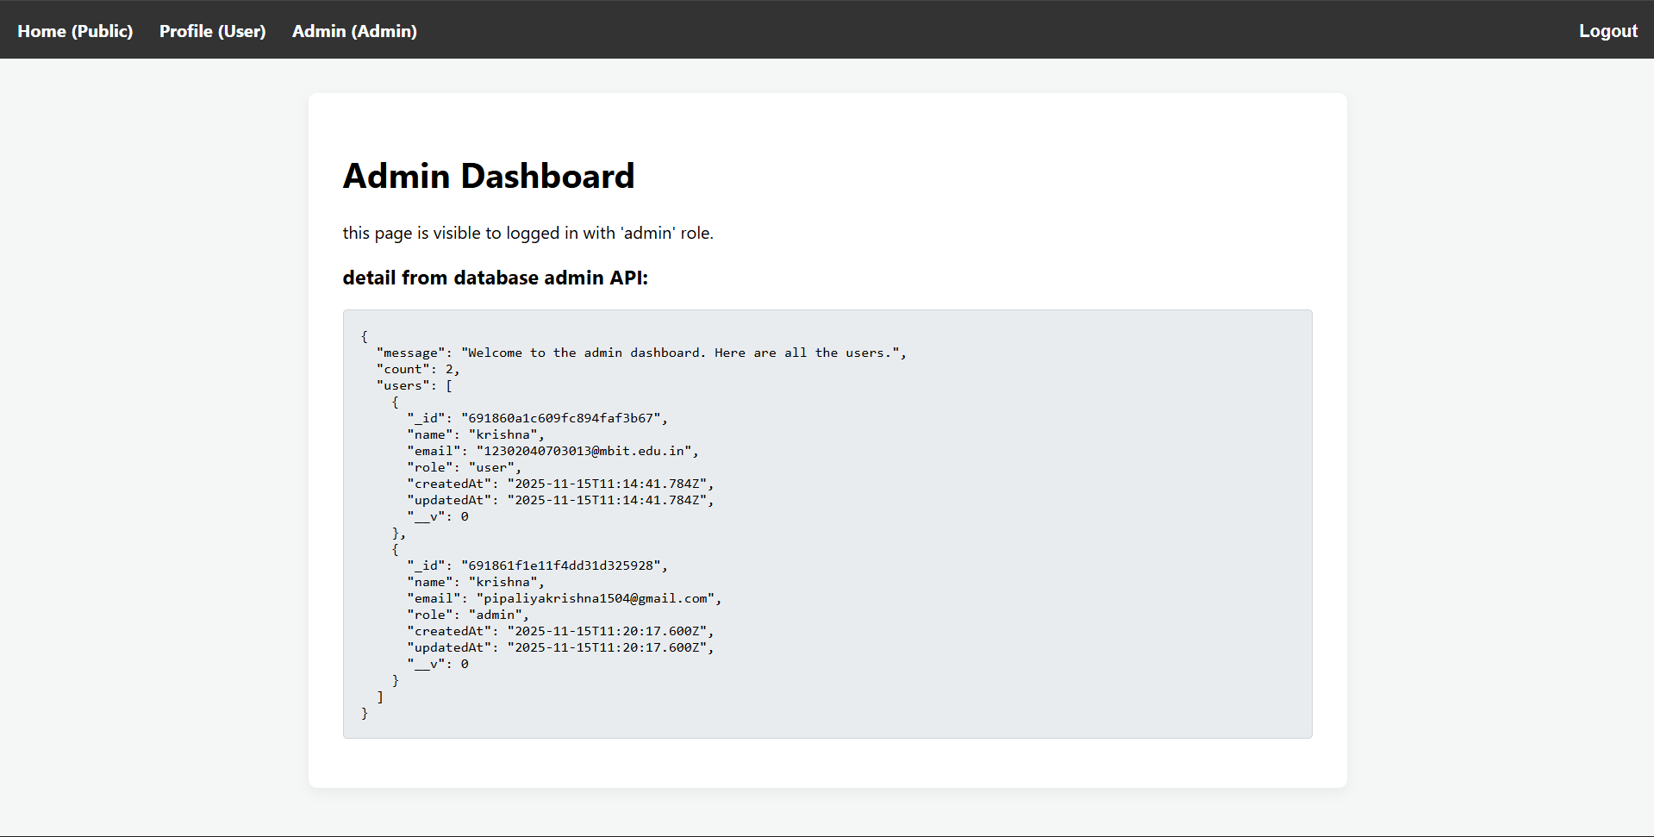

- Widget/Algorithm Used In Task
- Backend
  - mongoose (MongoDB): Used to define the User schema.
  - bcryptjs: To convert password into hasecode before store into database.
  - jsonwebtoken (JWT)
  - Custom authMiddleware.js (Core Algorithm):
    - protect Middleware: This function runs on API routes. It verifies the Authorization header, decodes the JWT, finds the user in the database, and attaches the user's data to the req object.
    - authorize Middleware: This is a higher-order function that takes an array of allowed roles. It runs after the protect middleware and checks if the req.user.role is included in the list of allowed roles. If not, it returns a 403 error.
- Frontend (React)
  - react-router-dom: Used to manage all client-side routing for the application
  - AuthContext (React Context API): A global state management solution. It stores the current user's authentication details and shares them with all components in the app.
  - ProtectedRoute.jsx (Core Algorithm): This is a custom React component that acts as a wrapper around protected routes. Its logic is as follows:
    - It consumes the AuthContext to get the current user.
    - It checks: Is a user logged in?
    - If not, it redirects the user to the /login page.
    - If a user logged in, it checks: Does the user.role match the allowed Roles
    - If the role does not match, it redirects the user to the home page.
    - If the user is logged in and has the correct role, it open profile page.
  - axios Interceptor: An axios instance is configured to act as an "interceptor." This automatically attaches the user's JWT token (retrieved from localStorage) as an Authorization: Bearer <token> header to every outgoing API request, authenticating the user with the backend.

