Angular

One way input binding
HTML
<input (input)=”functionName($event)”>

TS
functionName=(inputData)=>{
console.log(inputData.target.value)
}

Dynamic disable a element
HTML
<input disabled>
<input [disabled]=”isInputdisabled”>

TS
isInputdisabled=true

Two-Way-Binding

Important: FormsModule is Required for Two-Way-Binding!
Important: For Two-Way-Binding (covered in the next lecture) to work, you need to enable the ngModel directive. This is done by adding the FormsModule to the imports[] array in the AppModule.
You then also need to add the import from @angular/forms in the app.module.ts file:
import { FormsModule } from '@angular/forms';

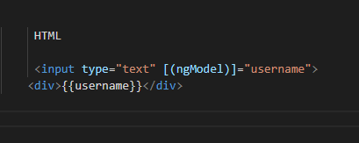

Directives

*ngIf

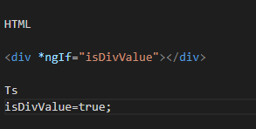

*ngIf with else

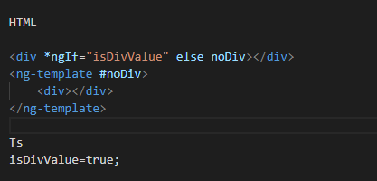

ngStyle

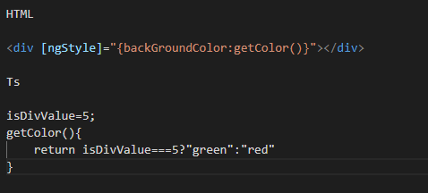

ngClass

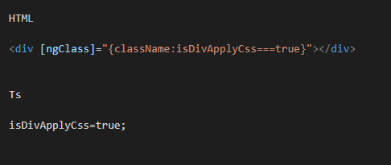

ngFor

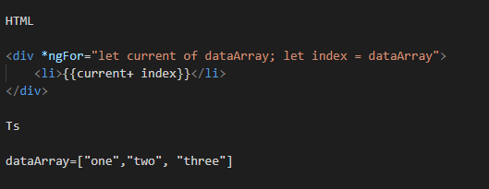

Pass data to a child component

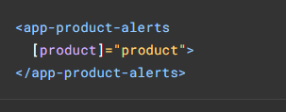
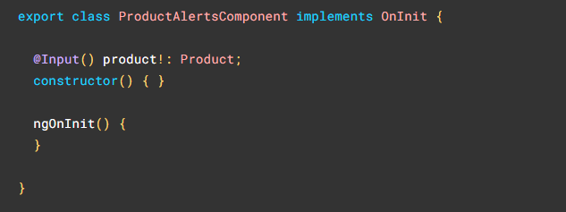

Pass data to a parent component
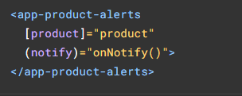
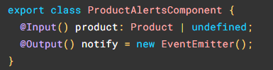
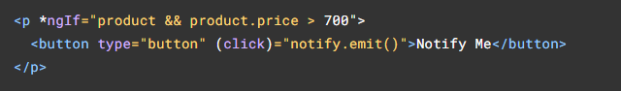
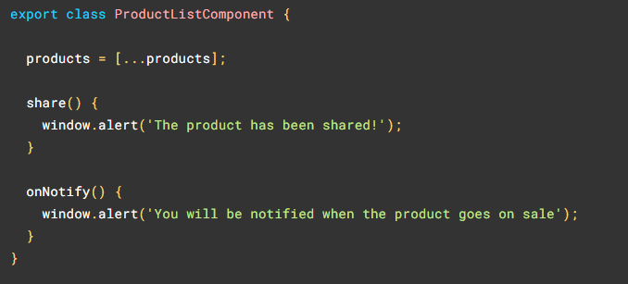

Lifecycle hooks
An interface that allows you to tap into the lifecycle of directives and components as they are created, updated, and destroyed.
Each interface has a single hook method whose name is the interface name prefixed with ng. For example, the OnInit interface has a hook method named ngOnInit.
Angular runs these hook methods in the following order:

 | HOOK METHOD | DETAILS
1 | ngOnChanges | When an input or output binding value changes.
2 | ngOnInit | After the first ngOnChanges.
3 | ngDoCheck | Developer's custom change detection.
4 | ngAfterContentInit | After component content initialized.
5 | ngAfterContentChecked | After every check of component content.
6 | ngAfterViewInit | After the views of a component are initialized.
7 | ngAfterViewChecked | After every check of the views of a component.
8 | ngOnDestroy | Just before the directive is destroyed.

- ngOnChanges()
ngOnChanges()Called before ngOnInit() (if the component has bound inputs) and whenever one or more data-bound input properties change.
- ngOnInit()
Called once, after the first ngOnChanges(). ngOnInit() is still called even when ngOnChanges() is not (which is the case when there are no template-bound inputs).
- ngDoCheck()
To monitor changes that occur where ngOnChanges() won't catch them .Called immediately after ngOnChanges() on every change detection run, and immediately after ngOnInit() on the first run.
4.

