RXJS

RxJS is a library for composing asynchronous and event-based programs by using observable sequences. It provides one core type, the Observable, satellite types (Observer, Schedulers, Subjects) and operators inspired by Array methods (map, filter, reduce, every, etc) to allow handling asynchronous events as collections.

The essential concepts in RxJS which solve async event management are:
- Observable: represents the idea of an invokable collection of future values or events
- .Observer: An Observer is a consumer of values delivered by an Observable. Observers are simply a set of callbacks, one for each type of notification delivered by the Observable: next, error, and complete.
- Subscription: represents the execution of an Observable, is primarily useful for cancelling the execution.
- Operators: are pure functions that enable a functional programming style of dealing with collections with operations like map, filter, concat, reduce, etc.
- Subject: is equivalent to an EventEmitter, and the only way of multicasting a value or event to multiple Observers.
- Schedulers: are centralized dispatchers to control concurrency, allowing us to coordinate when computation happens on e.g. setTimeout or requestAnimationFrame or others
Observable
Observables are lazy Push collections of multiple values.

import { Observable } from 'rxjs';

const observable = new Observable(function subscribe(subscriber) {
const id = setInterval(() => {
subscriber.next('hi');
}, 1000);
});

observable.subscribe((x) => console.log(x)); ==> hi

In an Observable Execution, zero to infinite Next notifications may be delivered. If either an Error or Complete notification is delivered, then nothing else can be delivered afterwards.
The following is an example of an Observable execution that delivers three Next notifications, then completes:
import { Observable } from 'rxjs';
const observable = new Observable(function subscribe(subscriber) {
subscriber.next(1);
subscriber.next(2);
subscriber.next(3);
subscriber.complete();});
Observables strictly adhere to the Observable Contract, so the following code would not deliver the Next notification 4:
import { Observable } from 'rxjs';
const observable = new Observable(function subscribe(subscriber) {
subscriber.next(1);
subscriber.next(2);
subscriber.next(3);
subscriber.complete();
subscriber.next(4); // Is not delivered because it would violate the contract});
It is a good idea to wrap any code in subscribe with try/catch block that will deliver an Error notification if it catches an exception:
import { Observable } from 'rxjs';

const observable = new Observable(function subscribe(subscriber) {
try {
subscriber.next(1);
subscriber.next(2);
subscriber.next(3);
subscriber.complete();
} catch (err) {
subscriber.error(err); // delivers an error if it caught one
}
})

Disposing Observable Executions
const subscription = observable.subscribe((x) => console.log(x));
subscription.unsubscribe();

Observer

What is an Observer? An Observer is a consumer of values delivered by an Observable. Observers are simply a set of callbacks, one for each type of notification delivered by the Observable: next, error, and complete.

RxJS Operators
Operators are functions. There are two kinds of operators:
1.Pipeable Operators A Pipeable Operator is a function that takes an Observable as its input and returns another Observable. It is a pure operation: the previous Observable stays unmodified.
These include, filter(...), and mergeMap(...). When called, they do not change the existing Observable instance. Instead, they return a new Observable, whose subscription logic is based on the first Observable.

- Creation Operators are the other kind of operator, which can be called as standalone functions to create a new Observable. For example: of(1, 2, 3) creates an observable that will emit 1, 2, and 3, one right after another.

Creation Operators

Of- Converts the arguments to an observable sequence

import { of } from 'rxjs';

of(10, 20, 30)
.subscribe({
next: value => console.log('next:', value),
error: err => console.log('error:', err),
complete: () => console.log('the end'),
});

// Outputs
// next: 10
// next: 20
// next: 30
// the end

of([1, 2, 3])
.subscribe({
next: value => console.log('next:', value),
error: err => console.log('error:', err),
complete: () => console.log('the end'),
});

// Outputs
// next: [1, 2, 3]
// the end

from- Creates an Observable from an Array, an array-like object, a Promise, an iterable object, or an Observable-like object.

import { from } from 'rxjs';

const array = [10, 20, 30];
const result = from(array);
result.subscribe(x => console.log(x));
// Logs
// 10
// 20
// 30

interval- Creates an Observable that emits sequential numbers every specified interval of time, on a specified SchedulerLike.

import { interval, take } from 'rxjs';

const numbers = interval(1000);

const takeFourNumbers = numbers.pipe(take(4));

takeFourNumbers.subscribe(x => console.log('Next: ', x));

// Logs:
// Next: 0
// Next: 1
// Next: 2
// Next: 3

range- Creates an Observable that emits a sequence of numbers within a specified range.
import { range } from 'rxjs';

const numbers = range(100, 3);

numbers.subscribe({
next: value => console.log(value),
complete: () => console.log('Complete!')
});

// Logs:
// 100
// 101
// 102
// 'Complete!'

timer- Creates an observable that will wait for a specified time period, or exact date, before emitting the number 0.
import { of, timer, concatMap } from 'rxjs';

// This could be any observable
const source = of(1, 2, 3);

timer(3000)
.pipe(concatMap(() => source))
.subscribe(console.log);

Since interval waits for the passed delay before starting, sometimes that's not ideal. You may want to start an interval immediately. timer works well for this. Here we have both side-by-side so you can see them in comparison.

import { timer, interval } from 'rxjs';

timer(0, 1000).subscribe(n => console.log('timer', n));
interval(1000).subscribe(n => console.log('interval', n));

Join Creation Operators
zip- Combines multiple Observables to create an Observable whose values are calculated from the values, in order, of each of its input Observables.

import { of, zip, map } from 'rxjs';

const age$ = of(27, 25, 29);
const name$ = of('Foo', 'Bar', 'Beer');
const isDev$ = of(true, true, false);

zip(age$, name$, isDev$).pipe(
map(([age, name, isDev]) => ({ age, name, isDev }))
)
.subscribe(x => console.log(x));

// Outputs
// { age: 27, name: 'Foo', isDev: true }
// { age: 25, name: 'Bar', isDev: true }
// { age: 29, name: 'Beer', isDev: false }

partition- Splits the source Observable into two, one with values that satisfy a predicate, and another with values that don't satisfy the predicate.

import { of, partition } from 'rxjs';

const observableValues = of(1, 2, 3, 4, 5, 6);

const [evens$, odds$] = partition(observableValues, value => value % 2 === 0);

odds$.subscribe(x => console.log('odds', x));
evens$.subscribe(x => console.log('evens', x));

// Logs:
// odds 1
// odds 3
// odds 5
// evens 2
// evens 4
// evens 6

concat- Creates an output Observable which sequentially emits all values from the first given Observable and then moves on to the next.

import { interval, take, concat } from 'rxjs';

const timer1 = interval(1000).pipe(take(10));
const timer2 = interval(2000).pipe(take(6));
const timer3 = interval(500).pipe(take(10));

const result = concat(timer1, timer2, timer3);
result.subscribe(x => console.log(x));

// results in the following:
// (Prints to console sequentially)
// -1000ms-> 0 -1000ms-> 1 -1000ms-> ... 9
// -2000ms-> 0 -2000ms-> 1 -2000ms-> ... 5
// -500ms-> 0 -500ms-> 1 -500ms-> ... 9

merge- an Observable that emits items that are the result of every input Observable.
import { of, merge } from 'rxjs';

const a = of(1, 2, 3);
const b = of(4, 5, 6);

merge(a, b).subscribe(console.log);

// Outputs
// 1
// 2
// 3
// 4
// 5
// 6

combineLatest- Combines multiple Observables to create an Observable whose values are calculated from the latest values of each of its input Observables.

import { timer, combineLatest } from 'rxjs';

const firstTimer = timer(0, 1000); // emit 0, 1, 2... after every second, starting from now

const secondTimer = timer(500, 1000); // emit 0, 1, 2... after every second, starting 0,5s from now

const combinedTimers = combineLatest([firstTimer, secondTimer]);

combinedTimers.subscribe(value => console.log(value));

// Logs
// [0, 0] after 0.5s
// [1, 0] after 1s
// [1, 1] after 1.5s
// [2, 1] after 2s

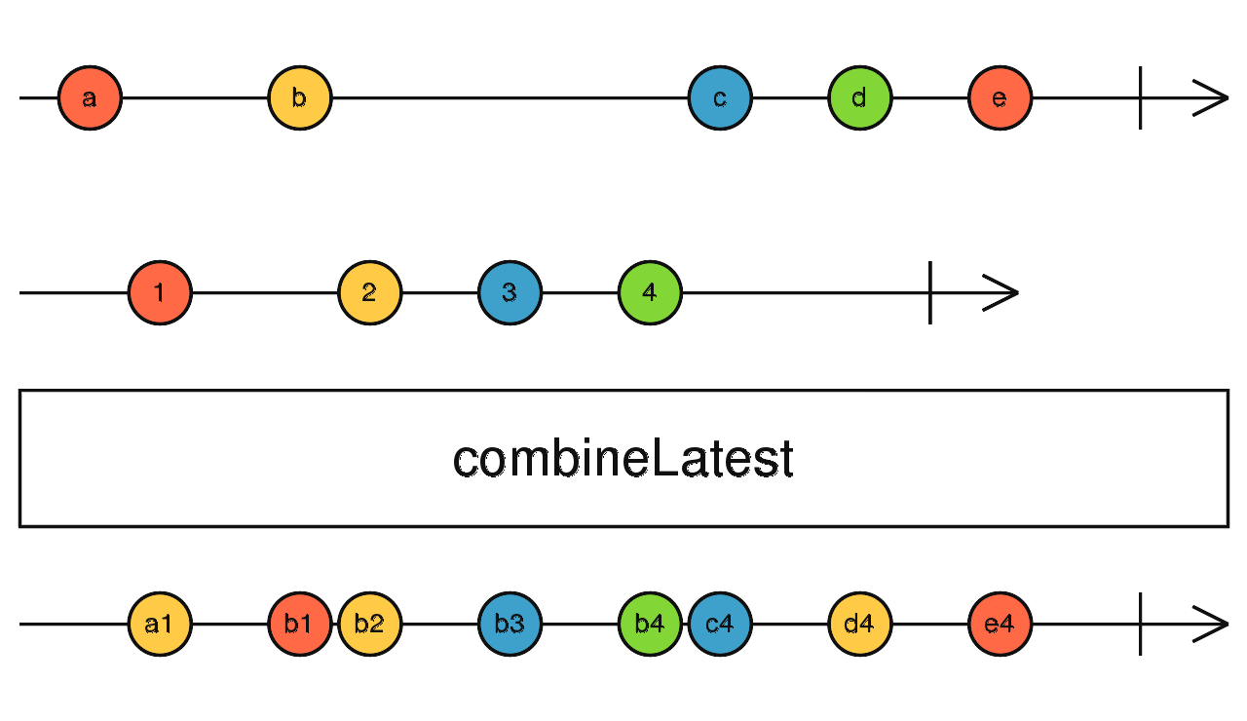

Transformation Operators
map- A function that iterate through each value or event of a obervale modify it and return a new value or event

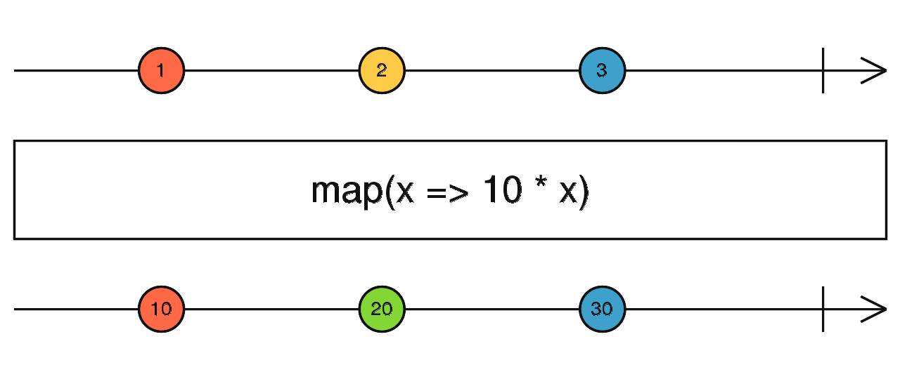
mergeMap-A function that merge source value concurrently modified and return a new value

import { of, mergeMap, interval, map } from 'rxjs';

const letters = of('a', 'b', 'c');
const result = letters.pipe(
mergeMap(x => interval(1000).pipe(map(i => x + i)))
);

result.subscribe(x => console.log(x));

// Results in the following:
// a0
// b0
// c0
// a1
// b1
// c1
// continues to list a, b, c every second with respective ascending integers

pluck- A function that returns an Observable of property values from the source values.
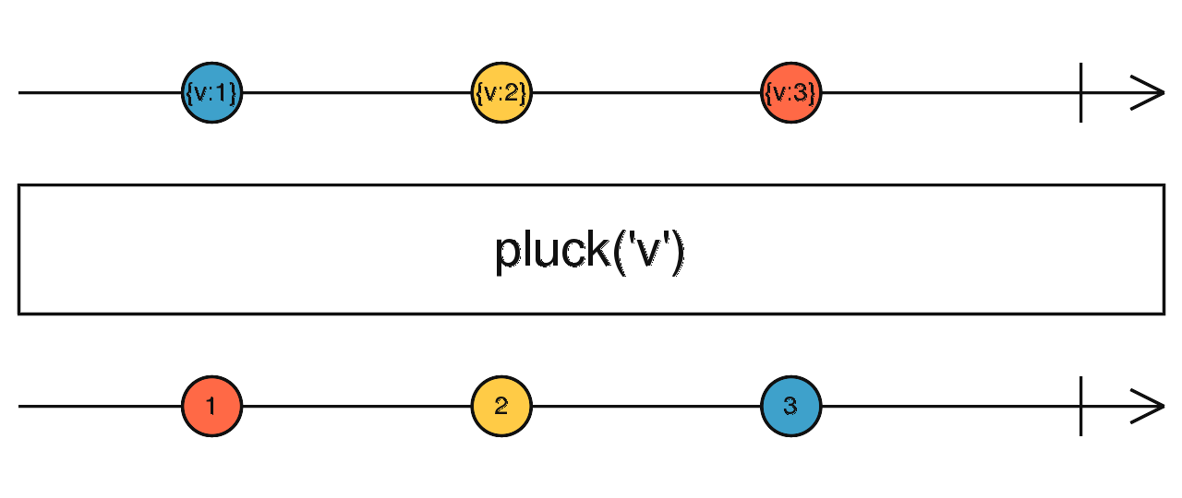

Filtering Operators

debounceTime- A function that delays the emissions of the source Observable by the specified dueTime,

distinct- A function that returns emits items from the source Observable with distinct values.
import { of, distinct } from 'rxjs';

of(1, 1, 2, 2, 2, 1, 2, 3, 4, 3, 2, 1)
.pipe(distinct())
.subscribe(x => console.log(x));

// Outputs
// 1
// 2
// 3
// 4

elementAt- Emits the single value at the specified index
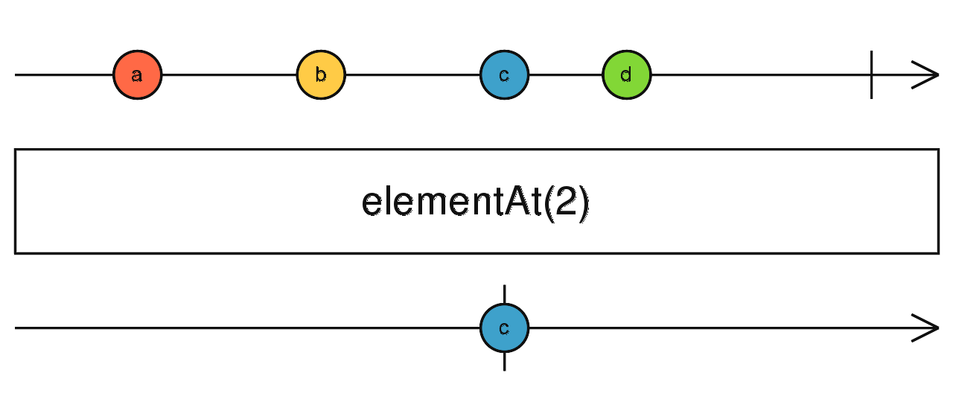

filter- A function that returns an Observable that emits items from the source Observable that satisfy the specified predicate.
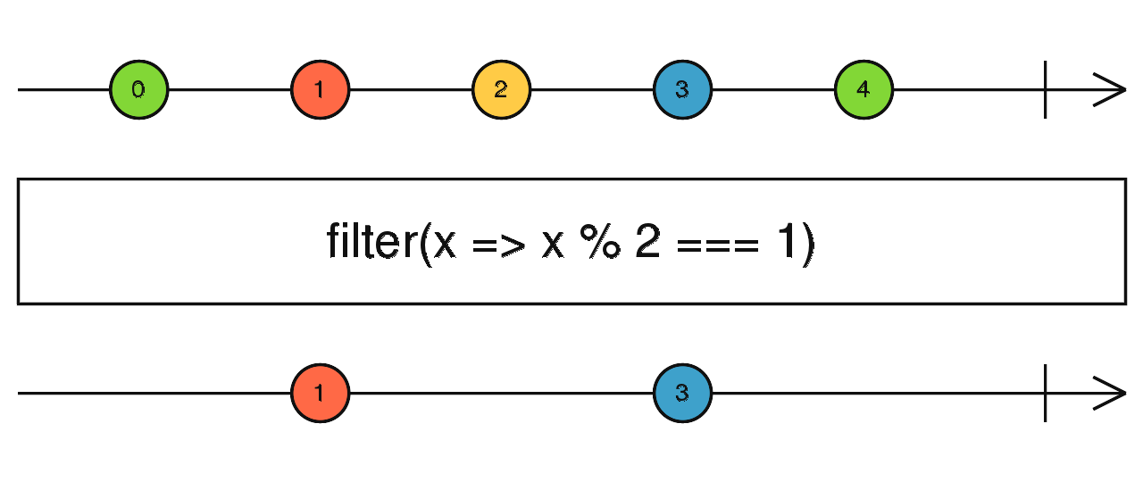
first- A function that returns an Observable that emits the first item that matches the condition.

import { fromEvent, first } from 'rxjs';

const clicks = fromEvent(document, 'click');
const result = clicks.pipe(first());
result.subscribe(x => console.log(x));

import { fromEvent, first } from 'rxjs';

const div = document.createElement('div');
div.style.cssText = 'width: 200px; height: 200px; background: #09c;';
document.body.appendChild(div);

const clicks = fromEvent(document, 'click');
const result = clicks.pipe(first(ev => (<HTMLElement>ev.target).tagName === 'DIV'));
result.subscribe(x => console.log(x));

last- A function that returns an Observable that emits only the last item satisfying the given condition from the source, or a NoSuchElementException if no such items are emitted.

import { from, last } from 'rxjs';

const source = from(['x', 'y', 'z']);
const result = source.pipe(last());

result.subscribe(value => console.log(`Last alphabet: ${ value }`));

// Outputs
// Last alphabet: z

import { from, last } from 'rxjs';

const source = from(['x', 'y', 'z']);
const result = source.pipe(last(char => char === 'a', 'not found'));

result.subscribe(value => console.log(`'a' is ${ value }.`));

// Outputs
// 'a' is not found.

single- A function that returns an Observable that emits the single item emitted by the source Observable that matches the predicate

A function that emits a single item which satisfy the condition
import { of, single } from 'rxjs';

const source1 = of(
{ name: 'Ben' },
{ name: 'Tracy' },
{ name: 'Laney' },
{ name: 'Lily' }
);

source1
.pipe(single(x => x.name.startsWith('B')))
.subscribe(x => console.log(x));
// Emits 'Ben'

const source2 = of(
{ name: 'Ben' },
{ name: 'Tracy' },
{ name: 'Bradley' },
{ name: 'Lincoln' }
);

source2
.pipe(single(x => x.name.startsWith('B')))
.subscribe({ error: err => console.error(err) });
// Error emitted: SequenceError('Too many values match')

const source3 = of(
{ name: 'Laney' },
{ name: 'Tracy' },
{ name: 'Lily' },
{ name: 'Lincoln' }
);

source3
.pipe(single(x => x.name.startsWith('B')))
.subscribe({ error: err => console.error(err) });
// Error emitted: NotFoundError('No values match')

skip- A function that skips the first values based on number argument

import { interval, skip } from 'rxjs';

// emit every half second
const source = interval(500);
// skip the first 10 emitted values
const result = source.pipe(skip(10));

result.subscribe(value => console.log(value));
// output: 10...11...12...13...

skipLast-A function that skips the last values based on number argument

import { of, skipLast } from 'rxjs';

const numbers = of(1, 2, 3, 4, 5);
const skipLastTwo = numbers.pipe(skipLast(2));
skipLastTwo.subscribe(x => console.log(x));

// Results in:
// 1 2 3
// (4 and 5 are skipped)

skipWhile- A function that skips the values continuously until the condition is false
.
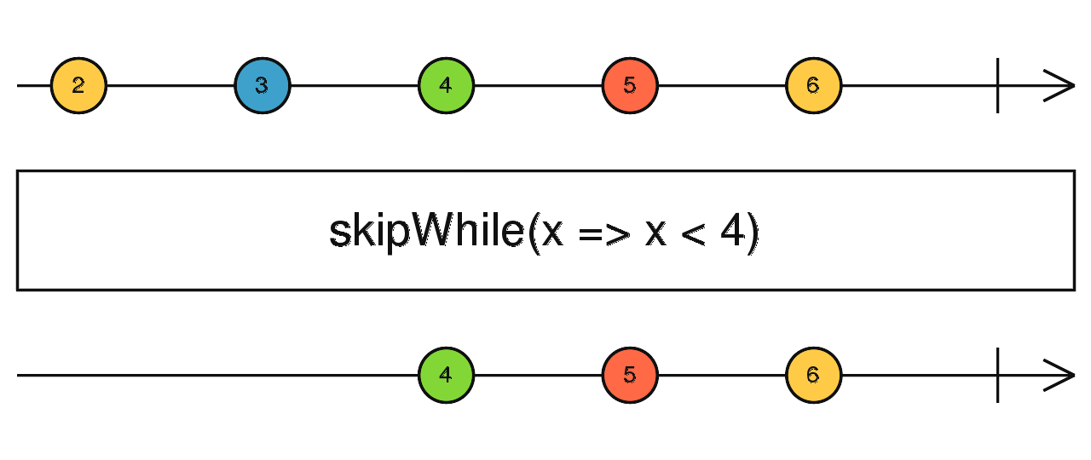
take- A function that return the first count values based on number argument

import { interval, take } from 'rxjs';

const intervalCount = interval(1000);
const takeFive = intervalCount.pipe(take(5));
takeFive.subscribe(x => console.log(x));

// Logs:
// 0
// 1
// 2
// 3
// 4

takeLast- A function that return the last values based on number argument
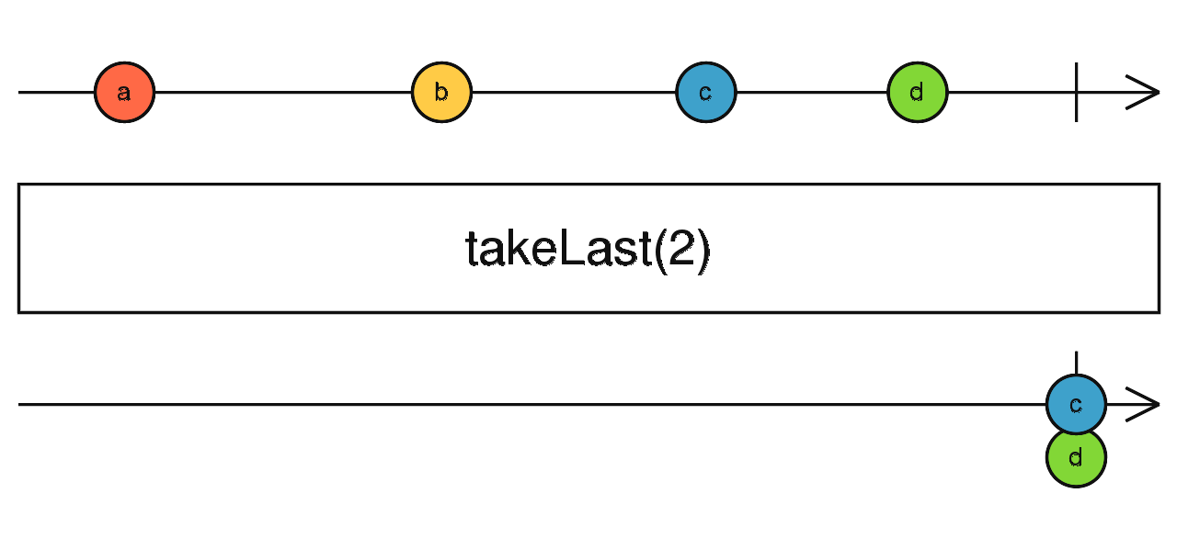

takeWhile- A function that return the values continuously until the condition is false.

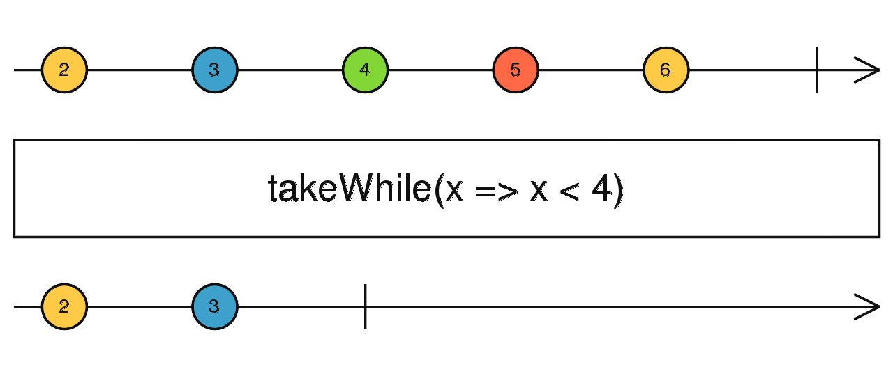

Mathematical and Aggregate Operators
count- Tells how many values were emitted, when the source completes.

Counts how many odd numbers are there between 1 and 7
import { range, count } from 'rxjs';

const numbers = range(1, 7);

const result = numbers.pipe(count(i => i % 2 === 1));

result.subscribe(x => console.log(x));

// Results in:
// 4

max- A function that returns an Observable that emits item with the largest value.

import { of, max } from 'rxjs';

of(5, 4, 7, 2, 8)
.pipe(max())
.subscribe(x => console.log(x));

// Outputs
// 8

min- A function that returns an Observable that emits item with the lowest value.

import { of, min } from 'rxjs';

of(5, 4, 7, 2, 8)
.pipe(min())
.subscribe(x => console.log(x));

// Outputs
// 2

reduce- import { reduce } from 'rxjs';

const ones = of(1,2,3,4,5);
const seed = 0;
const count = ones.pipe(reduce((acc, one) => acc + one, seed));

count.subscribe(x => console.log(x));

//15

Conditional and Boolean Operators

every- A function that returns an Observable of booleans that determines if all items of the source Observable meet the condition specified.

import { of, every } from 'rxjs';

of(1, 2, 3, 4, 5, 6)
.pipe(every(x => x < 5))
.subscribe(x => console.log(x)); // -> false

find- : A function that returns an Observable that emits the first item that matches the condition.
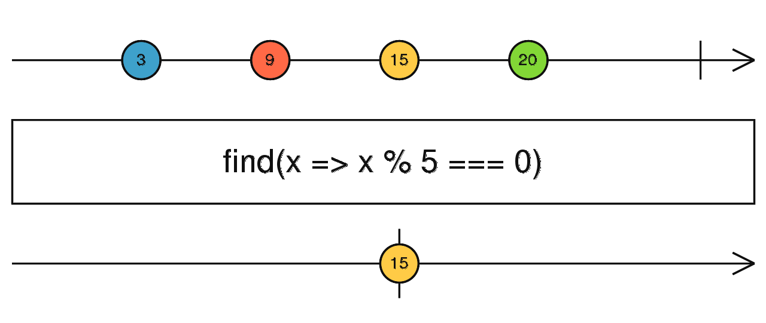

findIndex- A function that returns an Observable that emits the index of the first item that matches the condition.
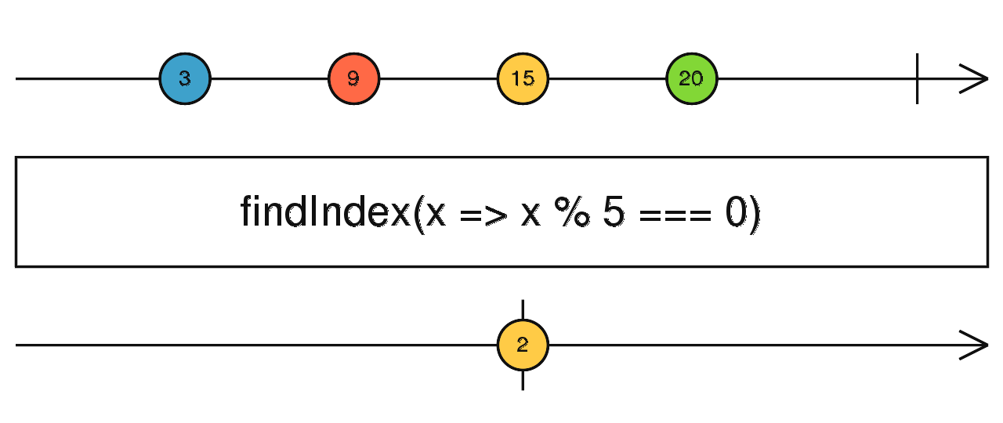

isEmpty- A function that returns an Observable that emits boolean value indicating whether the source Observable was empty or not

import { EMPTY, isEmpty } from 'rxjs';

const result = EMPTY.pipe(isEmpty());
result.subscribe(x => console.log(x));

// Outputs
// true

Utility Operators

delay- A function that returns an Observable that delays the emissions of the source Observable by the specified timeout or Date

import { fromEvent, delay } from 'rxjs';

const clicks = fromEvent(document, 'click');
const delayedClicks = clicks.pipe(delay(1000)); // each click emitted after 1 second
delayedClicks.subscribe(x => console.log(x));

import { fromEvent, delay } from 'rxjs';

const clicks = fromEvent(document, 'click');
const date = new Date('March 15, 2050 12:00:00'); // in the future
const delayedClicks = clicks.pipe(delay(date)); // click emitted only after that date
delayedClicks.subscribe(x => console.log(x));

subscribeOn- With subscribeOn you can decide what type of scheduler a specific Observable will be using when it is subscribed to.
Schedulers control the speed and order of emissions to observers from an Observable stream.
import { of, subscribeOn, asyncScheduler, merge } from 'rxjs';

const a = of(1, 2, 3).pipe(subscribeOn(asyncScheduler));
const b = of(4, 5, 6);

merge(a, b).subscribe(console.log);

// Outputs
// 4
// 5
// 6
// 1
// 2
// 3

timeinterval- A function that returns an Observable that emits information about value and interval.

import { interval, timeInterval } from 'rxjs';

const seconds = interval(1000);

seconds
.pipe(timeInterval())
.subscribe(value => console.log(value));

// NOTE: The values will never be this precise,
// intervals created with `interval` or `setInterval`
// are non-deterministic.

// { value: 0, interval: 1000 }
// { value: 1, interval: 1000 }
// { value: 2, interval: 1000 }

toArray- A function that emits an array of items emitted by the source Observable when source completes.

import { interval, take, toArray } from 'rxjs';

const source = interval(1000);
const example = source.pipe(
take(10),
toArray()
);

example.subscribe(value => console.log(value));

// output: [0, 1, 2, 3, 4, 5, 6, 7, 8, 9]

Error Handling Operators

retry- A function that returns an Observable that will resubscribe to the source stream when the source stream errors, at most count times.
A function that repeat the count emission of value on error
import { interval, mergeMap, throwError, of, retry } from 'rxjs';

const source = interval(1000);
const result = source.pipe(
mergeMap(val => val > 5 ? throwError(() => 'Error!') : of(val)),
retry(2) // retry 2 times on error
);

result.subscribe({
next: value => console.log(value),
error: err => console.log(`${ err }: Retried 2 times then quit!`)
});

// Output:
// 0..1..2..3..4..5..
// 0..1..2..3..4..5..
// 0..1..2..3..4..5..
// 'Error!: Retried 2 times then quit!'

Subject
What is a Subject? An RxJS Subject is a special type of Observable that allows values to be multicasted to many Observers. While plain Observables are unicast (each subscribed Observer owns an independent execution of the Observable), Subjects are multicast.
A Subject is like an Observable, but can multicast to many Observers. Subjects are like EventEmitters: they maintain a registry of many listeners.
import { Subject } from 'rxjs';

const subject = new Subject<number>();

subject.subscribe({
next: (v) => console.log(`observerA: ${v}`),
});
subject.subscribe({
next: (v) => console.log(`observerB: ${v}`),
});

subject.next(1);
subject.next(2);

// Logs:
// observerA: 1
// observerB: 1
// observerA: 2
// observerB: 2

Since a Subject is an Observer, this also means you may provide a Subject as the argument to the subscribe of any Observable, like the example below shows:

import { Subject, from } from 'rxjs';

const subject = new Subject<number>();

subject.subscribe({
next: (v) => console.log(`observerA: ${v}`),
});
subject.subscribe({
next: (v) => console.log(`observerB: ${v}`),
});

const observable = from([1, 2, 3]);

observable.subscribe(subject); // You can subscribe providing a Subject

// Logs:
// observerA: 1
// observerB: 1
// observerA: 2
// observerB: 2
// observerA: 3
// observerB: 3

BehaviorSubject

Create service file
import { Injectable } from '@angular/core';
import { BehaviorSubject } from 'rxjs';

@Injectable()
export class ProductService {
private product$ = new BehaviorSubject<any>({});
selectedProduct$ = this.product$.asObservable();

setProduct(product: any) {
this.product$.next(product);
}
}

Take value
constructor(private productService: ProductService) {}

ngOnInit(): void {
this.productService.selectedProduct$.subscribe((value) => {
this.selectedProduct = value;
});
}

Edit value
constructor(private productService: ProductService) {}

onSelectedProduct(product) {
this.productService.setProduct(product);
}

