**Battle of Neighbors**

**# Business Problem**

A travel company are unable to understand and recommend a better choice of various other entertainments or recreational programmes for customers when compared to competitors. Due to poor range of choice customers are opting to do the bookings from other agencies.

**# Recommended Solution**

To overcome this the company has to analyse the data using Data science techniques and tools to understand the hidden truth in the data and need to categorise data and study so that a better recommended services can be provided to customers inline to their destionation. For this we use the Foursqaure data. The data collected will involve comparison of two locations to determine which is the best location to recommend to a customer. The two locations under consideration are Virginia Beach, VA and Pompano Beach. The customer has requested our business to get him a location with the best coffee shop. We examine these two locations to get the best coffee shops and recommend them to our customers.

**# Methodology**

The data was accessed through FourSquare API interface. The data was then visualized using folium package to see the number of coffee shops near Pompano and Virginia Beach. The customer requirements included a bit of shopping places as well as good sites to see. The most important requirement was good coffee shop. The data extracted from the FourSquare API will be arranged as a dataframe for visualization.

**## Results**

**# Virginia Beach**

We found 14 coffee shops. The nearest was Starbucks, which was 700 meters from the beach. It has a rating of 8.2 and has 32 tips. The coffee shops are located a bit far from each other indicating that the area has lesser concentration of coffee customers.

**# Pampano Beach**

We found 17 coffee shop. The nearest Starbucks coffee was a bit far, 2398 meters. It has a rating of 8.3 and 21 tips. The coffee shops are closely located to each other meaning that the area attracts more customers.

**# Output**

Based on the customer requirements for good coffee shops and analysis presented above, we will recommend Pompano Beach to our customer. We hope that the higher concentration of coffee shops in Pompano as well as availability of quality coffee shops like Starbucks will give our customer good selection and variety. By applying data science principles, we have been able to compare two locations and visualize the distribution of coffee shops in the area. We hope this will differentiate our product from our competitors and helps us to customize travel experiences for our customers.

**Virgin Beach**

**Transform the data into dataframe to analyse easily**

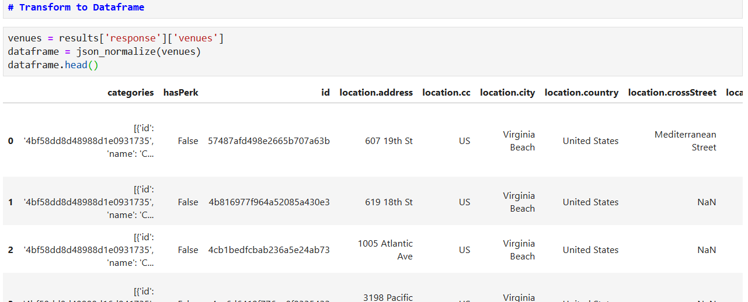

**Retain columns related to location**

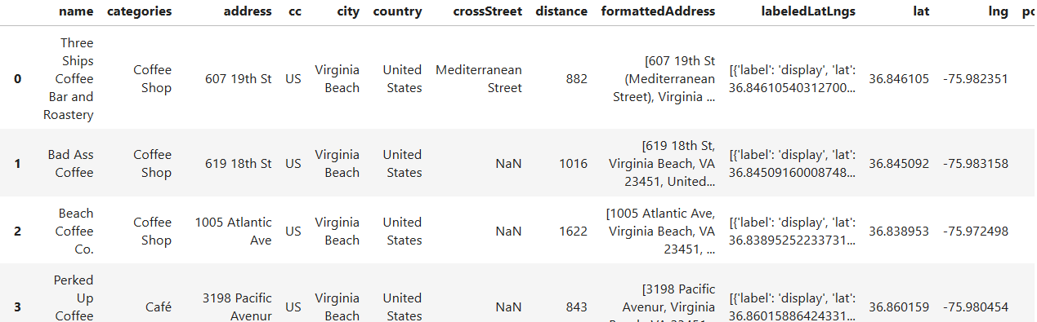

**Display Map**

The red circle is for Conrad hotel and blue one’s for Italian restuarant

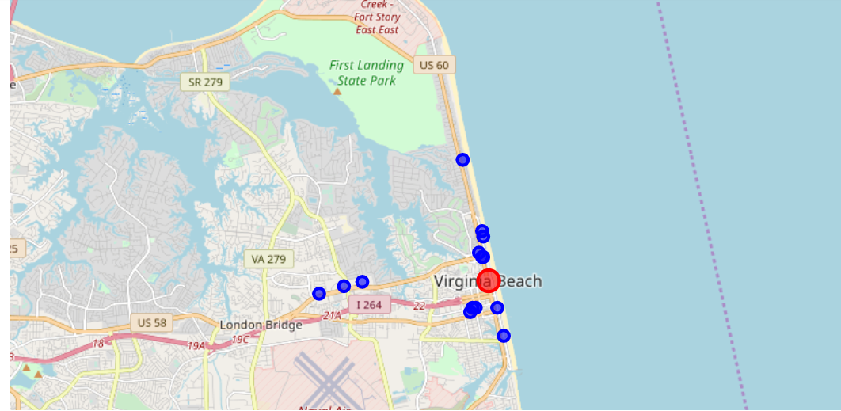

**Display tips posted by other customers**

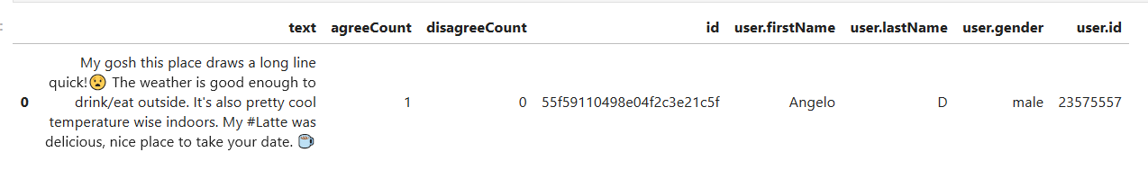

**Pampano Beach**

Transform data and keep anything related to location

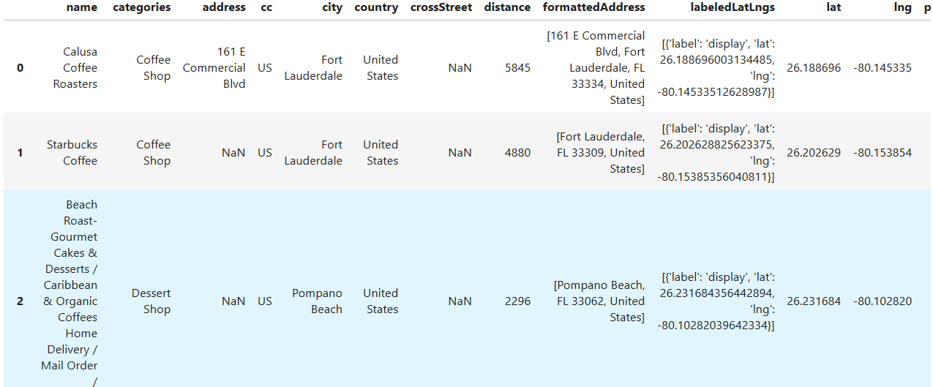

**Display Map**

Red circle represents Conrad Hotel and Blue one’s for Italian Restaurant

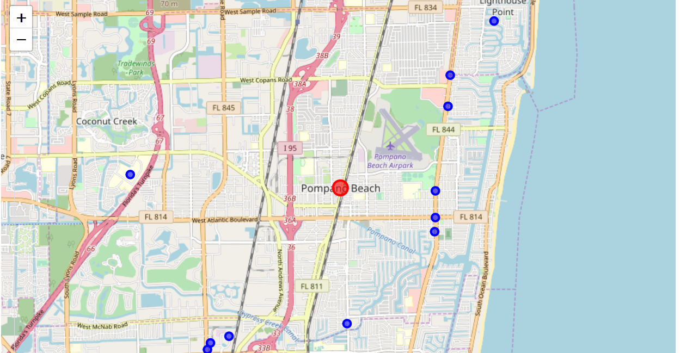

**Filter for Tips**

