DISTRIBUTED JOB SCHEDULER
Software Design Decisions Document
Prepared For: Backend Internship Assignment
Prepared By: KRISHNA R

Table of Contents
- 1 Introduction
- 2 Project Overview
- 3 Objectives
- 4 Functional Requirements
- 5 Non-Functional Requirements
- 6 Technology Stack
- 7 Overall Architecture
- 8 Database Design
- 9 Authentication
- 10 Queue Management
- 11 Dispatcher Service
- 12 Worker Architecture
- 13 Job Lifecycle
- 14 Scheduling
- 15 Retry Mechanisms
- 16 Dead Letter Queue
- 17 Logging
- 18 Metrics
- 19 API Design
- 20 Security
- 21 Scalability
- 22 Design Trade-offs
- 23 Future Enhancements
- 24 Testing Strategy
- 25 Deployment Considerations
- 26 Conclusion
- Appendix A
- Appendix B

1. Introduction
The Distributed Job Scheduler is designed to execute asynchronous background jobs using multiple workers while ensuring reliability, scalability, and maintainability. The project demonstrates production-inspired concepts including queue management, worker coordination, retries, scheduling, monitoring, and secure REST APIs. This design decision improves maintainability, reliability, scalability, and future extensibility while keeping the implementation modular and easy to understand.
The Distributed Job Scheduler is designed to execute asynchronous background jobs using multiple workers while ensuring reliability, scalability, and maintainability. The project demonstrates production-inspired concepts including queue management, worker coordination, retries, scheduling, monitoring, and secure REST APIs. This design decision improves maintainability, reliability, scalability, and future extensibility while keeping the implementation modular and easy to understand.
The Distributed Job Scheduler is designed to execute asynchronous background jobs using multiple workers while ensuring reliability, scalability, and maintainability. The project demonstrates production-inspired concepts including queue management, worker coordination, retries, scheduling, monitoring, and secure REST APIs. This design decision improves maintainability, reliability, scalability, and future extensibility while keeping the implementation modular and easy to understand.
The Distributed Job Scheduler is designed to execute asynchronous background jobs using multiple workers while ensuring reliability, scalability, and maintainability. The project demonstrates production-inspired concepts including queue management, worker coordination, retries, scheduling, monitoring, and secure REST APIs. This design decision improves maintainability, reliability, scalability, and future extensibility while keeping the implementation modular and easy to understand.

2. Project Overview
The system is divided into authentication, project management, queue management, scheduling, dispatcher, worker services, execution history, monitoring, and metrics. Each module has a clearly defined responsibility which improves modularity and maintainability. This design decision improves maintainability, reliability, scalability, and future extensibility while keeping the implementation modular and easy to understand.
The system is divided into authentication, project management, queue management, scheduling, dispatcher, worker services, execution history, monitoring, and metrics. Each module has a clearly defined responsibility which improves modularity and maintainability. This design decision improves maintainability, reliability, scalability, and future extensibility while keeping the implementation modular and easy to understand.
The system is divided into authentication, project management, queue management, scheduling, dispatcher, worker services, execution history, monitoring, and metrics. Each module has a clearly defined responsibility which improves modularity and maintainability. This design decision improves maintainability, reliability, scalability, and future extensibility while keeping the implementation modular and easy to understand.
The system is divided into authentication, project management, queue management, scheduling, dispatcher, worker services, execution history, monitoring, and metrics. Each module has a clearly defined responsibility which improves modularity and maintainability. This design decision improves maintainability, reliability, scalability, and future extensibility while keeping the implementation modular and easy to understand.

3. Objectives
The primary objective is to build a reliable scheduler supporting immediate, delayed, scheduled, cron, and batch jobs while preventing duplicate execution and providing operational visibility. This design decision improves maintainability, reliability, scalability, and future extensibility while keeping the implementation modular and easy to understand.
The primary objective is to build a reliable scheduler supporting immediate, delayed, scheduled, cron, and batch jobs while preventing duplicate execution and providing operational visibility. This design decision improves maintainability, reliability, scalability, and future extensibility while keeping the implementation modular and easy to understand.
The primary objective is to build a reliable scheduler supporting immediate, delayed, scheduled, cron, and batch jobs while preventing duplicate execution and providing operational visibility. This design decision improves maintainability, reliability, scalability, and future extensibility while keeping the implementation modular and easy to understand.

4. Functional Requirements
Users can authenticate, create projects, manage queues, register workers, create jobs, configure retries, schedule executions, monitor progress, and inspect execution logs. This design decision improves maintainability, reliability, scalability, and future extensibility while keeping the implementation modular and easy to understand.
Users can authenticate, create projects, manage queues, register workers, create jobs, configure retries, schedule executions, monitor progress, and inspect execution logs. This design decision improves maintainability, reliability, scalability, and future extensibility while keeping the implementation modular and easy to understand.
Users can authenticate, create projects, manage queues, register workers, create jobs, configure retries, schedule executions, monitor progress, and inspect execution logs. This design decision improves maintainability, reliability, scalability, and future extensibility while keeping the implementation modular and easy to understand.
Users can authenticate, create projects, manage queues, register workers, create jobs, configure retries, schedule executions, monitor progress, and inspect execution logs. This design decision improves maintainability, reliability, scalability, and future extensibility while keeping the implementation modular and easy to understand.
Users can authenticate, create projects, manage queues, register workers, create jobs, configure retries, schedule executions, monitor progress, and inspect execution logs. This design decision improves maintainability, reliability, scalability, and future extensibility while keeping the implementation modular and easy to understand.

5. Non-Functional Requirements
The platform prioritizes reliability, security, scalability, maintainability, modularity, fault tolerance, observability, and performance. This design decision improves maintainability, reliability, scalability, and future extensibility while keeping the implementation modular and easy to understand.
The platform prioritizes reliability, security, scalability, maintainability, modularity, fault tolerance, observability, and performance. This design decision improves maintainability, reliability, scalability, and future extensibility while keeping the implementation modular and easy to understand.
The platform prioritizes reliability, security, scalability, maintainability, modularity, fault tolerance, observability, and performance. This design decision improves maintainability, reliability, scalability, and future extensibility while keeping the implementation modular and easy to understand.
The platform prioritizes reliability, security, scalability, maintainability, modularity, fault tolerance, observability, and performance. This design decision improves maintainability, reliability, scalability, and future extensibility while keeping the implementation modular and easy to understand.
The platform prioritizes reliability, security, scalability, maintainability, modularity, fault tolerance, observability, and performance. This design decision improves maintainability, reliability, scalability, and future extensibility while keeping the implementation modular and easy to understand.

6. Technology Stack
Node.js provides asynchronous execution. Express.js simplifies REST API development. PostgreSQL offers ACID transactions and relational integrity. Prisma ORM enables type-safe database access. JWT secures APIs. Swagger documents endpoints. This design decision improves maintainability, reliability, scalability, and future extensibility while keeping the implementation modular and easy to understand.
Node.js provides asynchronous execution. Express.js simplifies REST API development. PostgreSQL offers ACID transactions and relational integrity. Prisma ORM enables type-safe database access. JWT secures APIs. Swagger documents endpoints. This design decision improves maintainability, reliability, scalability, and future extensibility while keeping the implementation modular and easy to understand.
Node.js provides asynchronous execution. Express.js simplifies REST API development. PostgreSQL offers ACID transactions and relational integrity. Prisma ORM enables type-safe database access. JWT secures APIs. Swagger documents endpoints. This design decision improves maintainability, reliability, scalability, and future extensibility while keeping the implementation modular and easy to understand.
Node.js provides asynchronous execution. Express.js simplifies REST API development. PostgreSQL offers ACID transactions and relational integrity. Prisma ORM enables type-safe database access. JWT secures APIs. Swagger documents endpoints. This design decision improves maintainability, reliability, scalability, and future extensibility while keeping the implementation modular and easy to understand.
Node.js provides asynchronous execution. Express.js simplifies REST API development. PostgreSQL offers ACID transactions and relational integrity. Prisma ORM enables type-safe database access. JWT secures APIs. Swagger documents endpoints. This design decision improves maintainability, reliability, scalability, and future extensibility while keeping the implementation modular and easy to understand.
Node.js provides asynchronous execution. Express.js simplifies REST API development. PostgreSQL offers ACID transactions and relational integrity. Prisma ORM enables type-safe database access. JWT secures APIs. Swagger documents endpoints. This design decision improves maintainability, reliability, scalability, and future extensibility while keeping the implementation modular and easy to understand.

7. Overall Architecture
Clients communicate with REST APIs. The dispatcher periodically discovers executable jobs, atomically claims them, assigns workers, records execution history, and updates job states. PostgreSQL persists all data. This design decision improves maintainability, reliability, scalability, and future extensibility while keeping the implementation modular and easy to understand.
Clients communicate with REST APIs. The dispatcher periodically discovers executable jobs, atomically claims them, assigns workers, records execution history, and updates job states. PostgreSQL persists all data. This design decision improves maintainability, reliability, scalability, and future extensibility while keeping the implementation modular and easy to understand.
Clients communicate with REST APIs. The dispatcher periodically discovers executable jobs, atomically claims them, assigns workers, records execution history, and updates job states. PostgreSQL persists all data. This design decision improves maintainability, reliability, scalability, and future extensibility while keeping the implementation modular and easy to understand.
Clients communicate with REST APIs. The dispatcher periodically discovers executable jobs, atomically claims them, assigns workers, records execution history, and updates job states. PostgreSQL persists all data. This design decision improves maintainability, reliability, scalability, and future extensibility while keeping the implementation modular and easy to understand.
Clients communicate with REST APIs. The dispatcher periodically discovers executable jobs, atomically claims them, assigns workers, records execution history, and updates job states. PostgreSQL persists all data. This design decision improves maintainability, reliability, scalability, and future extensibility while keeping the implementation modular and easy to understand.

8. Database Design
The schema is normalized into Users, Organizations, Projects, Queues, Jobs, Workers, JobExecutions, JobLogs, ScheduledJobs, CronJobs, BatchJobs, and DeadLetterJobs. Foreign keys preserve relationships and indexes improve lookup performance. This design decision improves maintainability, reliability, scalability, and future extensibility while keeping the implementation modular and easy to understand.
The schema is normalized into Users, Organizations, Projects, Queues, Jobs, Workers, JobExecutions, JobLogs, ScheduledJobs, CronJobs, BatchJobs, and DeadLetterJobs. Foreign keys preserve relationships and indexes improve lookup performance. This design decision improves maintainability, reliability, scalability, and future extensibility while keeping the implementation modular and easy to understand.
The schema is normalized into Users, Organizations, Projects, Queues, Jobs, Workers, JobExecutions, JobLogs, ScheduledJobs, CronJobs, BatchJobs, and DeadLetterJobs. Foreign keys preserve relationships and indexes improve lookup performance. This design decision improves maintainability, reliability, scalability, and future extensibility while keeping the implementation modular and easy to understand.
The schema is normalized into Users, Organizations, Projects, Queues, Jobs, Workers, JobExecutions, JobLogs, ScheduledJobs, CronJobs, BatchJobs, and DeadLetterJobs. Foreign keys preserve relationships and indexes improve lookup performance. This design decision improves maintainability, reliability, scalability, and future extensibility while keeping the implementation modular and easy to understand.
The schema is normalized into Users, Organizations, Projects, Queues, Jobs, Workers, JobExecutions, JobLogs, ScheduledJobs, CronJobs, BatchJobs, and DeadLetterJobs. Foreign keys preserve relationships and indexes improve lookup performance. This design decision improves maintainability, reliability, scalability, and future extensibility while keeping the implementation modular and easy to understand.
The schema is normalized into Users, Organizations, Projects, Queues, Jobs, Workers, JobExecutions, JobLogs, ScheduledJobs, CronJobs, BatchJobs, and DeadLetterJobs. Foreign keys preserve relationships and indexes improve lookup performance. This design decision improves maintainability, reliability, scalability, and future extensibility while keeping the implementation modular and easy to understand.

Figure Placeholder

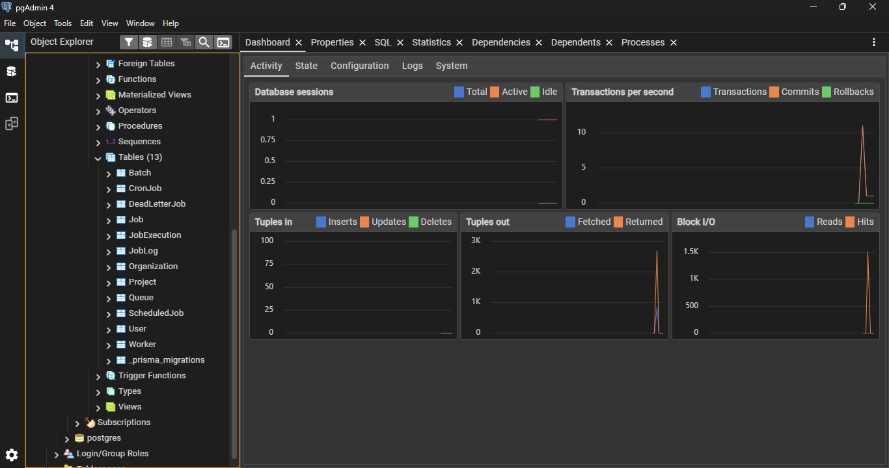9. Authentication
JWT authentication protects all APIs. Middleware validates bearer tokens before controller execution. This design decision improves maintainability, reliability, scalability, and future extensibility while keeping the implementation modular and easy to understand.
JWT authentication protects all APIs. Middleware validates bearer tokens before controller execution. This design decision improves maintainability, reliability, scalability, and future extensibility while keeping the implementation modular and easy to understand.
JWT authentication protects all APIs. Middleware validates bearer tokens before controller execution. This design decision improves maintainability, reliability, scalability, and future extensibility while keeping the implementation modular and easy to understand.
JWT authentication protects all APIs. Middleware validates bearer tokens before controller execution. This design decision improves maintainability, reliability, scalability, and future extensibility while keeping the implementation modular and easy to understand.

10. Queue Management
Queues support priority, configurable concurrency, pause/resume, and statistics. Queue isolation enables independent workload management. This design decision improves maintainability, reliability, scalability, and future extensibility while keeping the implementation modular and easy to understand.
Queues support priority, configurable concurrency, pause/resume, and statistics. Queue isolation enables independent workload management. This design decision improves maintainability, reliability, scalability, and future extensibility while keeping the implementation modular and easy to understand.
Queues support priority, configurable concurrency, pause/resume, and statistics. Queue isolation enables independent workload management. This design decision improves maintainability, reliability, scalability, and future extensibility while keeping the implementation modular and easy to understand.
Queues support priority, configurable concurrency, pause/resume, and statistics. Queue isolation enables independent workload management. This design decision improves maintainability, reliability, scalability, and future extensibility while keeping the implementation modular and easy to understand.
Queues support priority, configurable concurrency, pause/resume, and statistics. Queue isolation enables independent workload management. This design decision improves maintainability, reliability, scalability, and future extensibility while keeping the implementation modular and easy to understand.

11. Dispatcher Service
The dispatcher checks pending jobs, retry windows, scheduled execution times, queue state, and worker availability before assigning work. This design decision improves maintainability, reliability, scalability, and future extensibility while keeping the implementation modular and easy to understand.
The dispatcher checks pending jobs, retry windows, scheduled execution times, queue state, and worker availability before assigning work. This design decision improves maintainability, reliability, scalability, and future extensibility while keeping the implementation modular and easy to understand.
The dispatcher checks pending jobs, retry windows, scheduled execution times, queue state, and worker availability before assigning work. This design decision improves maintainability, reliability, scalability, and future extensibility while keeping the implementation modular and easy to understand.
The dispatcher checks pending jobs, retry windows, scheduled execution times, queue state, and worker availability before assigning work. This design decision improves maintainability, reliability, scalability, and future extensibility while keeping the implementation modular and easy to understand.
The dispatcher checks pending jobs, retry windows, scheduled execution times, queue state, and worker availability before assigning work. This design decision improves maintainability, reliability, scalability, and future extensibility while keeping the implementation modular and easy to understand.
The dispatcher checks pending jobs, retry windows, scheduled execution times, queue state, and worker availability before assigning work. This design decision improves maintainability, reliability, scalability, and future extensibility while keeping the implementation modular and easy to understand.

12. Worker Architecture
Workers transition through IDLE, ACTIVE, and SHUTTING_DOWN states. Heartbeats confirm health while graceful shutdown allows active jobs to complete. This design decision improves maintainability, reliability, scalability, and future extensibility while keeping the implementation modular and easy to understand.
Workers transition through IDLE, ACTIVE, and SHUTTING_DOWN states. Heartbeats confirm health while graceful shutdown allows active jobs to complete. This design decision improves maintainability, reliability, scalability, and future extensibility while keeping the implementation modular and easy to understand.
Workers transition through IDLE, ACTIVE, and SHUTTING_DOWN states. Heartbeats confirm health while graceful shutdown allows active jobs to complete. This design decision improves maintainability, reliability, scalability, and future extensibility while keeping the implementation modular and easy to understand.
Workers transition through IDLE, ACTIVE, and SHUTTING_DOWN states. Heartbeats confirm health while graceful shutdown allows active jobs to complete. This design decision improves maintainability, reliability, scalability, and future extensibility while keeping the implementation modular and easy to understand.
Workers transition through IDLE, ACTIVE, and SHUTTING_DOWN states. Heartbeats confirm health while graceful shutdown allows active jobs to complete. This design decision improves maintainability, reliability, scalability, and future extensibility while keeping the implementation modular and easy to understand.

13. Job Lifecycle
Jobs move through Pending, Running, Completed, Retry, Failed, and Dead Letter Queue depending on execution outcomes. This design decision improves maintainability, reliability, scalability, and future extensibility while keeping the implementation modular and easy to understand.
Jobs move through Pending, Running, Completed, Retry, Failed, and Dead Letter Queue depending on execution outcomes. This design decision improves maintainability, reliability, scalability, and future extensibility while keeping the implementation modular and easy to understand.
Jobs move through Pending, Running, Completed, Retry, Failed, and Dead Letter Queue depending on execution outcomes. This design decision improves maintainability, reliability, scalability, and future extensibility while keeping the implementation modular and easy to understand.
Jobs move through Pending, Running, Completed, Retry, Failed, and Dead Letter Queue depending on execution outcomes. This design decision improves maintainability, reliability, scalability, and future extensibility while keeping the implementation modular and easy to understand.

Figure Placeholder

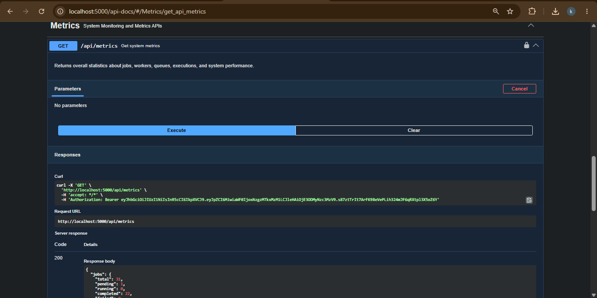14. Scheduling
Immediate, delayed, scheduled, cron, and batch execution modes support varied business scenarios. This design decision improves maintainability, reliability, scalability, and future extensibility while keeping the implementation modular and easy to understand.
Immediate, delayed, scheduled, cron, and batch execution modes support varied business scenarios. This design decision improves maintainability, reliability, scalability, and future extensibility while keeping the implementation modular and easy to understand.
Immediate, delayed, scheduled, cron, and batch execution modes support varied business scenarios. This design decision improves maintainability, reliability, scalability, and future extensibility while keeping the implementation modular and easy to understand.
Immediate, delayed, scheduled, cron, and batch execution modes support varied business scenarios. This design decision improves maintainability, reliability, scalability, and future extensibility while keeping the implementation modular and easy to understand.
Immediate, delayed, scheduled, cron, and batch execution modes support varied business scenarios. This design decision improves maintainability, reliability, scalability, and future extensibility while keeping the implementation modular and easy to understand.

15. Retry Mechanisms
Fixed, Linear, and Exponential retry strategies improve resilience while avoiding retry storms. This design decision improves maintainability, reliability, scalability, and future extensibility while keeping the implementation modular and easy to understand.
Fixed, Linear, and Exponential retry strategies improve resilience while avoiding retry storms. This design decision improves maintainability, reliability, scalability, and future extensibility while keeping the implementation modular and easy to understand.
Fixed, Linear, and Exponential retry strategies improve resilience while avoiding retry storms. This design decision improves maintainability, reliability, scalability, and future extensibility while keeping the implementation modular and easy to understand.
Fixed, Linear, and Exponential retry strategies improve resilience while avoiding retry storms. This design decision improves maintainability, reliability, scalability, and future extensibility while keeping the implementation modular and easy to understand.
Fixed, Linear, and Exponential retry strategies improve resilience while avoiding retry storms. This design decision improves maintainability, reliability, scalability, and future extensibility while keeping the implementation modular and easy to understand.
Fixed, Linear, and Exponential retry strategies improve resilience while avoiding retry storms. This design decision improves maintainability, reliability, scalability, and future extensibility while keeping the implementation modular and easy to understand.

Figure Placeholder

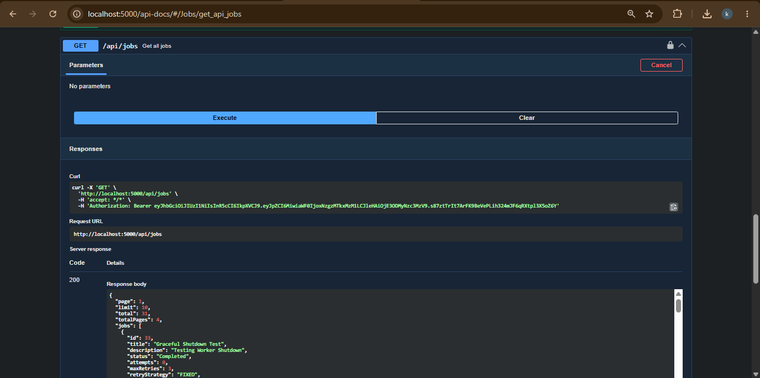16. Dead Letter Queue
Failed jobs exceeding retry limits are stored with failure reasons for later analysis. This design decision improves maintainability, reliability, scalability, and future extensibility while keeping the implementation modular and easy to understand.
Failed jobs exceeding retry limits are stored with failure reasons for later analysis. This design decision improves maintainability, reliability, scalability, and future extensibility while keeping the implementation modular and easy to understand.
Failed jobs exceeding retry limits are stored with failure reasons for later analysis. This design decision improves maintainability, reliability, scalability, and future extensibility while keeping the implementation modular and easy to understand.
Failed jobs exceeding retry limits are stored with failure reasons for later analysis. This design decision improves maintainability, reliability, scalability, and future extensibility while keeping the implementation modular and easy to understand.

17. Logging
Execution logs capture worker assignment, timestamps, duration, retries, errors, and completion status. This design decision improves maintainability, reliability, scalability, and future extensibility while keeping the implementation modular and easy to understand.
Execution logs capture worker assignment, timestamps, duration, retries, errors, and completion status. This design decision improves maintainability, reliability, scalability, and future extensibility while keeping the implementation modular and easy to understand.
Execution logs capture worker assignment, timestamps, duration, retries, errors, and completion status. This design decision improves maintainability, reliability, scalability, and future extensibility while keeping the implementation modular and easy to understand.
Execution logs capture worker assignment, timestamps, duration, retries, errors, and completion status. This design decision improves maintainability, reliability, scalability, and future extensibility while keeping the implementation modular and easy to understand.

18. Metrics
Metrics APIs expose queue health, worker activity, job counts, throughput, and execution summaries. This design decision improves maintainability, reliability, scalability, and future extensibility while keeping the implementation modular and easy to understand.
Metrics APIs expose queue health, worker activity, job counts, throughput, and execution summaries. This design decision improves maintainability, reliability, scalability, and future extensibility while keeping the implementation modular and easy to understand.
Metrics APIs expose queue health, worker activity, job counts, throughput, and execution summaries. This design decision improves maintainability, reliability, scalability, and future extensibility while keeping the implementation modular and easy to understand.
Metrics APIs expose queue health, worker activity, job counts, throughput, and execution summaries. This design decision improves maintainability, reliability, scalability, and future extensibility while keeping the implementation modular and easy to understand.

19. API Design
REST APIs follow consistent naming, validation, pagination, filtering, structured responses, and Swagger documentation. This design decision improves maintainability, reliability, scalability, and future extensibility while keeping the implementation modular and easy to understand.
REST APIs follow consistent naming, validation, pagination, filtering, structured responses, and Swagger documentation. This design decision improves maintainability, reliability, scalability, and future extensibility while keeping the implementation modular and easy to understand.
REST APIs follow consistent naming, validation, pagination, filtering, structured responses, and Swagger documentation. This design decision improves maintainability, reliability, scalability, and future extensibility while keeping the implementation modular and easy to understand.
REST APIs follow consistent naming, validation, pagination, filtering, structured responses, and Swagger documentation. This design decision improves maintainability, reliability, scalability, and future extensibility while keeping the implementation modular and easy to understand.
REST APIs follow consistent naming, validation, pagination, filtering, structured responses, and Swagger documentation. This design decision improves maintainability, reliability, scalability, and future extensibility while keeping the implementation modular and easy to understand.

Screenshot Placeholder

20. Security
JWT authentication, input validation, and controlled access reduce security risks. This design decision improves maintainability, reliability, scalability, and future extensibility while keeping the implementation modular and easy to understand.
JWT authentication, input validation, and controlled access reduce security risks. This design decision improves maintainability, reliability, scalability, and future extensibility while keeping the implementation modular and easy to understand.
JWT authentication, input validation, and controlled access reduce security risks. This design decision improves maintainability, reliability, scalability, and future extensibility while keeping the implementation modular and easy to understand.
JWT authentication, input validation, and controlled access reduce security risks. This design decision improves maintainability, reliability, scalability, and future extensibility while keeping the implementation modular and easy to understand.

21. Scalability
Additional workers can be added without modifying business logic. Queue concurrency and modular services improve scalability. This design decision improves maintainability, reliability, scalability, and future extensibility while keeping the implementation modular and easy to understand.
Additional workers can be added without modifying business logic. Queue concurrency and modular services improve scalability. This design decision improves maintainability, reliability, scalability, and future extensibility while keeping the implementation modular and easy to understand.
Additional workers can be added without modifying business logic. Queue concurrency and modular services improve scalability. This design decision improves maintainability, reliability, scalability, and future extensibility while keeping the implementation modular and easy to understand.
Additional workers can be added without modifying business logic. Queue concurrency and modular services improve scalability. This design decision improves maintainability, reliability, scalability, and future extensibility while keeping the implementation modular and easy to understand.
Additional workers can be added without modifying business logic. Queue concurrency and modular services improve scalability. This design decision improves maintainability, reliability, scalability, and future extensibility while keeping the implementation modular and easy to understand.

22. Design Trade-offs
Polling simplifies implementation but introduces slight latency. PostgreSQL favors consistency over lightweight deployment. Prisma improves productivity but advanced SQL may still require raw queries. This design decision improves maintainability, reliability, scalability, and future extensibility while keeping the implementation modular and easy to understand.
Polling simplifies implementation but introduces slight latency. PostgreSQL favors consistency over lightweight deployment. Prisma improves productivity but advanced SQL may still require raw queries. This design decision improves maintainability, reliability, scalability, and future extensibility while keeping the implementation modular and easy to understand.
Polling simplifies implementation but introduces slight latency. PostgreSQL favors consistency over lightweight deployment. Prisma improves productivity but advanced SQL may still require raw queries. This design decision improves maintainability, reliability, scalability, and future extensibility while keeping the implementation modular and easy to understand.
Polling simplifies implementation but introduces slight latency. PostgreSQL favors consistency over lightweight deployment. Prisma improves productivity but advanced SQL may still require raw queries. This design decision improves maintainability, reliability, scalability, and future extensibility while keeping the implementation modular and easy to understand.
Polling simplifies implementation but introduces slight latency. PostgreSQL favors consistency over lightweight deployment. Prisma improves productivity but advanced SQL may still require raw queries. This design decision improves maintainability, reliability, scalability, and future extensibility while keeping the implementation modular and easy to understand.
Polling simplifies implementation but introduces slight latency. PostgreSQL favors consistency over lightweight deployment. Prisma improves productivity but advanced SQL may still require raw queries. This design decision improves maintainability, reliability, scalability, and future extensibility while keeping the implementation modular and easy to understand.

23. Future Enhancements
Workflow dependencies, queue sharding, distributed locking, WebSockets, RBAC, AI-assisted failure summaries, and rate limiting can be added later. This design decision improves maintainability, reliability, scalability, and future extensibility while keeping the implementation modular and easy to understand.
Workflow dependencies, queue sharding, distributed locking, WebSockets, RBAC, AI-assisted failure summaries, and rate limiting can be added later. This design decision improves maintainability, reliability, scalability, and future extensibility while keeping the implementation modular and easy to understand.
Workflow dependencies, queue sharding, distributed locking, WebSockets, RBAC, AI-assisted failure summaries, and rate limiting can be added later. This design decision improves maintainability, reliability, scalability, and future extensibility while keeping the implementation modular and easy to understand.
Workflow dependencies, queue sharding, distributed locking, WebSockets, RBAC, AI-assisted failure summaries, and rate limiting can be added later. This design decision improves maintainability, reliability, scalability, and future extensibility while keeping the implementation modular and easy to understand.
Workflow dependencies, queue sharding, distributed locking, WebSockets, RBAC, AI-assisted failure summaries, and rate limiting can be added later. This design decision improves maintainability, reliability, scalability, and future extensibility while keeping the implementation modular and easy to understand.

24. Testing Strategy
Unit tests, integration tests, API tests, retry validation, worker coordination tests, and concurrency tests help ensure correctness. This design decision improves maintainability, reliability, scalability, and future extensibility while keeping the implementation modular and easy to understand.
Unit tests, integration tests, API tests, retry validation, worker coordination tests, and concurrency tests help ensure correctness. This design decision improves maintainability, reliability, scalability, and future extensibility while keeping the implementation modular and easy to understand.
Unit tests, integration tests, API tests, retry validation, worker coordination tests, and concurrency tests help ensure correctness. This design decision improves maintainability, reliability, scalability, and future extensibility while keeping the implementation modular and easy to understand.
Unit tests, integration tests, API tests, retry validation, worker coordination tests, and concurrency tests help ensure correctness. This design decision improves maintainability, reliability, scalability, and future extensibility while keeping the implementation modular and easy to understand.
Unit tests, integration tests, API tests, retry validation, worker coordination tests, and concurrency tests help ensure correctness. This design decision improves maintainability, reliability, scalability, and future extensibility while keeping the implementation modular and easy to understand.

Screenshot Placeholder

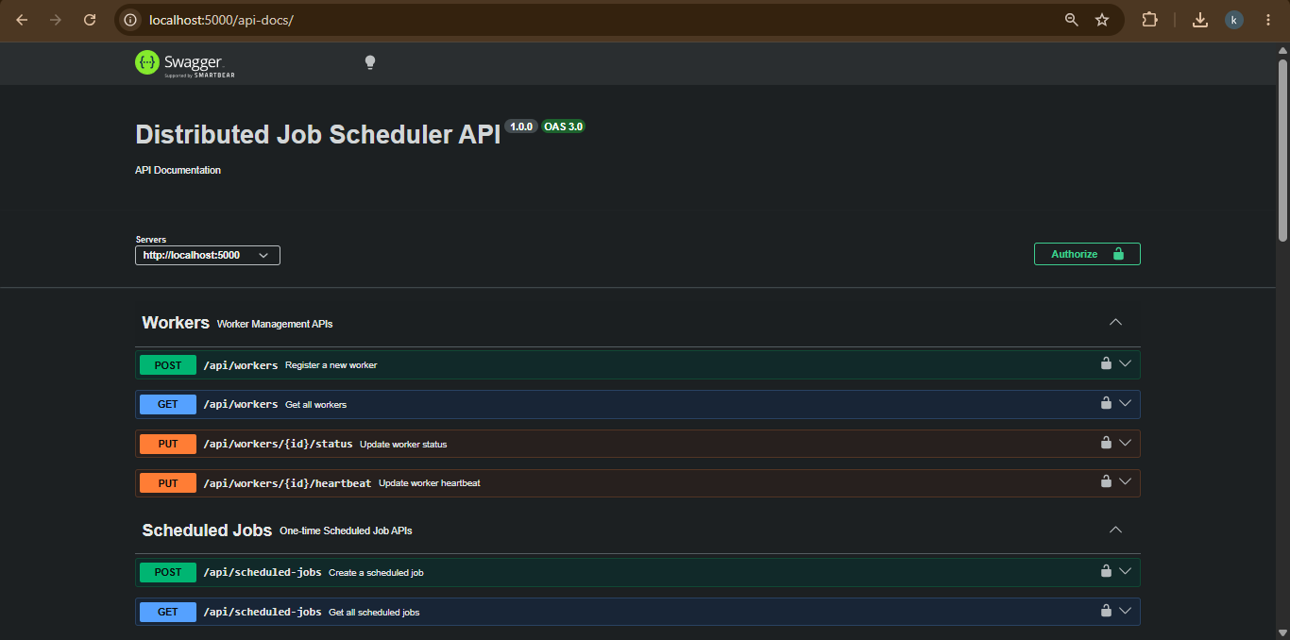

25. Deployment Considerations
Environment variables, database migrations, production logging, HTTPS, and process managers such as PM2 should be used for deployment. This design decision improves maintainability, reliability, scalability, and future extensibility while keeping the implementation modular and easy to understand.
Environment variables, database migrations, production logging, HTTPS, and process managers such as PM2 should be used for deployment. This design decision improves maintainability, reliability, scalability, and future extensibility while keeping the implementation modular and easy to understand.
Environment variables, database migrations, production logging, HTTPS, and process managers such as PM2 should be used for deployment. This design decision improves maintainability, reliability, scalability, and future extensibility while keeping the implementation modular and easy to understand.
Environment variables, database migrations, production logging, HTTPS, and process managers such as PM2 should be used for deployment. This design decision improves maintainability, reliability, scalability, and future extensibility while keeping the implementation modular and easy to understand.

26. Conclusion
The final architecture provides a solid foundation for reliable distributed background processing while remaining maintainable and extensible. This design decision improves maintainability, reliability, scalability, and future extensibility while keeping the implementation modular and easy to understand.
The final architecture provides a solid foundation for reliable distributed background processing while remaining maintainable and extensible. This design decision improves maintainability, reliability, scalability, and future extensibility while keeping the implementation modular and easy to understand.
The final architecture provides a solid foundation for reliable distributed background processing while remaining maintainable and extensible. This design decision improves maintainability, reliability, scalability, and future extensibility while keeping the implementation modular and easy to understand.

Appendix A - Architecture Diagram

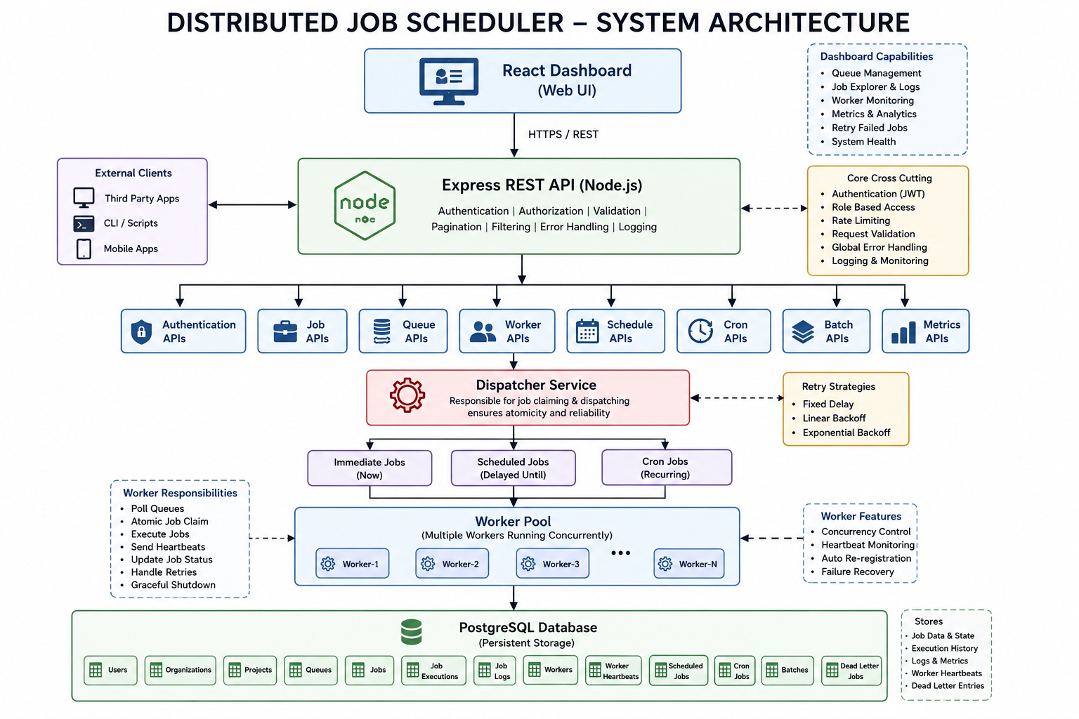

Appendix B - ER Diagram

