Question | The hybridization of the central carbon in CH3C≡N and the bond angle CCN are
Type | multiple_choice
Option | sp² , 180°
Option | Sp, 180°
Option | sp² , 120°
Option | sp³ , 109°
Answer | 1,2
Solution | Sp, 180°  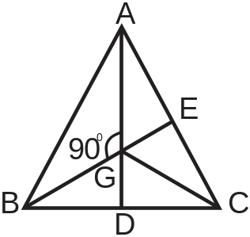
Positive Marks | 4
Negative Marks | 1

Question | ${x }^{8}-1$ और $x^{4}+2x^{3}-2x-1$ का महत्‍तम समापवर्तक है-  The HCF of ${x }^{8}-1$ and $x^{4}+2x^{3}-2x-1$ is-
Type | multiple_choice
Option | $x-1$
Option | $$x^{2}-1$$
Option | $$x^{2}+1$$
Option | $$x+1$$
Answer | 2
Solution | a e i o u, they are 5
Positive Marks | 4
Negative Marks | 1

Question | Ashwin is a/an _________ reader and he can read upto _________ chapter(s) a day
Type | multiple_choice
Option | sp² , 180°
Option | Sp, 180°
Option | sp² , 120°.
Option | sp³ , 109°.
Answer | 1,2
Solution
Positive Marks | 4
Negative Marks | 1

Question | Type in Hindi | Easy Hindi Typing (हिन्दी में टाइप करें)  इंग्लिश में टाइप करे स्पेस दबाये यह हिन्दी में परिवर्तित हो जाएगा  Many educationalists consider it a weak and woolly field, too far removed from the practical applications of the real world to be useful. But philosophers dating back to Plato and the Ancient Greeks have given the area much thought and emphasis, and there is little doubt that their work has helped shape the practice of education over the millennia.
Type | multiple_choice
Option | sp² , 180°
Option | Sp, 180°
Option | sp² , 120°.
Option | sp³ , 109°.
Answer | 1,2
Solution | any explanation for the same
Positive Marks | 4
Negative Marks | 1

