user language dependent messaging app

*Submitted By:*

Krishna Sarma

C1755773

# Abstract (NOT READY YET)

Human migration has led to the mixing of people speaking different languages in vast numbers. Be it for professional or personal reasons, it has become very important for people to be able to communicate freely and correctly. Moreover, because of the availability of more advanced and cheap technology, today smartphone has become an integral part of everybody’s life. Hence, this project aims to build a messaging application that provides real-time language translation to the language of the receiver’s choice. For example: if user A has language set as English and user B has language set as French, then when A sends a message to B in English, B receives it in French and vice versa.

This application provides usage for people from all fields, from students to employees. It provides a platform where users can send their messages in their native language and the receiver can receive it in their native language.

# Acknowledgement

Contents

Abstract 2

Acknowledgement 3

Chapter 1: Introduction 5

Background Research 5

1. Smartphone users: 5

2. Most popular form of communication: 6

3. Bilingual people around the world: 7

4. How do bilingual people communicate? 7

5. Language death: 7

Problem Statement 7

The Proposed Solution 8

Development Methodology and Thesis Structure: 9

Chapter 2: Literature Review 9

References 12

# Chapter 1: Introduction

In this section we will talk about the Background Research that were implemented while developing this project, the communication gap that is being faced by the people globally, the solution proposed and the overview of the steps taken to tackle the problem.

## Background Research

### Smartphone users:

Following is the timeline of smartphone advancements since world’s first smartphone:

* 1992 IBM launched world’s first smartphone, Simon Personal Communicator. It had features such as email, fax, touchscreen and 1 hour of battery life. (Andrew, 2018)
* Next, BlackBerry launched its mobile device with BlackBerry 5810. Its targeted business professionals and gained the smartphone market before Apple launched its smartphone device. (Andrew, 2018)
* Apple launched its first smartphone device with iPhone and it was one of the most advanced smartphones consumers had ever seen. Since its launch, Apple had sold 1.4 million in its first year. (Andrew, 2018)

The present smartphones have faster and more powerful multi-core processor, more memory, HD cameras, longer lasting battery etc. With advanced technology coupled with cheaper rates, the number of smartphone users globally have risen to 3 billion with Asia-Pacific leading. The forecast for the number of active smartphone users is made to be risen to 3.8 billion by 2021. The following graph shows the rise of active smartphone users from 2016 onwards. (Kooistra, 2018)

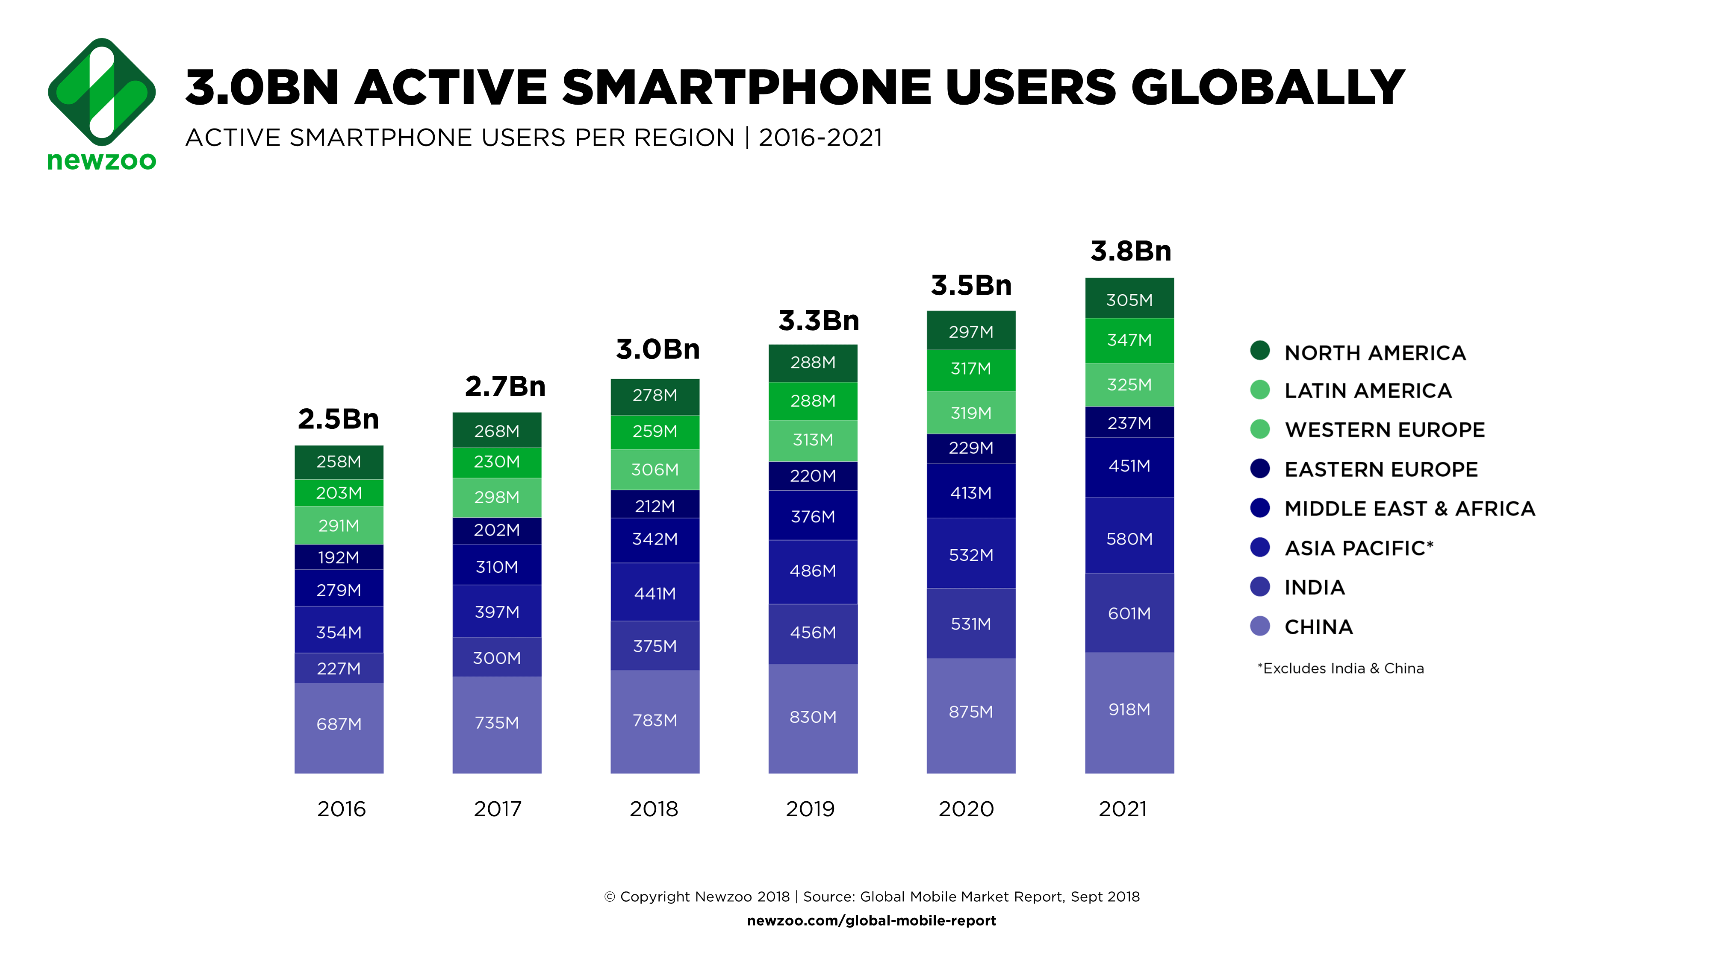

Figure 1: Active smartphone users globally (Kooistra, 2018)

More than 1.5 billion smartphones were sold globally and smartphone penetration rate is higher than 70 in highly populated countries such as India and China. Hence even though there is a stagnation in the smartphone market due to high average Selling Price, it still has a growth potential. (Holst, 2019)

### Most popular form of communication:

According to surveys texting is the most common platform used for communication. In United States 68% of Americans younger than 30 and 47% from age 30-49 use mobile phones for texting (Newport, 2014). Similarly, in the United Kingdom (UK), text messaging has overtaken phone calls as the most common form of communication. 58% of UK adults use text messages at least once a day (Noah, 2012).

Among all numerous numbers of chat apps available the most common ones are (Kim, 2018):

* **WhatsApp**: WhatsApp is the most used messaging app globally. It provides end-end encrypted secure message transmission, voice and video calling. It is used by more than 1.5 billion people worldwide.
* **Facebook Messenger**: Facebook messenger app is used by about 1.3 billion users globally. It is Facebook’s native messaging app.
* **WeChat**: The messaging app market in China is dominated by WeChat. It is used by more than 1 billion users.

Following image shows the messaging app most used around the world

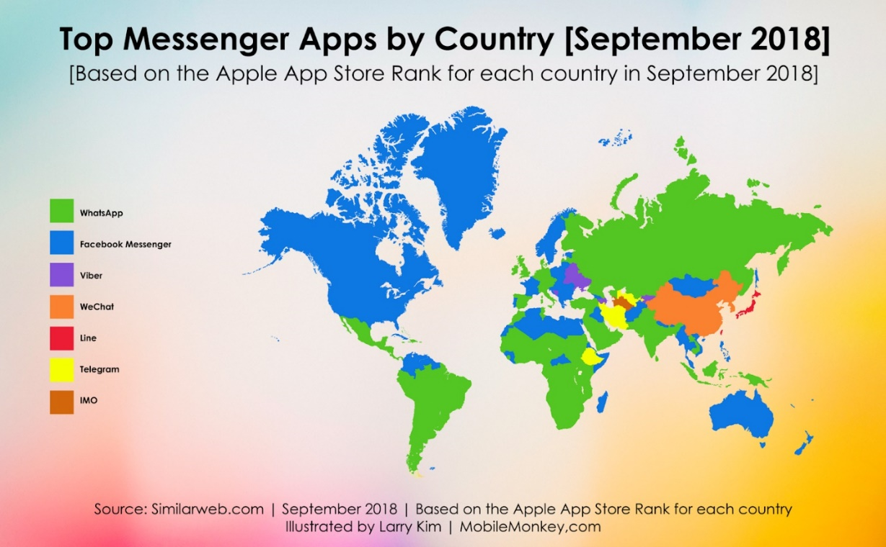

Figure 2: Messaging app most common globally (Kim, 2018).

### Bilingual people around the world:

Multilingualism is the use of two or more languages and Bilingualism is the use of two languages, such as English and Spanish. It has already been established that there are more than 50% of the world’s population that are multilingual. Its present in all continent, countries, classes of people and age groups. In Asia and Africa there are a huge number of bilinguals. In Europe, more than half the population is bilingual, 35% in Canada and about 20% in North America are bilinguals (Grosjean, 2010). Moreover, in some countries such as China and India, there are policies that recognise a number of languages as official or national language. For example, in India the Eight Schedule of the Constitution of India has 22 languages and there are 99 languages that are not included in the Eight Schedule of the Constitution of India (Gulf News Asia, 2018). The main cause of bilingualism is the movement of people for reasons such as political, social, economic, religious. For instance, students moving in to United Kingdom for education purpose. The total international student in the year 2017-18 was 468,385 with China and India among the top non-EU sending countries and Italy and France as the top most EU sending countries. In the year of 2017-18 Cardiff University had a total of 7,975 international students (UKCISA, 2019).

### How do bilingual people communicate?

When a bilingual individual communicates in a non-native language then they tend to translate the words in their mind before responding (Kroll, 2008). If a bilingual has a dominant language then the dominant language is the one that has a direct link to the memory. While communicating in a non-dominant language the mind translates the language into the dominant language and the translation is then used to connect to the memory. This causes a cognitive load to the mind of a bilingual individual.

### Language death:

Language death is the end of a language. There are many reasons of language death, however the most common one is Language Shift (Jordan, 2015). Language shift is when a community that used to speak only one language, starts speaking another. The languages most widely used are Mandarin Chinese, Spanish, English and Hindi. English is the most spoken language in the world (Klappenbach, 2019). It has more than 360 million native speakers and almost twice as many non-native speakers. It is also the official language of the sky, i.e., all pilots communicate in English.

## Problem Statement

Firstly, one of the main problems faced by international student in UK is language barrier. Even with students who clear the IELTS (International English Language Testing System) with great marks suffer from this due to the different accent or slangs used locally (Karki, 2019). International students in United States also go through language barrier. Moreover, this problem is not only limited to international students. It is faced by immigrants from all age group and profession.

Secondly, the text messaging apps most commonly used such as WhatsApp, Facebook Messenger and WeChat do not provide language translation facilities. One can send message in their native language but the receiver receives the message in the same language.

Thirdly, as discussed in section 4 of Background Research, when an individual communicates in a non-native language, they translate the words in their mind to their native language. This forms a cognitive load on the mind of the individual and it relies on the individual to remember the words and rules of the non-native language thus forming a communication gap.

## The Proposed Solution

In order to address the problem defined above, the solution proposed is to build an Android app that would allow users to send and receive messages in their own language. That is, let user A set their chosen language as English and user B set their chosen language as Spanish, then when A sends a message to B in English, B receives it in Spanish and vice versa.

This solution contributes towards a number of sides of the problem:

1. It works as a platform where international students can communicate in their native language.
2. It bridges the communication gap by eliminating the need to translate every message in their native language because the app does the translation for the user.
3. It helps prevent death of a language by providing users a mean to communicate in a language they prefer and not just in English.

Hence, the primary aim of this project is to incorporate a reliable and free translation API to an android messaging app that would securely and in real-time translate the message received.

The motivation for developing this project was achieved during an experience of team working received in Software Engineering module. In this module as a part of assignment work, the class was divided into multiple teams, where the team-members were from different countries. One of the problems faced during this assignment was correct and proper communication between students with different first languages. It was noticed that a lot of messages was lost in translation and this led to a team member not being actively involved in the project.

Moreover, all the solutions present today such as google translate and itranslate (discussed in Literature Review) only provide ways to translate a text before sending the message or after receiving the message. These solutions are good when the user needs to translate one or two messages but, in a situation, where there is an ongoing conversation between users of two different languages then translating each and every message before sending or after receiving it gets very tedious. In such cases, the proposed solution where the message translation takes place after the message is sent and before the message is received provides a hassle free global chat interface to the users.

## Development Methodology and Thesis Structure:

The methods used for project management and while development were all professional methods. These methods were implemented after gaining experience in them in the Placement year. Initially research was done to find the languages and framework available to develop the app and then the right one was chosen such as the right translation API to be used. Then, after taking approval from Cardiff University Ethics Committee an online survey was done as to what form of features were expected by users for the User Interface and then development was done keeping into account the feedback received. After the app development was completed then a final feedback was taken to examine if the app solves the problem defined and if the solution includes all the parts as mentioned above.

This chapter is followed by Literature Review chapter where the existing work done in the field of text translation is reviewed. Then comes the project management and technology used chapter that talks about what technology is used and why it’s used. Next chapter is the UI chapter which discusses and justifies the decisions made to build the UI. Chapter 5 talks about the final product and the feedback received from the users. Chapter 6 is the conclusion chapter which discusses future improvements, self-reflection and overall conclusion.

# Chapter 2: Literature Review

In today’s world, thanks to the development of technology there are many ways in which a user can translate from one language to another. The technology that translates texts from one language to another with the help of a software is called Machine Translation. There are various types of machine translation (Andover, 2018):

* Rule Based Machine Translation (RBMT): It is based on set of linguistic rules set by experts that helps in identifying words and sentence structure and then converting to targeted language.
* Statistical Machine Translation (SMT): This is most widely used form of translation. It trains the translation engine with the help of huge set of bilingual and monolingual corpora. It then gathers statistical correlations between source texts and translations, thus building translation model. On receiving an input text, it then generates scores regarding probability of an input being matched to the translation.
* Neural Machine Translation (NMT): It is the newest form of machine translation and is based on machine learning. It uses neural network that consist of nodes which can hole from words to sentences and relate through complex relations based on the bilingual text used to train the system.

The tools available for people to translate from one language to another are:

1. Mobile Apps:

Some of the most common translation apps available for users are:

* iTranslate Translator: It is a translation and dictionary app. It provides a translator for 100+ languages, keyboard extensions where users can send messages in different language in popular chat apps such as WhatsApp. Some of the other features include voice translation, camera translation, offline translation, verb conjugations, phrasebook and visual dictionary.
* Google Translate: It is a translator provided by Google. It is available in the form of website, both Android and IOS app and as an API for developers to integrate in their software or apps.

Translators in chat apps:

* Viber: Viber is a chat app which allows translation in the app. When a message of different language is received then the receiver has the option to select the message and translate it to the language that they desire.
* Google translate can be integrated into any app that allows users to translate text within any app.

1. Websites and Browser extensions:

There a number of translator websites and Browser extensions available today. The most used and market dominated website is Google Translate. It also provides web extension for Chrome users. For Firefox extension, even though Google Translator do not officially provide any extension there are various services like Google Translator for Firefox that uses the Translator’s API. Another common translator website is DeepL. It uses Artificial Intelligence for translations.

Notes: (NOT FOR REVIEW)

1. Talk about FCM integration and data flow there. And the data flow used
2. Talk about why react-native, express, socketio.
3. Talk about why android and not ios
4. Talk about image storage facility
5. Talk about API changeability
6. Talk about nosql
7. Talk about Sprints and version control.
8. Talk about connection to Contacts and using phone number
9. Talk about only showing users whose email is saved
10. Deploying server to EC2 instances
11. Various facilities firebase auth provides
12. Google signin

Save languages in DB so that internet connection is not needed to get the languages from Microsoft.

# References

1. Andover, 2018. Machine Translation. [Online]   
   Available at: https://www.andovar.com/machine-translation/  
   [Accessed 22 08 2019].
2. Andrew, O., 2018. The History and Evolution of the Smartphone: 1992-2018. [Online]   
   Available at: https://www.textrequest.com/blog/history-evolution-smartphone/  
   [Accessed 19 August 2019].
3. Grosjean, F., 2010. Bilingualism's Best Kept Secret. [Online]   
   Available at: https://www.psychologytoday.com/us/blog/life-bilingual/201011/bilingualisms-best-kept-secret  
   [Accessed 21 08 2019].
4. Gulf News Asia, 2018. Census: More than 19,500 languages spoken in India as mother tongues. [Online]   
   Available at: https://gulfnews.com/world/asia/india/census-more-than-19500-languages-spoken-in-india-as-mother-tongues-1.2244791#  
   [Accessed 21 08 2019].
5. Holst, A., 2019. Number of smartphone users worldwide from 2016 to 2021 (in billions). [Online]   
   Available at: https://www.statista.com/statistics/330695/number-of-smartphone-users-worldwide/  
   [Accessed 20 August 2019].
6. Jordan, S.-C., 2015. What Causes the Death of a Language?. [Online]   
   Available at: https://alphaomegatranslations.com/foreign-language/what-causes-the-death-of-a-language/  
   [Accessed 22 08 2019].
7. Karki, S., 2019. Problems faced by International students in UK. [Online]   
   Available at: https://oyaschool.com/problems-faced-by-international-students-in-uk/  
   [Accessed 22 08 2019].
8. Kim, L., 2018. The Top 7 Messenger Apps in the World. [Online]   
   Available at: https://www.inc.com/larry-kim/the-top-7-messenger-apps-in-world.html  
   [Accessed 21 08 2019].
9. Klappenbach, A., 2019. Most spoken languages in the world 2019. [Online]   
   Available at: https://blog.busuu.com/most-spoken-languages-in-the-world/  
   [Accessed 22 08 2019].
10. Kooistra, J., 2018. Newzoo’s 2018 Global Mobile Market Report: Insights into the World’s 3 Billion Smartphone Users. [Online]   
    Available at: https://newzoo.com/insights/articles/newzoos-2018-global-mobile-market-report-insights-into-the-worlds-3-billion-smartphone-users/  
    [Accessed 19 August 2019].
11. Kroll, J. F., 2008. Juggling Two Languages in One Mind. [Online]   
    Available at: https://www.apa.org/science/about/psa/2008/01/kroll  
    [Accessed 22 08 2019].
12. Newport, F., 2014. The New Era of Communication Among Americans. [Online]   
    Available at: https://news.gallup.com/poll/179288/new-era-communication-americans.aspx  
    [Accessed 21 08 2019].
13. Noah, S., 2012. Texting overtakes talking as most popular form of communication in UK. [Online]   
    Available at: https://www.independent.co.uk/news/uk/home-news/texting-overtakes-talking-as-most-popular-form-of-communication-in-uk-7956016.html  
    [Accessed 21 08 2019].
14. UKCISA, 2019. International student statistics: UK higher education. [Online]   
    Available at: https://www.ukcisa.org.uk/Research--Policy/Statistics/International-student-statistics-UK-higher-education  
    [Accessed 21 08 2019].