SIMATS ENGINEERING
ASSESSMENT TOOL 1

COURSE CODE: CSA14 COURSE NAME: Compiler Design

COURSE OUTCOME COVERED

CO1: Apply lexical analysis for token specification and recognition using LEX tool. (BL3)

Assessment Tool Weightage: 40%

Duration :60 Mins
On Class
QUESTIONS: 5 Total Marks:50

Annexure A

ANALYTICAL PROBLEM SOLVING

Code of Conduct:

I _Y. Krishna Tejesh Reddy (192411200)_ (Name / Reg No) certify that this submission is my original work and that I have adhered to the guidelines specified for this assessment.
I understand that any violation of academic integrity rules will result in disciplinary action.

Signature of the student:

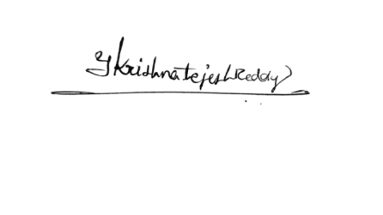

Annexure A

ANALYTICAL PROBLEM SOLVING
Q1. Apply your understanding of compiler design to demonstrate how a source program is processed through all phases of a compiler.
Consider the statement:
w=x∗y−z+20
where w,x,y,z are of type real.
Illustrate the transformation of the above statement through each phase of the compiler, including:
(i). Lexical Analysis – Identify tokens and construct the symbol table.
(ii). Syntax Analysis – Show how the statement is validated using grammar rules.
(iii). Semantic Analysis – Verify type consistency and correctness of the expression.
(iv). Intermediate Code Generation – Represent the statement in an intermediate form.
(v). Code Optimization – Apply possible optimizations to improve efficiency.
(vi). Target Code Generation – Generate the final machine-level or assembly-like code.
Clearly show how the internal representation of the program changes at each phase and explain the role of each phase in the translation process. (10 Marks)

Q2. Construct appropriate regular expressions for the following subsets of {0,1}*:
(i) All strings beginning and ending with 1.
(ii) All strings containing the substring 01.
(iii) All strings with exactly one 0.
(iv) All strings with at least two 1's.
(v) All strings that do not end with 0. (10 Marks)

Q3. Apply your understanding of Formal Languages and Automata Theory to interpret regular expressions and construct the corresponding languages.
For each of the following regular expressions, construct and describe the language generated. Represent your answer by listing example strings and explaining the pattern of the language.
- (ϵ+aa∗)∗
Construct the language and describe the possible forms of strings generated.
- (a∗+b∗)∗abb
Determine the language and explain the structure of strings ending with a specific pattern.
(iii) (a∗b∗)∗ aba
Construct the language and identify the mandatory substring condition.
- (a+ab)∗
Generate the language and describe how repetition affects string formation.
- (aba)∗+(a∗b∗)∗
Construct the combined language and explain the contribution of each part of the expression. (10 Marks)

Q4. Apply your understanding of Compiler Design to design components of a lexical analyzer using Lex for a simple programming language.
Identifier Recognition using Lex
You are given a programming language with the following token specifications:
Keywords: if, else, while
Identifiers: A sequence of letters (uppercase and lowercase) and digits, starting with a letter
Constants: Integer values
Operators: +, -, *, /
Delimiters: (, ), {, }, ;
(i) Construct a Lex regular expression that recognizes identifiers in this language.
(ii) Justify how your regular expression correctly identifies valid identifiers while avoiding conflicts with keywords.expressions distinguish between valid and invalid numeric formats with suitable examples.
(10 Marks)

Q5. Apply algebraic properties of regular expressions to prove the following identities:
(i) (0∗1∗)* = (0+1)∗
(ii) (0+1)∗(0+1)∗=(0+1)∗
(iii) (0∗)∗=0∗
(iv) (0+1)∗0(0+1)∗+(0+1)∗1(0+1)∗=(0+1)⁺
(v) ε+0(0)∗=0∗ (10 Marks)
.

RUBRICS FOR CALCULATION:

Criteria | Weightage | Level 4 – Exemplary | Level 3 – Proficient | Level 2 – Developing | Level 1 – Beginning
Problem Understanding | 20% | Clearly interprets problem, identifies all parameters and requirements accurately | Understands problem with minor gaps | Partial understanding; misses key elements | Misinterprets or unable to understand problem
Method Selection | 20% | Selects most appropriate method/formula with strong justification | Selects correct method with minor errors | Inappropriate or partially correct method | Unable to select method
Solution Process | 25% | Logical, systematic steps with correct approach throughout | Mostly correct steps with minor mistakes | Disorganized steps; multiple errors | No clear process
Accuracy of Calculation | 20% | All calculations accurate; correct final answer | Minor calculation errors | Frequent errors; incorrect final answer | No valid calculations
Interpretation of Results | 15% | Clearly interprets results with units and engineering relevance | Basic interpretation with minor omissions | Limited or unclear interpretation | No interpretation

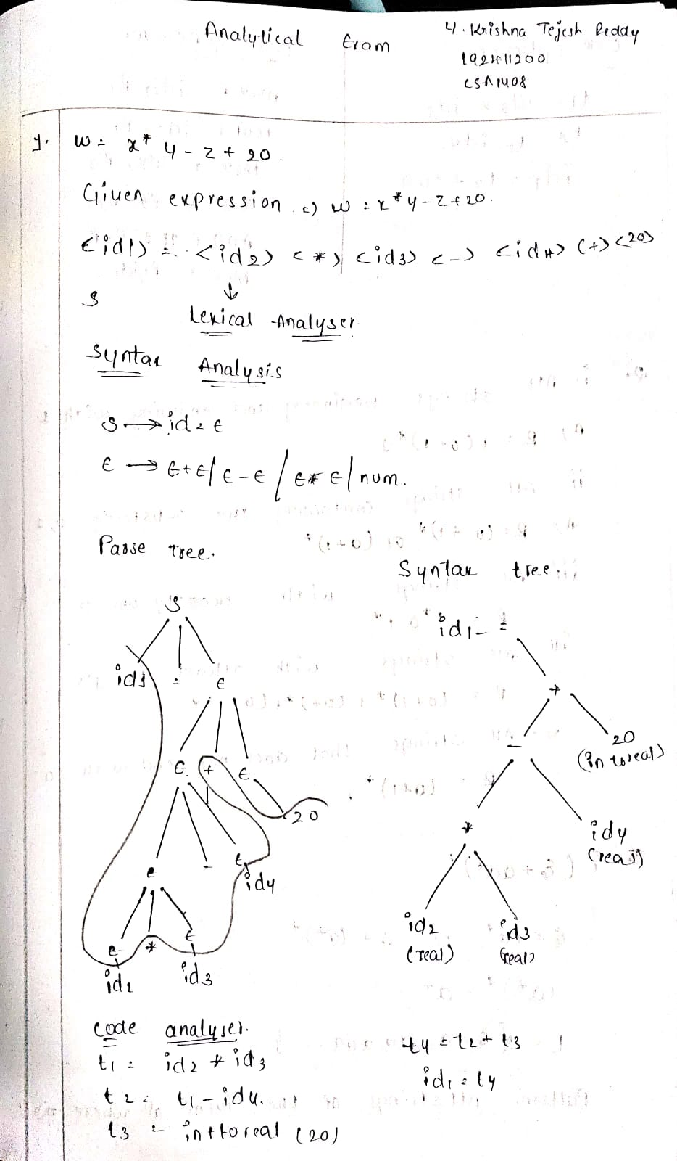Scannel
