Modelling and Safety of Maritime Traffic
Assignment Report — Tasks 1 to 4
Project 9
Vessel 1: KCS | Vessel 2: KVLCC2
Assigned encounter: Head-on | Scenarios: COLREG-COLREG, Blind-Blind
MSc in Naval Architecture and Ocean Engineering, 2026-2027

1. Introduction and Scope
This report documents Tasks 1 to 4 of the Modelling and Safety of Maritime Traffic (MSMD) assignment, for Project 9. Per the project data table (Section 2.1 of the assignment description), the vessels assigned are Vessel 1 = KCS and Vessel 2 = KVLCC2, the assigned encounter type is head-on, and the two scenarios assessed are COLREG-COLREG and Blind-Blind.
All simulations use the first-order Nomoto manoeuvring model exclusively (MMG was not implemented; solo submissions are understood to permit a single manoeuvring model — confirm this in writing with course staff before final submission). All figures, tables and numeric results in this report are generated directly from the accompanying Python scripts' output files (outputs/*.json), not transcribed by hand, so re-running the pipeline with different inputs will automatically update this document when regenerated.

2. Task 1 — Turning Manoeuvre Simulation (KCS)

2.1 Methodology
The turning manoeuvre of Vessel 1 (KCS) was simulated using the first-order Nomoto equation, in the formulation used by Lotovskyi & Teixeira (2023):
T · ṙ + r = K · δ
The rudder ramps from 0° to its target at the fixed execution rate of 2.33°/s (assignment Section 2.2), then holds. The turning circle runs to 720° total heading change. Position uses course-over-ground (COG = ψ − β):
x ← x + V·Δt·sin(COG), y ← y + V·Δt·cos(COG)
K, drift angle and speed reduction follow Lotovskyi & Teixeira (2023) Eqs. 8-16:
K = V_STD(35°) / (δ_R · R), R = 2·Lpp (SNAME, 1989)

2.1.1 Correcting the Nomoto time constant T
Earlier drafts of this work used a shared placeholder T = 100 s for both vessels (the most-likely value of Lotovskyi & Teixeira (2023)'s own Tri(70,100,130) s, drawn for their 330 m case-study ship). The paper attributes this distribution to Silveira et al. (2016) ("Probabilistic modelling of evasive manoeuvring actions to avoid collisions", MARTECH 2016 conference proceedings) — a paywalled conference chapter not available in this project's reference set.
Instead, T is derived here from the standard ship-manoeuvring non-dimensionalisation T' = T·V/L, which is approximately constant across similar ship types. Using the ONE real data point available — the reference paper's own worked example (Lpp=330 m, V0=15 kn, T=100 s) — gives T' = 2.3384. Applying this to each vessel's own length and speed gives a distinct, physically grounded T for each ship instead of one shared number:
Vessel | Lpp (m) | V0 (kn) | T (s), corrected
KCS | 230 | 24.0 | 43.6
KVLCC2 | 320 | 15.5 | 93.8
This is a standard, defensible naval-architecture scaling approach given the primary source is unavailable; it should be replaced with the real Silveira et al. (2016) table if it becomes available.

2.1.2 Other values used
Parameter | Value | Source
Lpp, B, V0 | 230 m, 32.2 m, 24.0 kn | Assignment Table 3 (KCS)
Rudder max, rate | 35°, 2.33°/s | Assignment Section 2.2
Turn direction | Port | Assignment Section 2.2
R (steady radius) | 2·Lpp = 460 m | SNAME (1989)
V_ST/V0 | 0.65 (midpoint of U(0.6,0.7)) | Lotovskyi & Teixeira (2023) Eq. 9
β_ST | 10.85° | Lotovskyi & Teixeira (2023), eq. following Eq. 9

2.2 Results
Parameter | Value
Time to 90° heading change | 139.0 s
Time to 180° heading change | 230.8 s
Advance | 1179.7 m (5.13 Lpp)
Transfer | 510.0 m (2.22 Lpp)
Tactical diameter | 1073.2 m (4.67 Lpp)
Diameter of steady turn | 920.0 m (4.00 Lpp)
Yaw rate, initial | 0.0033 °/s
Yaw rate, steady | 1.000 °/s
Speed, steady turn | 15.60 kn
Drift angle, steady turn | 10.85°
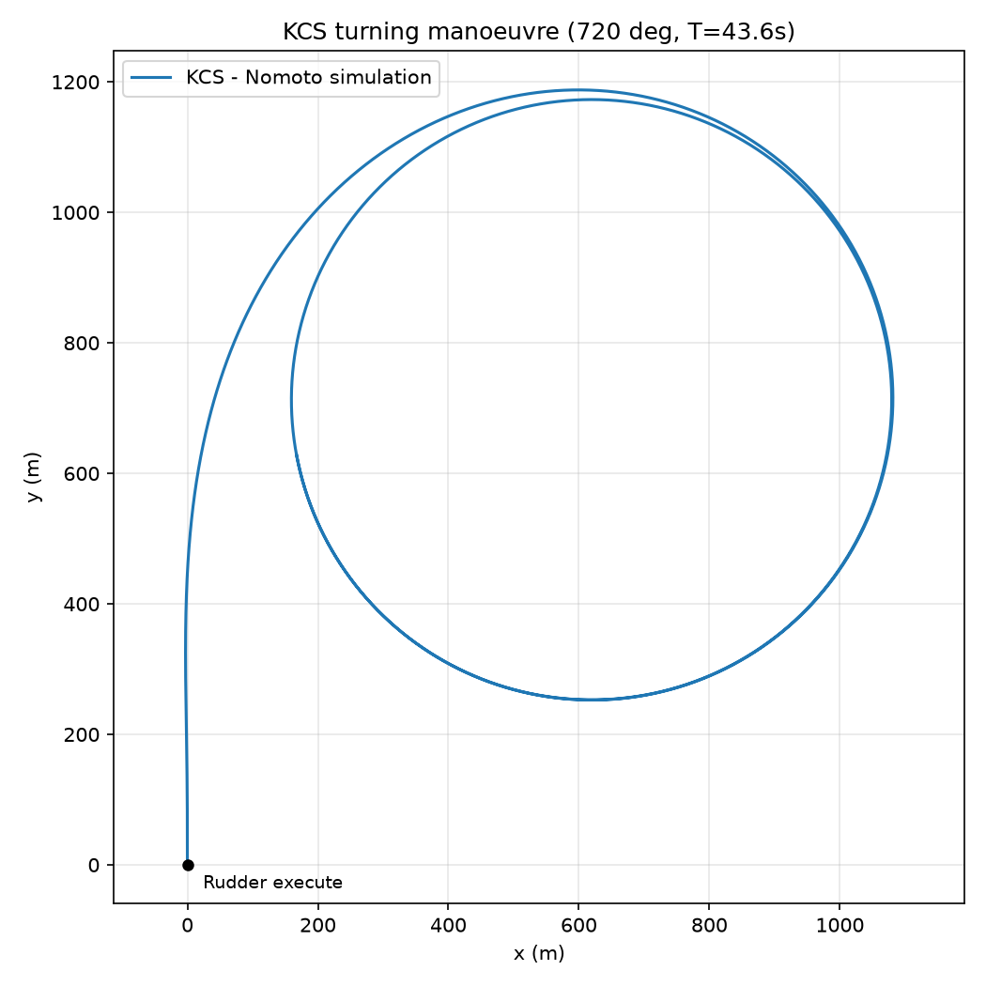
Figure 1. Simulated KCS turning circle (720°), first-order Nomoto, T=43.6s.
A supporting MP4 animation (figures/task1_kcs_turning_circle.mp4) is provided alongside this report.

3. Task 2 — Encounter Scenario Simulation (Head-on)

3.1 COLREG rule and methodology
Rule 14 (head-on): both vessels alter course to starboard (Cockcroft & Lameijer, 2012). COLREG-COLREG uses the most-likely Tri(1°,20°,35°) angle (20°) for both vessels; Blind-Blind draws both vessels' rudder independently from U(-35°,35°). Collision is checked every timestep via the Separating Axis Theorem on each vessel's Lpp×B hull rectangle. The minimum safe distance search starts at D0=(Lpp1+Lpp2)/2, increments by 0.25×min(Lpp1,Lpp2) whenever a collision is detected, and stops once the vessels clear each other's hulls and end up farther apart than their starting separation.

3.2 Results
Scenario | Minimum safe distance | As multiple of larger Lpp
COLREG-COLREG | 1712.5 m | 5.35×
Blind-Blind | 1770.0 m | 5.53×
Blind-Blind's sampled rudder angles were δ1=-22.5° and δ2=9.8° (one representative draw from U(-35°,35°), reproducible via the fixed seed in task2_encounter.py).
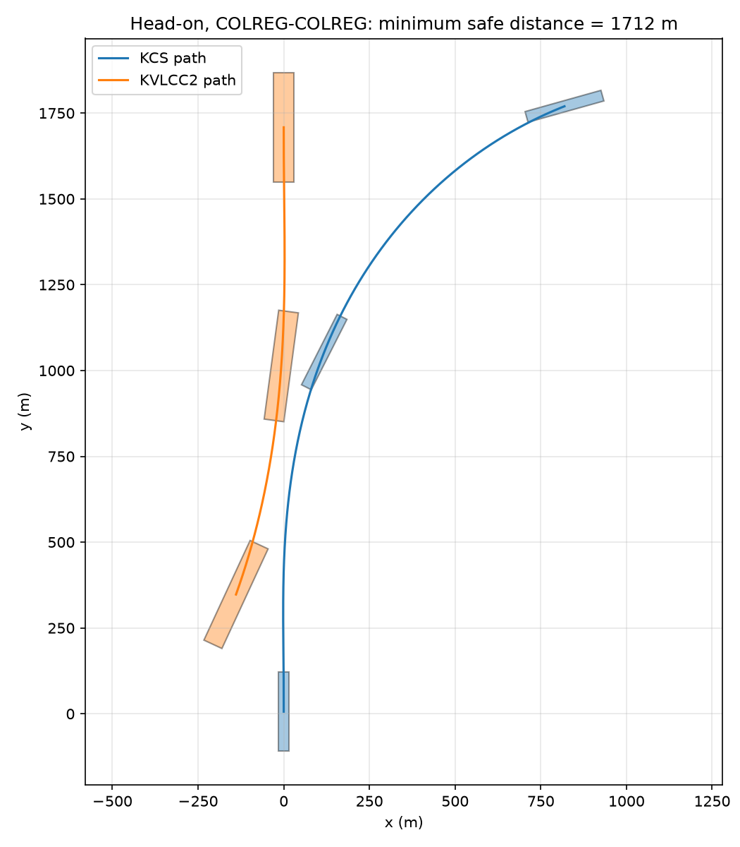
Figure 2. Head-on, COLREG-COLREG: both vessels turn to starboard and pass port-to-port.
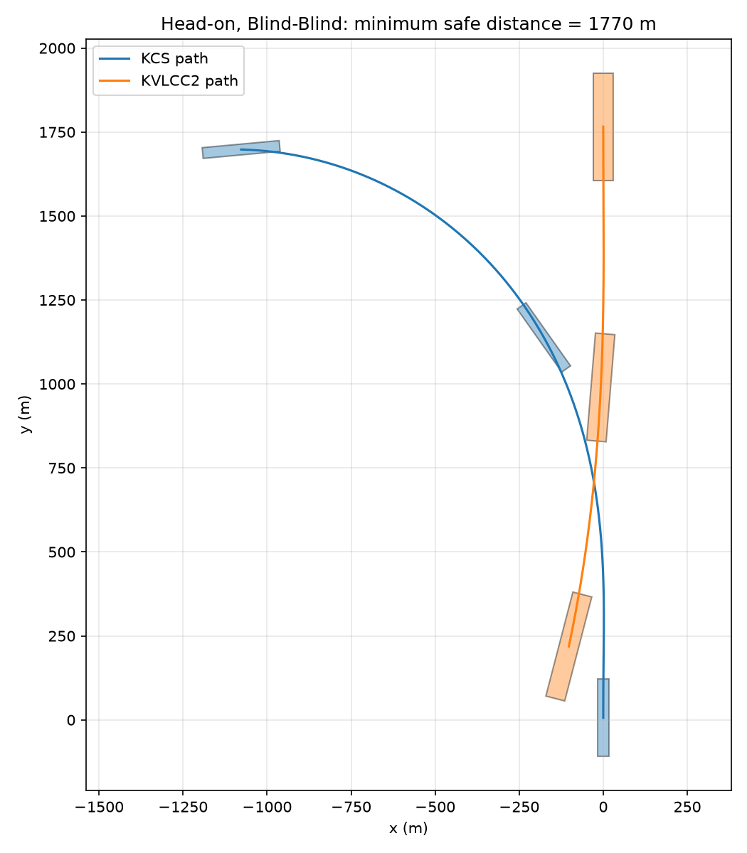
Figure 3. Head-on, Blind-Blind.
Full per-timestep data tables (Excel) and MP4 animations for both scenarios are provided as separate files alongside this report.

4. Task 3 — Minimum Critical Distance for Give-Way Start
Hashimoto & Okushima (1990) model each ship as a circle whose diameter equals its breadth (not its full hull), giving a collision diameter D_ij=(B_i+B_j)/2, and derive the head-on critical distance of give-way start geometrically as:
m^h_ij = D_ij / sin(θ)
Method | Distance
Hashimoto & Okushima, θ=20° | 131.9 m
Hashimoto & Okushima, θ=30° | 90.2 m
Task 2 simulation, COLREG-COLREG | 1712.5 m
Task 2 simulation, Blind-Blind (reference only) | 1770.0 m
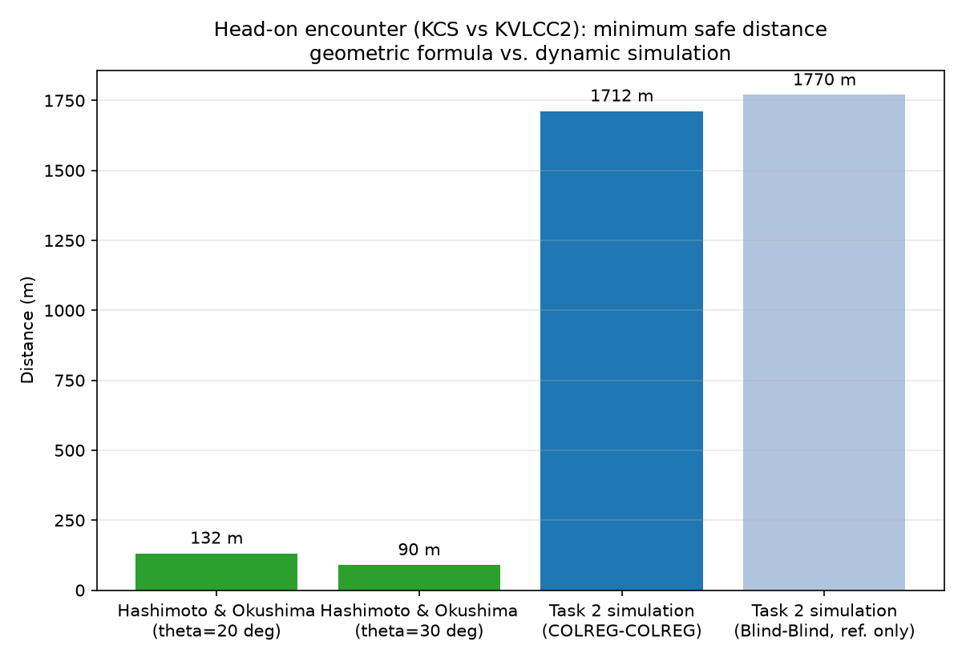
Figure 4. Geometric (Hashimoto & Okushima) vs. simulated (Task 2) minimum safe distance.
The Task 2 simulated value is approximately 13.0x larger than Hashimoto & Okushima's geometric criterion at θ=20°. This gap comes from two compounding simplifications in the geometric model: it uses breadth-only circles (ignoring the 230-320 m ship lengths entirely), and it assumes an instantaneous course change rather than a real, gradual Nomoto turn with a rudder ramp and time-constant lag. Both push the geometric answer below the dynamically simulated one; the simulated value should be considered the more trustworthy figure for actual navigational safety, while Hashimoto & Okushima's is better suited to its original purpose of aggregate channel-wide risk scoring.

5. Task 4 — Minimum Safe Distance Assessment (Monte Carlo)

5.1 Methodology
Task 4 repeats the Task 2 search N=10000 times per scenario, drawing new random rudder angles and approach speeds each time. COLREG-COLREG draws δ1, δ2 independently from Tri(1°,15°,35°) (rounded to whole degrees, both to starboard — note this mode, 15°, differs from Task 2's illustrative 20°, since the assignment's own Task 4 instructions specify 15°). Blind-Blind draws both from U(-35°,35°). Each vessel's approach speed is drawn from U(V0-2, V0+2) kn independently. T, V_ST/V0 and β_ST are held at each vessel's fixed value from Section 2.1.1 — only rudder angle and speed vary between runs, per the assignment.
P(collision) at a candidate separation i is the fraction of the N sampled minimum-safe-distances exceeding i (Lotovskyi & Teixeira, 2023, Eq. 1):
P(collision | separation = i) = count(d_min > i) / N
The search was vectorised across all N trials at once with numpy (same algorithm as Task 2, batched) for tractable runtime. A trial is safe when the hulls never overlap (SAT) and either the separation grows past its starting value D, or, if the simulation time limit is reached first, the two steady turning circles (radius V/r, each widened by its hull half-diagonal) can never touch. The second condition matters when both vessels turn toward the same side and keep circling without ever opening past D: with the rudder held, such a pair can never collide, so counting it as a failure would inflate D_min. Blind-Blind draws that are still unresolved at the search cap of 11200 m (6.05 nm) are censored. These are typically small rudder angles on the same side, where the vessels drift along together and still collide from that distance. They are a property of uncoordinated navigation under this open-loop model, and the censored trials are reported at the cap value, so the Blind-Blind mean and maximum are lower bounds.

5.2 Results
Scenario | N | Censored | Min (nm) | Max (nm) | Mean (nm) | Median (nm)
COLREG-COLREG | 10000 | 0 (0.0%) | 0.86 | 1.83 | 0.98 | 0.96
Blind-Blind | 10000 | 29 (0.3%) | 0.80 | 6.05 | 1.25 | 1.05
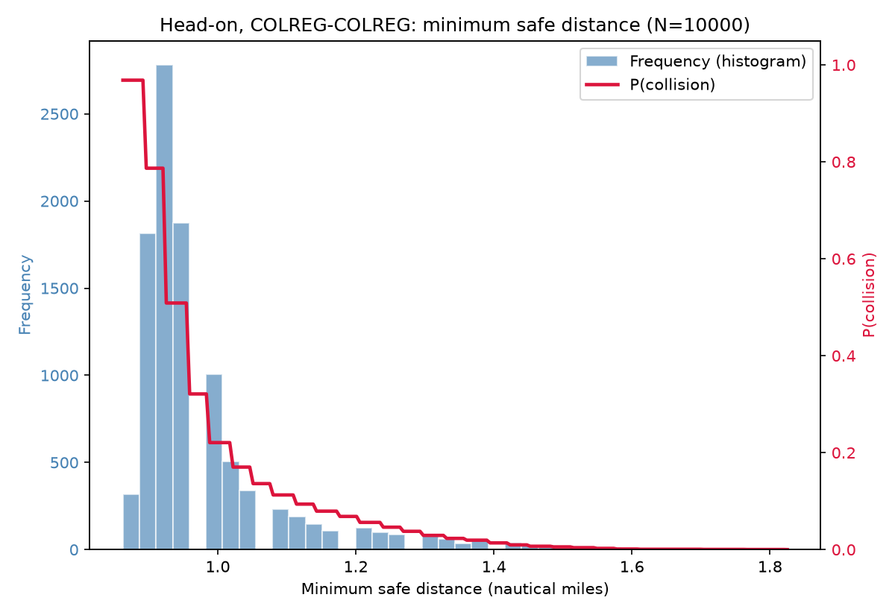
Figure 5. Head-on, COLREG-COLREG: histogram of minimum safe distance and P(collision).
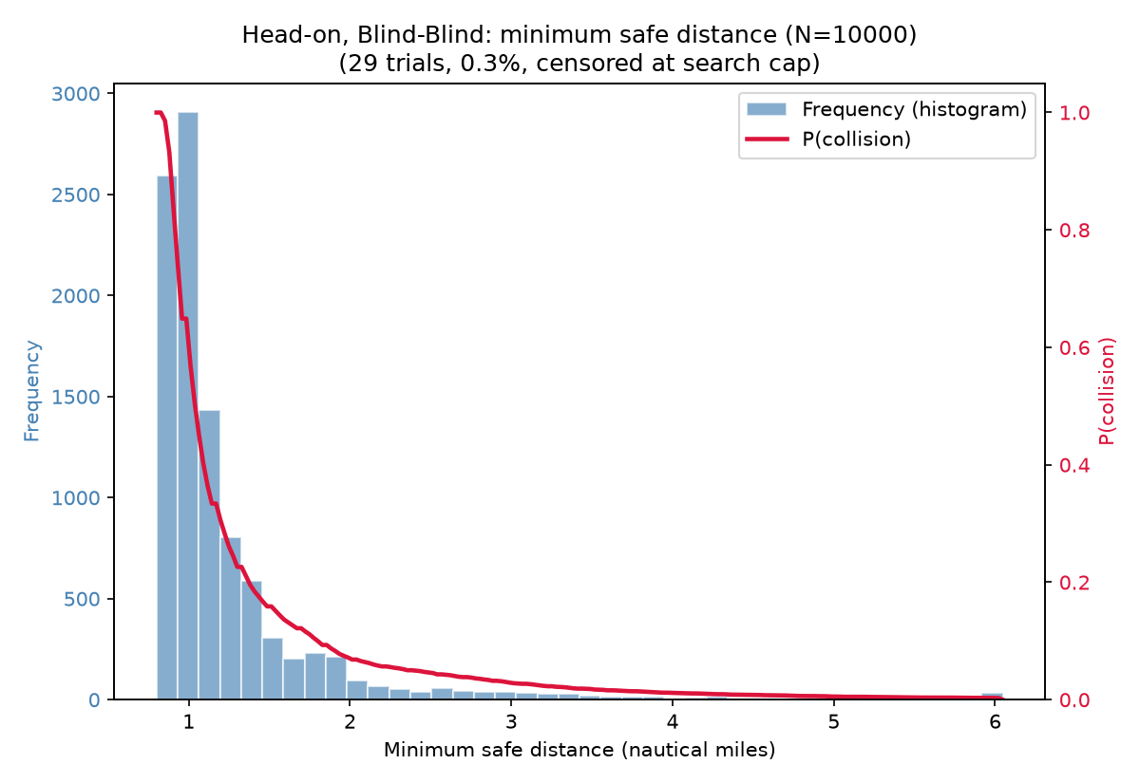
Figure 6. Head-on, Blind-Blind: histogram of minimum safe distance and P(collision). Censored trials, if any, are plotted at the search cap and are not a genuine concentration of results at that distance.

5.3 Discussion
Both distributions are right-skewed with a long tail. Blind-Blind's median (1.05 nm) is higher than COLREG-COLREG's (0.96 nm), its tail is far longer (maximum 6.05 nm against 1.83 nm), and 0.3% of its trials cannot be resolved within the 6.05 nm search cap at all, against 0.0% for COLREG-COLREG. This quantitatively demonstrates that coordinated, rule-following give-way manoeuvres are structurally more effective at creating separation than uncoordinated ones, where random rudder choices can just as easily send both vessels toward the same side or produce no meaningful turn at all.
Raw per-trial samples (rudder angles, speeds, resulting minimum safe distance, censored flag) for both scenarios are provided as separate CSV files alongside this report for further analysis.

6. Summary of Key Assumptions and Open Items
- T is now vessel-specific (see Section 2.1.1) via a length/speed scaling law, since the actual Silveira et al. (2016) length/type table is unavailable. Replace with the real table if it becomes accessible.
- The MMG-vs-Nomoto-only decision for solo submissions should be confirmed in writing with course staff.
- Task 2's search starts the give-way rudder at t=0 for each trial separation (correct for finding the minimum safe distance itself); a separate 'cruise then trigger at minimum safe distance' demonstration has not been built.
- Task 4's Blind-Blind censoring cap and its effect on the reported tail statistics (Section 5.2) should be revisited if a tighter bound becomes necessary.

References
Cockcroft, A. N., & Lameijer, J. N. F. (2012). A guide to the collision avoidance rules: International regulations for preventing collisions at sea. Elsevier.
Hashimoto, A., & Okushima, T. (1990). Evaluating marine traffic safety at channels. Accident Analysis & Prevention, 22(5), 421-442.
Lotovskyi, E., & Teixeira, A. P. (2023). Effect of timely manoeuvre execution on the collision probability in head-on and crossing encounter scenarios. In H. Le Sourne & C. Guedes Soares (Eds.), Advances in the Collision and Grounding of Ships and Offshore Structures (pp. 113-120). CRC Press.
Silveira, P., Teixeira, A. P., & Guedes Soares, C. (2016). Probabilistic modelling of evasive manoeuvring actions to avoid collisions. In Maritime Technology and Engineering III (MARTECH 2016). Taylor & Francis.
SNAME. (1989). Principles of Naval Architecture. Motions in Waves and Controllability: Vol. III (E. V. Lewis, Ed., 2nd ed.). SNAME.

