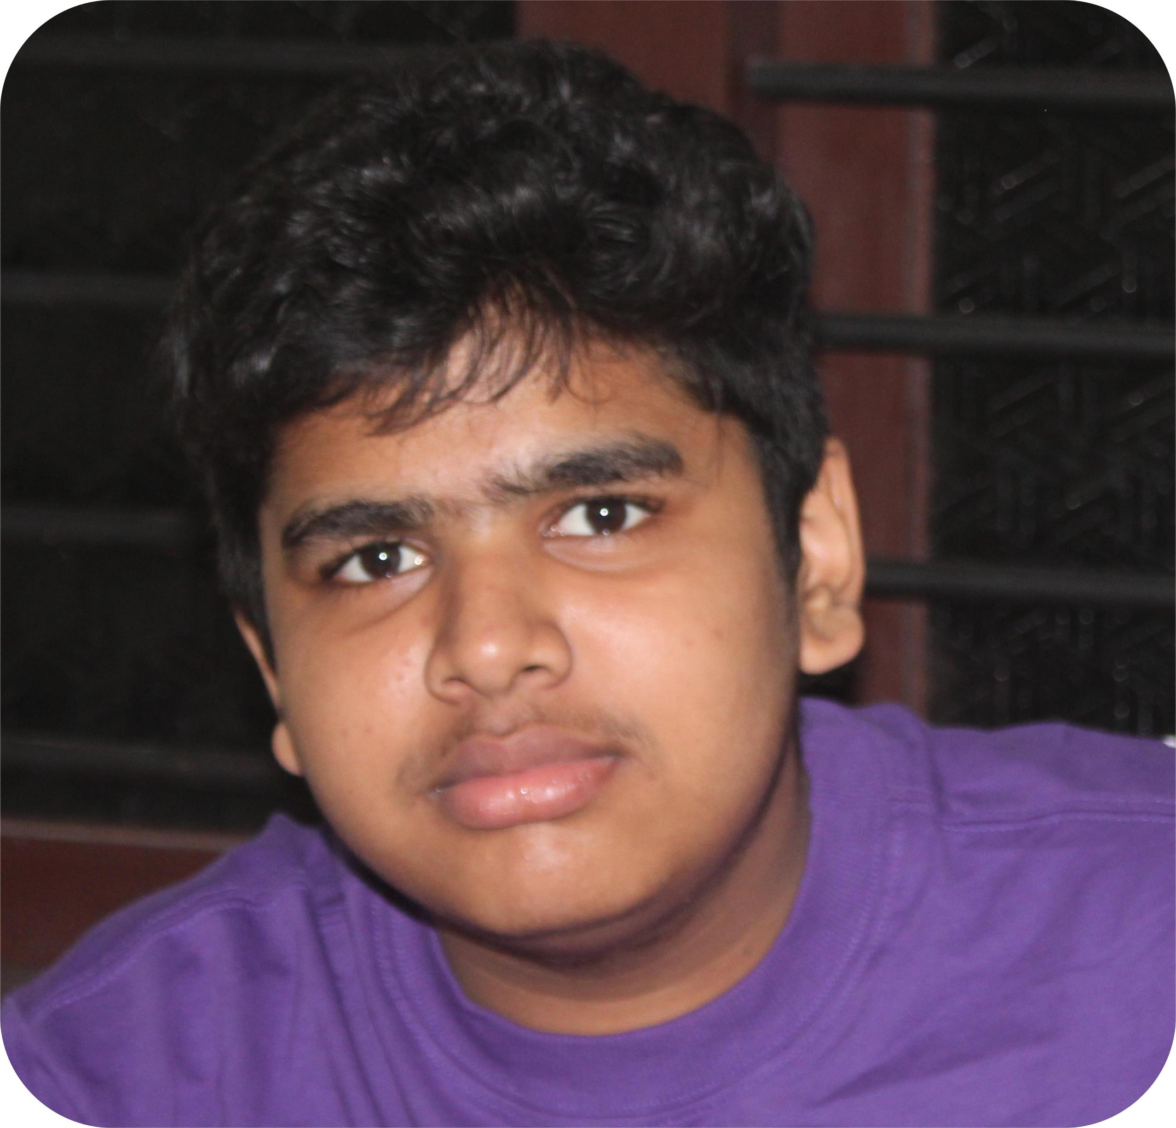 |  | KRISHNA  BHADRN.K  STUDENT
Profile  Passionate and enthusiastic student with a strong interest in robotics, programming, and web development. Skilled in working with Arduino and ESP32 boards, as well as coding in C and C++. Looking for opportunities to enhance my technical knowledge and work on innovative projects.  Contact  PHONE:  9745458678  WEBSITE:  Website goes here  EMAIL:  Krishnabhadrank@gmail.com  Hobbies  Coding  Robotics  Learning new things  Web development |  | EDUCATION  SREE SASTHA  2016 - 2023  IHRD VATTAKULAM  2023 - NOW  WORK EXPERIENCE  Arduino-Based Automation Projects: Created small projects using Arduino for automation tasks.  ESP32 IoT Projects: Explored IoT applications with ESP32.  Basic Web Development: Developed simple websites using HTML, CSS, and JavaScript.  SKILLS  Coding  Robotics  Learning new things  Web development

