A CEP Project on Plant Identification, Data Collection, Classification, and QR-Code Tagging at Vijay Nursery, Andheri (East)

Krishna Nandkumar Chaudhary S074

S.Y. B. Sc. Computer Science Semester IV

Under the Guidance of Mr. Rohit Kumar Sahu

SHETH L.U.J. AND SIR M.V. COLLEGE
Academic Year – 2025-26

GUIDE INTERACTION DIARY

Sr.  No. | Date | Discussion Points / Agenda | Key Feedback / Suggestions from Guide | Signature of Guide
1 | 13-01-2026 | Meeting 1 – Project Kickoff & Group Allocation | Successful kickoff and clear group roles
2 | 21-01-2026 | Meeting 2 – Data Collection Strategy & Technical Framework | Well-planned data collection and framework
3 | 04-02-2026 | Meeting 3 – Midway Progress Review | Steady progress and timely milestone completion
4 | 11-02-2026 | Meeting 4 – Implementation | Implementation executed effectively and accurately
5 | 18-02-2026 | Meeting 5 – Final Review & Submission Preparation | Final review completed; submission ready

GUIDE INTERACTION DIARY FORM

I, the undersigned Ms. /Mr. Krishna Nandkumar Chaudhary
Roll No. S074, currently enrolled in the Second Year of B.Sc. Computer Science Full-time
Program Semester IV at Sheth L.U.J. and Sir M.V. College, am undertaking my Community Engagement Project work under the
guidance of Mr. Rohit Kumar Sahu, and I hereby confirm that I have
met my Internal guide on the following dates mentioned below for Project Guidance: -

Sr. No. | Date | Signature of the Internal Guide

I, Mr. Krishna Nandkumar Chaudhary Institute Sheth L.U.J. and Sir M.V. college studying Student of in Second Year Computer Science hereby declare that I have completed the Community Engagement Project titled A Community Engagement Project on Plant Identification, Data Collection, Classification, and QR-Code Tagging at Vijay Nursery, Andheri (East), Mumbai during the academic year 2025-2026.

The report is original and the information/data included in the report is true emerging from the primary and/ secondary data gathered and analyzed as part of this Community Engagement project.

Due credit is extended on the work of Literature/Secondary Survey by endorsing it in the
Bibliography as per prescribed format.

Krishna Nandkumar Chaudhary

I would like to express my sincere gratitude to my respected guide, Mr. Rohit Kumar Sahu, for his valuable guidance, continuous support, and constructive feedback throughout the completion of this Community Engagement Project. His mentorship helped in planning the project systematically and ensuring proper execution of fieldwork and documentation.

I am deeply thankful to Mr. Satyam Gupta, Owner of Vijay Nursery, Gupta Compound, Mahakali Caves Road, Andheri (East), Mumbai – 400093, for granting formal permission to conduct the field study within the nursery premises. His cooperation made the data collection and community interaction process smooth and informative.

A special note of appreciation goes to my group members, who worked collaboratively in
collecting plant data, taking photographs, analyzing details, and compiling all information into a
systematic format. Their teamwork and dedication ensured the successful completion of this project.

I also extend my appreciation to the nursery staff for sharing valuable insights about plant care, classification, and horticultural practices.

Finally, I acknowledge the contribution of various online biodiversity portals and reference materials that supported the scientific validation of plant data.

This Community Engagement Project was conducted at Vijay Nursery, Andheri (East), Mumbai, to document plant diversity and promote environmental awareness using digital tools. The project involved plant identification, photography, data collection, classification, and QR-code generation.

Community interaction with the nursery owner and staff provided practical knowledge about plant care and categorization. Plants were grouped into ornamental, indoor, medicinal, and landscaping types. Each plant was linked to digital information through a QR code, allowing easy access via smartphones.

The project connected classroom learning with real-world application and strengthened research skills, teamwork, and environmental awareness. It demonstrates how digital technology can support sustainable knowledge sharing in community-based environmental settings.

INDEX

Sr. No | Title | Page No. | Sign
1 | Introduction | 1-2
1.1 | Purpose of the Community Engagement | 1
1.2 | Background Information | 1
1.3 | Scope of the Report | 2
2 | Literature Review | 3
3 | Methodology | 4
3.1 | Approach and Data Collection Methods | 4
3.2 | Tools and Techniques Used | 4
3.3 | Rationale for Selected Methods | 4
4 | Description of Community Interactions, Observations and Analysis | 5
5 | Conclusion & Recommendations | 6
6 | References | 7
7 | Appendices | 8-13
8 | Student Feedback on CEP | 14-16

- Introduction

Purpose of the Visit

The purpose of this Community Engagement Project was to document plant diversity at Vijay Nursery, Andheri (East), Mumbai, and to promote environmental awareness through digital technology. The project aimed to connect classroom knowledge of Computer Science with real-world community interaction by applying techniques such as data collection, classification, validation, and QR-code tagging.

Through this engagement, we aimed to understand the role of urban nurseries in environmental sustainability and systematically document plant species. The project also focused on developing a QR-code based digital information system to make plant details easily accessible. It provided a practical opportunity to apply theoretical concepts like structured data organization and digital documentation in a real-world setting.

Background Information

Vijay Nursery, located at Gupta Compound, Mahakali Caves Road, Andheri (East), Mumbai – 400093, is a commercial plant nursery that supplies ornamental, indoor, medicinal, and landscaping plants. Urban nurseries play a significant role in promoting eco-awareness, home gardening culture, and biodiversity conservation in metropolitan cities.

Under the NEP 2020 framework, Community Engagement Projects are designed to sensitize students towards socio-environmental issues and encourage practical problem-solving

This project is significant because it demonstrates how digital tools can support environmental education and community awareness in a commercial urban setting.

Scope of the Report

This report covers:

- Plant identification and classification at Vijay Nursery.
- Community interaction with the nursery owner and staff.
- Data collection, cleaning, and validation methods.
- QR-code generation and digital linking process.
- Observations and analytical findings.
- Recommendations for expanding digital awareness initiatives.

The scope is limited to plant species observed during the visit and does not include a complete commercial inventory of the nursery.

Literature Review

Urban biodiversity documentation has been widely recognized as essential for environmental awareness and ecological balance. Studies suggest that structured plant documentation improves public understanding of local flora and promotes sustainable practices.

Traditional plant documentation methods include manual labeling and herbarium records. However, these methods have limitations in accessibility and information depth.

With advancements in digital technology, QR-code systems have been increasingly used in educational and botanical contexts to enhance interactive learning. Research indicates that digital tagging improves user engagement and knowledge retention.

The integration of digital systems in environmental documentation aligns with the objectives of Community Engagement Projects under NEP 2020

This project applies these concepts within a commercial nursery environment, demonstrating practical implementation at a local level.

Methodology

The methodology of our project combined traditional field study techniques with digital tools to achieve accurate plant documentation and effective awareness generation through QR codes.

Approach Used

The methodology combined observational techniques, community interaction, digital validation, and structured documentation.

Methods Used:

- Direct observation of plant species.
- Photography documentation.
- Interaction with nursery owner and staff.
- Use of digital identification tools (Google Lens, biodiversity portals).
- QR-code generation and linking to website platform.

Rationale Behind the Methods

- Observational methods were chosen to ensure accurate recording of plant morphology and characteristics.
- Community interaction provided contextual knowledge regarding plant sourcing, maintenance, and demand patterns.
- Digital validation ensured scientific accuracy.
- QR-code integration was selected to demonstrate practical application of Computer Science concepts and improve accessibility of plant information.

Description of CEP, Observations and Analysis

Site Description

Vijay Nursery, located at Gupta Compound, Mahakali Caves Road, Andheri (East), Mumbai, is a well-organized commercial plant nursery containing a wide variety of indoor, ornamental, and landscaping plants. The nursery is arranged systematically with different plant sections categorized based on usage and plant type. It is regularly visited by gardeners and plant enthusiasts, making it suitable for promoting digital plant awareness.

Field Work Activities

- Plant photographs were taken systematically.
- Names were cross-checked with plant guides.
- Observations were recorded in tabular form.
- QR codes were generated linking to short write-ups.

Observations

I identified more than 10 plant species, some of the major ones being:

● Money Plant (Neon Pothos) – A popular indoor ornamental plant known for its bright neon-green leaves and air-purifying qualities
● Boston Fern – A lush indoor plant with arching fronds, widely used for decorative and air-purifying purposes.
● Chinese Evergreen (Aglaonema) – A hardy indoor plant valued for its patterned foliage and low maintenance requirements.
● Spider Plant (Chlorophytum comosum) – An easy-to-grow indoor plant known for its air-purifying properties and cascading leaves.
● String of Bananas (Senecio radicans) – A trailing succulent plant with banana-shaped leaves, commonly used in hanging baskets.
● Monstera (Swiss Cheese Plant) – A tropical indoor plant recognized for its large, split leaves and aesthetic appeal.
● Bird of Paradise (White) – A striking ornamental plant with large banana-like leaves, commonly used in landscaping.
● Norfolk Island Pine – A decorative evergreen plant often used as an indoor Christmas tree alternative.
● Snake Plant (Sansevieria) – A hardy indoor plant known for its upright leaves and strong air-purifying ability.
● Bird’s Nest Fern – A tropical fern with broad, wavy fronds growing in a rosette pattern, ideal for shaded indoor environments.

Conclusion & Recommendations

Conclusion

The Community Engagement Project conducted at Vijay Nursery highlighted the diversity of indoor, ornamental, and landscaping plants and demonstrated that QR-code integration is an effective tool for spreading environmental awareness. By combining systematic plant documentation with digital technology, the project enhanced our practical understanding of plant classification and improved the accessibility of plant information for visitors.

Key Findings

● The nursery maintains a diverse collection of ornamental and indoor plants.
● Digital QR codes enhance interactive learning and information access.
● Structured data documentation ensures better organization and accuracy.
● Community interaction improves real-world understanding of environmental practices.

Recommendations

● Implement permanent QR-code tags for plant information within the nursery.
● Develop a digital plant inventory system for better record management.
● Conduct awareness sessions for customers on plant care and sustainability.
● Expand similar digital documentation projects to other nurseries and urban green spaces.

References

- Diazgranados, M. & Funk, V.A. (2013). Utility of QR codes in biological collections. PhytoKeys.
- Sharma, A. (2020). QR Codes and Digital Awareness Campaigns. Journal of Environmental Education.
- India Biodiversity Portal – www.indiabiodiversity.org
- Flowers of India – www.flowersofindia.net

Appendices

Plant Image | Description
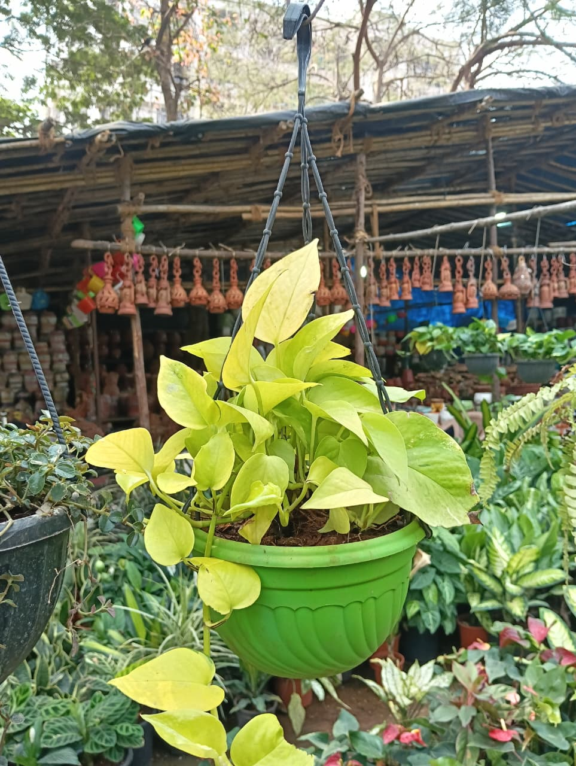  7.1 Money Plant (Neon Pothos) | Money Plant (Neon Pothos) –  Neon Pothos is a popular indoor ornamental plant known for its bright, neon-green heart-shaped leaves. It thrives in indirect light and requires minimal maintenance, making it ideal for homes and offices. Apart from its decorative appeal, it is valued for its air-purifying properties and ability to adapt to various indoor conditions.
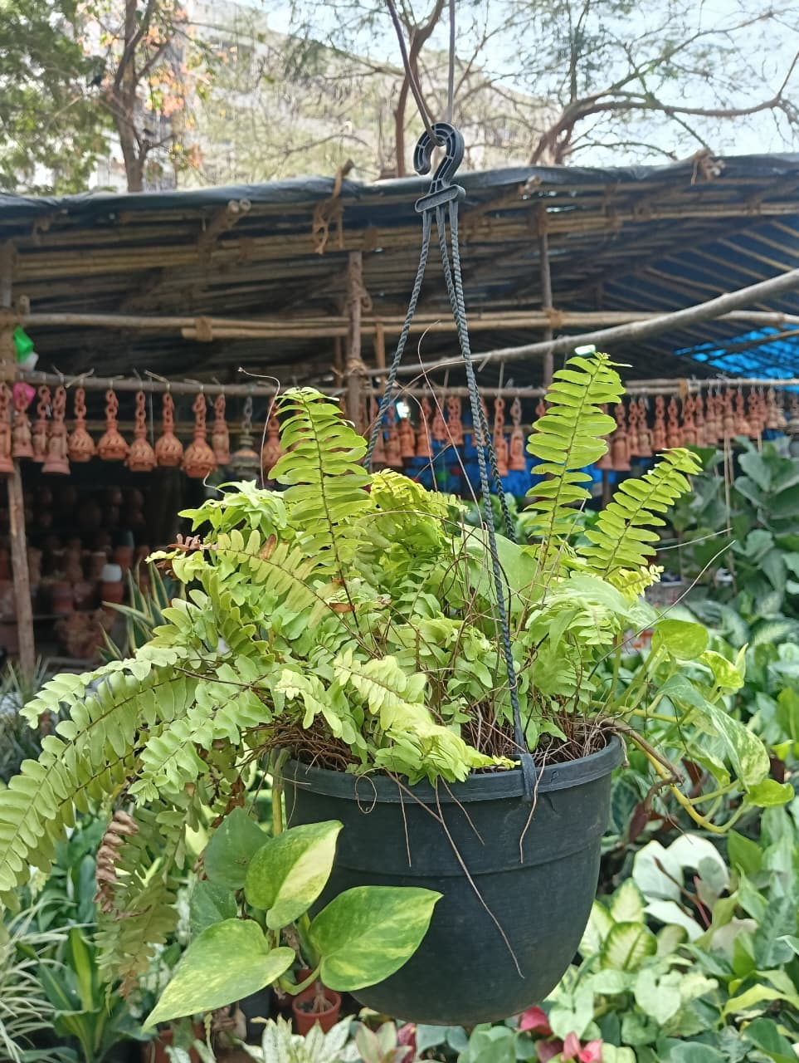  7.2 Boston Fern | Boston Fern –  Boston Fern is a lush, feathery indoor plant admired for its arching fronds and vibrant green foliage. It prefers humid environments and indirect sunlight. The plant is widely appreciated for its ability to improve indoor air quality and add a refreshing aesthetic touch to interior spaces.

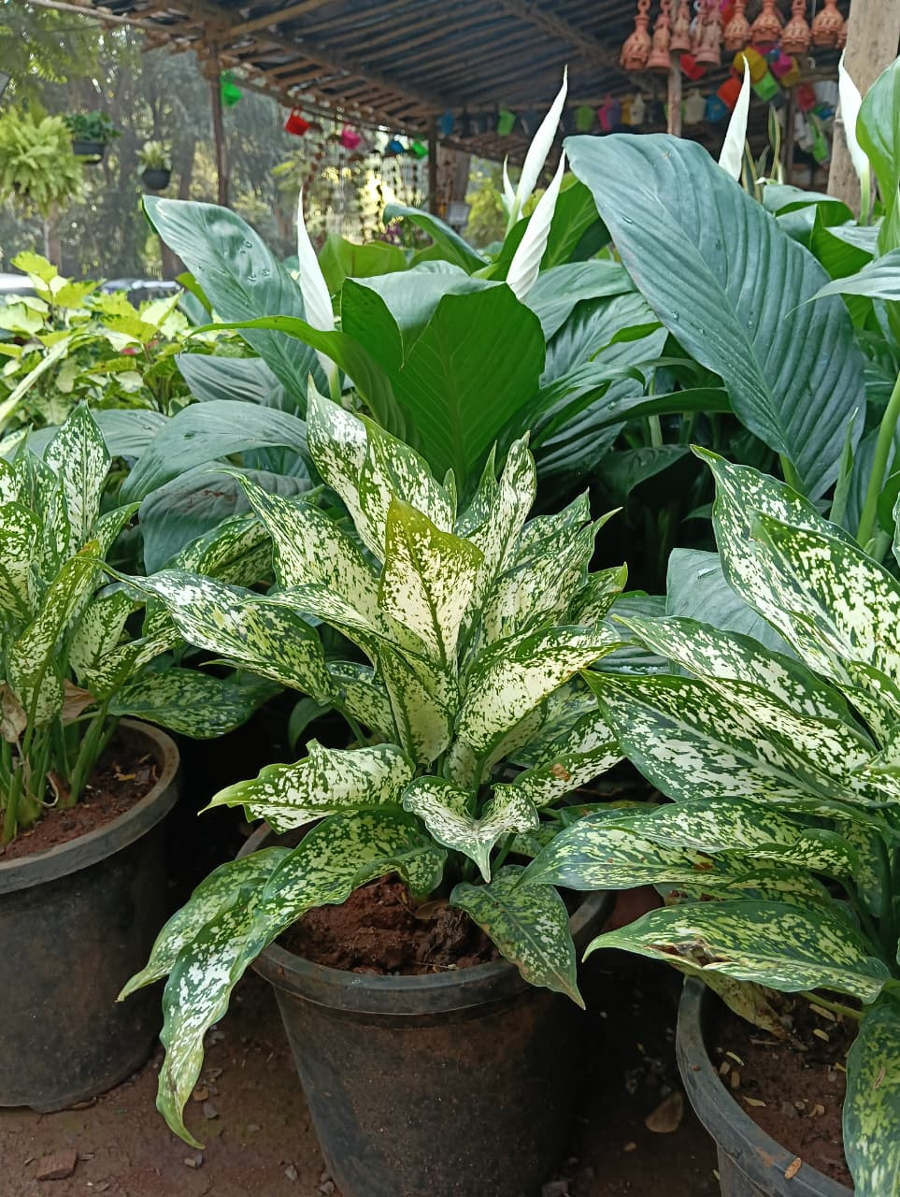  7.3 Chinese Evergreen (Aglaonema) | Chinese Evergreen (Aglaonema) –  Chinese Evergreen is a hardy indoor plant known for its attractive variegated leaves in shades of green and silver. It is highly tolerant of low light and requires minimal care. This plant is popular for indoor decoration and is also recognized for its air-purifying qualities.
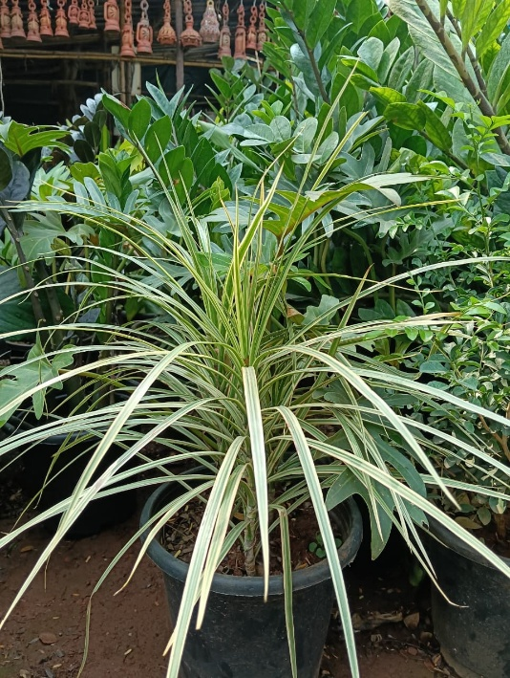  7.4 Spider Plant | Spider Plant –  Spider Plant is an easy-to-grow indoor plant characterized by its long, narrow leaves and cascading growth pattern. It produces small plantlets and adapts well to indoor environments. It is widely valued for its ability to remove indoor pollutants and improve air quality.

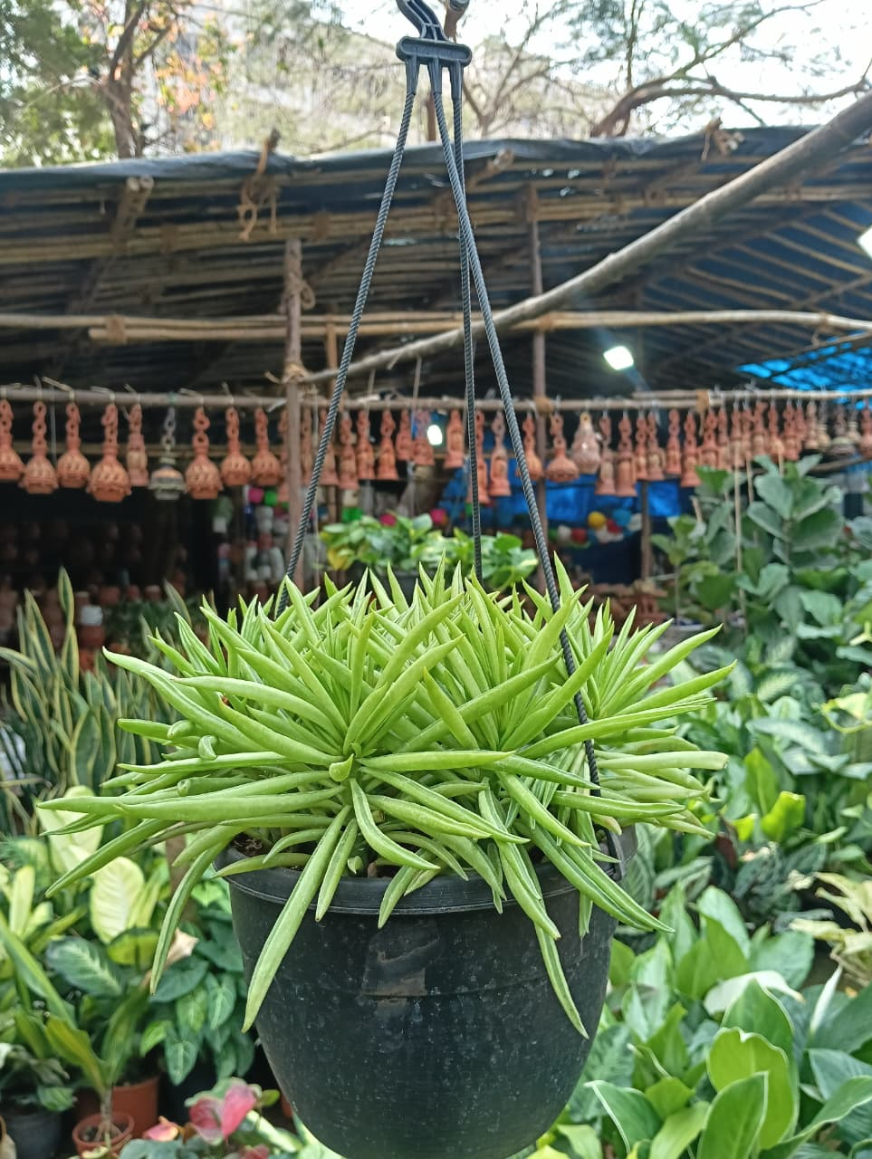  7.5 String of Bananas | String of Bananas –  String of Bananas is a trailing succulent plant with unique banana-shaped leaves. It grows well in hanging baskets and requires bright, indirect sunlight. This low-maintenance plant adds visual interest and is commonly used for decorative indoor and balcony arrangements.
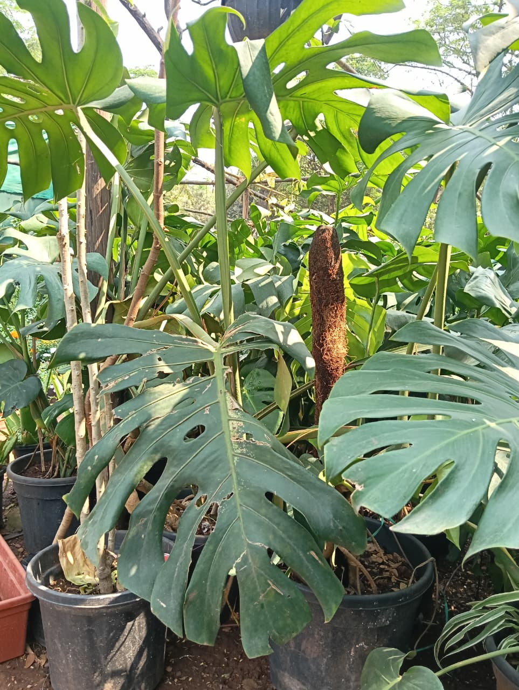  7.6 Monstera | Monstera (Swiss Cheese Plant) –  Monstera is a tropical ornamental plant known for its large, glossy leaves with natural splits and holes. It thrives in moderate light and humid conditions. Its bold foliage makes it a popular choice for interior decoration and modern landscaping designs.

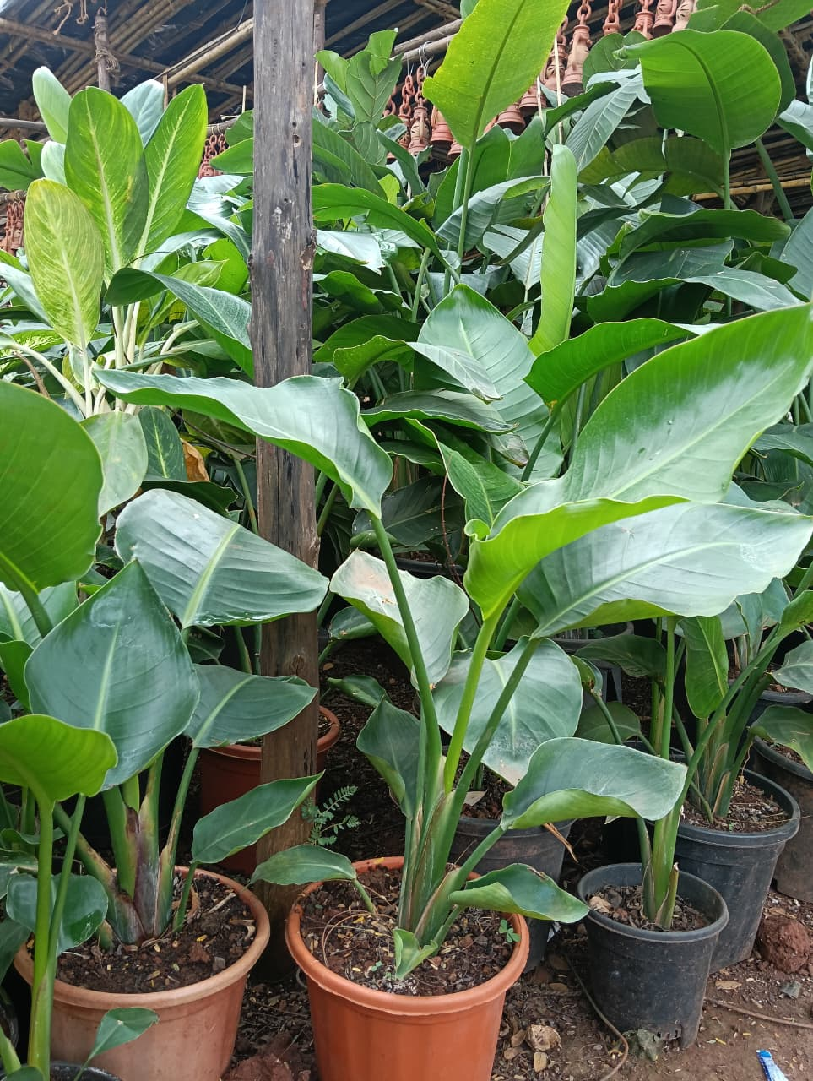  7.7 Bird of Paradise (White) | Bird of Paradise (White) –  White Bird of Paradise is a striking ornamental plant with large, banana-like leaves. It is commonly used in landscaping and spacious indoor areas. The plant symbolizes tropical beauty and thrives in bright light with proper watering.
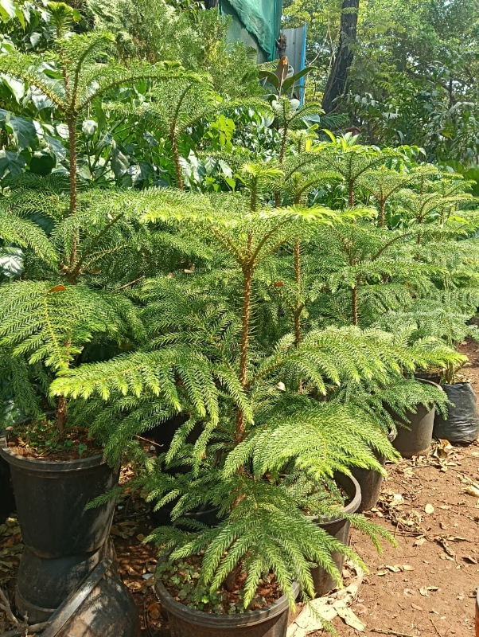  7.8 Norfolk Island Pine | Norfolk Island Pine –  Norfolk Island Pine is an evergreen conifer often grown as an indoor decorative tree. It has symmetrical branches and soft needle-like leaves. This plant is commonly used as a natural Christmas tree alternative and prefers bright, indirect sunlight.

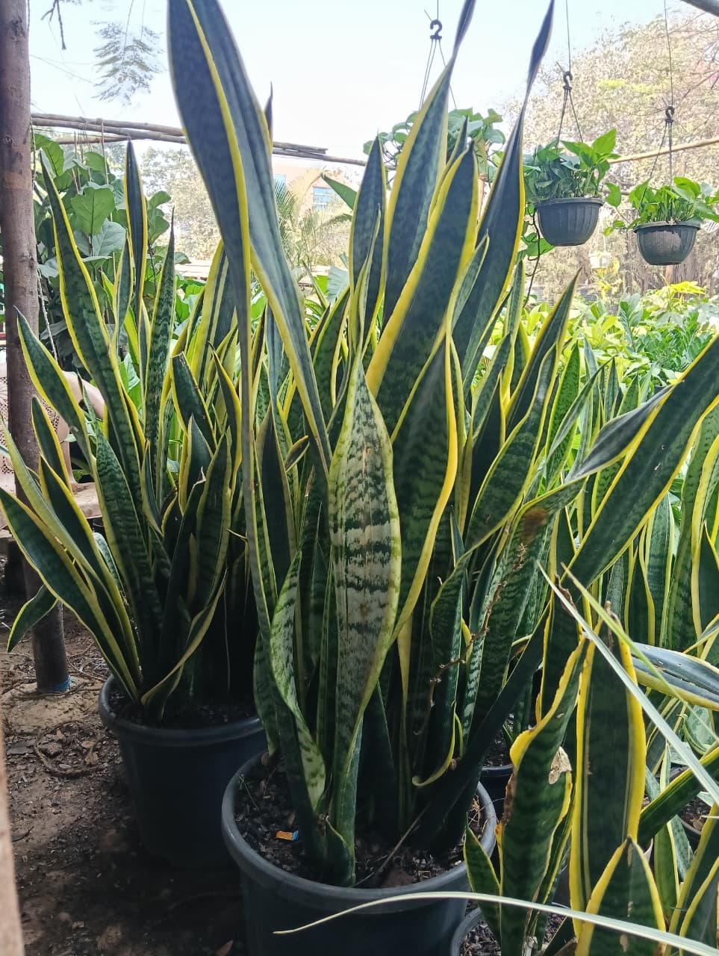  7.9 Snake Plant | Snake Plant –  Snake Plant is a hardy indoor plant with upright, sword-shaped leaves. It is highly tolerant of low light and irregular watering. Known for its strong air-purifying properties, it is one of the most popular indoor plants for improving air quality.
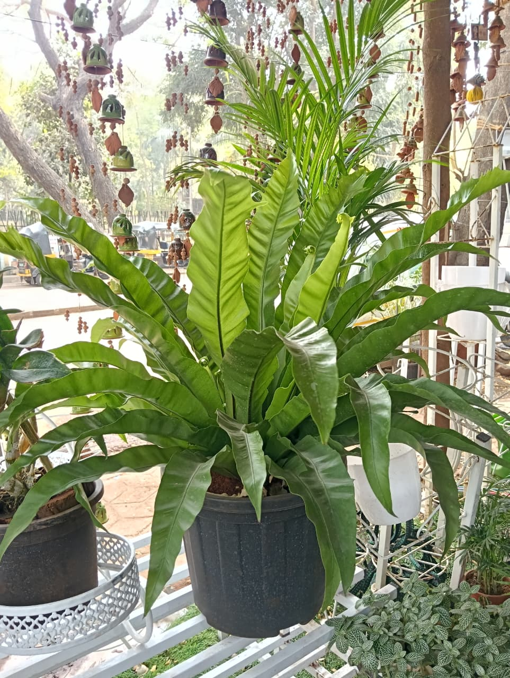  7.10 Bird’s Nest Fern | Bird’s Nest Fern –  Bird’s Nest Fern is a tropical plant with broad, wavy fronds arranged in a rosette pattern resembling a bird’s nest. It thrives in shaded, humid conditions and is widely used as an indoor ornamental plant. Its lush foliage enhances aesthetic appeal while contributing to a healthier indoor environment.

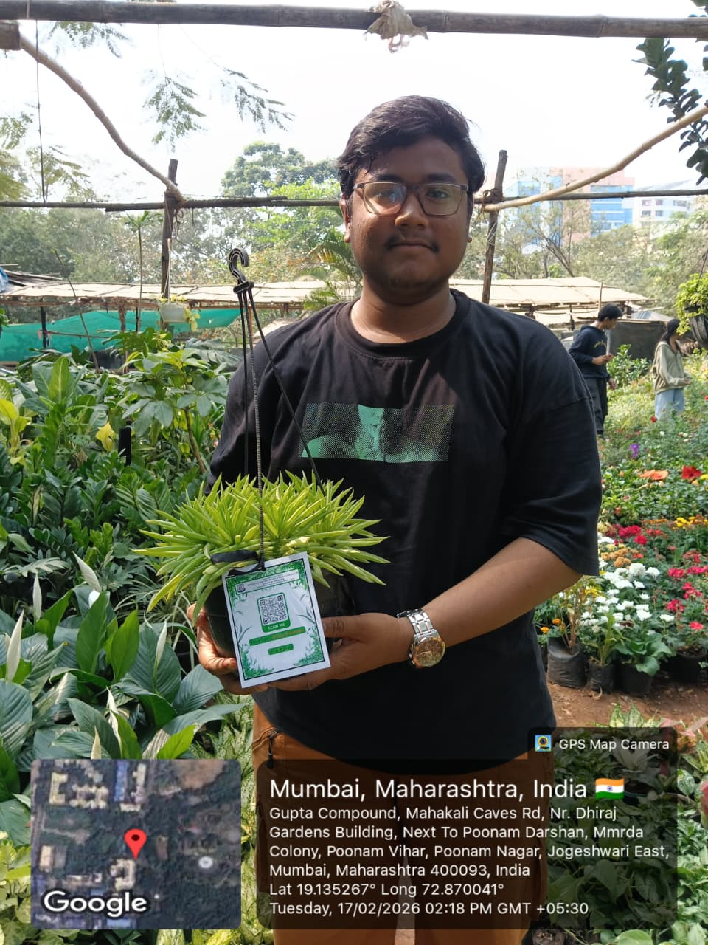  7.11 QR Photo | 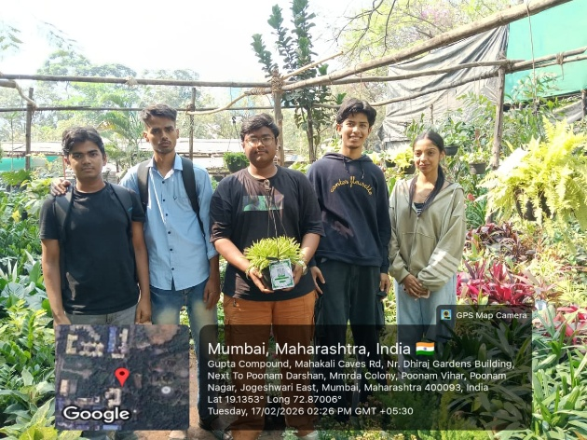  7.12 Group Photo
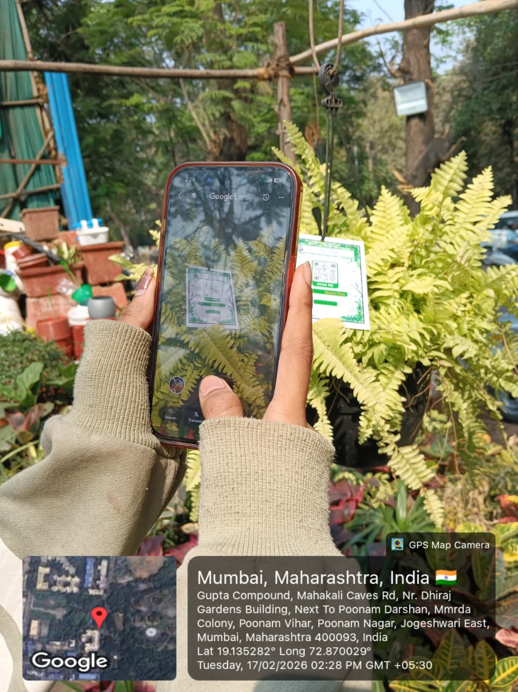  7.13 Person Scanning QR Code | 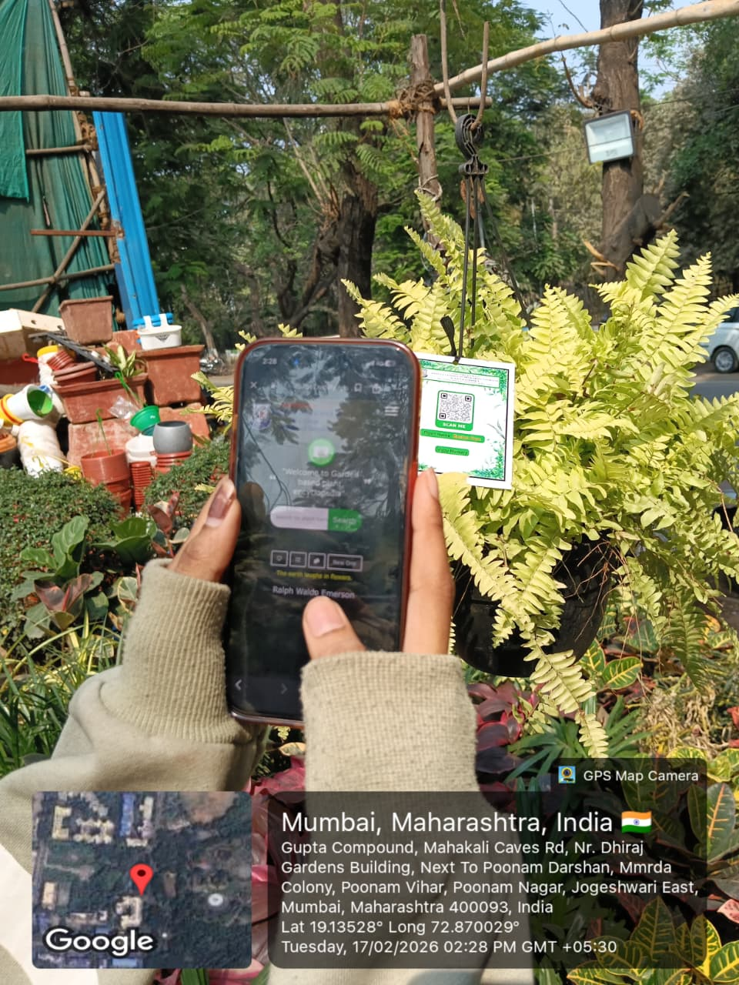  7.14 Website

- Student Feedback on FP

Student Name: Krishna Nandkumar Chaudhary Roll No.: S074
Email: chaudharykrishnacs242513@gmail.com Department: Computer Science
Name of the Mentor: Mr. Rohit Kumar Sahu
Title/Heading of Community Engagement Project: A Community Engagement Project on Plant Identification, Data Collection, Classification, and QR-Code Tagging at Vijay Nursery, Andheri (East), Mumbai

Brief Description of CEP Carried Out:

- The CEP involved documentation of plant species at Vijay Nursery through field observation, photography, data collection, and classification. The collected data was cleaned and validated using digital tools, and QR codes were generated linking to a website developed by the team. The project integrated computer science concepts such as structured data organization and digital documentation with real-world environmental engagement.

Dates of CEP:
- Fieldwork and reviews aligned with guide interactions: 13-01-2026 (Kickoff), 21-01-2026 (Data Strategy), 04-02-2026 (Midway Review), 11-02-2026 (Implementation), 18-02-2026 (Final Review & Submission)

My internship experience was related to my major area of study/ academic program?
- Agree

Indicate the degree to which you agree or disagree with the following statements:

This experience has: | Strongly Agree | Agree | No opinion | Disagree | Strongly Disagree
Has increased my sensitivity towards societal problems | ✔️
Given me the opportunity to explore a career field | ✔️
Allowed me to apply classroom theory to practice | ✔️
Helped me develop my decision- making and problem-solving skills |  | ✔️
Expanded my knowledge about the work world before permanent employment |  | ✔️
Helped me develop my written and oral communication skills |  | ✔️
Provided a chance to use leadership skills (influence others, develop ideas with others, stimulate decision- making and action) |  | ✔️
Expanded my sensitivity to the ethical implications of the work  involved |  | ✔️
Made it possible for me to be more confident in new situations |  | ✔️
Given me a chance to improve my interpersonal skills |  | ✔️
Helped me learn to handle responsibility and use my time wisely | ✔️
Helped me discover new aspects of myself  that I didn’t know existed before | ✔️
Helped me develop new interests and abilities | ✔️
Helped me clarify my career goals |  | ✔️
Allowed me to acquire information and/ or use equipment not available at my Institute |  | ✔️
Allowed me to realize socio- economic issues in the society |  | ✔️

The faculty mentor extended guidance and mentoring through-out the CEP process:
- Strongly Agree.

Were you able to accomplish the initial goals, tasks and new skills that were set down in CEP plan?
- Strongly Agree

Considering your overall experience, how would you rate this CEP? (Circle one):

- Poor/ Satisfactory/ Good/ Excellent.

Give suggestions as to how your CEP experience could have been improved.
(✓ = satisfactory, ✗ = needs improvement)
- Aspect of CEP Experience
✓ Clear orientation and briefing at the start
✓ Relevance of project to academic learning
✓ Availability and support from internal guide
✓ Adequate field exposure and hands-on engagement
✓ Clarity in roles and responsibilities
✓ Time provided for project completion

Krishna Chaudhary 18/02/2026

