SOP to Fetch and Push Recordings from Ameyo to AWS

Document Title: SOP to Fetch and Push Recordings from Ameyo to AWS
Effective Date: 16th February 2025
Version: 1.0
Department: IT Department
Prepared By: Anaswara C G, PBX Product owner
Approved By: Keerthi Raj P P, CRM Product Owner

1. Purpose
The purpose of this SOP is to ensure the systematic backup, storage, and retrieval of call recordings from Ameyo and Ozonetel. Since the Ameyo portal retains recordings for only 45 days, manual backup is necessary to prevent data loss. By following this SOP, recordings are securely stored in both a local hard disk and AWS (Amazon S3) for long-term access, compliance, and operational needs. Additionally, the SOP provides a structured process for retrieving recordings from AWS when required.

2. Scope
This SOP applies to the process of fetching, storing, and retrieving call recordings from Ameyo and Ozonetel within the organization. It is intended for Admin, IT, and Support teams responsible for managing call recording backups and ensuring data availability for compliance, audit, and operational purposes.
3. Procedure

In the Ameyo portal, call recordings are accessible for only 45 days. Therefore, it is necessary to manually back up these recordings. Follow the steps below to fetch and store them securely.

Step 1: Fetching Call Recordings from Ameyo
- Log in to the Ameyo portal using an Admin or Supervisor account.
- Navigate to Voice Logs → Search.
- Set the date range and time, then choose System Disposition as Connected.
- Click on the Search button at the bottom of the window.
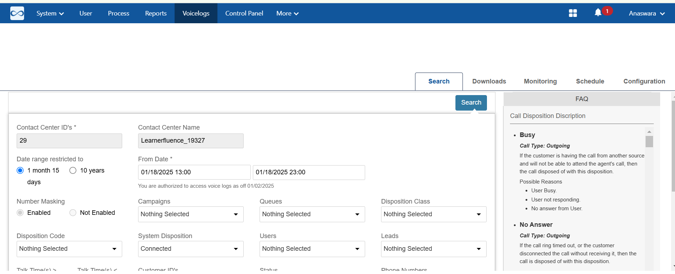
5. Once the results are displayed, click on Download All to initiate the download.
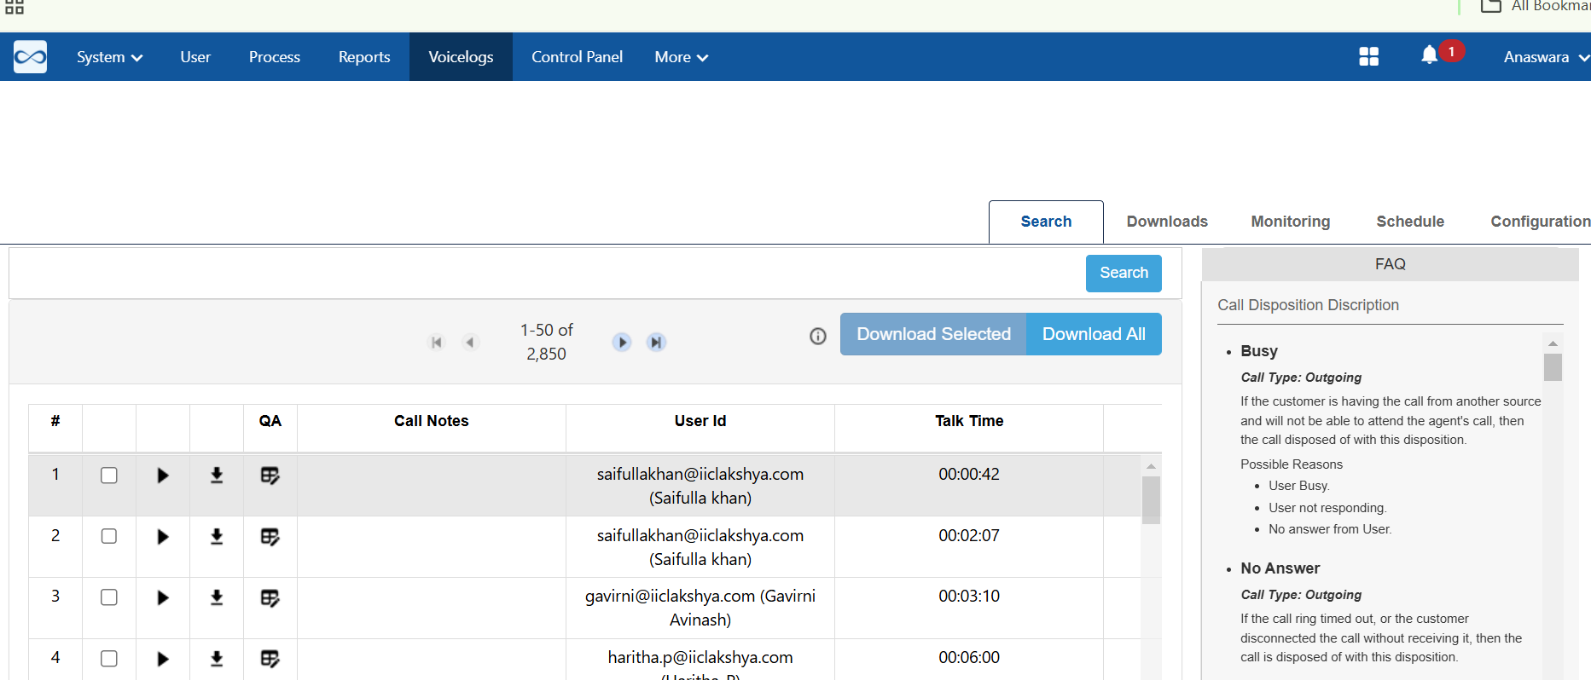
6. Monitor the download status under the Downloads section.
7. Once completed, click on the Download icon to save the file to your system.

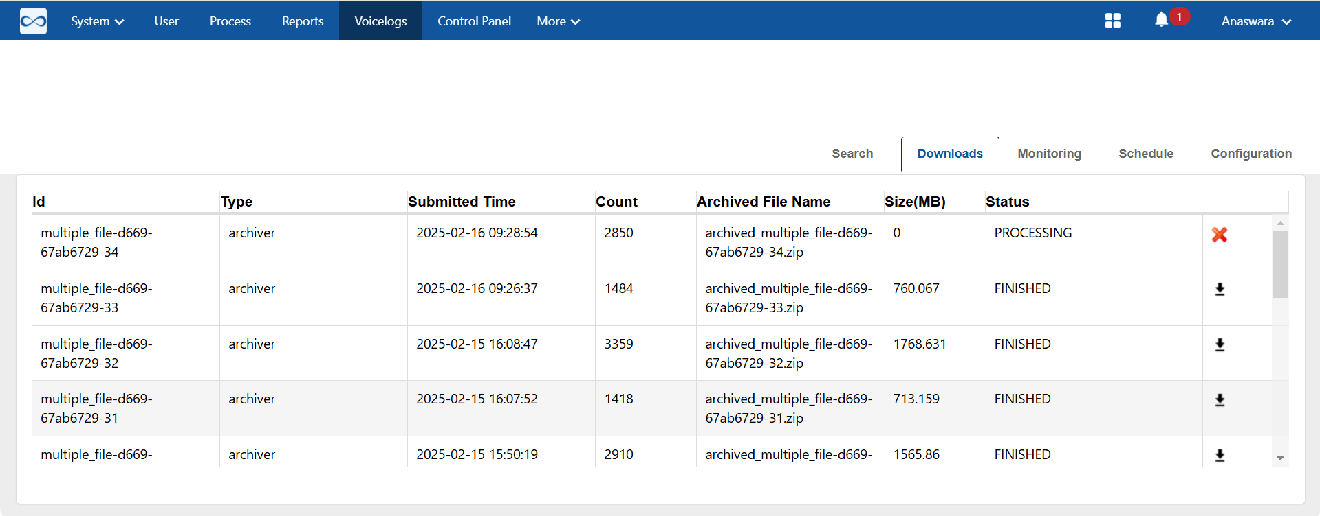

Step 2: Storing Recordings on AWS
- Transfer the downloaded recordings to a secure hard disk for local backup.
- Log in to the AWS account->Amazon S3 bucket
- Navigate to the callrecordingsameyo folder.
- Open the respective year, month, and create a folder with the date.
- Upload the necessary recordings to this folder.
This process ensures secure and organized storage of call recordings for future reference.
Our AWS account stores call recordings from both Ozonetel and Ameyo in separate folders. Follow the steps below to fetch the required recordings.

Retrieving Ozonetel Recordings
- Obtain the call details from Ozonetel reports (backups are available in the shared drive).
- Copy the recording URL from the Ozonetel report.
  - Example URL:
https://s3.ap-southeast-1.amazonaws.com/recordings.kookoo.in/lakshya/TXR7447654c144310f878c7d1b0745bb75e.mp3
  - Extract only the file name: TXR7447654c144310f878c7d1b0745bb75e.mp3.
- Navigate to Amazon S3 bucket → Call Recordings Ozonetel → Recordings → Lakshya.
- Select the year, month, and date folder.
- Paste the extracted file name into the search bar.
- Open the file and click on the Download button to save it.

Retrieving Ameyo Recordings
- Navigate to Amazon S3 bucket → Callrecordingsameyo.
- Select the relevant year, month, and date folder.
- Open the required recording and click on the Download button.
This process ensures efficient retrieval of recordings for reference or compliance purposes.

4. Safety and Compliance
Ensuring the security and compliance of call recordings is essential to protect sensitive data and adhere to regulatory requirements. The following measures must be followed:
4.1 Data Security
- Access to the Ameyo portal, AWS S3, and shared drives must be restricted to authorized personnel only.
- Use secure credentials and enable multi-factor authentication (MFA) for AWS access.
- Store local backups on encrypted hard disks to prevent unauthorized access.
4.2 Compliance with Regulations
- Ensure adherence to data protection laws such as GDPR, CCPA, and any local telecom regulations.
- Maintain call recordings for the required duration as per compliance policies.
- Do not share or distribute recordings without proper authorization.
4.3 Audit and Monitoring
- Keep logs of who accessed and downloaded recordings for audit purposes.
- Perform regular checks to ensure proper backup and storage procedures are followed.
- Report any security breaches or unauthorized access immediately to the IT and Compliance teams.

Revision History
Version | Date | Changes | Author
1.0 | 16th February 2025 | Initial draft | Anaswara C G
2.0

