NAME: N. KRISHNAKANTH

INDEX NO: 190323C

Q1)

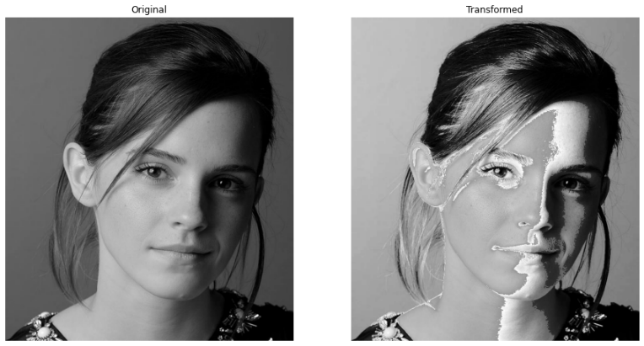0-50 and 150-255 ranges map to the same range in the output indicates the highly blackish and whitish regions in the image remains same. But since 50-150 mapped to 100-255, it indicates blackish gray region is mapped to whitish gray region and within that region whitish gray is mapped to even more white as the whiteness increases. Also 50-100 gray region is avoided in the output image and

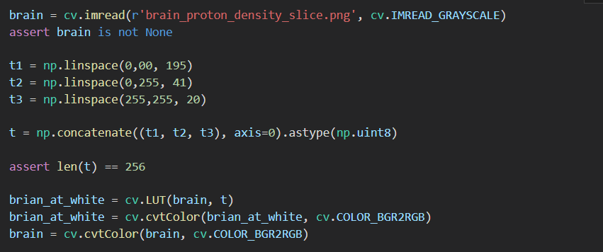Q2)

1. 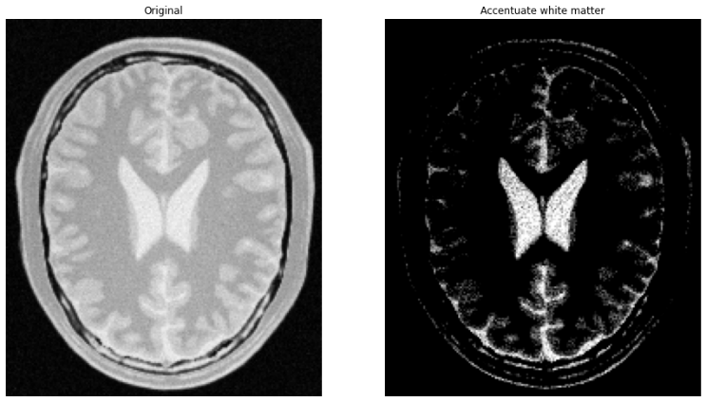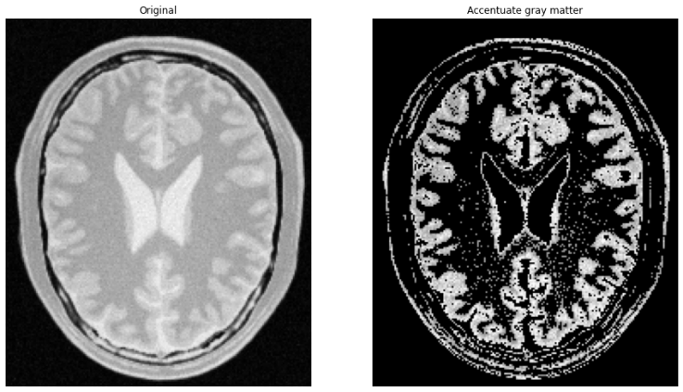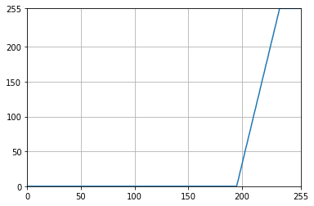To accentuate white matter, all blackish and blackish gray area are mapped to black and small range of white at the rightmost values mapped to 255. Small range of whitish gray is mapped to the whole range to make the visibility clear.
2. 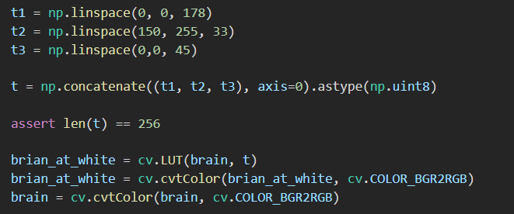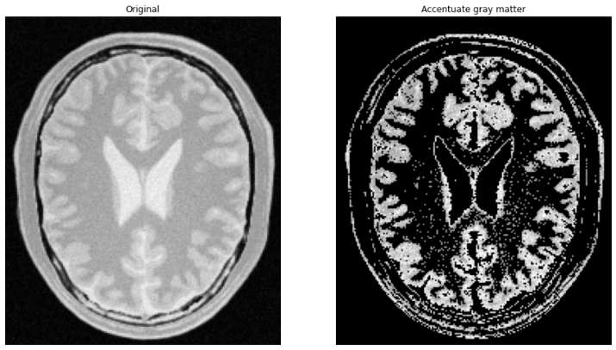Gray matter lies in the mid-range. Thus we should attenuate highly black and white regions. As shown in the graph black and white regions mapped to black. After experimentation the range correspond to gray matter became nearly 180-200. So this region is mapped to a more brighter region in a linear manner for visibility.

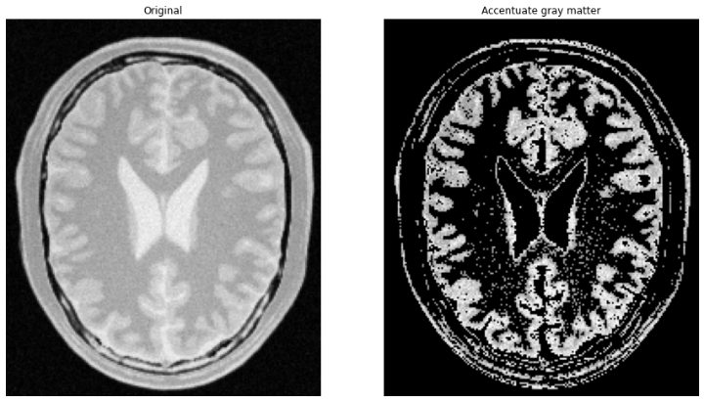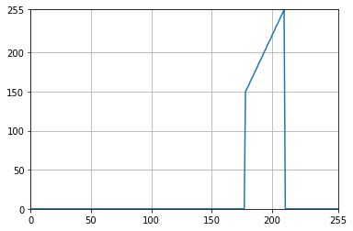

Q3)

1. Text

   Description automatically generatedIn the L\*a\*b\* plane of an image the L indicates the lightness of the image. Increasing the value to maximum results in white and the lowest value represents black. Choosing the value of L, softens the brightness of the respective color. In here the L plane’s intensity value is gamma corrected and observed as the gamma value ranges [0.2, 0.5, 0.8, 1.2, 1.5, 2]. Reducing the gamma increase the brightness of the image and undetectable details of the original image can be observed here. But further reducing it near to 0 results in bright image. On the other hand increasing the gamma value darkens the image hiding the already visible details.

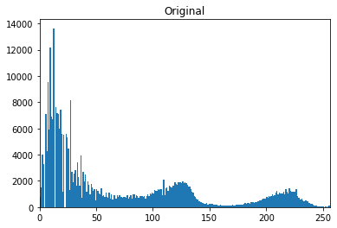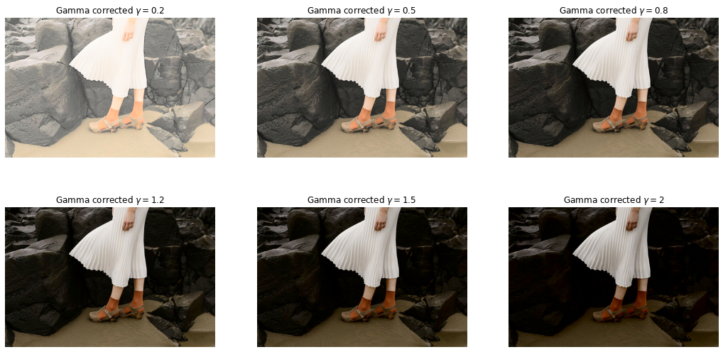

1. Histograms below shows the number of pixels in the L plane with the given intensity. As we can see when the gamma value increases the number of low value pixels which corresponds to blackness increases (number of high pixel values decreases). It is what exactly observed above pictures. But the other two a\* and b\* planes won’t change.

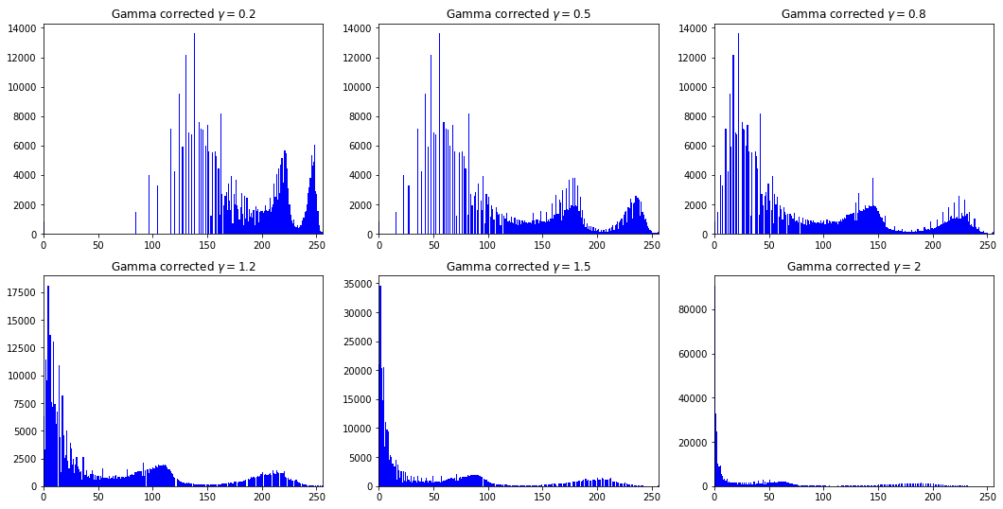

Q4)