DIGITAL ASSESSMENT

Name: Krishna Koushik

Reg No: 22BCE3413

TOPIC NAME: Book Management

Tools Used:

VS Code

HTML, CSS, JavaScript (FRONTEND)

Python (BACKEND)

Index.html:

App.py

Sql_query:

ER Diagram:

App Deployment: 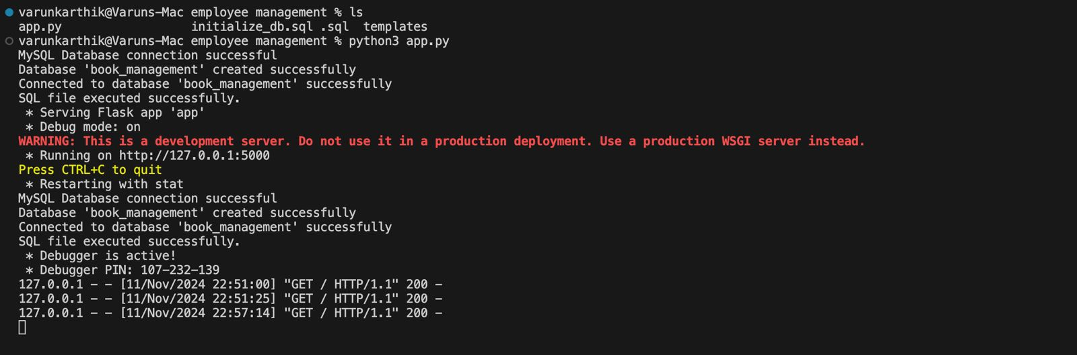

Index page:

Database: