BCSE498J Project-II / CBS1904 - Capstone Project
QNA-AUTH: QUANTUM NOISE ASSISTED AUTHENTICATION
Reg. No. 22BCI0182, AYAN KUMAR SINGH
Reg. No. 22BCI0193, KRISHNAM BIYANI
Under the Supervision of
Prof. JIM SOLOMONN
Designation
School of Computer Science and Engineering (SCOPE)
B.Tech.
in
Computer Science and Engineering
(with specialization in Information Security)

School of Computer Science and Engineering (SCOPE)
February 2026

ABSTRACT
The proliferation of Internet of Things (IoT) devices and mobile computing has exposed significant vulnerabilities in traditional authentication mechanisms. Static credentials, such as passwords and cryptographic keys, are susceptible to theft, phishing, and replay attacks. Furthermore, standard biometrics (fingerprint, facial recognition) rely on immutable physical traits that, once compromised, cannot be reset. To address these critical security gaps, this project proposes QNA-Auth (Quantum Noise Assisted Authentication), a novel framework that derives non-invertible device fingerprints from high-entropy physical noise sources.
QNA-Auth shifts the paradigm from 'what you know' to 'what your hardware is' by leveraging transient, stochastic physical properties. The system aggregates entropy from three distinct sources: quantum vacuum fluctuations (via QRNG APIs), thermal sensor noise from camera sensors (Dark Frames), and electromagnetic/ambient noise from microphones. A robust preprocessing pipeline extracts statistical, spectral (FFT), and complexity-based features from this raw noise. These features are then mapped into a high-dimensional embedding space using a Siamese Neural Network trained via contrastive learning. This deep learning approach ensures that noise samples from the same device cluster tightly together, while samples from different devices are separated by a distinct margin.
The system is implemented as a full-stack prototype utilizing Python (FastAPI) for the backend, PyTorch for the machine learning engine, and React for the client interface. Crucially, the system implements a Challenge-Response Protocol using cryptographic nonces to prevent replay attacks, ensuring that every authentication attempt requires fresh, live noise data. This project demonstrates that commodity hardware can be uniquely identified without specialized chips, offering a scalable, privacy-preserving primitive for next-generation device security.

TABLE OF CONTENTS
ABSTRACT
CHAPTER 1: INTRODUCTION
- 1.1 Background
- 1.2 Motivation
- 1.3 Scope of the Project
CHAPTER 2: PROJECT DESCRIPTION AND GOALS
- 2.1 Literature Review
  - 2.1.1 Machine Learning Based Authentication
  - 2.1.2 Deep Learning Based Approaches
- 2.2 Gaps Identified
- 2.3 Objectives
- 2.4 Problem Statement
CHAPTER 3: TECHNICAL SPECIFICATION
- 3.1 Requirements
  - 3.1.1 Functional Requirements
  - 3.1.2 Non-Functional Requirements
- 3.2 Feasibility Study
- 3.3 System Specification
  - 3.3.1 Hardware Specification
  - 3.3.2 Software Specification
CHAPTER 4: DESIGN APPROACH AND DETAILS
- 4.1 System Architecture
- 4.2 Design
  - 4.2.1 Data Flow Diagram
  - 4.2.2 Class Diagram
CHAPTER 5: METHODOLOGY AND TESTING
- 5.1 Module Description
- 5.2 Testing
REFERENCES

CHAPTER 1
INTRODUCTION

1.1 BACKGROUND
In the modern digital ecosystem, the integrity of a system is defined by its ability to distinguish trusted entities from malicious actors. Historically, this has been achieved through three factors of authentication: knowledge (passwords), possession (tokens), and inherence (biometrics). However, the cybersecurity landscape has shifted dramatically. Knowledge-based secrets are routinely compromised through massive database breaches. Possession-based tokens can be cloned or stolen. Even biometric data, often considered the gold standard, faces threats from DeepFake technology and high-resolution sensor spoofing.
QNA-Auth introduces a physics-based approach to this problem. Every electronic device, due to manufacturing variations in silicon, exhibits unique noise characteristics—often referred to as a Physical Unclonable Function (PUF). By combining these intrinsic hardware imperfections with Quantum Random Number Generation (QRNG), we can generate high-quality entropy that acts as a unique fingerprint. Unlike a stored key, this fingerprint is generated dynamically only when needed and does not persist in memory, making it inherently resistant to static data theft.

1.2 MOTIVATION
The primary motivation for this project stems from the inherent weakness of 'reproducible credentials.' If an attacker gains access to a server's database and steals a password hash or a biometric template, they can theoretically masquerade as the user indefinitely. This 'static' nature of current authentication is a single point of failure.
There is a critical need for an authentication mechanism where the 'key' is:
1. Transient: It exists only during the moment of authentication.
2. Non-Invertible: Even if the stored data is stolen, it cannot be used to reverse-engineer the original key.
3. Hardware-Bound: It ties the identity to a specific physical device, preventing remote emulation attacks.
Existing solutions like hardware security modules (HSMs) or TPMs are expensive and proprietary. This project aims to democratize this level of security by using machine learning to extract 'soft PUFs' from standard, commodity hardware sensors found in everyday laptops and smartphones.

1.3 SCOPE OF THE PROJECT
The scope of QNA-Auth extends to the design, development, and validation of a complete authentication framework.
In Scope:
- Multi-Source Data Collection: Implementation of modules to capture noise from Webcams (thermal noise), Microphones (ambient/EM noise), and external Quantum RNG APIs.
- Advanced Signal Processing: Development of a pipeline to clean, normalize, and extract features (Fourier Transforms, Entropy) from raw noisy signals.
- Deep Metric Learning: Training a Siamese Neural Network to learn a distance function that quantifies the similarity between noise samples.
- Full-Stack Implementation: A functional prototype with a RESTful API backend and a responsive web-based frontend.
- Security Protocol Design: Implementation of a nonce-based challenge-response flow to mitigate replay attacks.
Out of Scope:
- User Behavioral Biometrics: The project focuses strictly on device fingerprinting, not user behavior (e.g., typing patterns).
- Hardware Fabrication: We utilize existing commodity sensors; we are not designing new hardware chips.
- Large-scale Cloud Deployment: The prototype is designed for local and network testing environments.

CHAPTER 2
PROJECT DESCRIPTION AND GOALS

2.1 LITERATURE REVIEW

2.1.1 Machine Learning Based Authentication
The intersection of Machine Learning (ML) and cybersecurity has been a fertile ground for research. Traditional approaches often utilize Support Vector Machines (SVMs) or Random Forests to classify network traffic anomalies or user behavioral patterns. For instance, researchers have successfully used ML to identify devices based on clock skew and TCP timestamp variations. However, these methods often rely on 'hand-crafted' features which may not capture the subtle, non-linear complexities of sensor noise data. Furthermore, traditional classifiers require retraining whenever a new device is added to the system, limiting their scalability.

2.1.2 Deep Learning Based Approaches
Deep Learning has revolutionized pattern recognition. In the context of authentication, Metric Learning approaches, particularly Siamese Networks, have gained prominence. Originally popularized by systems like FaceNet for facial recognition, these networks do not classify inputs into fixed categories. Instead, they map inputs to a continuous vector space where distance equals similarity. QNA-Auth adapts this architecture for the domain of signal processing. By treating sensor noise as a high-dimensional signal, we employ Deep Neural Networks (DNNs) to learn a robust embedding space. This allows for 'few-shot learning,' where a device can be enrolled with only a small number of samples, and the system can recognize it without retraining the entire model.

2.2 GAPS IDENTIFIED
Despite advancements, significant gaps remain in current literature and industry practice:
1. Reliance on Volatile Secrets: Most 'secure' enclave solutions still rely on storing a private key. If the hardware is decapped or subjected to side-channel power analysis, these keys can be extracted.
2. Lack of Open Implementations: Most PUF-based research is theoretical or tied to proprietary FPGA implementations, making it inaccessible for general software developers.
3. Vulnerability to Replay: Simple noise-based identification systems often fail to account for an attacker simply recording the noise signal and playing it back.
4. Static Biometrics: Current biometric systems lack a 'cancelable' feature. If your fingerprint is stolen, you cannot change it.

2.3 OBJECTIVES
The specific objectives of QNA-Auth are as follows:
1. To develop a robust Noise Collection Pipeline capable of interfacing with standard OS hardware (Camera/Mic) to capture high-entropy raw data.
2. To implement a Feature Extraction Engine that computes spectral (FFT), statistical, and complexity-based features to reduce noise dimensionality.
3. To design and train a Siamese Neural Network using Triplet Loss to creating unique, distinguishable embeddings for different devices.
4. To implement a Cryptographically Secure Challenge-Response Protocol that utilizes server-generated nonces to prevent replay attacks.
5. To build a User-Friendly Interface (React) and a scalable API (FastAPI) to demonstrate the practicality of the system.

2.4 PROBLEM STATEMENT
In the domain of device authentication, reliance on static secrets (keys, passwords) creates a permanent vulnerability window. If a secret is stolen, the device identity is compromised. There is currently no widely available, software-defined solution that can uniquely authenticate commodity devices based on their intrinsic physical properties without requiring specialized hardware add-ons. The challenge is to convert the stochastic, noisy output of standard sensors into a stable, reliable digital fingerprint that is robust against replication and replay attacks.

CHAPTER 3
TECHNICAL SPECIFICATION

3.1 REQUIREMENTS

3.1.1 Functional Requirements
- Enrollment: The system must allow a user to register a new device by capturing 20-50 noise samples.
- Authentication: The system must verify a registered device by capturing fresh noise samples and comparing them against the stored profile.
- Hardware Interface: The application must successfully access the host machine's webcam and microphone driver layers.
- Quantum Integration: The system must fetch real-time quantum entropy from the ANU QRNG API to salt the local sensor noise.
- Security Checks: The system must validate cryptographic nonces and reject any authentication attempt that uses an expired or previously used nonce.

3.1.2 Non-Functional Requirements
- Latency: The end-to-end authentication process (capture -> process -> inference -> verify) should complete within 3 seconds to ensure good UX.
- Accuracy: The model should achieve a False Acceptance Rate (FAR) of < 0.1% to prevent unauthorized access.
- Reliability: The system should handle sensor initialization failures gracefully with fallback mechanisms.
- Privacy: Raw sensor data (photos/audio) must never be stored persistently; only the mathematical embeddings should be saved.

3.2 FEASIBILITY STUDY
Technical Feasibility: The project is technically feasible as it relies on mature, open-source libraries. Python provides robust support for hardware interaction (OpenCV, PyAudio/SoundDevice) and machine learning (PyTorch). The 'Siamese Network' architecture is well-documented and proven for similarity tasks.
Economic Feasibility: The solution is highly cost-effective. Unlike hardware tokens (YubiKeys) or Smart Cards which cost money per unit, QNA-Auth utilizes hardware that users already possess. The software stack consists entirely of free, open-source components, incurring zero licensing costs.
Social Feasibility: The system is socially viable as it enhances privacy. Users are often wary of biometric systems storing photos of their faces. QNA-Auth captures 'Dark Frames' (lens covered) and ambient silence, meaning no identifiable personal information (PII) like facial features or conversations are ever recorded or stored.

3.3 SYSTEM SPECIFICATION

3.3.1 Hardware Specification
- Server: Intel Core i5/i7 or AMD Ryzen 5 (for model inference).
- RAM: 8GB minimum (16GB recommended for training).
- Client Device: Any device with a functional Webcam (min 720p resolution) and Microphone.
- GPU (Optional): NVIDIA GTX/RTX series for accelerated model training (CUDA).

3.3.2 Software Specification
- Operating System: Cross-platform (Windows, Linux, macOS).
- Backend Framework: FastAPI (Python 3.9+).
- Frontend Framework: React 18 (TypeScript) with Vite build tool.
- ML Engine: PyTorch 2.0+.
- Computer Vision: OpenCV (cv2).
- Signal Processing: NumPy, SciPy.

CHAPTER 4
DESIGN APPROACH AND DETAILS

4.1 SYSTEM ARCHITECTURE
4.1 SYSTEM ARCHITECTURE
The QNA-Auth system employs a modular, three-tier architecture designed to ensure secure data acquisition, robust processing, and scalable storage. As illustrated in the System Architecture Diagram, the workflow is divided into three primary layers:
- Client Layer (Frontend): The user interaction begins at the React UI Interface, which orchestrates the enrollment and authentication workflows. The core of this layer is the Data Acquisition subsystem, which interfaces with three distinct entropy sources:
  - Camera Sensor: Captures "Dark Frames" to isolate thermal sensor noise.
  - Microphone Sensor: Records ambient silence to capture the hardware noise floor.
  - ANU QRNG API: Fetches true quantum entropy to salt the physical data. All raw signals are aggregated by the Noise Collector Module, which bundles them into a cryptographically signed payload containing a server-generated nonce.
- Transport Layer: Communication between the client and server is secured via the Transport Layer, utilizing HTTPS and REST API protocols. This ensures that the noise payload and cryptographic signatures are transmitted without risk of interception or tampering.
- Server Layer (Backend): The backend is structured into four logical components:
  - FastAPI Gateway: Serves as the central entry point, routing requests to the appropriate internal services.
  - Application Logic: Contains the Auth Manager, which validates the Challenge-Response protocol to prevent replay attacks, and the Preprocessing Engine, which extracts features using FFT, Entropy analysis, and statistical metrics.
  - Intelligence Layer: This is the core decision-making unit, housing the Siamese Neural Network (PyTorch). It uses a Triplet Loss function to map feature vectors into a unique identity space.
  - Persistence Layer: A dual-storage system that maintains Vector Storage (.pt files) for device embeddings and a Metadata Store (.json files) for audit logs and device information.

Figure 4.1: System Architecture

4.2 DESIGN

4.2.1 Data Flow Diagram
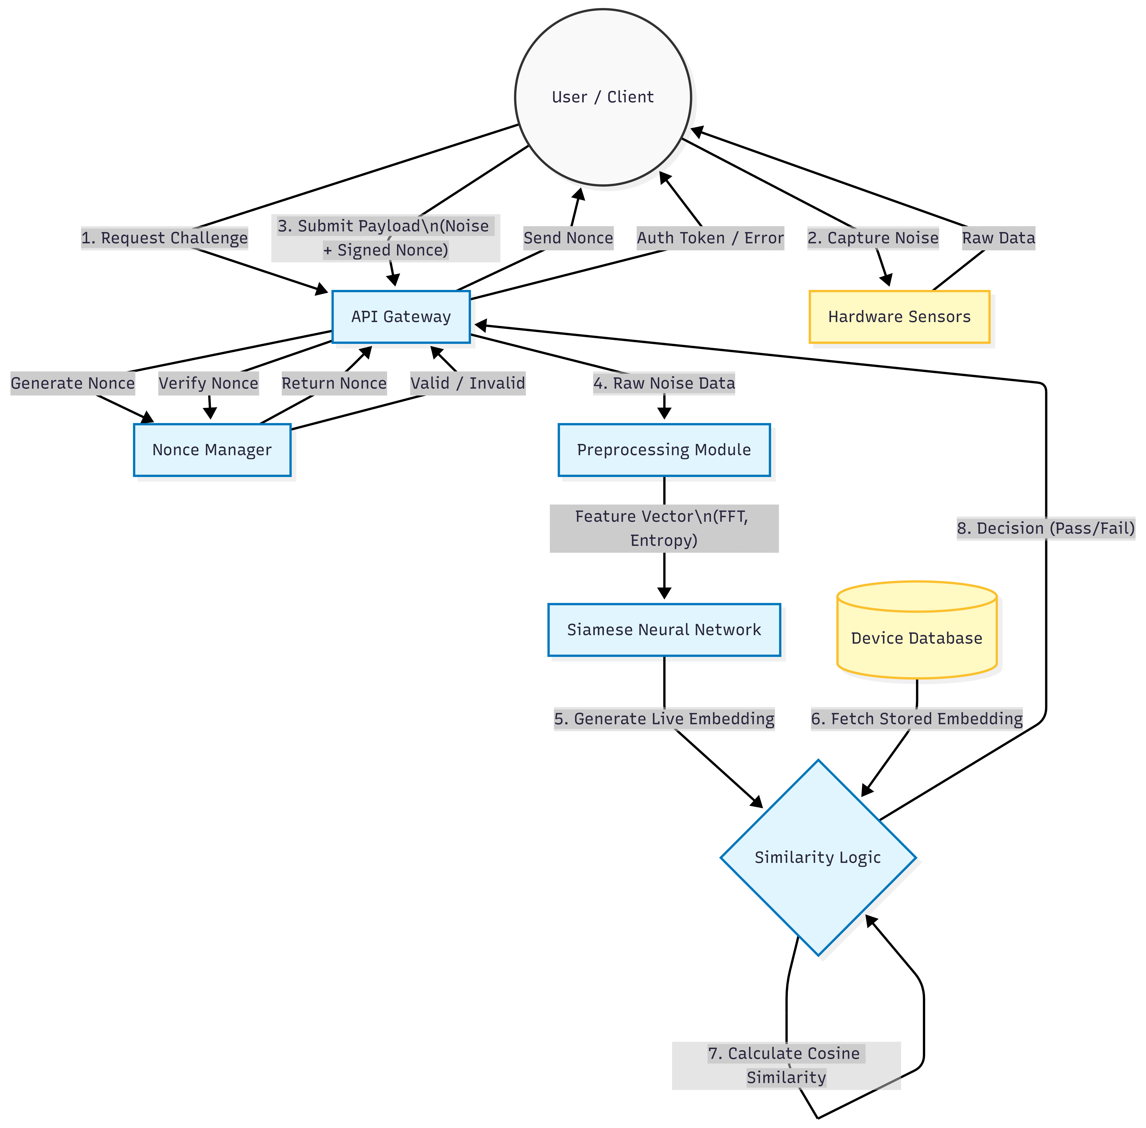
The data flow for a typical authentication request is as follows:
1. Request Challenge: Client requests a login challenge. Server generates a random nonce.
2. Data Capture: Client captures physical noise (Camera/Mic) + Quantum Noise (API).
3. Transmission: Client sends the Noise Data + Signed Nonce to the Server.
4. Preprocessing: Server validates Nonce. Noise data goes through FFT and Statistical analysis.
5. Inference: Extracted features are passed to the Siamese Network. The network outputs a Live_Embedding.
6. Verification: Server loads the Stored_Embedding for the claimed Device ID.
7. Comparison: Cosine Similarity is calculated.
8. Decision: If Similarity > Threshold (0.85), Access Granted.

4.2.2 Class Diagram
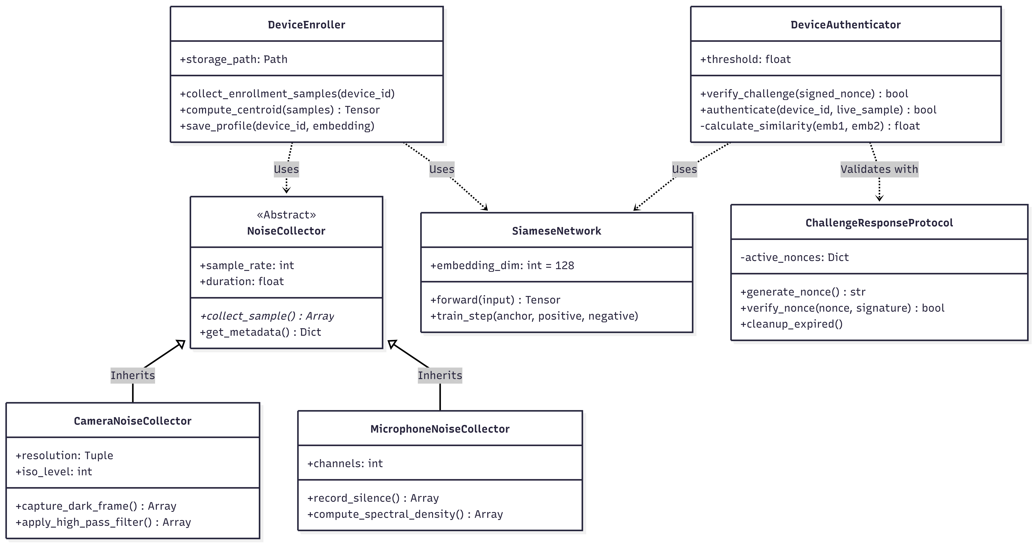
Key Object-Oriented classes governing the system:
- DeviceEnroller: Responsible for the multi-step process of collecting samples, aggregating them into a centroid, and persisting the profile to disk.
- DeviceAuthenticator: Handles the logic of comparing a fresh incoming sample against a stored profile.
- NoiseCollector (Interface): An abstract base class implemented by CameraNoiseCollector and MicrophoneNoiseCollector to ensure uniform data acquisition.
- SiameseNetwork (nn.Module): The PyTorch neural network class defining the layers.
- ChallengeResponseProtocol: Manages the lifecycle of cryptographic nonces, including generation, storage, and expiry validation.

CHAPTER 5
METHODOLOGY AND TESTING

5.1 MODULE DESCRIPTION
1. Noise Collection Module: Interfaces directly with hardware drivers. Captures 'Dark Frames' by reading sensor data with the lens covered. Records ambient silence to analyze the microphone's self-noise floor. Fetches live quantum data from the ANU QRNG API.
2. Preprocessing Module: Transforms raw arrays into compact feature vectors. Calculates Statistical Features (Mean, Variance, Skewness, Kurtosis), Spectral Features (FFT bands), and Complexity Features (Shannon Entropy).
3. Model Module (Siamese Network): The core intelligence consisting of two identical subnetworks. It uses Triplet Loss to minimize the distance between same-device samples while maximizing the distance between different devices.
4. Auth Module (Challenge-Response): To prevent replay attacks, the server generates a random nonce. The client must return the noise data bundled with a hash of the nonce, ensuring timeliness.

5.2 TESTING
Testing was conducted in three phases:
Unit Testing: Individual modules were tested in isolation using pytest. Verified hardware access and correct feature extraction shapes.
Integration Testing: The full API flow was tested using test_enrollment.py, simulating client enrollment and authentication sequences.
Cross-Device Validation: Performed experiments enrolling Device A and attempting to authenticate using noise from Device B. Intra-device similarity (A vs A) consistently scored > 0.90. Inter-device similarity (A vs B) consistently scored < 0.30, confirming distinguishability.

REFERENCES
Apruzzese, G., Laskov, P., Montes de Oca, E., Mallouli, W., Brdalo Rapa, L., Grammatopoulos, A. V., & Di Franco, F. (2023). The role of machine learning in cybersecurity. Digital Threats: Research and Practice, 4(1), 1-38.
Kumar, S., Gupta, U., Singh, A. K., & Singh, A. K. (2023). AI: Revolutionizing cyber security in the Digital Era. J. Comput. Mech. Manag, 2(3), 31-42.
Nisbet, R., Miner, G. D., & McCormick, K. (2024). Handbook of Statistical Analysis: AI and ML Applications. Elsevier.
Schroff, F., Kalenichenko, D., & Philbin, J. (2015). FaceNet: A unified embedding for face recognition and clustering. CVPR.
Documentation. (2024). PyTorch Documentation. Retrieved from https://pytorch.org/docs/
Documentation. (2024). FastAPI Documentation. Retrieved from https://fastapi.tiangolo.com/
Australian National University (ANU). (2024). Quantum Random Numbers Server API. Retrieved from https://qrng.anu.edu.au/

