**Basic Calculator App Using Android UI Controls**

**EXP NO: 9**

# AIM:

Develop an Android application using controls like Button, TextView, EditText for designing a calculator having basic functionality like Addition, Subtraction, multiplication, and Division.

# CODE:

## MainActivity.kt

package com.example.myapplication_karthick_79

import android.os.Bundle import android.view.View import android.widget.Button import android.widget.EditText import android.widget.Toast

import androidx.appcompat.app.AppCompatActivity class MainActivity : AppCompatActivity() {

private lateinit var display: EditText private var currentInput: String = "" private var operand1: Double = 0.0 private var operand2: Double = 0.0 private var operator: String = ""

override fun onCreate(savedInstanceState: Bundle?) { super.onCreate(savedInstanceState) setContentView(R.layout.*activity_main*)

display = findViewById(R.id.*display*)

// Number buttons setButtonClickListener(R.id.*button0*) setButtonClickListener(R.id.*button1*) setButtonClickListener(R.id.*button2*) setButtonClickListener(R.id.*button3*) setButtonClickListener(R.id.*button4*) setButtonClickListener(R.id.*button5*) setButtonClickListener(R.id.*button6*) setButtonClickListener(R.id.*button7*) setButtonClickListener(R.id.*button8*) setButtonClickListener(R.id.*button9*)

// Operator buttons setOperatorClickListener(R.id.*buttonAdd*, "+") setOperatorClickListener(R.id.*buttonSubtract*, "-") setOperatorClickListener(R.id.*buttonMultiply*, "*") setOperatorClickListener(R.id.*buttonDivide*, "/")

// Clear button findViewById<Button>(R.id.*buttonClear*).setOnClickListener {

currentInput = "" operand1 = 0.0

operand2 = 0.0 operator = "" display.setText("")

}

// Equal button findViewById<Button>(R.id.*buttonEqual*).setOnClickListener {

if (operator.*isEmpty*()) return@setOnClickListener

try {

operand2 = currentInput.*toDouble*()

val result = when (operator) { "+" -> operand1 + operand2 "-" -> operand1 - operand2 "*" -> operand1 * operand2 "/" -> {

if (operand2 == 0.0) {

Toast.makeText(this@MainActivity, "Cannot divide by zero", Toast.*LENGTH_SHORT*).show()

return@setOnClickListener

}

operand1 / operand2

}

else -> 0.0

}

display.setText(result.toString())

operand1 = result // Update operand1 for subsequent calculations operator = ""

currentInput = result.toString()

} catch (e: Exception) {

Toast.makeText(this@MainActivity, "Error: Invalid Input", Toast.*LENGTH_SHORT*).show()

}

}

}

// Set up number button listeners

private fun setButtonClickListener(buttonId: Int) { val button: Button = findViewById(buttonId) button.setOnClickListener {

currentInput += button.*text*.toString() display.setText(currentInput)

}

}

// Set up operator button listeners

private fun setOperatorClickListener(buttonId: Int, op: String) { val button: Button = findViewById(buttonId)

button.setOnClickListener {

if (currentInput.*isNotEmpty*()) { operand1 = currentInput.*toDouble*() currentInput = ""

operator = op

}

}

}

// Optional: Add functionality to handle decimal point (if needed) private fun isDecimalPointValid(): Boolean {

return !currentInput.*contains*(".")

}

}

## activity_main.xml

<?xml version="1.0" encoding="utf-8"?>

<LinearLayout xmlns:android="<http://schemas.android.com/apk/res/android>" xmlns:tools="<http://schemas.android.com/tools>" android:id="@+id/calculatorLayout" android:layout_width="match_parent" android:layout_height="match_parent"

android:orientation="vertical" android:padding="16dp" tools:context=".MainActivity">

<EditText android:id="@+id/display"

android:layout_width="match_parent" android:layout_height="80dp" android:background="#000000" android:textColor="#FFFFFF" android:textSize="28sp" android:gravity="end|center_vertical" android:inputType="none" android:focusable="false" android:clickable="false" android:padding="12dp" android:layout_marginBottom="12dp" />

<!-- Row 1: 7 8 9 / -->

<LinearLayout android:layout_width="match_parent" android:layout_height="wrap_content" android:orientation="horizontal">

<Button android:id="@+id/button7" style="@style/CalcButton" android:text="7" />

<Button android:id="@+id/button8" style="@style/CalcButton" android:text="8" />

<Button android:id="@+id/button9" style="@style/CalcButton" android:text="9" />

<Button android:id="@+id/buttonDivide" style="@style/CalcButton" android:text="/" />

</LinearLayout>

<!-- Row 2: 4 5 6 * -->

<LinearLayout

android:layout_width="match_parent" android:layout_height="wrap_content" android:orientation="horizontal">

<Button android:id="@+id/button4" style="@style/CalcButton" android:text="4" />

<Button android:id="@+id/button5" style="@style/CalcButton" android:text="5" />

<Button android:id="@+id/button6" style="@style/CalcButton" android:text="6" />

<Button android:id="@+id/buttonMultiply" style="@style/CalcButton" android:text="*" />

</LinearLayout>

<!-- Row 3: 1 2 3 - -->

<LinearLayout android:layout_width="match_parent" android:layout_height="wrap_content" android:orientation="horizontal">

<Button android:id="@+id/button1" style="@style/CalcButton" android:text="1" />

<Button android:id="@+id/button2" style="@style/CalcButton" android:text="2" />

<Button android:id="@+id/button3" style="@style/CalcButton" android:text="3" />

<Button android:id="@+id/buttonSubtract" style="@style/CalcButton" android:text="-" />

</LinearLayout>

<!-- Row 4: 0 C = + -->

<LinearLayout android:layout_width="match_parent" android:layout_height="wrap_content" android:orientation="horizontal">

<Button android:id="@+id/button0" style="@style/CalcButton" android:text="0" />

<Button android:id="@+id/buttonClear" style="@style/CalcButton" android:text="C" />

<Button android:id="@+id/buttonEqual" style="@style/CalcButton" android:text="=" />

<Button android:id="@+id/buttonAdd" style="@style/CalcButton" android:text="+" />

</LinearLayout>

</LinearLayout>

## styles.xml

<resources>

<style name="CalcButton">

<item name="android:layout_width">0dp</item>

<item name="android:layout_height">wrap_content</item>

<item name="android:layout_weight">1</item>

<item name="android:padding">16dp</item>

<item name="android:textSize">24sp</item>

<item name="android:background">?attr/selectableItemBackground</item>

<item name="android:textColor">#000000</item>

</style>

</resources>

# OUTPUT:

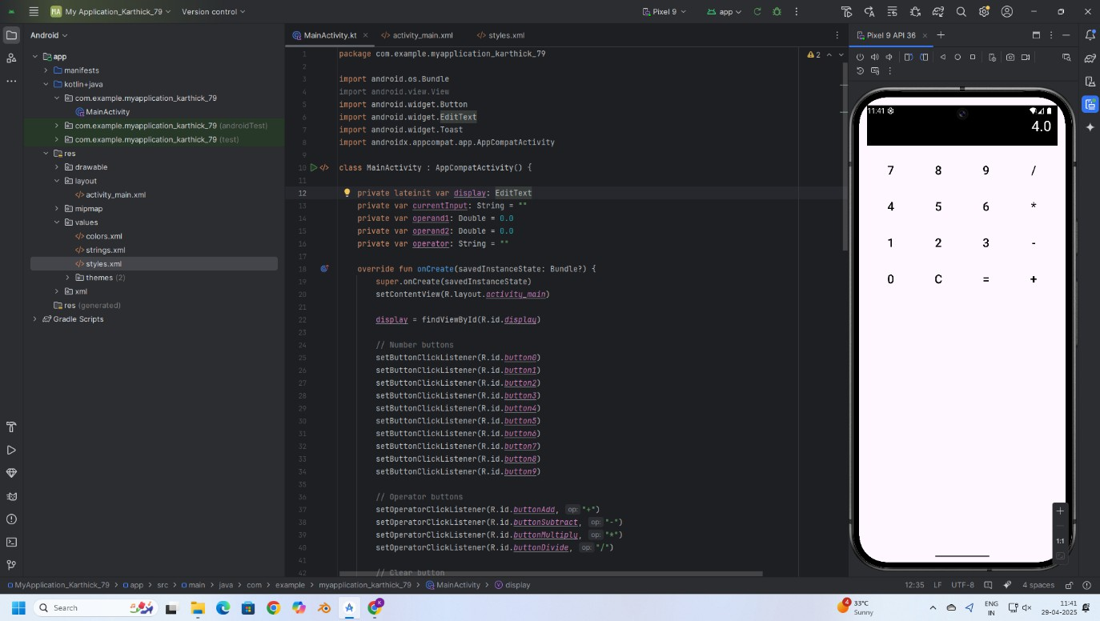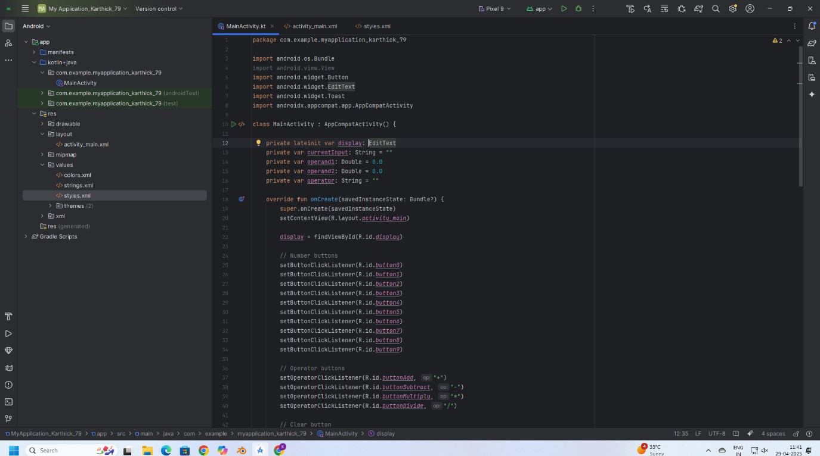

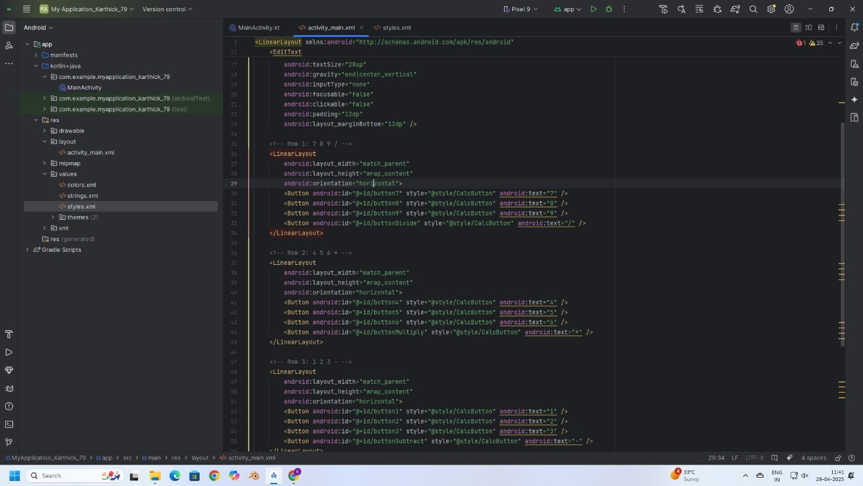

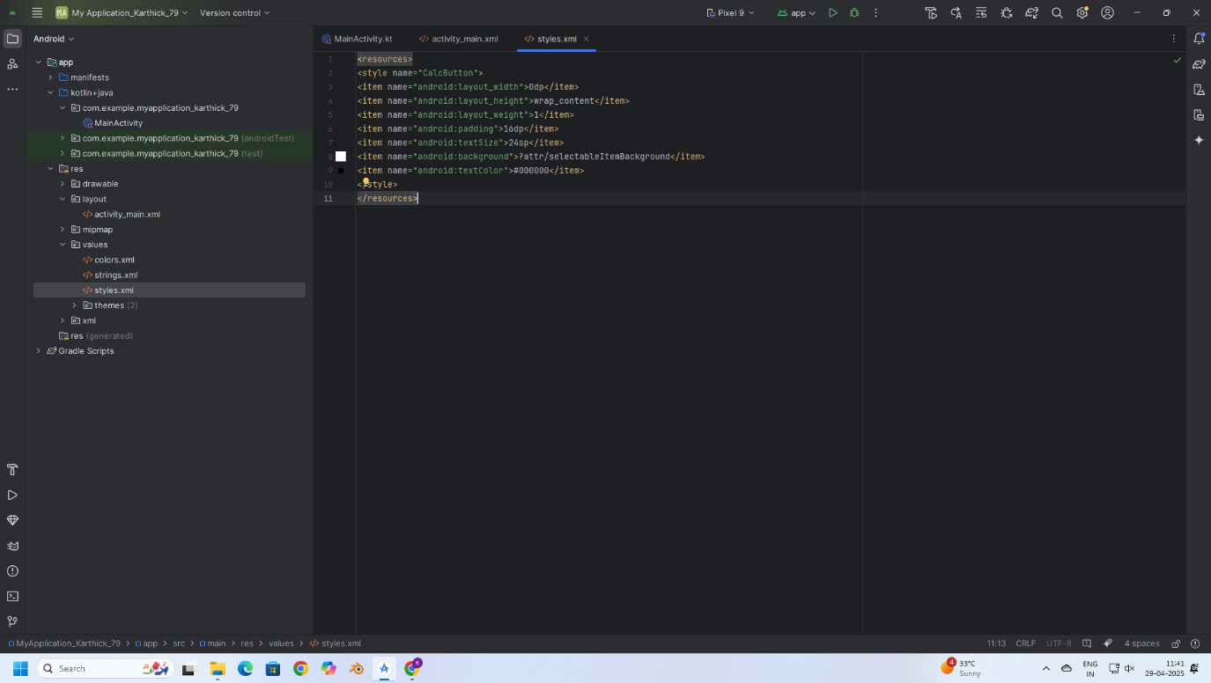

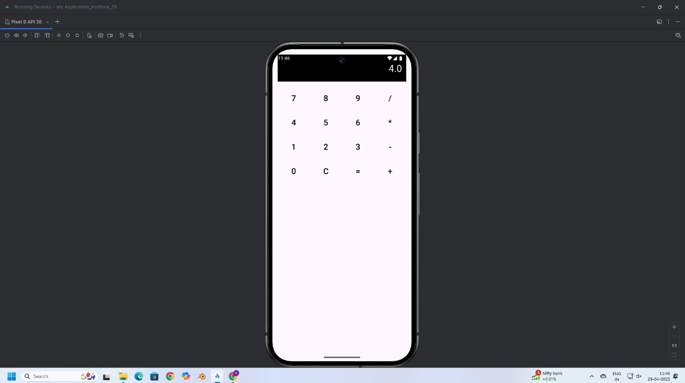

**RESULT:**

Thus, a basic calculator application was successfully developed using Android controls like Button, TextView, and EditText to perform addition, subtraction, multiplication, and division operations.