HTTP

What is HTTP ?



* **HTTP** stands for **H**yper **T**ext **T**ransfer **P**rotocol
* **WWW** stands for **W**orld **W**ide **W**eb is about communication between web clients and servers
* Communication between client computers and web servers is done by sending **HTTP Requests** and receiving **HTTP Responses**
* **Clients** are often browsers (Chrome, Edge, Safari), but they can be any type of program or device
* **Servers** are most often computers in the cloud.

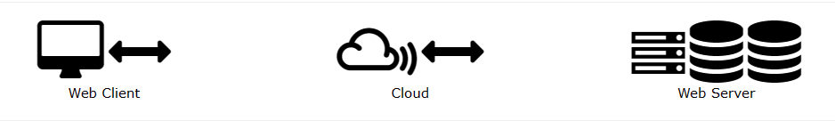

## HTTP Request / Response

1. A client (a browser) sends an **HTTP request** to the web
2. A web server receives the request
3. The server runs an application to process the request
4. The server returns an **HTTP response** (output) to the browser
5. The client (the browser) receives the response

## HTTP- Request Method

## 1.GET

The GET method is used to retrieve information from the given server using a given URI. Requests using GET should only retrieve data and should have no other effect on the data.

**2**.**HEAD**

Same as GET, but it transfers the status line and the header section only.

**3**.**POST**

A POST request is used to send data to the server, for example, customer information, file upload, etc. using HTML forms.

**4**.**PUT**

Replaces all the current representations of the target resource with the uploaded content.

**5**.**DELETE**

Removes all the current representations of the target resource given by URI.

**6.CONNECT**

Establishes a tunnel to the server identified by a given URI.

**7.OPTIONS**

Describe the communication options for the target resource.

**8**.**TRACE**

Performs a message loop back test along with the path to the target resource.

# HTTP – Responses

Status Code

The Status-Code element is a 3-digit integer where first digit of the Status-Code defines the class of response and the last two digits do not have any categorization role. There are 5 values for the first digit:

* **1xx: Informational**

It means the request was received and the process is continuing.

* **2xx: Success**

It means the action was successfully received, understood, and accepted.

* **3xx: Redirection**

It means further action must be taken in order to complete the request.

* **4xx: Client Error**

It means the request contains incorrect syntax or cannot be fulfilled.

* **5xx: Server Error**

It means the server failed to fulfill an apparently valid request.

**Uniform Resource Locator (URL)**

1. A client that wants to access the document in an internet needs an address and to facilitate the access of documents, the HTTP uses the concept of Uniform Resource Locator (URL).
2. The Uniform Resource Locator (URL) is a standard way of specifying any kind of information on the internet.
3. The URL defines four parts: method, host computer, port, and path.

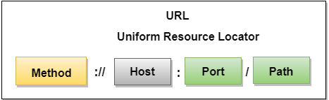

* **Method:** The method is the protocol used to retrieve the document from a server. For example, **HTTP**.
* **Host:** The host is the computer where the information is stored, and the computer is given an alias name. Web pages are mainly stored in the computers and the computers are given an alias name that begins with the characters "**www**". This field is not mandatory.
* **Port:** The URL can also contain the port number of the server, but it's an optional field. If the port number is included, then it must come between the host and path and it should be separated from the host by a colon.
* **Path:** Path is the pathname of the file where the information is stored. The path itself contain slashes that separate the directories from the subdirectories and files.