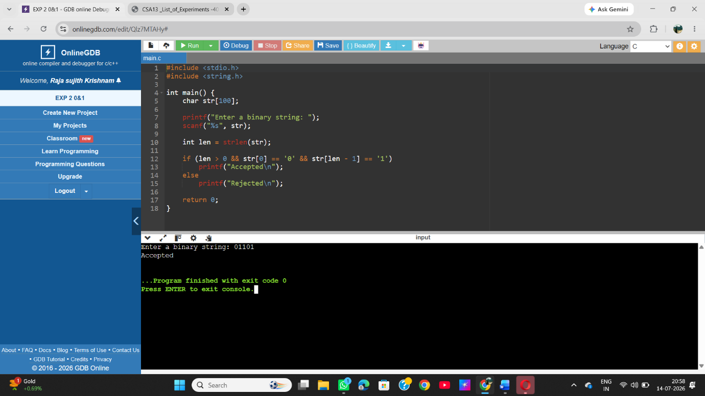
Write a C program to simulate a Deterministic Finite Automata (DFA) for the given language representing strings that start with 0 and end with 1

