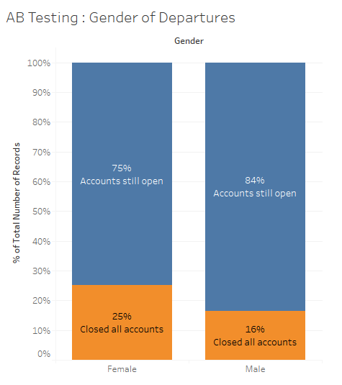The executives at Sample Bank International are losing customers at an alarming rate. We are going to investigate a 10,000-row, 14-column .xls file (Churn Modeling.xls) to determine possible reasons for the customer departure.

We first practiced with Tableau to prepare an ad-hoc AB test of those who departed and their gender.

In this figure, we can see that there is a higher percentage of females who left the Bank during our study period, but should be tested for statistical significance to determine any substantial conclusions.

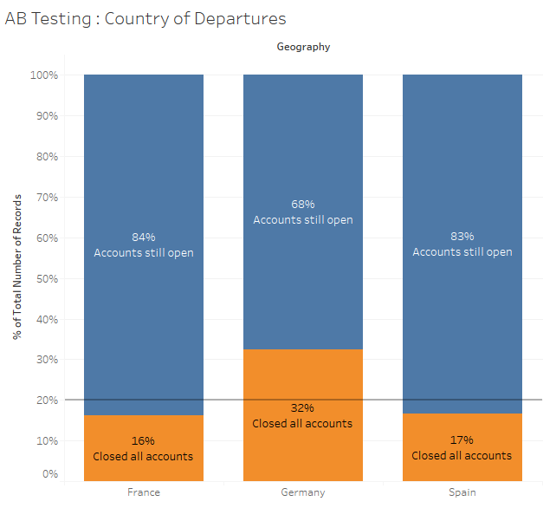We also tested the country of departures and noticed a rapid rate of departure from Germany, which may be statistically significant. Note this is no longer a pseudo-AB test, because of the number of variables.

A reference line was added at 20% which represents the overall rate of departure.

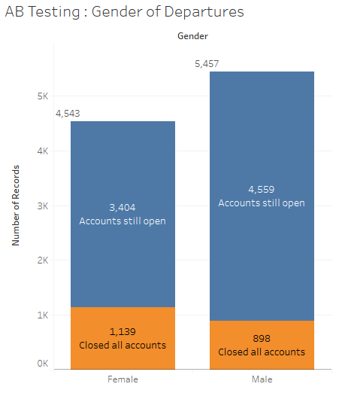Running an AB test with chi-squared, our result shows that “Sample 1 is more successful” which means that women indeed have a higher rate of leaving the bank, and is statistically significant with a p-value of .001.

Using the exit values of 1139 out of 4543 for women, and 898 out of 5457 for men, we are able to calculate our findings.

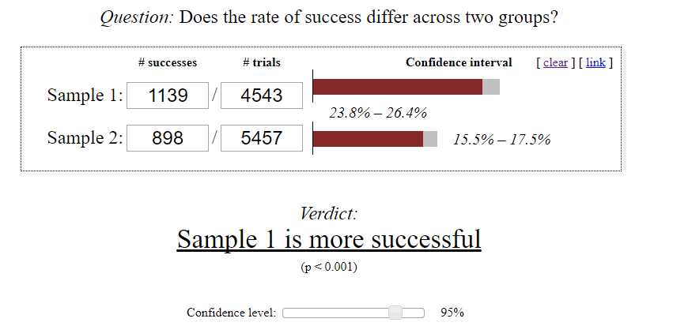

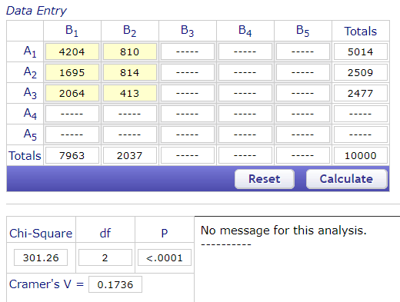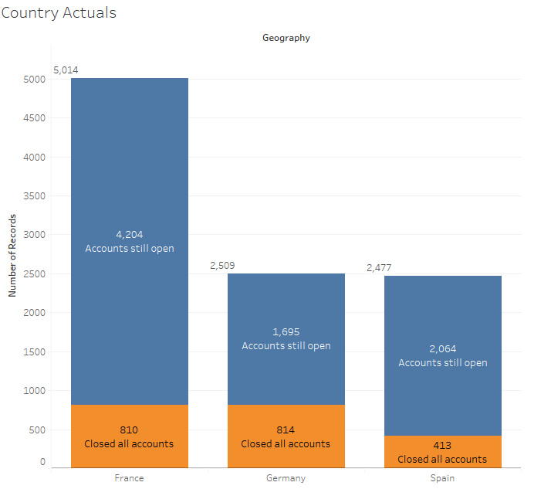Running a similar test, a contingency test, on the geographical significance provides there exists a statistical significance across all samples, and that Germany’s 34% departure rate is also significant. Further details are provided below.

*Percentage deviation*http://vassarstats.net/white.gif and *standardized residual* are both measures of the degree to which an observed chi-square cell frequency differs from the value that would be expected on the basis of the null hypothesis.

For each cell, *percentage deviation* is calculated as

|  |  |  |
| --- | --- | --- |
| xxx | observed — expected  expected | x 100 |

Thus, a percentage deviation of +15% within a cell indicates that the observed frequency is 15% greater than the expected, while a percentage deviation of -15% indicates that the observed frequency is 15% smaller than the expected.   
  
In the special case of df=1, the calculation of percentage deviation incorporates a correction for continuity:Q

|  |  |  |
| --- | --- | --- |
| xxx | |observed — expected| —0.5  expected | x 100 |

The resulting value is then given a positive sign if *observed>expected* and a negative sign if *observed<expected.*Q

The *standardized residual* for a cell in a chi-square table is a version of the standard normal deviate, z, calculated asQ

|  |  |  |
| --- | --- | --- |
| xxx | z = | observed — expected  sqrt[expected] |

In the special case of df=1, the calculation of the standardized residual incorporates a correction for continuity:Q

|  |  |  |
| --- | --- | --- |
| xxx | z = | |observed — expected| —0.5  sqrt[expected] |

The resulting value of z is then given a positive sign if *observed>expected* and a negative sign if *observed<expected.*   
  
The chi-square value that results from a chi-square analysis is equal to the sum of the squares of the standardized residuals.   
  
Assuming the null hypothesis to be true, and providing that the expected value for a cell is at least 5, values of the standardized residual belong to a normally distributed sampling distribution with a mean of zero and a standard deviation of ±1.0.

