Problem : Having different version of nodejs in Development and Operational Environment

Desc : Developer is facing problem in nodejs version to Fix an Operational issue while working on any new development on latest nodejs version. Most of the functions are deprecated from the older to new version this may cause irresponsive on server startup.

Solution: To overcome the above problem developer need to follow the below steps,

* All nodejs version has to be uninstalled from the system.
* Install Node version manager
  + Download the Node Version Manager from the repository ‘’ <https://github.com/coreybutler/nvm-windows#installation--upgrades>”
  + 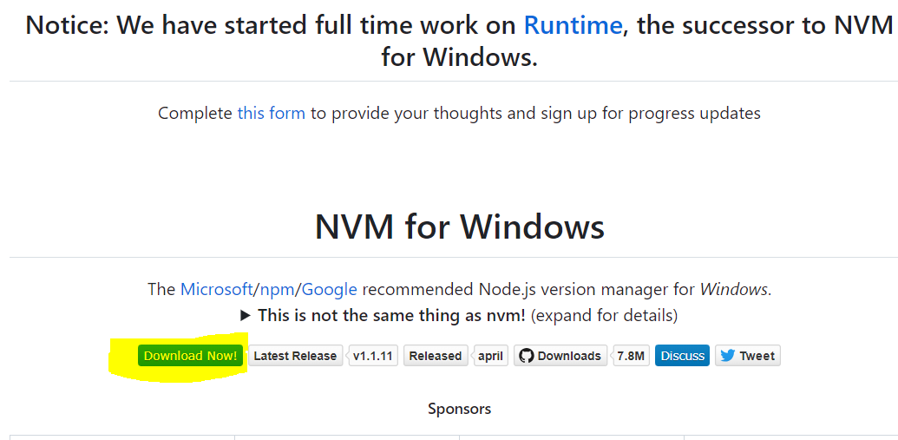
  + Install nvm-windows for windows and for other operating system find the available pack and install it.
  + If the System is having Admin user then we need to install under Admin user only since nvm will modify Environment variable while installing NodeJS.
  + While installing we have to be very careful about the installation folder. It should be under public folder not to any specific user.
* Install a version of Node by using the following command.
  + **nvm install node-version**

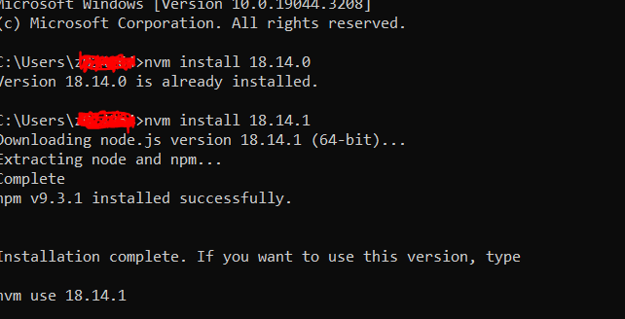

* To see the versions of Node you have installed on your machine
  + **nvm list**

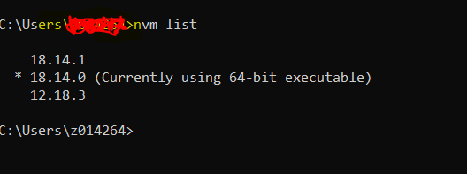

* To use a specific version of Node
  + **nvm use node-version**