Description
1. Research and study the basics of Docker Containerization platform .
2. install docker on your machine
3.build a container from the available docker images.
4.study basic docker commands

- Update System Packages:
sudo yum update -y

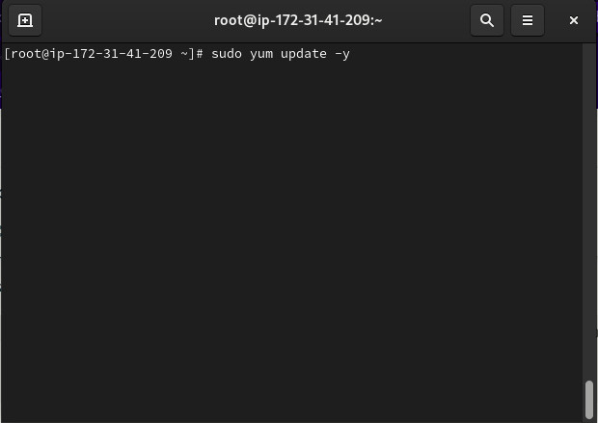

2.Install Required Dependencies:
sudo yum install -y yum-utils device-mapper-persistent-data lvm2

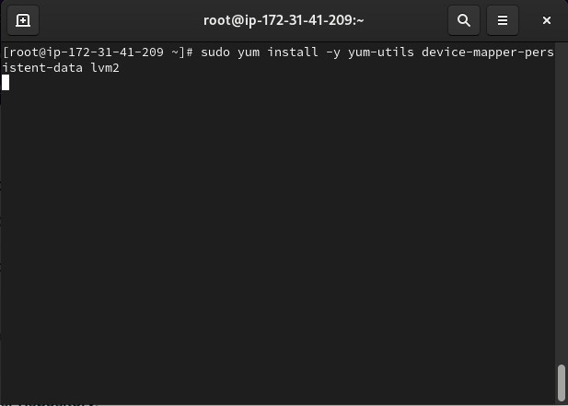

3.Add Docker Repository:

sudo yum-config-manager --add-repo https://download.docker.com/linux/rhel/docker-ce.repo

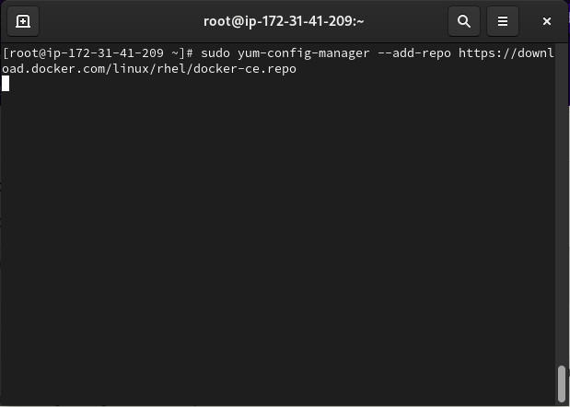

4.Install Docker CE:

sudo yum install -y docker-ce docker-ce-cli containerd.io
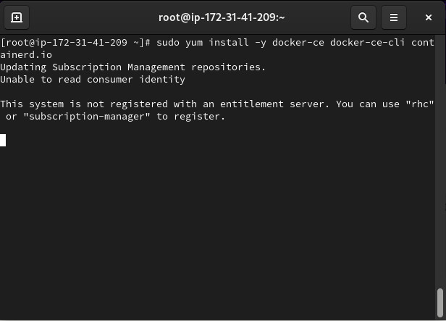

5. Start and Enable Docker:
sudo systemctl start docker
sudo systemctl enable docker
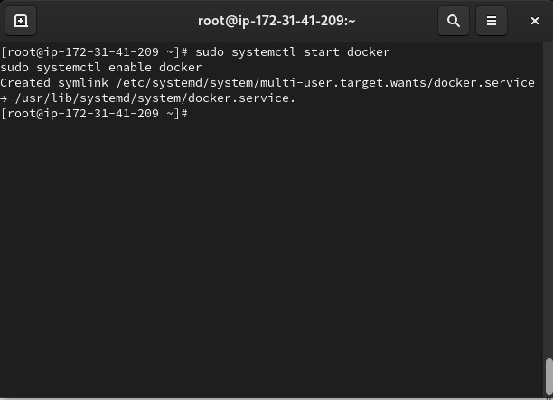

6.Allow Non-Root User Access (Optional):

sudo usermod -aG docker ec2-user
pull an NGINX image if hosting a static website:

sudo docker pull nginx
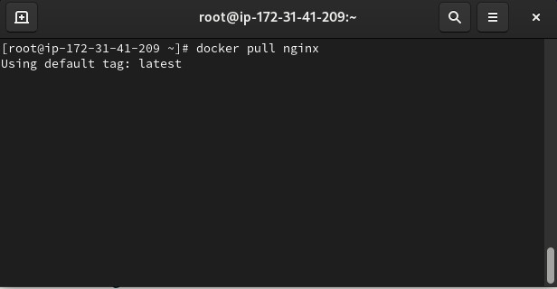

Pull a Static Website Docker Image
If you don't have your own website files, you can use a pre-built static website image from Docker Hub. For example, pull an image like httpd:2.4 or a custom static website image:

sudo docker pull “image_name”
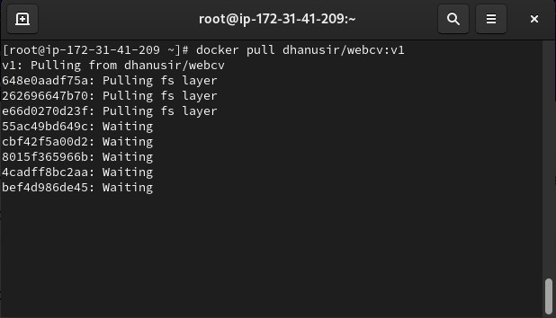

3. Run the Static Website Container
Run the container and map it to port 80 on your EC2 instance:

sudo docker run --name static-website -d -p 80:80 dhanusir/webcv:v1
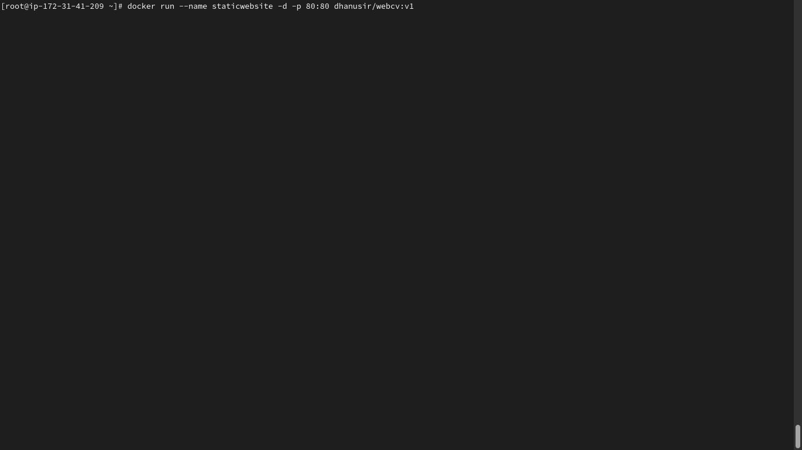

output

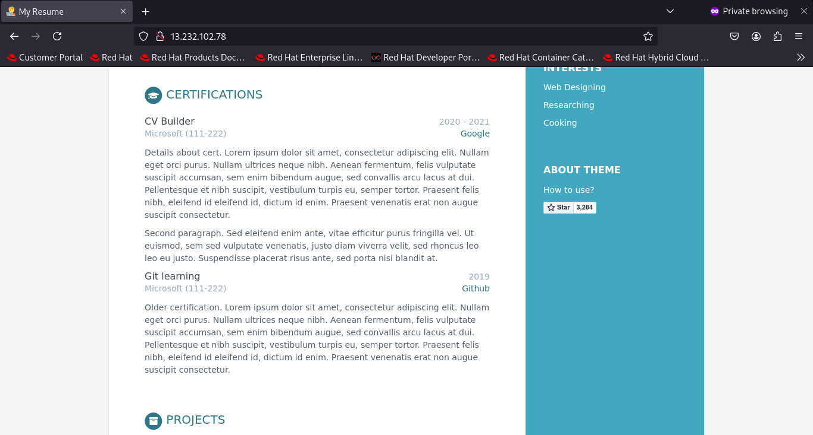
Thank you

