**TRAFFIC MANANGEMENT SYSTEM**

**Creating a platform for Traffic manangement system using MIT App Inventor involves several steps. MIT App Inventor is a user-friendly platform for creating Android apps, and it can be used to build a mobile app that monitors and controls Traffic lights. Here's a basic outline of the steps involved.**

**Design the User Interface (UI):**

Use MIT App Inventor's drag-and-drop interface to design the screens for your app.

Include buttons, labels, and other UI components to control and display information about the traffic management system.

**Map Integration:**

If you want to show a map with traffic data, you can use the Google Maps component in MIT App Inventor.

**Sensors and Data Collection:**

If your traffic system involves collecting data, such as traffic light statuses, you might need to use external sensors and hardware connected to your mobile device.

**Block-Based Coding:**

Utilize MIT App Inventor's blocks to program the logic of your traffic management system.

Set up event handlers for UI components to control the system.

**Traffic Control Algorithms:**

Implement algorithms to manage traffic lights, intersections, or any other aspects of your system.

Use conditions and loops in your block-based code to simulate the behavior of a traffic management system.

**Communication:**

If you're working on a system that involves communication between devices or sensors, you might need to use Bluetooth or Wi-Fi components available in MIT App Inventor.

**Testing and Debugging:**

Test your app on an Android device using the MIT AI Companion app or by building an APK file.

Debug and refine your code as needed.

**User Feedback and Monitoring:**

Implement features for users to provide feedback or monitor the traffic system's status.

**Documentation:**

Document your code and how the traffic management system works.

**Deployment:**

Once your app is ready, you can deploy it on Android devices.teps involved.

**Circuit design & program:**

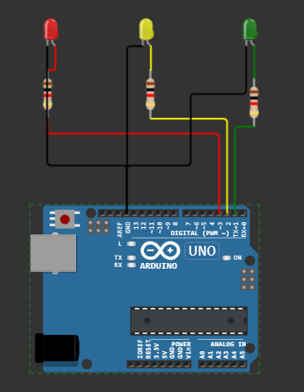

**Program:**

# Define traffic light states

GREEN = 1

YELLOW = 2

RED = 3

# Initialize the traffic light state

current_state = GREEN

while True:

if current_state == GREEN:

print("Green Light - Go")

time.sleep(10) # Green light duration

current_state = YELLOW

elif current_state == YELLOW:

print("Yellow Light - Prepare to Stop")

time.sleep(2) # Yellow light duration

current_state = RED

else:

print("Red Light - Stop")

time.sleep(10) # Red light duration

current_state = GREEN

**Block design for app:**

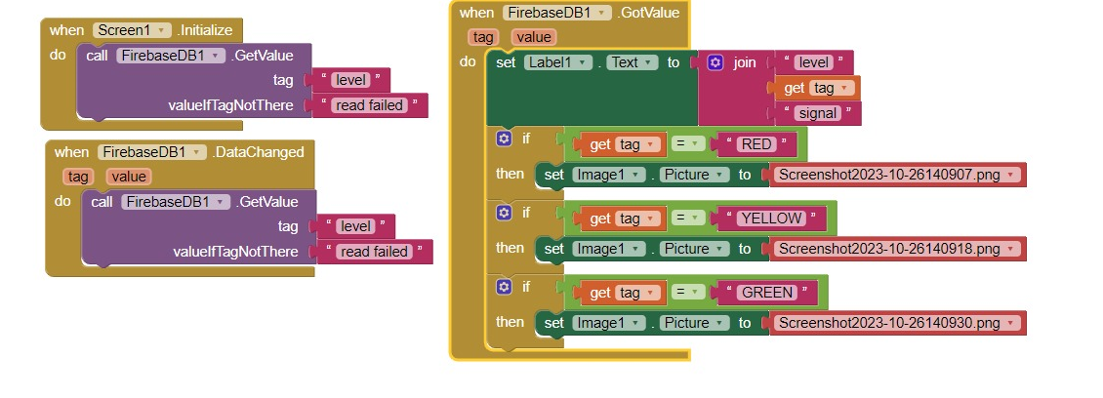**Start a New Project:**

Begin by starting a new project in MIT App Inventor. Give it a meaningful name, such as "TrafficManagerApp."

**Design the User Interface:**

Drag and drop components onto the interface canvas for features like maps, buttons, text labels, and input fields.

Organize and layout the interface for a user-friendly experience.

**Screen Layouts:**

Create different screens (e.g., Home, Maps, Reporting) for various app functions. Use the "Screen Arrangement" component for this.

Define how users will navigate between these screens using buttons or menus.

**Define Components:**

For each screen, add necessary components (e.g., Google Maps, TextBox for user input, Labels for display, etc.).

**Design User Interaction:**

Use event handlers to specify how users will interact with the app components (e.g., what happens when a button is clicked).

**Implement Traffic Data Collection:**

Add components for data collection, like GPS or sensor.

Define how the app will collect and process traffic data, such as real-time traffic information.

**Route Planning Module:**

Create a separate block for route planning using the "Directions" component.

Allow users to input their destination and receive directions.

**User Management:**

Implement user management features, including registration, login, and profile management.

Use "Firebase Authentication" or a similar service for user authentication.

**Reporting and Feedback:**

Add a reporting feature that allows users to report traffic incidents or road conditions

Create a form or input mechanism for users to submit reports.

**Data Storage:**

Use Firebase or a local database component to store user data, traffic information, and reports.

**Security:**

Implement security measures to protect user data and app functionality.

Ensure user authentication for sensitive actions.

**Testing and Debugging:**

Test the app on a physical device or an emulator.

Debug and fix any issues that arise during testing.

**Error Handling:**

Include error handling and notifications for situations where the app encounters problems.

**Integration:**

If needed, integrate external APIs or services for additional data sources, like weather data or traffic APIs.

**User Feedback and Reporting:**

Include mechanisms for users to provide feedback or report issues within the app.

**Documentation:**

Document the app's components, functions, and event handlers for future reference.

**Refinement and Optimization:**

Optimize the app for performance and user experience.

Refine the design based on user feedback.

**Continuous Improvement:**

Plan for future updates and enhancements to the app.