Classic Segmentation of U2OS Cell Nuclei in Fluorescence Microscopy Images
Name: Krishnanand Sagar
Student ID: C5056945
Academic year: 2025-26

Introduction
Nuclei segmentation is the mandatory prerequisite for quantitative microscopy analysis. In research utilising the U2OS human osteosarcoma cell line, precise spatial delineation of nuclei is essential for tracking cell cycle dynamics, quantifying nuclear morphology, and assessing phenotypic responses in high content screening. U2OS cells are particularly favored in these assays due to their robust adherence and distinct morphological phenotypes when subjected to chemical perturbations. In this study the nuclei are visualised using HOECHST stain, a fluorescent dye that binds specifically to the minor groove of double stranded DNA.
The challenge of algorithmic segmentation stems from touching nuclei in dense fields, high variance in intensity, uneven illumination, and the presence of faint nuclei that bleed into the background. These intensity variations are not merely imaging artifacts; they represent genuine biological differences in chromatin compaction and DNA content at different phases of the cell cycle. Consequently, a rigid algorithmics approach often fails. Manual annotation to resolve these issues is subjective, slow, and requires extensive domain expertise.
This report presents a classic, non-CNN pipeline to segment U2OS nuclei. Built as a baseline and systematically improved over four stages, the approach relies on adaptive thresholding, morphological operations, and marker-controlled watershed segmentation. The dataset utilised is a sample of BBBC039v1 collection, comprising 16-bit fluorescence fields of HOECHST-stained DNA, initially curated to evaluate algorithms capable of separating individual nucleus instances regardless of local cell density or shape complexity.

Methodology
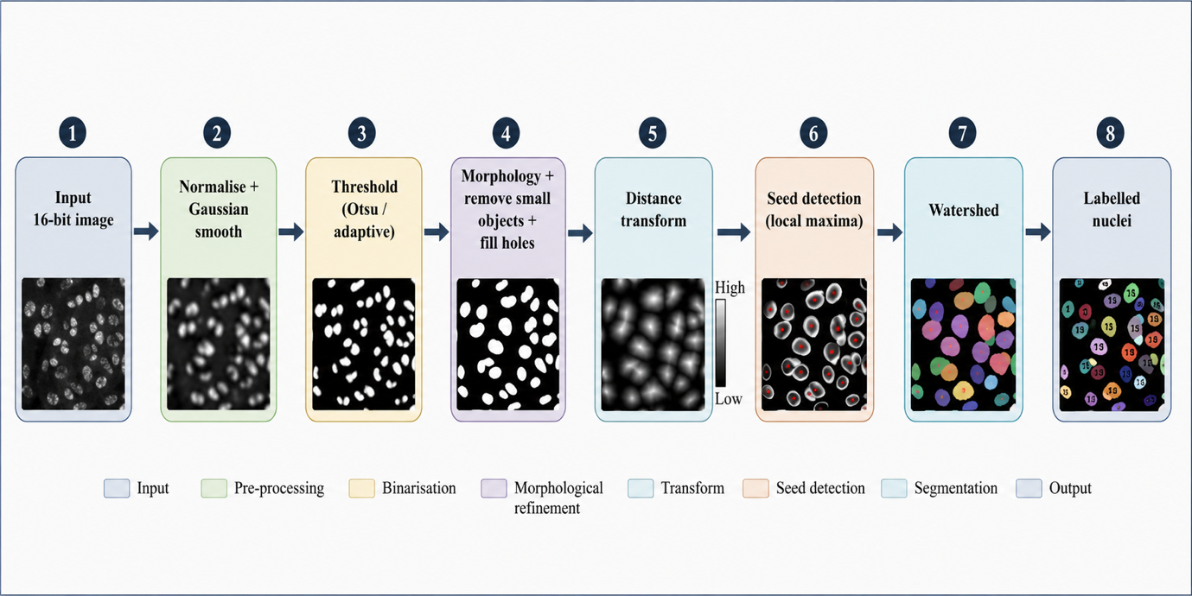
The algorithmic pipeline operates sequentially across four stages to isolate single nuclear instances for raw 16-bit inputs.
Figure 1 —Pipeline Flowchart.

Stage 1 (Baseline): Images are normalised to the [0,1] range utilising the first and 99.5th percentiles to map the limited dynamic range while robustly ignoring extreme outlier pixels that would otherwise skew the intensity distribution. A Gaussian filter is applied to suppress high-frequency sensor noise and internal nuclear texture. Without this smoothing, internal variations in chromatin density would cause the subsequent thresholding step to fracture a single nucleus into multiple disconnected components. Binarization is executed via a global Otsu threshold, maximising between class variance to isolate bulk foreground. Mathematically, Otsu’s algorithm iteratively searches for the threshold that minimises the intra-class variance of the background and foreground pixels, which is conceptually identical to maximising the variance between those two classes.
Stage 2 (Cleanup): To refine the baseline, morphological opening eliminates speckle noise. Morphological opening is a compound operation consisting of an erosion followed by a dilation. The erosion strips away small, isolated pixels and breaks thin connections between larger objects. The subsequent dilation restores the remaining, valid nuclei back to their original morphological boundaries without resurrecting the erased noise. Internal holes with nuclear masks are filled, and objects below 30-pixel area threshold are discarded to ensure boundary integrity.
Stage 3 (Watershed): To separate clustered nuclei, a Euclidean distance transform is applied to the binary mask. This transform computes the linear distance from every foreground pixel to the nearest background pixel, effectively mapping the internal topography of the nuclei. Local Maxima within the distance map are identified as unique seeds for each nucleus, as the furthest point from the background naturally correlates with the geometric centre of a roughly convex object. A marker-controlled watershed is then executed on the inverted distance map. Conceptualized as a geographical immersion simulation, the algorithm “floods” catchment basins starting from the identified local maxima. As the water level rise, ridge lines are computationally erected exactly where the basins of adjacent nuclei intersect, successfully cleaving fused instances.
Stage 4 (Refinement): To account for uneven elimination, the global Otsu threshold is replaced by a local adaptive threshold. Instead of evaluating the entire image histogram, this technique computes a distinct threshold for each localised pixel neighbourhood, allowing faint nuclei in darker regions to be detected. However, to prevent background noise from being an amplified into foreground objects in empty regions of the field, the local threshold is strictly gated by a global floor. The outputs are processed through the identical cleanup and watershed logic from stages 2 and 3.
Implementation Details
The pipeline was engineered in Python. sci-kit-image was selected as the core framework for its robust, peer reviewed implementations of classical operations, explicitly threshold_otsu, threshold_local, and watershed.spicy.ndimage was leveraged for high performance computation of the distance_transform _edt and connected component labelling.
16-bit TIFF arrays were handled via tifffile. Preserving the native 16-bit depth rather than down-sampling to 8-bit is non-negotiable in quantitative microscopy, as it prevents the destruction of subtle intensity gradients necessary for separating tightly packed nuclei. Computations were executed on a CPU based runtime; as the methodology strictly adheres to classical computer vision techniques without tensor based deep learning, GPU acceleration was structurally unnecessary and would offer zero performance field. Furthermore, relying on classical libraries ensures strict reproducibility of results, bypassing the stochastic variance inherent in neural network initialising and training. We used image set BBBC039v1, available from the Broad Bioimage Benchmark Collection.

Results
Table 1 — Mean pixel-level metrics across all images, by pipeline stage.
Stage | IoU (fg) | mIoU | Dice | Sensitivity | Specificity
S1: Otsu | 0.887 | 0.930 | 0.940 | 0.907 | 0.996
S2: + cleanup | 0.885 | 0.929 | 0.939 | 0.904 | 0.996
S3: + watershed | 0.884 | 0.928 | 0.938 | 0.904 | 0.996
S4: + adaptive | 0.909 | 0.944 | 0.952 | 0.950 | 0.991

Table 2— Object-level evaluation (Stage 4, IoU>0.5 matching).
Metric | Value
Object precision | 0.74
Object recall | 0.87
Object F1 | 0.80
Predicted nuclei | 111
Ground-truth nuclei | 94
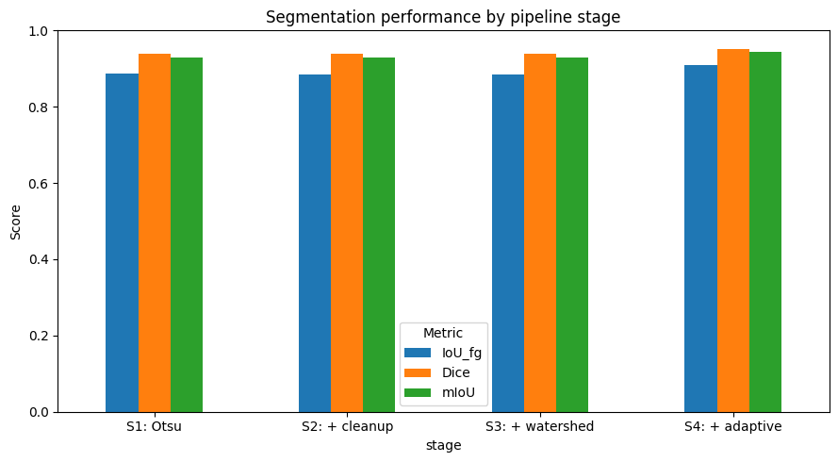
Figure 2— the 'Segmentation performance by pipeline stage’ bar chart
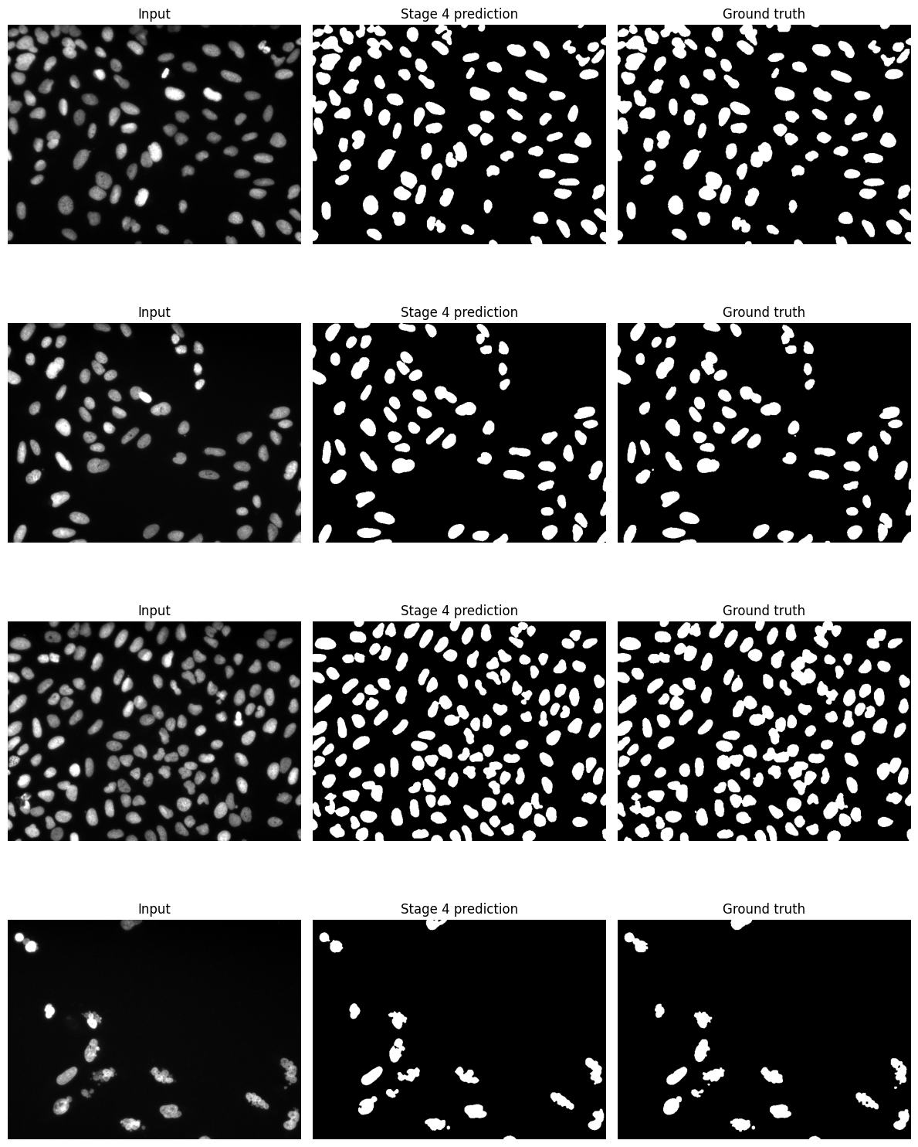
Figure 3— QUALITATIVE PANELS: Input | Stage-4 prediction | Ground truth
Performance was quantified sequentially across the four pipeline stages. At the pixel level, stage 1 achieved a baseline foreground Intersection over Union of 0.887 and a Dice coefficient of 0.940. Stages 2 and 3 maintain foreground IoU of 0.884, indicating a stabilisation of bulk foreground classification. The deployment of adaptive thresholding stage 4 yielded peak performance: foreground IoU increased to 0.909, Dice to 0.952, and mean IoU to 0.944.
The shift in stage 4 was driven by a rise in sensitivity allowing the detection of previously missed faint nuclei. This 4.3% absolute increase in sensitivity confirms that local adaptive thresholding successfully compensated for the fluorescence attenuation at the edges of illumination field. This was achieved with a negligible drop in specificity, demonstrating that global floor parameters successfully suppressed false positive in background.
At the object level, evaluated via instance matching at IoU > 0.5, stage 4 achieved a precision of 0.74, a recall of 0.87 and F1 score of 0.80. The algorithm predicted 111 nuclei instances compared to the 94 present in the ground truth annotation, indicating a clear propensity for over-segmentation rather than under-segmentation.
Discussion
The quantitative output reveals specific operational realities of the pipeline. First the requested mIoU metric is highly susceptible to class imbalance. Nuclei represent approximately 2 to 6% of a spatial filled; consequently, the massive volume of true negative pixels anchors the background IoU near 0.99, artificially inflating the mean. If an algorithm trivially predicted the entire image as background, it would still achieve a deceptively high background IoU. Therefore, Foreground IoU and the Dice coefficient serve as the mathematically honest indicators of segmentation accuracy.
Second, the apparent stagnation of pixel metrics during stages 2 and 3 is expected. Morphological opening and watershed ridge- lines alter only boundary pixels. These micro-adjustments are statically invisible to bulk pixel overlap calculations but are mission critical at the object level for instance separation. A pixel level metric evaluates the total area of paint on a canvas, but it cannot evaluate whether that paint represents one large house or two smaller, distinct houses. The watershed algorithm provides the latter.
The primary limitation of this pipeline is over segmentation, evidenced by the generation of 111 predicted objects against 94 ground truth instances. The Euclidean distance transform occasionally generates multiple local maxima within a single, irregularly shaped nucleus, causing the watershed algorithm to inappropriately split the instance. Classical methods rely on morphological priors-specifically, the assumptions that nuclei are fundamentally convex shapes. When a nucleus exhibits a concave or kidney like morphology, the distance map naturally produces a peak at each lobe, subverting the logic of the local maxima seed detection. While the stage 4 refinement proved highly effective at recovering faint nuclei under uneven illumination, it does not natively resolve complex dense clusters.
Compared to contemporary literature, deep learning CNN architectures routinely achieve foreground IoU's exceeding 0.90 on similar fluorescence data. This classical pipeline matches that benchmark while eliminating the requirement for annotated training data. While CNNs implicitly learn complex special features through gradient descent, this pipeline relies on explicitly engineered features. This trades the absolute peak accuracy of deep learning for a highly interpretable, computationally lightweight alternative that can run instantly on commodity hardware.
Conclusions
This project successfully developed a classical four stage segmentation algorithm for U2OS cell nuclei, peaking at the foreground IoU of 0.909 and an object F1 score 0.80 without deep learning. The pipeline demonstrates that computationally efficient, traditional morphological techniques can still yield highly robust quantitative results. The primary limitation remains the over segmentation of dense or irregular shaped nuclei. Future iterations must implement H-maxima transforms to dynamically suppress spurious local maxima in the distance map before watershedding, establish an automated hyperparameter optimization protocol for block sizes, and deploy a baseline U-Net CNN to quantitatively compare the trade-offs between classical interpretability and learned special representations.
References
[1] N. Otsu, “A threshold selection method from gray-level histograms,” IEEE Transactions on Systems, Man, and Cybernetics, vol. 9, no. 1, pp. 62–66, 1979.
[2] L. Vincent and P. Soille, “Watersheds in digital spaces: an efficient algorithm based on immersion simulations,” IEEE Transactions on Pattern Analysis and Machine Intelligence, vol. 13, no. 6, pp. 583–598, 1991.
[3] J. C. Caicedo et al., “Nucleus segmentation across imaging experiments: the 2018 Data Science Bowl,” Nature Methods, vol. 16, no. 12, pp. 1247–1253, 2019, doi: 10.1038/s41592-019-0612-7.
[4] V. Ljosa, K. L. Sokolnicki, and A. E. Carpenter, “Annotated high-throughput microscopy image sets for validation,” Nature Methods, vol. 9, no. 7, p. 637, 2012, doi: 10.1038/nmeth.2083.
[5] J. C. Caicedo et al., “Evaluation of deep learning strategies for nucleus segmentation in fluorescence images,” Cytometry Part A, vol. 95, no. 9, pp. 952–965, 2019, doi: 10.1002/cyto.a.23863.
[6] S. van der Walt et al., “scikit-image: image processing in Python,” PeerJ, vol. 2, e453, 2014, doi: 10.7717/peerj.453.

