Freight Rate Prediction
Spotter Machine Learning Engineer Assessment Report
Prepared from reproducible project outputs; internal metrics are not official Spotter scores.

1. Executive Summary
This project predicts freight rates for unseen loads. The final solution uses a Ridge regression pipeline trained on all 48,000 labeled January–October 2025 loads. It applies deterministic cleaning, compact geographic/calendar features, training-fitted imputation, and unknown-category-safe encoding. A chronological September–October holdout was used to simulate future prediction. The selected candidate achieved internal holdout MAE of $149.63, RMSE of $643.53, and R² of 0.8222. Final predictions for 12,000 validation loads and 31 December scenario rows passed the supplied scorer validation.

2. Problem Understanding
The task is supervised regression: learn posted_rate from labeled historical loads and predict posted_rate for the unlabeled validation loads. The final validation file contains 12,000 unique load IDs and later dates than development data.

3. Dataset Overview
Dataset | Rows | Columns | Date coverage
Development | 48,000 | 14 | 2025-01-01 to 2025-10-31
Final validation | 12,000 | 13 | 2025-11-01 to 2025-12-31
December scenario | 31 | 7 | 2025-12-01 to 2025-12-31
Target: posted_rate. Validation includes the same input schema as development except for the target.

4. Exploratory Data Analysis
Target statistic | Value
Minimum | $57.22
Median | $2030.76
Mean | $2373.98
Standard deviation | $1486.49
95th percentile | $4953.77
99th percentile | $5972.83
Maximum | $25533.00
Posted rates are right-skewed: the mean exceeds the median and the maximum is substantially above the 99th percentile. Distance is the strongest numeric relationship with posted_rate (Pearson correlation 0.9085). Reefer loads had the highest mean rate ($2,553.64), followed by Flatbed ($2,445.09) and Dry Van ($2,271.55).
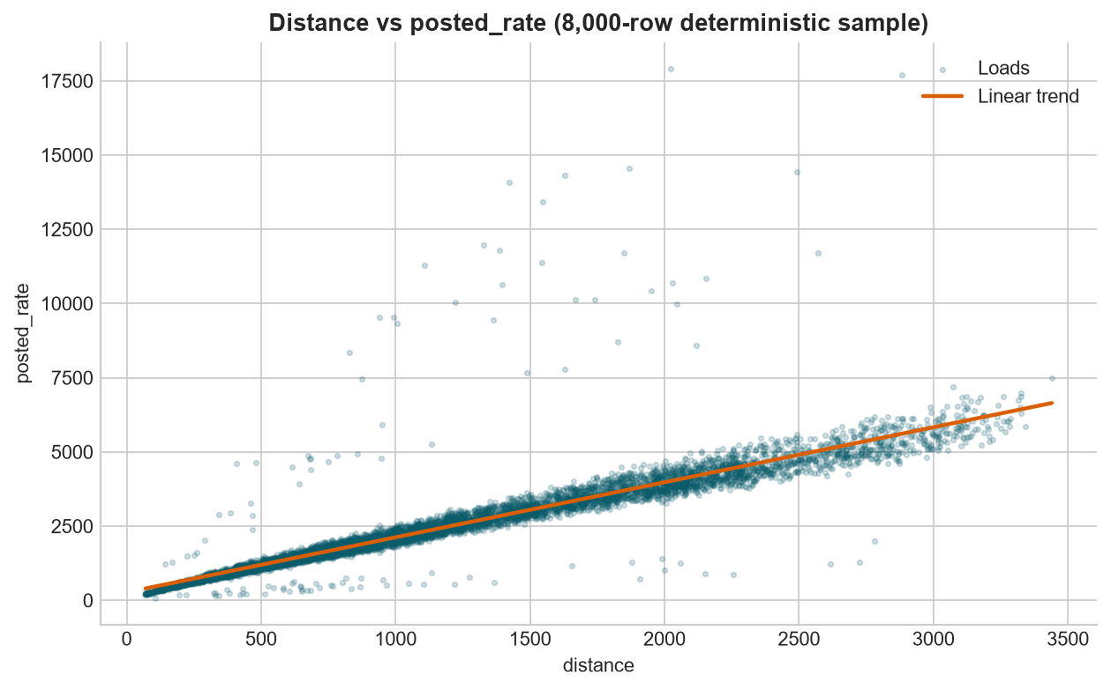
Figure 1. Distance has a strong positive, but not perfectly linear, relationship with posted rate.

5. Data Quality Issues
Issue | Development | Validation | Finding
Missing weight | 300 | 165 | Requires consistent numeric handling
Missing market_index | 374 | 249 | Requires consistent numeric handling
Negative weight | 292 | 145 | Physically invalid
Duplicate rows / load IDs | 0 / 0 | 0 / 0 | No removal required
Validation-only cities | N/A | 8 pickup and 8 delivery values | Must support unseen categories
All dates parsed successfully. No non-positive distances, invalid coordinate ranges, or non-positive training targets were found.

6. Data Cleaning Strategy
- Negative weights were not dropped or converted to absolute values. They were converted to missing values and retained through weight_was_negative.
- Numeric fields are median-imputed inside the training-fitted pipeline, with missing-value indicators.
- Categorical fields use most-frequent imputation and one-hot encoding with handle_unknown='ignore'.
- No preprocessing statistic is fitted on final validation data.

7. Feature Engineering
The final features retain raw coordinates, distance, weight, market index, quote signal, equipment, and city fields. Added features are distance_log1p, latitude/longitude differences, haversine distance, distance × market index, day of week, cyclic day-of-year features, and weight_was_negative. The route string was intentionally rejected: development had 4,014 routes and 1,461 validation rows used unseen routes.

8. Train/Validation Split Strategy
Partition | Rows | Dates | Purpose
Fit | 38,477 | 2025-01-01 to 2025-08-31 | Fit candidate pipelines
Internal holdout | 9,523 | 2025-09-01 to 2025-10-31 | Future-like model comparison
Final validation | 12,000 | 2025-11-01 to 2025-12-31 | Unlabeled final prediction
A chronological cutoff of 2025-09-01 was chosen because the 61-day September–October holdout matches the 61-day November–December final horizon. A random split would mix earlier and later dates in both partitions and produce a less realistic estimate of future performance.

9. Baseline Model
Model | MAE | RMSE | R² | Observation
Ridge baseline | $149.70 | $643.54 | 0.8222 | Underpredicted rare high-rate loads; 11 non-positive raw estimates

10. Model Experiments
Model | MAE | RMSE | R² | RMSE gap | Train sec
ridge | $149.63 | $643.53 | 0.8222 | 58.44 | 0.37
extra_trees | $156.30 | $661.28 | 0.8122 | 326.90 | 71.50
random_forest | $160.27 | $655.92 | 0.8153 | 269.43 | 36.35
hist_gradient_boosting | $166.61 | $652.90 | 0.8170 | 192.95 | 6.68
All values are internal chronological-holdout metrics, not official Spotter scores.

11. Final Model Selection
Ridge was selected because it had the lowest chronological-holdout MAE ($149.63), lowest RMSE ($643.53), highest R² (0.8222), and smallest RMSE generalization gap (58.44). The tree models fitted historical rows more closely but did not improve performance on later unseen rows. The final Ridge pipeline includes a 0.01 positive prediction floor required by the scorer.

12. Validation Results
The selected model's internal evaluation is based only on September–October rows, with all preprocessing fit on January–August. The project does not claim an official Spotter score: final validation metrics are calculated by Spotter after submission.

13. Final Validation Prediction Generation
The saved pipeline was retrained on all 48,000 development rows and applied to all 12,000 final validation loads. validation_predictions.csv contains exactly load_id and predicted_rate, preserves template order, has no duplicate IDs or missing values, and passed local scorer-compatible checks.

14. December Prediction Analysis
For the fixed Lexington-to-Fort Wayne scenario (360 miles, Dry Van, 32,000 lb), all 31 December dates were predicted. Predictions range from $902.91 to $967.81. Only date changes across the scenario.

15. candidate_december.png
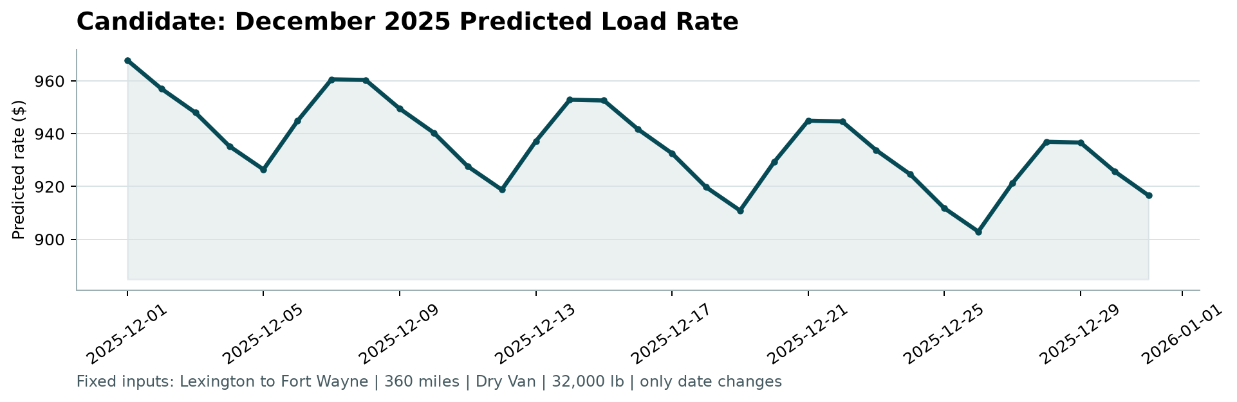
Figure 2. Candidate December 2025 predicted load rate, generated by the supplied score.py.

16. Limitations
- Only one chronological holdout window was used because of the assessment time limit; repeated rolling-origin validation could provide more confidence.
- Rare extreme-rate loads remain challenging: Ridge underpredicted the highest actual-rate holdout decile on average.
- The final validation period has a lower market_index distribution than development data, creating temporal distribution shift.
- December inputs omit market_index and quote_signal; the saved pipeline uses development-fitted imputation for those unavailable fields.
- The business provenance of market_index and quote_signal should be confirmed to ensure they are available at quote time.

17. Reproducibility / How to Run
From the repository root:
python -m pip install -r requirements.txt
python scripts/train_final_model.py
python scripts/predict_validation.py
python scripts/predict_december.py
python score.py --predictions validation_predictions.csv --december-predictions data/december-chart-inputs.csv
To regenerate this report: python scripts/generate_assessment_report.py

