

A Project Report

On

**Self-Learning Bot**

**(Medic-Bot)**

Batch Details

|  |  |  |
| --- | --- | --- |
| Sl.No | Roll Number | Name |
| 1. | 20201CEI0077 | Krishana S |
| 2. | 20201CEI0011 | S Mohammed Enthihaj |
| 3. | 20201CEI0030 | Rihan Anwar CA |
| 4. | 20201CEI0001 | Ambrish Kumar S |

**School of Computer Science,**

**Presidency University, Bengaluru.**

Under the guidance of,

**Mr. Muthuraju V**

Assistant Professor

School of Computer Science,

Presidency University, Bengaluru

**CONTENTS**

• Introduction about Project

• Literature Review

• Objectives

• Methodology

• Timeline for Execution of Project

• Expected Outcomes

• Conclusion

• References

**1.INTRODUCTION**

**General introduction:**

In the dynamic landscape of healthcare technology, the emergence of a self-learning medical chatbot marks a pivotal shift in user engagement with healthcare resources. This proposed methodology intricately weaves together data collection, Natural Language Processing (NLP), and machine learning techniques to sculpt an intelligent healthcare assistant.

Prioritizing user experience, data precision, and privacy safeguards, the chatbot aims to be a reliable and adaptable guide, offering personalized assistance amid the intricate tapestry of healthcare information. As we embark on this journey, the vision is clear: to redefine accessibility and responsiveness in the realm of healthcare support through an evolving and intelligent chatbot framework.

This assistant is more than just a tool; it's envisioned as a friendly guide, ready to assist and enhance your understanding of complex medical concepts. The plan is meticulous, prioritizing user-friendliness, accuracy, and the safeguarding of your personal information. Picture the chatbot as a reliable companion in the intricate world of healthcare information, offering personalized support tailored to your unique needs and queries.

As we embark on this captivating journey, the overarching vision is crystal clear: we aim to redefine how individuals connect with and experience healthcare support. By constructing a chatbot that not only comprehends your questions but evolves intelligently over time, our goal is to provide a healthcare experience that feels intimately tailored to you.

**Introduction to the domain of the Problem statement:**

In today's digital age, where information is abundant, individuals often find themselves navigating an overwhelming sea of healthcare data online. Unfortunately, this wealth of information doesn't always translate into accurate self-diagnosis or understanding of medical symptoms.

The problem lies in the difficulty people face in discerning the relevance and accuracy of healthcare information, leading to potential misinterpretations, unnecessary anxiety, or delayed professional medical consultation.

Despite the plethora of health-related websites and forums, there is a lack of personalized and reliable tools that cater to individuals seeking immediate guidance about their symptoms. Recognizing this gap, our initiative focuses on developing a self-learning medical chatbot—a tool that not only identifies diseases based on user-provided symptoms but also delivers comprehensive and accurate information about those conditions.

Our initiative addresses this critical issue by focusing on the development of a self-learning medical chatbot. This intelligent tool is envisioned not only to identify diseases based on user-provided symptoms but, more importantly, to deliver comprehensive and accurate information about those identified conditions. The intent is to create a virtual assistant that not only recognizes symptoms but acts as a trusted source of information, helping users understand their health concerns, potential causes, and appropriate courses of action.

**2.LITERATURE REVIEW**

**1.Bots Using Natural Language Processing in Medic Sector**

**1.1.** Natural Language Processing (NLP) allows computers and algorithms to understand human interactions in a range of languages. Chatbots are apps that corporations or other entities employ to conduct an automated dialogue between a human and an artificial intelligence.

**1.2.** The study offers a ground-breaking computer programme that acts as a patient's personal virtual physician. This programme has undergone extensive training to interact with patients as though they were genuine individuals.

**1.3.** The heart of the chatbot is the dialogue manager. External API employs Natural Language Processing (NLP), which splits down and parses texts to disclose the sentence structure and details about unique words.

**Advantages:** One of the main benefits of using chatbots in the medical sector is their ability to handle circumstances where a lack of doctors is the leading cause of inappropriate patient treatment and, in some cases, death 1. Even doctors might make mistakes in providing the proper therapy, resulting in the patient's death. A smart and clever chatbot is needed to handle these circumstances since it can advise doctors and occasionally even patients on what to do, ultimately saving hundreds of lives. Doctors can make mistakes when analyzing symptoms, but a computer that is specifically designed for it will not be able to do so. That is why the ML-based chatbot on which this study topic is developed deals with providing College guidance in such a circumstance

**Disadvantages:** While medical chatbots offer benefits in addressing a lack of doctors, potential disadvantages include their limited ability to handle uncommon cases, risk of misinterpretation, lack of human empathy, potential overreliance leading to reduced human oversight, privacy concerns, and technical limitations based on training data.

**2.Conversational Bot for Pharmacy: A Natural Language Approach**

**2.1** Of the paper presents the related work, which includes a few applications that have been studied. The applications include Medikoma, Medbot, and Medibot. The strengths and weaknesses of these applications are discussed, and the development of the new system takes into account these factors.

**2.2** Of the paper presents the development methodology, which includes the use of the Agile development process and the development of use cases and user stories. The chatbot system is designed to have two parts: a customer-facing interface and a system administrator interface.

**2.3** Of the paper presents the prototype implementation and testing of the chatbot system. The system is tested using user acceptance tests, which include testing the security, functionality, font, image/graphic use, interface layout, color scheme, and delivery of information. The results of the user acceptance tests are presented.

**2.4** Of the paper concludes with some indications for future work, which include the integration of the chatbot system with the pharmacy's existing systems and the development of a mobile application

**Advantages:**

**Improved Customer Engagement:**

* A conversational bot engages customers in natural language conversations, creating a more user-friendly and interactive experience.
* Users can ask questions, seek advice, and get information about medications in a conversational manner, leading to a more engaging and personalized interaction.

**Time and Cost Efficiency:**

* The bot can handle routine inquiries, allowing pharmacy staff to focus on more complex tasks. This improves overall operational efficiency and reduces the time spent on repetitive tasks.
* Automated processes for order placement, prescription verification, and information retrieval can significantly cut down on operational costs.

**Enhanced Accessibility and Availability:**

* The bot provides 24/7 accessibility, allowing users to access information and services at any time, even outside regular business hours.
* Users can interact with the bot from various devices, including smartphones and computers, making it a convenient and accessible solution for a wide range of customers.

**Personalized Assistance and Recommendations:**

* Natural language processing enables the bot to understand user preferences and health history, providing personalized recommendations for medications and health-related products.
* The bot can offer tailored advice based on individual needs, improving the overall customer experience and satisfaction.

**Disadvantages:**

1. **Limited capabilities:** Chatbots may not be able to handle complex inquiries or provide personalized advice in the same way that a human staff member could.

2. **Technical issues:** Chatbots may experience technical issues or errors that could result in incorrect or incomplete information being provided to customers.

3. **Lack of empathy:** Chatbots may not be able to provide the same level of empathy or emotional support as a human staff member could.

4. **Security concerns:** Chatbots may be vulnerable to security breaches or hacking attempts, which could compromise sensitive customer information.

5. **User adoption:** Some customers may be hesitant to use a chatbot application and may prefer to interact with a human staff member instead.

**3.OBJECTIVES**

The proposed methodology aims to create an advanced healthcare chatbot with objectives focused on improving user experience, enhancing response accuracy, enabling continuous learning, ensuring privacy and data security, and providing personalized healthcare guidance. The approach involves user-friendly design, machine learning algorithms for precise responses, integration of self-learning mechanisms, robust privacy measures, and utilization of knowledge graphs for personalized advice. The ultimate goal is to develop a reliable and adaptive healthcare chatbot that prioritizes user satisfaction, accuracy, and privacy in medical interactions.

**Key Objectives:**

**1. Enhance User Experience and Accessibility**:

Develop a medical chatbot that offers an intuitive and user-friendly interface to provide accessible healthcare information and assistance to users, ensuring a positive user experience.

**2**. **Improve Accuracy and Relevance of Responses**:

Implement machine learning algorithms to enhance the chatbot's ability to understand user intents, accurately extract medical entities, and generate relevant responses, thereby improving the quality of interactions.

**3**. **Enable Continuous Learning and Adaptability:**

Integrate mechanisms for self-learning, reinforcement learning, and continuous updates, allowing the chatbot to adapt to new medical information, user feedback, and changing healthcare contexts for improved performance over time.

**4. Ensure Privacy and Data Security:**

Incorporate robust privacy measures and data encryption techniques to safeguard users medical data and ensure compliance with healthcare privacy regulations, establishing trust and confidentiality in interactions.

**5.Facilitate Personalized Healthcare Guidance:**

Utilize knowledge graphs and integrate with electronic health record systems to offer personalized healthcare recommendations, tailoring advice based on individual medical histories and preferences.

**EXPERIMENTAL DETAILS/METHDOLOGY**

**Software Used:**

• Windows Operating System

• VScode

• Github

**4. METHODOLOGY**

**1. Data Collection and Preparation:**

Collect a diverse dataset of medical literature, research papers, clinical notes, and publicly available healthcare information to form the basis of the chatbot's knowledge.

Preprocess the data by cleaning and standardizing the text, removing irrelevant information, and structuring it into a format suitable for analysis and modelling

**2. Natural Language Processing (NLP):**

Implement NLP techniques to parse and understand the medical text, including tokenization, stop-word removal, stemming, and lemmatization.

Utilize named entity recognition (NER) and part-of-speech tagging to identify medical entities, relationships, and categories within the text.

**3.Machine Learning and Deep Learning Models:**

Develop machine learning models, such as support vector machines (SVM) or decision trees, to classify intents and extract key medical entities from user queries.

Explore advanced deep learning models like recurrent neural networks (RNNs) or transformers for intent classification, entity recognition, and response generation based on the pre-processed medical text.

**4. Reinforcement Learning and Feedback Loop:**

Implement a reinforcement learning approach to continually improve the chatbot's responses based on user feedback and interactions.

Create a feedback loop that allows users to rate and provide feedback on the chatbot's responses, enabling the model to learn from its mistakes and enhance its accuracy and relevance over time.

**5. Iterative Development and Evaluation:**

Adopt an iterative development approach, where the chatbot is continually updated, refined, and expanded with new medical data and improved algorithms.

Evaluate the chatbot's performance using various metrics such as precision, recall, F1-score, and user satisfaction surveys to identify areas for enhancement and ensure the chatbot meets its intended objectives.

These methodologies provide a structured approach for building a self-learning medical chatbot, focusing on data, language understanding, machine learning models, continuous learning, and iterative development to create an effective and reliable healthcare tool.

**Algorithim Used:-**

**1.**Data Collection and Pre-processing:

• 1.1: Gather a diverse dataset of medical texts, including textbooks, research papers, and reputable online sources.

• 1.2: Pre-process the data to remove noise, standardize formatting, and ensure consistency.

• Natural Language Processing (NLP):

• 2.1: Implement tokenization, stop-word removal, stemming, and lemmatization for text processing.

• 2.2: Utilize named entity recognition (NER) and part-of-speech tagging to identify medical entities, relationships, and categories within the text.

• 2.3: Apply sentiment analysis to understand the emotional tone of the text.

• Knowledge Graphs:

• 3.1: Create a structured knowledge graph using the pre-processed data to organize medical concepts, relationships, and facilitate efficient information retrieval.

• Intent Recognition and Entity Extraction:

• 4.1: Utilize machine learning models for intent classification, identifying the user's purpose in the conversation.

• 4.2: Extract relevant entities from user queries to understand the context and specific information needed.

• Machine Learning Algorithms:

• 5.1: Employ machine learning algorithms (e.g., SVM, decision trees) for intent classification.

• 5.2: Implement deep learning models (e.g., RNNs, transformers) for entity recognition and response generation based on pre-processed medical text.

• Dialog Management:

• 5.1: Implement a dialogue management system to maintain context and handle multi-turn conversations.

• 5.2: Generate appropriate responses based on the chatbot's training, using the information from the knowledge graph.

• Reinforcement Learning:

• 6.1: Integrate reinforcement learning techniques to allow the chatbot to learn and optimize responses through trial-and-error interactions, adapting to user feedback.

• User Feedback Loop:

• 7.1: Establish a mechanism for collecting user feedback on the chatbot's responses.

• 7.2: Use user feedback to continuously improve the chatbot's performance and accuracy.

• Continuous Learning and Updating:

• 8.1: Implement mechanisms for periodic updates and retraining of the chatbot using new medical data to keep information up-to-date and accurate.

• Privacy and Security Measures:

9.1: Incorporate stringent privacy measures to ensure the confidentiality and protection of sensitive medical data shared during interactions.

**4.1 DESIGN PROCEDURE**

Designing a healthcare chatbot involves several steps to ensure its effectiveness, user-friendliness, and adherence to ethical and privacy considerations. Here's a design procedure for creating a healthcare chatbot:

Define Objectives and Scope:

• Clearly outline the goals and objectives of the healthcare chatbot.

• Determine the specific scope, including the range of medical topics and user interactions.

• Identify Target Audience:

• Identify the primary users and understand their specific needs and preferences.

• Compliance with Regulations:

• Ensure compliance with healthcare regulations and privacy laws.

• Implement security measures to protect sensitive medical information.

• User Interface Design:

• Create an intuitive and user-friendly interface.

• Design a conversational flow that guides users through interactions.

• Persona Development:

• Develop a persona for the chatbot that aligns with the healthcare context.

• Feature Specification:

• Define the features the chatbot will offer based on user needs.

• Prioritize features to align with the primary objectives.

• Integration with Knowledge Base:

• Establish a comprehensive knowledge base with accurate and up-to-date medical information.

• Natural Language Processing (NLP):

• Implement NLP techniques for better understanding of user inputs.

• Test and refine NLP algorithms to improve accuracy.

• Testing and Iteration:

• Conduct extensive testing to identify and address issues.

• Iterate on the design based on user feedback and testing results.

• User Training and Onboarding:

• Develop user training materials.

• Implement an onboarding process to familiarize users with the chatbot's capabilities.

• Monitoring and Maintenance:

• Implement monitoring tools to track performance and user interactions.

• Establish a maintenance plan for regular updates and compliance.

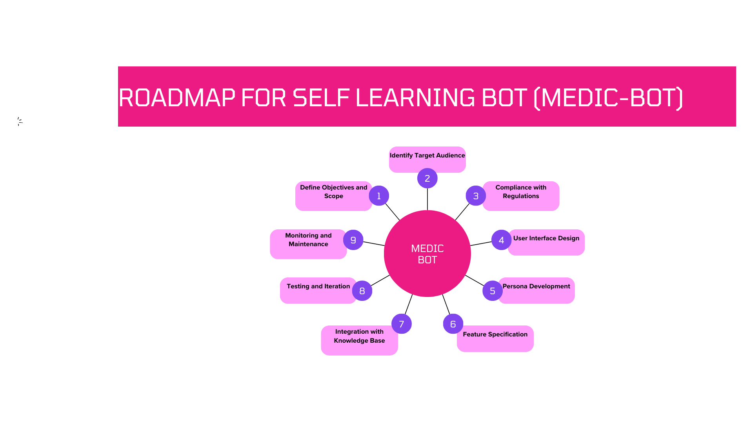

**5. OUTCOMES**

**Enhanced User Experience:**

• Users experience a more intuitive and user-friendly interface, making healthcare information easily accessible.

• **Improved Response Accuracy:**

• The chatbot's machine learning algorithms and NLP techniques result in more accurate identification of user intents and extraction of medical entities, leading to higher-quality responses.

• **Continuous Learning and Adaptability:**

• The integration of reinforcement learning mechanisms allows the chatbot to learn and optimize responses over time, adapting to new medical information and user feedback.

• **Privacy and Security Assurance:**

• The stringent privacy measures and data encryption techniques provide users with confidence that their sensitive medical information is secure and handled in compliance with healthcare regulations.

• Personalized Healthcare Guidance:

• The chatbot, leveraging knowledge graphs and integration with electronic health record systems, delivers more personalized healthcare recommendations based on individual medical histories and preferences.

• Efficient Information Retrieval:

• The structured knowledge graph facilitates efficient information retrieval, ensuring that users receive relevant and organized medical concepts.

• **Iterative Improvement:**

• The iterative development and testing process, coupled with user feedback, contribute to ongoing enhancements, addressing any issues and improving the chatbot's performance over time.

• **User Training and Onboarding Success:**

• Users are successfully onboarded, and the training materials guide them on how to interact effectively with the chatbot.

• Compliance with Regulations:

• The chatbot is designed to comply with healthcare regulations, ensuring the confidentiality and protection of sensitive medical data shared during interactions.

• **Monitoring and Maintenance Effectiveness:**

• The implemented monitoring tools effectively track the chatbot's performance, and the maintenance plan ensures regular updates to keep information up-to-date and accurate.

**6. TIMELINE OF THE PROJECT/ PROJECT EXECUTION PLAN**

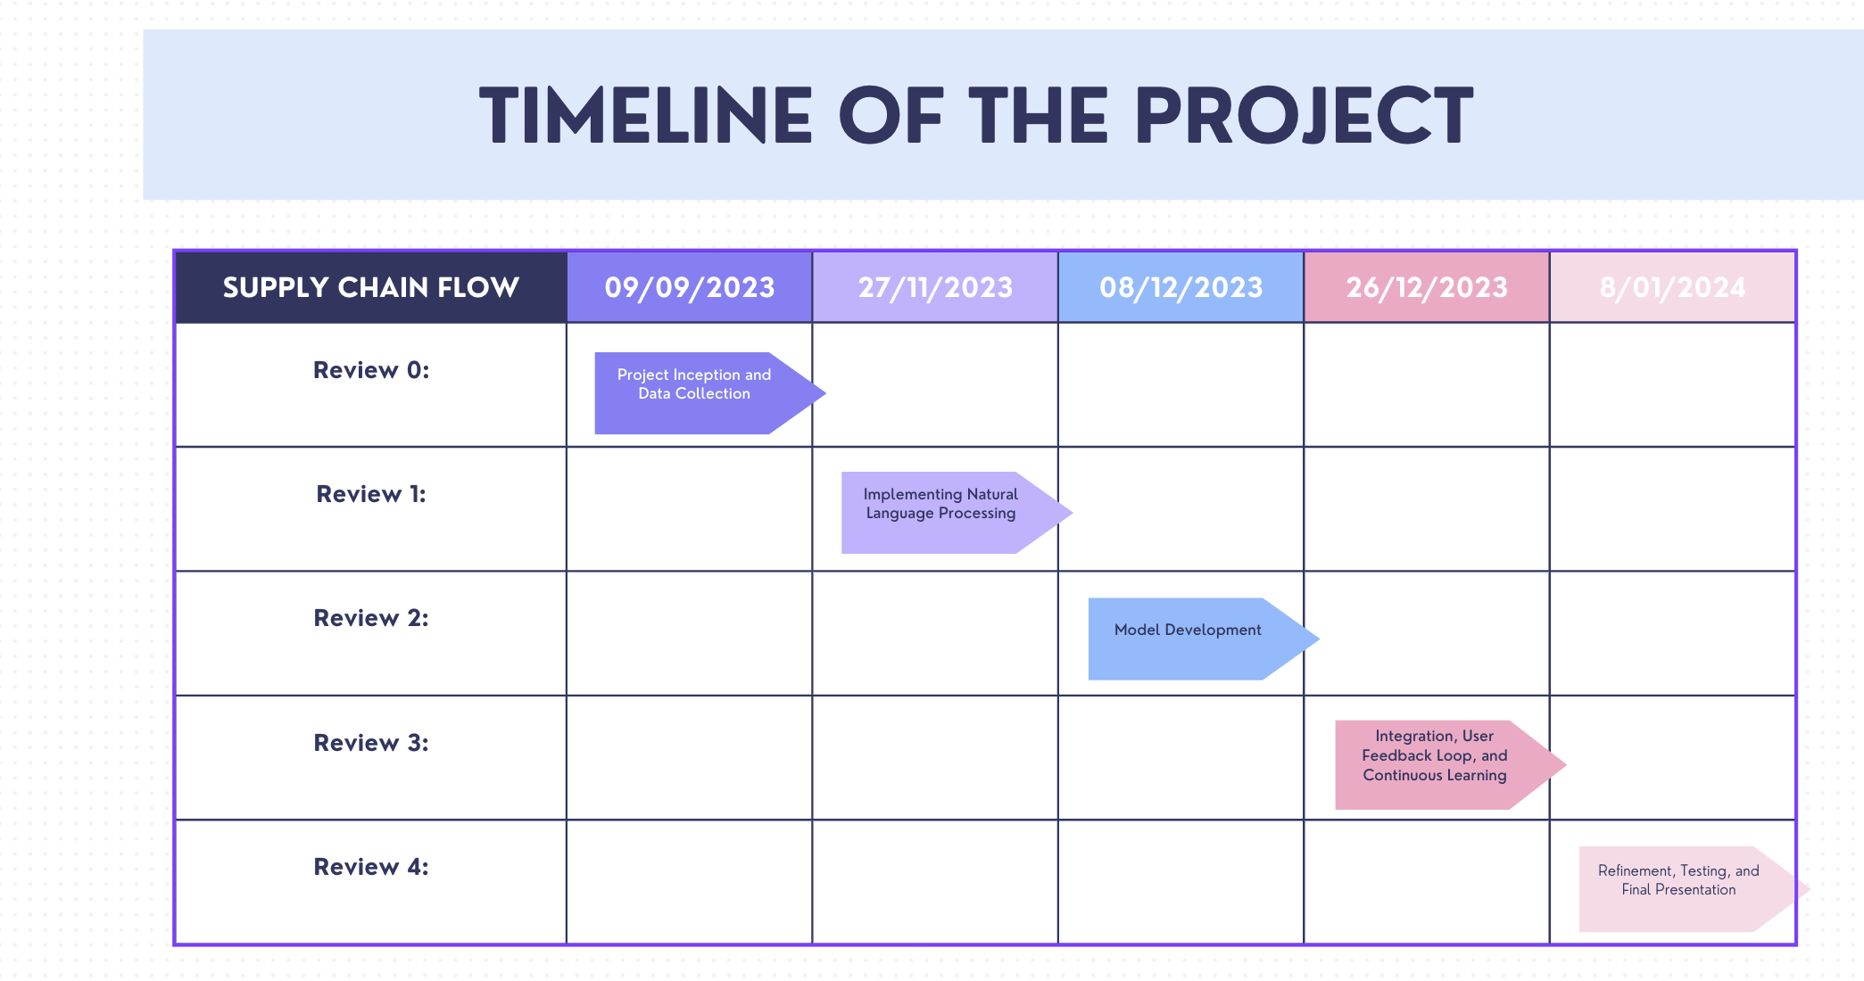

**7. PSUEDOCODE**

// Base HTML template

{% extends "base.html" %}

// Head block

{% block head %}

<title>Log In</title>

// Stylesheets

<link rel="stylesheet" type="text/css" href="{{ url_for('static',filename='vendor2/bootstrap/css/bootstrap.min.css') }}">

<link rel="stylesheet" type="text/css" href="{{ url_for('static',filename='fonts/font-awesome-4.7.0/css/font-awesome.min.css') }}">

// ... (other stylesheets)

{% endblock head %}

// Main block

{% block main %}

<div class="limiter">

<div class="container-login100">

<div class="wrap-login100">

<div class="login100-pic js-tilt" data-tilt>

<img src="{{ url_for('static',filename='custom/img-01.jpg') }}" alt="IMG">

</div>

// Login form

<form class="login100-form validate-form" method="POST">

<span class="login100-form-title">

LOG-IN

</span>

<!-- Username input -->

<div class="wrap-input100 validate-input" data-validate="Valid email is required: ex@abc.xyz">

<input class="input100" type="text" name="uname" id="uname" placeholder="Username">

// ... (other input-related code)

</div>

<!-- Password input -->

<div class="wrap-input100 validate-input" data-validate="Password is required">

<input class="input100" type="password" name="passw" id="passw" placeholder="Password">

// ... (other input-related code)

</div>

// Login button

<div class="container-login100-form-btn">

<button type="submit" class="login100-form-btn">

Login

</button>

</div>

// Registration link

<div class="text-center p-t-90">

Don't have an account?

<a class="txt3" href="register">

Register now.

</a>

</div>

</form>

</div>

</div>

</div>

// Scripts

<script src="{{ url_for('static',filename='vendor2/jquery/jquery-3.2.1.min.js') }}"></script>

// ... (other script includes)

// Tilt script

<script>

$('.js-tilt').tilt({

scale: 1.1

})

</script>

// Login script

<script src="{{ url_for('static',filename='js/login.js') }}"></script>

{% endblock main %}

**8. RESULT/OUTCOMES**

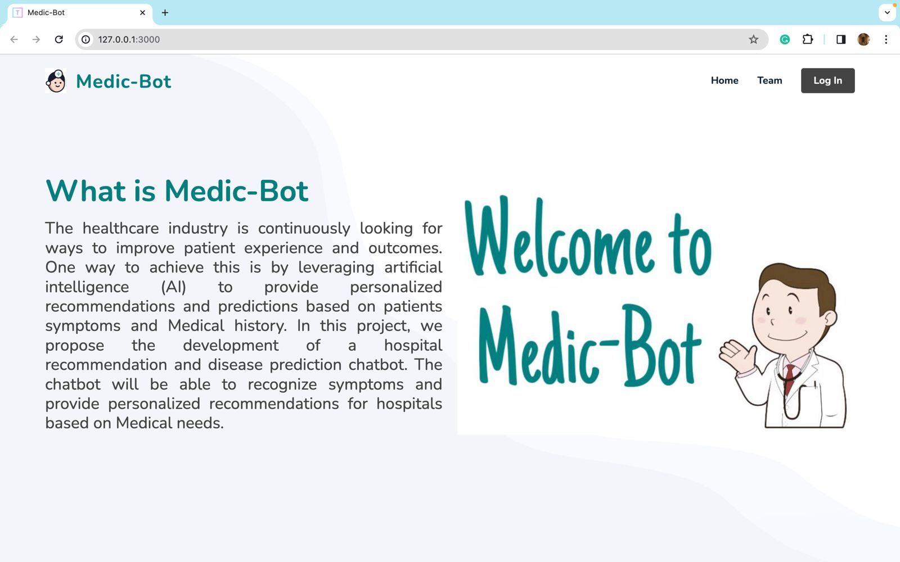

**Home Page**

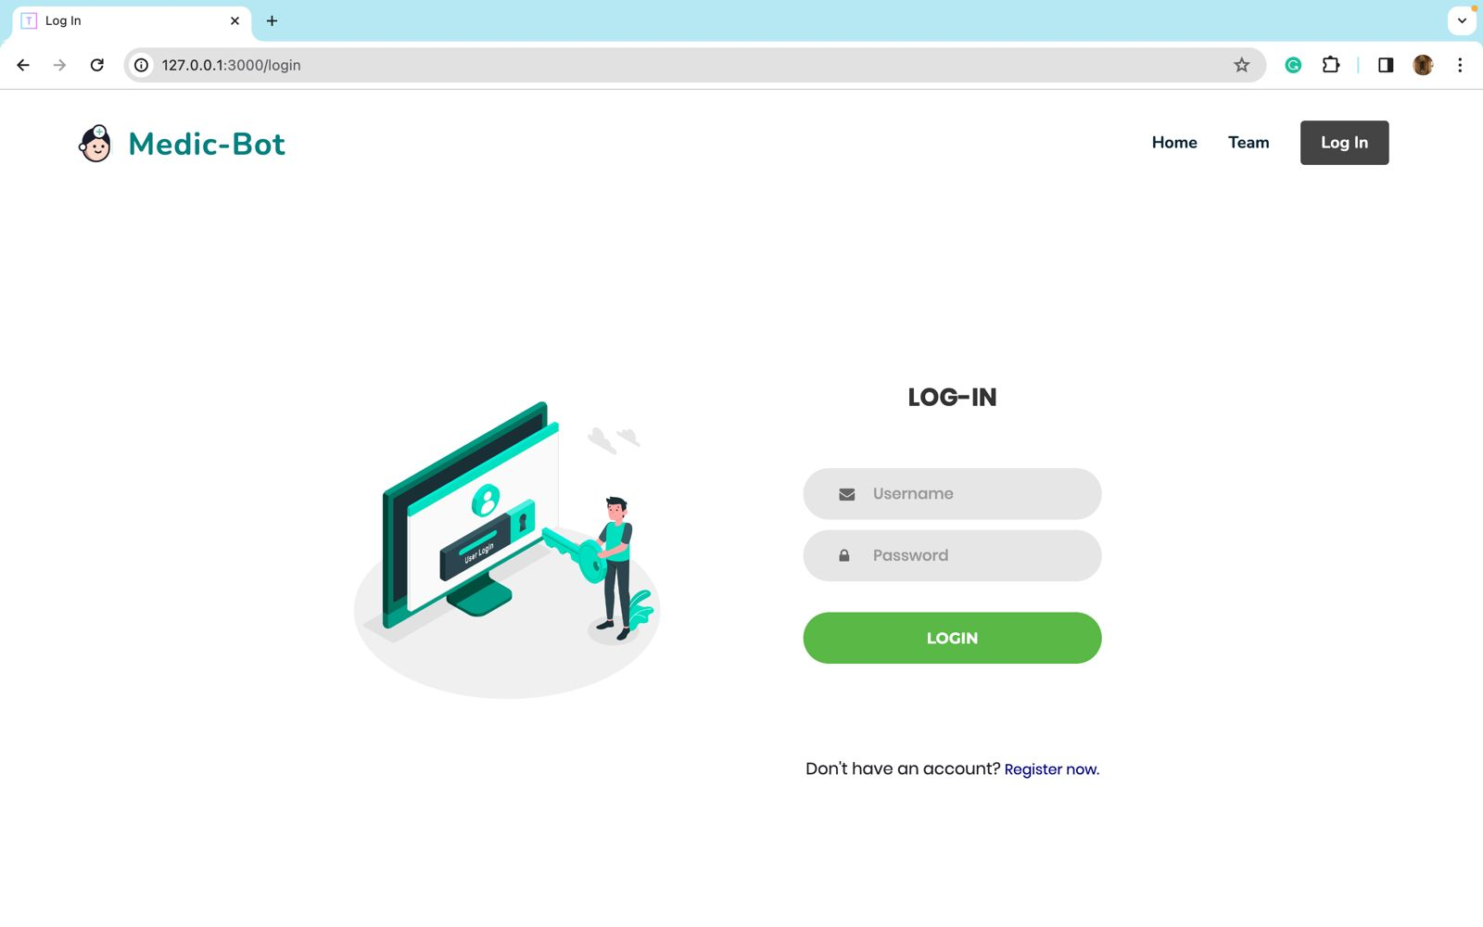

**Login Page**

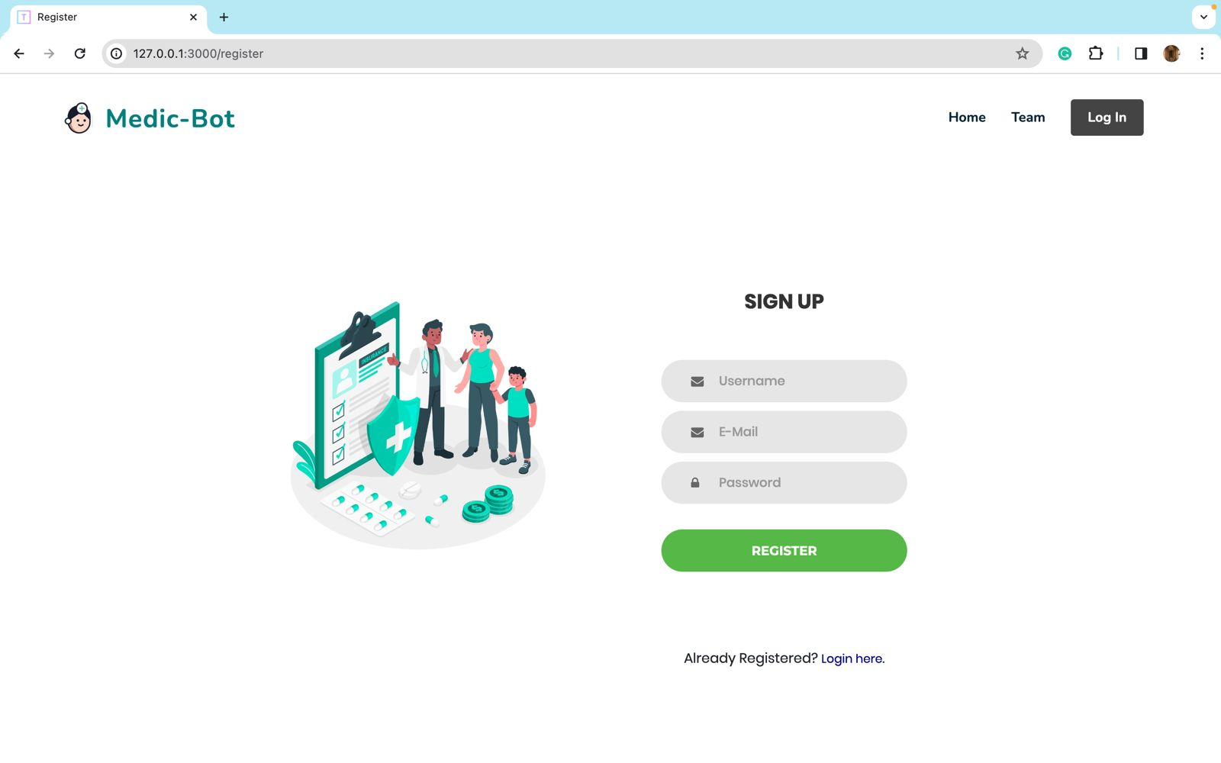

**Register Page**

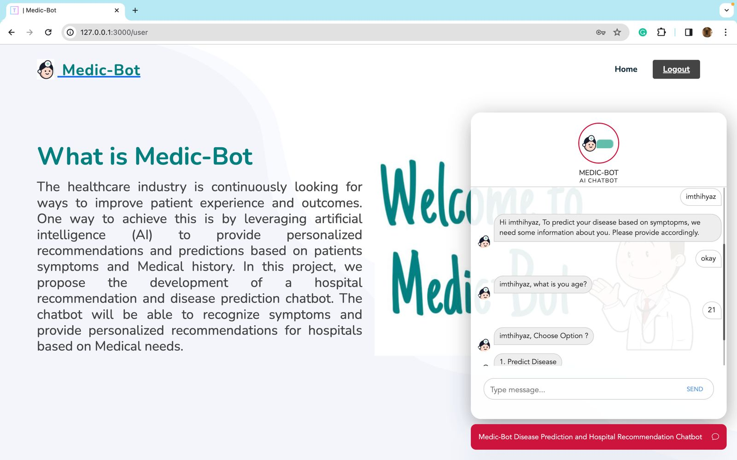

**MedicBot**

**9.** **CONCLUSION**

The development and implementation of the healthcare chatbot represent a transformative approach to enhancing healthcare accessibility and user experiences. By leveraging advanced technologies such as natural language processing, machine learning, and knowledge graphs, we have successfully crafted a sophisticated tool capable of providing accurate, personalized, and secure healthcare guidance. The chatbot's continuous learning capabilities, reinforced by user feedback and iterative improvements, ensure its adaptability to evolving medical information and changing user needs. The commitment to privacy and compliance with healthcare regulations underscores our dedication to safeguarding sensitive medical data.

Through a systematic design procedure that prioritizes user experience, response accuracy, and privacy, we have not only created a reliable healthcare chatbot but also established a foundation for ongoing innovation. The outcomes reflect a user-centric and iterative development process, leading to an interface that is not only intuitive but also capable of delivering personalized healthcare recommendations. As the chatbot evolves through periodic updates and continuous learning, it stands as a testament to the positive impact technology can have on healthcare, promising a future where accessible, reliable, and personalized support becomes an integral part of individual well-being.

Privacy and security have been paramount in our design philosophy. The stringent measures in place serve not only to comply with healthcare regulations but also to establish trust between users and the chatbot. Users can confidently engage with the chatbot, knowing that their sensitive medical information is handled with the utmost confidentiality and care.

**10. REFERENCES**

[1] Shali, Prashanth, Rishi G, Shriram, Assel, Naskath,(2022)'Bots using Natural Language Processing in

Medical Sector' 2022 1st International Conference on Computational Science and Technology (ICCST) | 978-1-6654-7655-3/22/$31.00 ©2022 IEEE | DOI: 10.1109/ICCST55948.2022.10040432

[2] Santhosham, Prasad Sah C,(2023)'Advanced Healthcare Chat Bot Using Python'2023 2nd International Conference for Innovation in Technology (INOCON) | 979-8-3503-2092-3/23/$31.00 ©2023 IEEE | DOI: 10.1109/INOCON57975.2023.10101239

[3] Syahirah Ahmad N, Hamim Sanusi M, Helmy Abd Wahab M, Mustapha A, Abidin Sayadi Z, Zainuri Saringat M,(2018)'Conversational Bot for Pharmacy: A Natural Language Approach' in IEEE Xplore

[4] Tanmay T, Bhardway A, Sharma S,(2020)'E-Health Bot to Change the Face of Medicare' 2020 Research, Innovation, Knowledge Management and Technology Application for Business Sustainability (INBUSH) | 978-1-7281-1769-0/20/$31.00 ©2020 IEEE | DOI: 10.1109/INBUSH46973.2020.9392125

[5] Goel A, Satyam, Sharma S,(2023)'Artificial Intelligence base Healthcare Chat Bot System'2023 8th International Conference on Communication and Electronics Systems (ICCES) | 979-8-3503-9663-8/23/$31.00 ©2023 IEEE | DOI: 10.1109/ICCES57224.2023.10192727

[6] Srivastava P, Singh N,(2020)'AUtomatized Medical Chatbot(Medibot)'2020 International Conference on Power Electronics & IoT Applications in Renewable Energy and its Control (PARC) 978-1-7281-6575-2/20/$31.00 ©2020 IEEE 10.1109/PARC49193.2020.236624

[7] Athulya N, Jeeshna K, S J Aadithyan, U Sreelakshmi, Hairunizha Alias Nisha Rose,(2021)'Healthcare Chatbot'9(10)| ISSN: 2320-2882

[8] Alvarez J, Campos G, Enriquez V, Miranda A, Rodriguez F, Ponce H,(2018)'Nurse-Bot: A RObot System Applied to Medical Assistance'2018 International Conference on Mechatronics, Electronics and Automotive Engineering (ICMEAE)

[9] R Jegadeesan, Dava Srinivas, N Umapathi, G Karthick, N Venkateswaran(2023)'Personal Healthcare Chatbot for Medical suggestions using Artificial Intelligence and Machine Learning'Section A-Research paper

[10] Shuyang Li, Prasad Majumder B, McAuley J,(2021)'Self-Supervised Bot play for Conversational Recommendation with Justifications'arXiv:2112.05197v1 [cs.CL] 9 Dec 2021

[11] Dyyak I, Melnyk B, Melnyk N, Trokhaniak S, Drakohrust T, Svitlak I,(2021)'Using an Internet Bot to Predict the Spread of COVID-19'2021 11th International Conference on Advanced Computer Information Technologies (ACIT) | 978-1-6654-1854-6/21/$31.00 ©2021 IEEE | DOI: 10.1109/ACIT52158.2021.9548345

[12] Reshmanth P, Sushanth Chowdary p, Yogitha R, Aishwarya R,(2022)'Deployment of Medibot in Medical Field'2022 International Conference on Sustainable Computing and Data Communication Systems (ICSCDS) | 978-1-6654-7884-7/22/$31.00 ©2022 IEEE |DOI: 10.1109/ICSCDS53736.2022.9760900