**Practicle No 3:**

**Input:**

class student:

def __init__(self,name,age,grade):

self.name=name

self.age=age

self.grade=grade

def display_info(self):

print("Student Name:",self.name)

print("Age:",self.age)

print("Grade:",self.grade)

student1= student("Alice",14,"9th")

student2= student("Bob",15,"10th")

print("Details of Student 1:")

student1.display_info()

print("\nDetails of Student 2:")

student2.display_info()

**Output:**

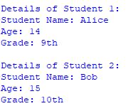

**Practical No 4:**

**Input**

class Calculator:

def add(self,*args):

if not args:

return 0

total=0

for num in args:

total+=num

return total

calc=Calculator()

print("Add() with no arguments:",calc.add())

print("Add(5):",calc.add(5))

print("Add(10,20):",calc.add(10,20))

print("Add(1,2,3,4):",calc.add(1,2,3,4))

**Output:**

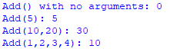

**Practical No 5:**

**Input**

class Vector:

def __init__(self,x,y):

self.x=x

self.y=y

def __add__(self,other):

return Vector(self.x+other.x,self.y+other.y)

def __str__(self):

return f"Vector({self.x},{self.y})"

v1=Vector(2,3)

v2=Vector(4,5)

v3=v1+v2

print("Vector 1:",v1)

print("Vector 2:",v2)

print("Sum of vectors:",v3)

**Output:**

