Case Study on Demonstration of Network Communication Models (OSI / TCP-IP) Using a Network Simulation Tool
Aim
To demonstrate how data moves across a network by using a network simulation tool, and to relate the seven-layer OSI model to the four-layer TCP/IP model through a small simulated network.
Objectives
- Study the purpose and functions of the OSI and TCP/IP communication models.
- Create a simple network topology using end devices, switches, and a router in a simulator.
- Configure IP addresses and observe communication between devices on the same and different networks.
- Use simulation or packet-inspection features to observe protocol encapsulation and packet movement.
- Compare the OSI and TCP/IP models and document observations, results, and limitations.
Selected Network Scenario
Small Office Network with Two IP Subnets
Overview
Network communication requires devices to follow agreed rules for addressing, data formatting, delivery, routing, and error handling. Layered models organize these functions so that each layer provides services to the layer above it.
The OSI model is a conceptual seven-layer reference model. The TCP/IP model is a practical suite-oriented model commonly described with four layers: Application, Transport, Internet, and Network Access. The exact mapping between models is approximate because their purposes and layer boundaries differ.
This case study uses a simulated office network to demonstrate local communication and routed communication. A tool such as Cisco Packet Tracer, GNS3, or an equivalent network simulator may be used. The steps are tool-neutral; interface labels may differ by simulator.
Network Topology
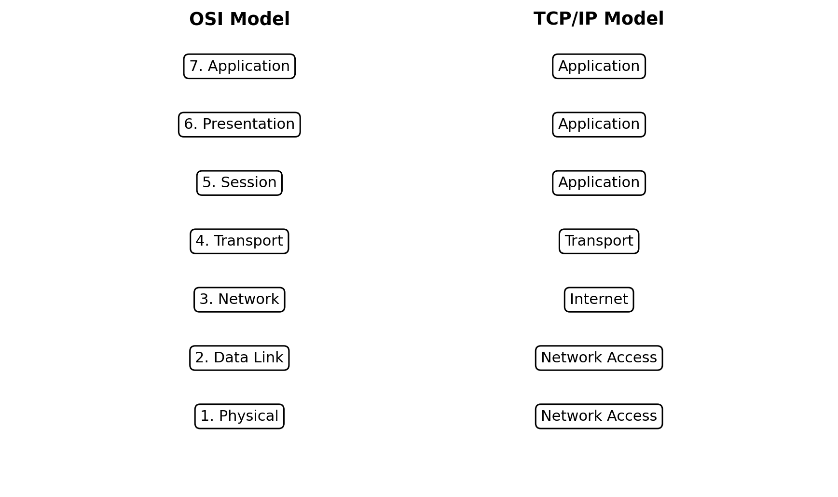
Topology description: PC-A and PC-B connect to Switch-A in 192.168.10.0/24. PC-C and PC-D connect to Switch-B in 192.168.20.0/24. A router connects the two subnets and acts as the default gateway for each subnet.
IP Addressing Table
Device / Interface | Type | IP Address | Subnet Mask | Default Gateway
PC-A | End device | 192.168.10.10 | 255.255.255.0 | 192.168.10.1
PC-B | End device | 192.168.10.20 | 255.255.255.0 | 192.168.10.1
Router LAN-A | Router interface | 192.168.10.1 | 255.255.255.0 | —
Router LAN-B | Router interface | 192.168.20.1 | 255.255.255.0 | —
PC-C | End device | 192.168.20.10 | 255.255.255.0 | 192.168.20.1
PC-D | End device | 192.168.20.20 | 255.255.255.0 | 192.168.20.1
Simulation Tool and Requirements
- Software: Cisco Packet Tracer, GNS3, or an equivalent network simulation tool.
- Devices: four end hosts, two Ethernet switches, one router, and suitable links.
- Protocols used for core checks: Ethernet, ARP, IPv4, and ICMP; HTTP or DNS may be added for application-layer inspection.
- Use private example addresses only in the simulation. No external network or real user data is required.
Procedure
- Open the network simulation tool and create a new project.
- Place four PCs, two switches, and one router on the workspace.
- Connect PC-A and PC-B to Switch-A, and PC-C and PC-D to Switch-B using appropriate Ethernet links.
- Connect each switch to a separate router interface. Use the simulator's supported cable type or automatic connection option.
- Configure the router interfaces with 192.168.10.1/24 and 192.168.20.1/24, then enable the interfaces.
- Configure the PC addresses, subnet masks, and default gateways using the addressing table.
- Wait for links to become active and verify that interface indicators show a working connection.
- Use the simulator's command prompt or diagnostic tool to ping PC-A to PC-B, then PC-A to PC-C.
- Switch to simulation mode or packet inspection, generate a ping or web request, and step through the packet path.
- Inspect the protocol stack or packet details at each hop, recording the visible Ethernet, IP, ICMP, TCP, UDP, or application information as supported by the tool.
- Repeat after clearing event lists or resetting the simulation, and save screenshots or notes as evidence.
OSI Model: Layer Functions and Observable Evidence
OSI Layer | Function | What to Observe
7. Application | Provides network services to user applications, such as HTTP, DNS, SMTP, and file transfer. | Application data; HTTP request/response or DNS query when generated.
6. Presentation | Represents data format, encoding, compression, and encryption concepts. | Often combined with application functions in TCP/IP; may not appear as a separate simulator layer.
5. Session | Manages logical dialog/session establishment and coordination. | Session control may be implemented within application protocols.
4. Transport | End-to-end delivery, ports, segmentation, reliability, and flow control; TCP or UDP. | TCP segment or UDP datagram; ports visible for applicable traffic.
3. Network | Logical addressing and routing between networks; IP. | IP packet with source/destination addresses; router makes forwarding decision.
2. Data Link | Local-link framing and MAC addressing; Ethernet switching. | Ethernet frame and source/destination MAC addresses.
1. Physical | Signals and transmission over physical media or simulated links. | Bits/signals and link status; often abstracted by simulator.
OSI and TCP/IP Layer Mapping
The mapping is approximate rather than one-to-one. TCP/IP's Application layer includes responsibilities often described separately as OSI Application, Presentation, and Session. The Network Access layer commonly groups local-link and physical functions.
Test Cases
The test cases below define expected behavior. Record the actual result and attach simulator screenshots or event-list evidence when performing the exercise.
Test ID | Scenario | Precondition | Test Steps | Expected Result | Pass Criteria
TC-01 | Same-subnet ping | PC-A and PC-B have valid addresses and same /24 network | Ping 192.168.10.20 from PC-A | Replies received; local traffic is switched within LAN-A. | Pass if echo replies arrive.
TC-02 | Cross-subnet ping | Router interfaces and gateways are configured | Ping 192.168.20.10 from PC-A | Packet is sent to gateway and routed to LAN-B. | Pass if replies arrive and route is correct.
TC-03 | Invalid gateway | Temporarily set PC-A gateway incorrectly | Ping PC-C from PC-A | Cross-subnet communication fails; same-subnet ping may still work. | Pass if failure matches expected routing behavior.
TC-04 | Duplicate IP check | Assign same IP to two hosts in a test segment | Attempt communication and inspect simulator warnings/ARP behavior | Address conflict or inconsistent reachability is observed. | Pass if conflict is identified and documented.
TC-05 | Subnet mismatch | Set one host to an incorrect subnet mask | Attempt ping across intended local segment | Reachability changes according to incorrect network interpretation. | Pass if effect is recorded and configuration is restored.
TC-06 | Layer observation | Simulation/packet inspection enabled | Generate ICMP echo request and inspect event details | Packet view shows protocol headers supported by the tool. | Pass if encapsulation and hop-by-hop changes are recorded.
TC-07 | Router interface down | Disable one router interface in the simulator | Ping a host in the disconnected subnet | Traffic to that subnet fails until interface is restored. | Pass if outage and recovery are observed.
TC-08 | Address restoration | Restore all intended settings after negative tests | Repeat TC-01 and TC-02 | Both same-subnet and routed communication succeed. | Pass if baseline connectivity is restored.
Comparison of OSI and TCP/IP Models
Criteria | OSI Model | TCP/IP Model
Number of layers | Seven | Commonly represented as four
Purpose | Reference framework for describing network functions | Protocol suite and practical architecture for internetworking
Upper layers | Application, Presentation, Session are separate | Application layer combines functions commonly associated with OSI upper layers
Transport | Transport layer | Transport layer
Routing | Network layer | Internet layer
Local network access | Data Link and Physical layers | Network Access / Link layer groups local delivery and physical transmission
Use in this exercise | Useful for classifying responsibilities and troubleshooting | Useful for explaining actual TCP/IP protocol operation
Troubleshooting Guide
Symptom | Possible Cause | Action
Same-subnet ping fails | Wrong IP/mask, disconnected link, host firewall, or duplicate address | Check link status, address settings, and ARP behavior.
Cross-subnet ping fails | Incorrect gateway, router interface down, or missing route | Verify gateway settings and router interface addresses/status.
Only one direction works | Return path or host configuration issue | Check both hosts, routes, and packet path in both directions.
Packet does not appear as expected | Wrong simulation filters or protocol not generated | Enable relevant protocol filters and generate fresh traffic.
Unexpected MAC address | Frame is being sent to the next hop rather than the remote host | Inspect Ethernet header at each link; router rewrites link-layer framing.
Precautions and Limitations
- Simulator command syntax and displayed protocol details vary by product and version.
- Do not interpret a missing separate Presentation or Session layer in the simulator as proof those functions do not exist; TCP/IP groups them differently.
- Use unique IP addresses and consistent subnet masks; restore intended settings after negative tests.
- Simulation results are educational and may abstract physical signals, timing, and real-world device performance.
- Capture only the test network's own traffic and avoid using real credentials or private data.
Results
- The simulator provides a safe environment for building a network and testing addressing, switching, and routing without physical equipment.
- Same-subnet traffic is expected to be delivered through the local switch, while traffic to another subnet is sent to the default gateway and routed.
- Packet inspection can show encapsulation across layers, though the exact visible fields depend on the selected simulator and protocol.
- The OSI model offers a detailed conceptual breakdown; TCP/IP groups several OSI functions into a smaller practical architecture.
Conclusion
This case study demonstrates the relationship between layered communication models and practical packet movement in a simulated network. Correct IP addressing, subnet masks, default gateways, active interfaces, and routing are necessary for end-to-end connectivity. Packet inspection helps connect theoretical layer functions to observable protocol headers. The OSI and TCP/IP models are complementary learning tools: OSI is useful for structured explanation and troubleshooting, while TCP/IP describes the protocol architecture used by modern internetworking.
References / Learning Resources
- Course notes and laboratory instructions on OSI and TCP/IP networking models.
- Documentation and built-in help for the selected network simulation tool.
- Protocol concepts referenced in the exercise: Ethernet, ARP, IPv4, ICMP, TCP, UDP, HTTP, and DNS.

