Krishnaprasad.nocode.10
Getting Started with Zoho Creator: Account Setup and Building a Form-Based Application
Aim
To understand the initial setup of a Zoho Creator account and build a basic form-based application for recording and managing service requests.
Objectives
- Describe the purpose and basic components of Zoho Creator.
- Outline safe account setup and application creation steps.
- Design a form with appropriate fields, validation, and data types.
- Preview and test the application using sample records.
- Recognise access control, privacy, and plan-related considerations.
Selected Application
Service Request Register for a Small Maintenance Team
Overview
A small maintenance team needs a simple way to capture customer service requests. The proposed application uses a form to collect customer and issue details, stores each submission as a record, and allows authorised staff to view and review requests. This experiment focuses on a basic form-based app; advanced workflows, integrations, and production deployment are outside the initial scope. Zoho Creator interfaces, account eligibility, and feature availability can vary by region, plan, or product updates, so consult current official documentation.
Application Requirements
- Capture customer name, contact email or phone, request category, issue description, preferred service date, and urgency.
- Require essential fields and validate formats where supported.
- Store submitted data as records that can be viewed by authorised users.
- Show a clear success message after submission.
- Use fictional data during practice; do not enter real customer or sensitive information.
Account Setup and Initial Preparation
- Use an authorised email address and follow the current Zoho sign-up process. Verify the account using the method requested by the provider.
- Enable multi-factor authentication where available and use a strong, unique password. Never share account credentials.
- Review the account’s available plan, trial or free-tier limits, data-region options, and terms before creating or publishing an app. Do not assume all features are free or permanently available.
- Open Zoho Creator from the account interface and review the current navigation for creating an application. Labels and screen layouts may change.
- Choose a blank application or an appropriate starter option. Name the app “Service Request Register” and add a concise purpose description.
Application Build Workflow
Create account → Create application → Build form → Configure fields → Preview and test → Publish or share with authorised users.
Form Design and Field Configuration
Field label | Suggested field type | Configuration / validation
Request ID | System-generated / record ID | Unique identifier; do not ask users to enter it manually if generated automatically
Customer Name | Single line | Required; apply reasonable length limit
Contact Email | Email | Required if email is the selected contact channel; validate format
Contact Phone | Phone / single line | Optional or required according to process; collect only if necessary
Request Category | Dropdown / choice | Examples: electrical, plumbing, general maintenance; restrict to defined values
Issue Description | Multi-line text | Required; set a suitable maximum length and explain what not to include
Preferred Date | Date | Optional; prevent invalid or past dates if the use case requires
Urgency | Dropdown / choice | Routine, soon, urgent; explain each option to avoid inconsistent selection
Status | Choice / default value | New, Assigned, In Progress, Completed; restrict changes to staff if supported
Build Procedure
- In the application builder, create a new form and choose a clear name such as “New Service Request”.
- Add the fields from the design table. Set required status, help text, choice values, and validation using the current builder controls.
- Set sensible defaults such as an initial status of “New” where supported. Avoid exposing internal staff-only fields to public submitters.
- Arrange fields in a logical order: contact details, request details, date/urgency, then submission. Add concise field instructions.
- Configure the post-submission confirmation message. Confirm whether submissions are limited to signed-in users or can be made through a shared form; use the safer option for the exercise.
- Save the form, preview it as a user, and correct layout or validation issues before entering test records.
Workflow Diagram
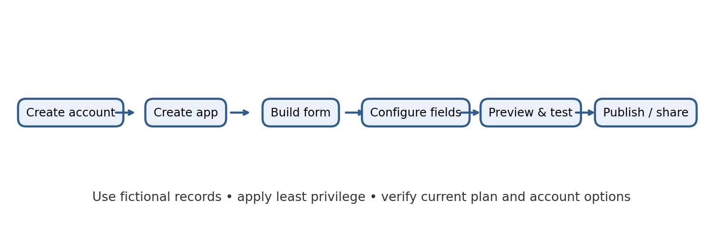
Testing and Verification
Test case | Expected result
Submit a complete valid request | Record is saved and a clear confirmation is displayed
Leave a required field blank | Validation prevents submission and identifies the missing field
Enter an invalid email format | Email validation displays an error or prevents invalid submission
Select a category | Only configured category values are selectable
Submit fictional sample information | Record appears in the app’s authorised record view
Open app as unauthorised user | Access is denied or limited according to the selected sharing configuration
Review form on mobile-sized display | Labels and controls remain usable without confusing clipping
Security, Privacy, and Sharing
- Use fictional names, contact details, and descriptions for classroom testing. Avoid personal, health, financial, or confidential records.
- Use least-privilege access: grant only the roles and permissions needed for the experiment. Review who can view, add, edit, or export records.
- Do not make the app public unless explicitly required and approved. A shareable link may allow broad access depending on configuration.
- Review field visibility, record access, and application sharing settings before inviting other users.
- Delete test records and disable unneeded sharing after the demonstration. Check the account’s current retention and deletion behaviour.
Expected Output and Learning Outcomes
- A named application with a working request submission form.
- A configured set of fields with suitable data types, required flags, choice values, and validation.
- Successful preview and test submissions using fictional information.
- Understanding that account setup and application configuration are only initial steps; production use requires permissions, privacy review, testing, ownership, and maintenance.
Limitations and Further Enhancements
This introductory app does not include automatic assignment, email notifications, approval workflows, analytics, or integrations. These can be considered later after the basic data structure and access model are validated. Any production extension should be tested against the organisation’s requirements and applicable policies. Plan-specific limits and capabilities should be confirmed before relying on a feature.
Conclusion
The experiment demonstrates a typical workflow for getting started with Zoho Creator: set up an account securely, create an application, design a form, configure fields and validation, then preview and test the result. A form-based application can standardise data collection and make records easier to manage. Safe account practices, careful field design, fictional test data, and controlled sharing are essential even for a small prototype. Verify current product features and account terms before deployment.

