Krishnaprasad.nocode.11
Designing Pages and Navigation for a Multi-Page Business Application in Zoho Creator
Aim
To design a clear page structure and navigation scheme for a multi-page business application in Zoho Creator, considering user tasks, usability, and access control.
Objectives
- Understand the purpose of pages and navigation in a business application.
- Organise application content around user roles and common tasks.
- Design a page hierarchy for a service-request management application.
- Apply usability principles to navigation labels, layout, and page flow.
- Plan testing for navigation, access permissions, and responsive use.
Selected Application
Service Request Management Application for a Small Maintenance Business
Overview
The application supports customers or coordinators submitting service requests, staff reviewing and updating work, and managers monitoring workload. A single form is not sufficient for all tasks; users need a landing page, a request list, a request detail view, a new-request form, and reports. In Zoho Creator, pages, forms, reports, and navigation can be arranged using the current application builder. Exact options and interface labels can change, so consult current product documentation.
User Roles and Primary Tasks
Role | Main tasks | Typical access
Coordinator | Review new requests, assign staff, update priority | Dashboard, all request records, reports
Technician | View assigned requests, update work status and notes | Assigned records and permitted detail actions
Manager | Review backlog, workload, and performance summaries | Dashboard and reports; limited record editing as needed
Customer / submitter | Submit a request and receive confirmation | Submission form and appropriate confirmation only
Information Architecture
The structure should match users’ mental model and frequent tasks. The proposed application has a landing dashboard, a request management area, a new-request form, individual request details, and reports. Navigation should use familiar labels and show only the destinations relevant to each role. Avoid duplicating the same feature under multiple names.
Proposed Pages and Navigation
Page / destination | Purpose | Key content or actions
Home / Dashboard | Orient users and show priority work | Open/new/overdue summaries; shortcuts based on role
Requests | Find and manage service requests | Search, filters, status, assignment, request list
New Request | Capture a service request | Validated form, clear instructions, confirmation
Request Details | Review one request and its history | Customer issue, status, assignment, permitted updates
Reports | Monitor workload and trends | Request counts by status, category, and time period
Help / guidance | Explain process and contact support | Short instructions, definitions, escalation route
Navigation Diagram
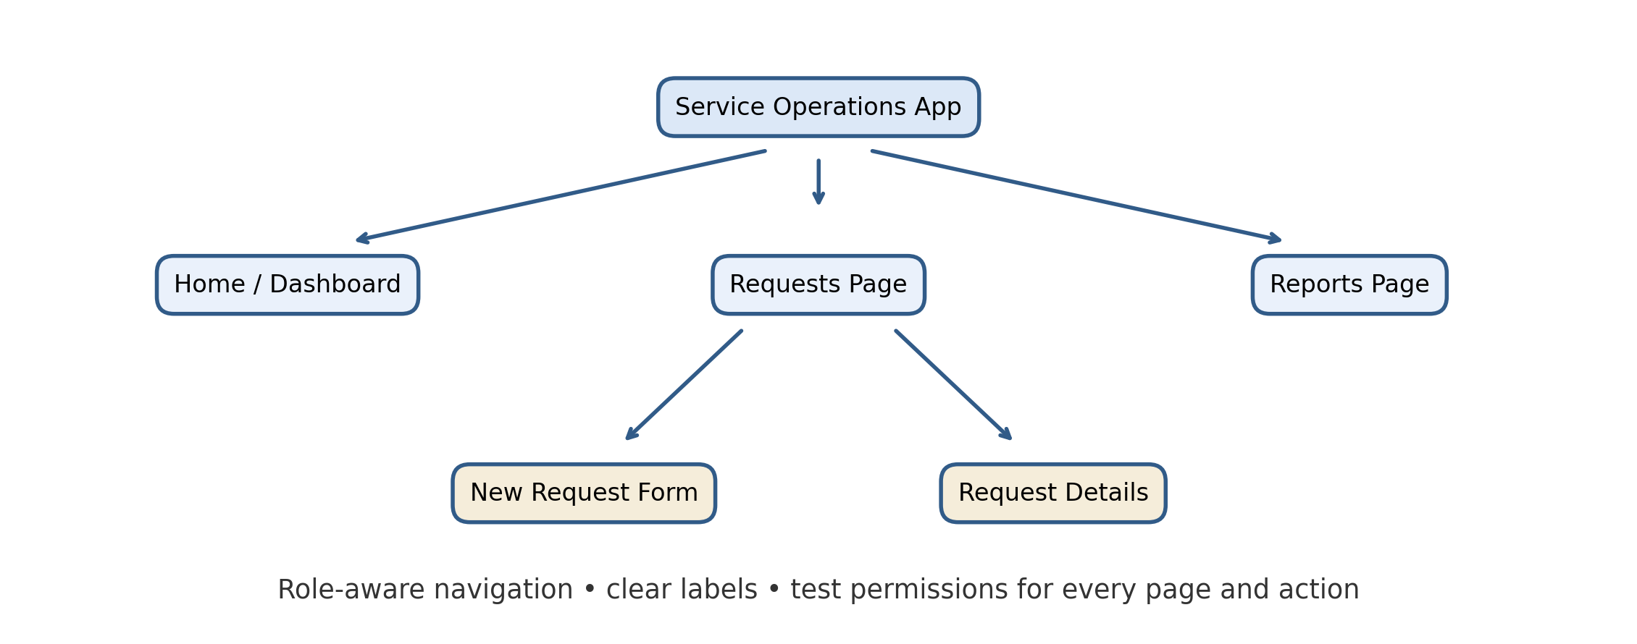
Page Design Principles
- Use a consistent page title, visual hierarchy, spacing, and terminology throughout the application.
- Put the most frequent and urgent actions near the top of the landing page. Avoid cluttering the dashboard with every available metric.
- Use descriptive labels such as “Requests” and “Create Request” rather than internal technical terms.
- Provide a clear path back to the request list from a detail page and preserve useful filters where feasible.
- Use status text and, if colour is used, do not rely on colour alone to communicate meaning.
- Keep forms readable on mobile screens; group related fields and provide concise help text.
- Show confirmation after important actions and provide useful error messages that explain how to recover.
Implementation Approach
- Map each role’s task journey before creating pages. For example: Coordinator → Dashboard → New Requests → Request Details → Assign Technician.
- Create the required forms and reports first, since pages may present or link to these components. Use fictional sample records during design.
- Create pages for the dashboard and role-specific summaries using supported components in the current builder.
- Add navigation items or links for the main areas. Arrange items in task order and use consistent labels.
- Add links from request summaries to the relevant report or detail view where the platform supports safe record-specific navigation.
- Configure role and record permissions separately from visual navigation. Hiding a menu item alone is not a security control.
- Preview the application as representative user roles and revise after feedback.
Navigation and Access Test Cases
Test case | Expected result
Coordinator opens dashboard | Coordinator sees relevant work summaries and permitted shortcuts
Technician opens Requests | Only records permitted to that technician are visible
Technician attempts unauthorised edit | Edit action is unavailable or blocked by permission enforcement
Select a request from list | Correct record detail opens and offers a clear return path
Use browser back or app navigation | User returns to a sensible prior page without losing essential context
Open app on mobile-sized screen | Navigation remains understandable and usable
Unauthorised user follows a direct page link | Access is denied according to configured authentication and permissions
Usability Evaluation Plan
Ask representative users to complete common tasks without coaching: locate an overdue request, create a request, update a status, and find a workload summary. Record task completion, time, navigation errors, and user comments. Revise confusing labels or page order and repeat the test. Check accessibility basics such as keyboard focus, readable text, and meaningful labels.
Security and Governance Considerations
- Configure authentication, role permissions, and record-level access based on the organisation’s policy. Validate permissions on direct links and actions, not only on the navigation menu.
- Limit sensitive customer information shown on dashboards and list pages. Use least privilege for viewing, editing, and exporting records.
- Use sample or anonymised data while prototyping. Review retention, auditability, and sharing settings before production.
- Assign an application owner and document page purpose, allowed roles, and any external links.
Results
- A role-oriented page structure reduces the effort required to find common actions and separates operational work from management reporting.
- Consistent labels, logical page relationships, responsive layouts, and clear feedback support usability.
- Navigation design must be paired with real access-control rules; hiding a link does not secure a page or data.
- Usability testing with representative users is necessary to validate assumptions and identify navigation problems.
Conclusion
A multi-page business application should organise pages around user goals and clearly distinguish dashboards, record lists, forms, details, and reports. For the service-request application, role-aware navigation can help coordinators, technicians, and managers reach their tasks efficiently. In Zoho Creator, the conceptual design should be implemented using the platform’s current page and navigation capabilities, then verified through role-based permission tests and user task testing. Clear information architecture and secure configuration together provide a usable and maintainable application.

