Krishnaprasad.nocode.12
Creating Reports and Dashboards for Data Visualization in Zoho Creator
Aim
To study how reports and dashboards can be designed in Zoho Creator to present business data clearly and support operational decision-making.
Objectives
- Understand the role of reports and dashboards in a business application.
- Identify useful measures and visualisations for service-request data.
- Design a dashboard that presents key indicators and trends.
- Consider filtering, refresh, permissions, and data quality.
- Develop a test plan to verify report accuracy and usability.
Selected Application
Service Request Management Application for a Small Maintenance Business
Overview
A maintenance team records service requests in an application. Managers need to monitor request volume, backlog, overdue work, categories, and completion. Operational staff need searchable reports that support follow-up and assignment. This case study proposes a set of reports and a management dashboard in Zoho Creator. The included dashboard graphic is a conceptual mock-up with illustrative values, not a screenshot or live application output. Current Creator features and options can vary by plan and product version; verify details using current vendor documentation.
Data Fields for Analysis
- Request ID and submission date/time
- Request category and priority
- Assigned technician or team
- Current status and status-change dates
- Preferred service date and completion date
- Customer contact fields (excluded from summary charts unless needed and authorised)
Report and Dashboard Concepts
A report is a structured view of application records used to search, filter, sort, group, or review detail. A dashboard combines selected summaries and visual components on one screen. A KPI card highlights a key value; a bar or column chart compares categories; a trend chart shows change over time; a table supports record-level investigation. Each visual should answer a defined business question and use a clearly stated time period and filter.
Proposed Reports
Report | Business question | Suggested display
Open Requests | Which requests still need action? | Filtered list of non-completed requests, sorted by age or urgency
Overdue Requests | Which requests have passed the target date? | List with due date, age, category, and assigned team
Requests by Category | What types of work are most common? | Bar chart or grouped summary
Workload by Technician | How is work distributed? | Count of open requests by assignee
Monthly Request Trend | Is request volume changing? | Time-series chart by submission month
Completion Time | How long does resolution take? | Average/median duration by category or month, where timestamps are reliable
Dashboard Layout and Visualisation Choices
Component | Purpose | Design note
Total requests KPI | Indicate overall volume in the selected period | Display date range and filter context
Open requests KPI | Show active backlog | Define which statuses count as open
Overdue KPI | Highlight work needing attention | Define due-date rule and avoid ambiguous thresholds
Completion rate KPI | Show share completed in period | Document numerator, denominator, and period
Category chart | Compare request types | Use readable labels and avoid too many categories
Status chart | Show workflow distribution | Use text labels as well as colour
Trend chart | Show volume over time | Use consistent time intervals and date filtering
Conceptual Dashboard
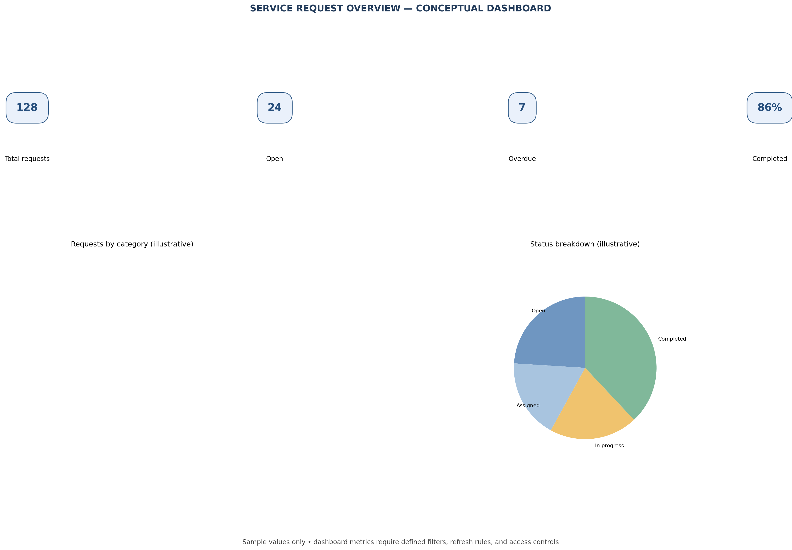
Design and Build Procedure
- Confirm the intended audience and decisions the dashboard should support. Identify the manager’s top questions before selecting chart types.
- Check the form’s data model. Ensure statuses, categories, dates, and assignees use consistent values suitable for grouping and filtering.
- Create reports for detailed records and summaries first. Apply meaningful filters, sorting, grouping, and labels.
- In the page or dashboard builder available in the current Creator environment, add KPI, chart, or report components supported by the platform.
- Set date ranges, criteria, and display labels. Keep related components on a consistent reporting period and clearly state the context.
- Arrange the page with priority indicators first, followed by trends and supporting detail. Preview at desktop and mobile sizes.
- Test each visual against manually counted sample records and refine labels, scales, and filters.
Example Metrics and Definitions
Metric | Example definition | Important check
Open requests | Count of records whose status is not Completed or Cancelled | Agree status mapping; exclude test records
Overdue requests | Open records with target date earlier than current date | Define timezone and whether today’s work is overdue
Completion rate | Completed requests in period ÷ requests eligible in period | Specify cohort, period, and treatment of cancellations
Average completion time | Mean elapsed time from submission to completion | Investigate extreme values; median may be more representative
Requests by category | Count of submitted requests per category | Handle blank or “Other” categories consistently
Testing and Validation
Test case | Expected result
Apply a date filter | All connected components reflect the selected range or clearly state exceptions
Compare KPI with source records | Displayed count matches an independent manual calculation
No records match filter | Clear empty-state message appears; chart does not mislead
Use a status category filter | Report includes only records matching the selection
Open a detail row | Authorised user can inspect the corresponding record
Technician views dashboard | Only permitted aggregate or record data is visible
View mobile layout | Labels and visualisations remain understandable and usable
Data Quality, Privacy, and Access
- Define a data dictionary for categories, statuses, dates, and measures. Inconsistent entry makes reports unreliable.
- Use role-based access for both dashboard components and the underlying records. Aggregated visuals can still reveal sensitive information in small groups.
- Show only necessary customer details in operational reports; avoid exposing personal contact data on management dashboards without a business need.
- Do not treat a chart as proof of causation. Explain sample size, filters, and time period.
- Use fictional data for classroom prototypes. Validate retention, export, sharing, and audit settings before production use.
Results
- Well-designed reports support record-level follow-up, while dashboards provide a concise summary of workload and performance.
- The proposed service-request dashboard uses KPIs, category and status breakdowns, and trends to address practical manager questions.
- Metric definitions, filter consistency, and data quality are necessary for trustworthy visualisation.
- Permissions must apply to underlying data and report components; dashboard access should be tested for each role.
- Charts should support decisions and prompt investigation rather than encourage interpretation without context.
Conclusion
Reports and dashboards in Zoho Creator can turn application records into useful operational insight when measures are clearly defined and visuals are chosen for specific questions. For the service-request case, a combination of backlog KPIs, overdue work, category distribution, workload, and trends can help managers prioritise operations. Accurate data, consistent filters, privacy controls, and independent validation are essential. The conceptual mock-up provides a starting point; actual values and functionality must be implemented and tested in the current platform environment.

