Krishnaprasad.nocode.13
Building Approval-Based Workflow Automation in a Zoho Creator Application
Aim
To design and study an approval-based workflow in a Zoho Creator application, including submission, review, decision, notification, and audit requirements.
Objectives
- Explain the purpose of approval workflows in business applications.
- Define roles, states, transitions, and approval rules for a sample process.
- Plan how to configure and test an approval workflow in Zoho Creator.
- Identify security, exception-handling, and audit considerations.
- Evaluate the benefits and limitations of workflow automation.
Selected Application
Purchase Request Approval Application for a Small Organisation
Overview
Employees submit purchase requests for materials or services. A manager reviews each request and either approves it or rejects it with a reason. The application records the decision, updates the request status, and notifies relevant users. This case study describes a configurable workflow concept; exact Creator menus and approval features can vary by product version, account, and plan. Confirm current capabilities in official documentation before implementation.
Business Requirements
- Employees can submit a request with item, purpose, quantity, estimated cost, and supporting details.
- Each request is assigned a unique reference and begins in a clear initial status.
- A designated approver reviews the request and can approve or reject it.
- Rejection requires a meaningful reason; the requester is notified of the outcome.
- Requesters cannot approve their own requests; only authorised approvers may decide.
- The application preserves the request and decision history for review.
Roles and Responsibilities
Role | Responsibilities | Access principle
Requester | Create request; view own requests and outcomes | May submit and see own records; cannot approve
Approver | Review request details; approve or reject; provide comments | Can act on requests assigned or available to approver role
Administrator | Maintain users, workflow configuration, and reference values | Restricted admin access; changes documented
Auditor / manager | Review status and decision records as authorised | Read-only access where possible
Workflow States and Transitions
Current state | Action | Next state | Control
Draft | Requester submits | Pending Approval | Required fields validated; reference created
Pending Approval | Approver approves | Approved | Only authorised approver can approve
Pending Approval | Approver rejects | Rejected | Rejection reason required
Rejected | Requester edits and resubmits | Pending Approval | Retain previous decision history if supported
Approved | Fulfilment begins | In Progress / Completed | Only authorised role updates fulfilment status
Workflow Diagram
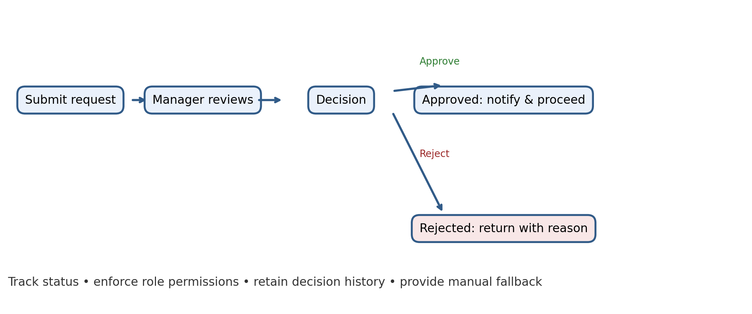
Application Design and Automation Logic
- Create a request form with clearly labelled fields and validation. Keep approval-only fields separate from requester inputs.
- Define status values and a unique request reference. Use a supported system-generated identifier where available.
- Set the initial status to “Pending Approval” only after a valid submission. Prevent invalid or incomplete requests from entering the approval queue.
- Configure a notification to the approver when a new request is submitted. Include a link or reference that opens the correct record securely.
- Provide approve and reject actions to approvers. On rejection, require a reason and store the decision, approver identity, and time.
- After a decision, update status and notify the requester. Ensure notifications do not expose unnecessary sensitive information.
- If supported, create reminders or escalation rules for requests awaiting action beyond a defined service period. Document a manual fallback if an automation fails.
Example Approval Policy
For this educational example, all requests route to a manager for review. In a real organisation, approval routing may depend on department, cost centre, or amount thresholds. Such rules must be defined and approved by the business. Do not invent financial authority levels: use the organisation’s documented policy, define boundary cases, and test requests exactly at and around each threshold.
Example Test Cases
Test case | Expected result
Submit complete request | Request is created with unique reference and Pending Approval status
Submit without purpose or amount | Validation identifies missing required information
Requester opens approval action | Requester cannot approve their own request
Approver approves request | Status becomes Approved; approver and decision time are recorded; requester is notified
Approver rejects without reason | Action is blocked and system requests a rejection reason
Approver rejects with reason | Status becomes Rejected; reason is stored and requester is notified
Automation/notification failure | Request remains recorded; failure is logged and manual follow-up is possible
User opens another person’s request URL | Record access is denied unless explicitly authorised
Security, Audit, and Exception Handling
- Enforce access control on records and actions; hiding approve/reject buttons is not sufficient by itself.
- Use individual user accounts and least privilege. Review approver membership and remove access when roles change.
- Record who made each decision and when. Retain previous status and comments where supported by the application and applicable policy.
- Protect personal, financial, or commercially sensitive details in email and in-app notifications. Use a secure authenticated link instead of including full request data.
- Define handling for unavailable approvers, duplicate submissions, cancellation, amended requests, and automation errors.
- Test permission changes and direct record links using requester, approver, and administrator accounts.
Implementation and Validation Plan
- Map the current approval process and obtain sign-off on roles, decision rules, and exceptions.
- Build a prototype with fictional request data and minimal required fields.
- Configure states, conditions, notifications, and role permissions using the current Creator capabilities.
- Test normal, boundary, invalid, and exception scenarios with representative users.
- Run a limited pilot alongside the current approved process; compare completion time, pending queue, and correction rate.
- Document the workflow, owner, support route, and rollback plan before production rollout.
Results
- An approval workflow makes the request lifecycle visible and can reduce manual follow-up when status changes and notifications are configured correctly.
- Explicit states and role-based transitions reduce ambiguity about who must act next.
- Audit details and clear rejection reasons improve accountability and help requesters correct submissions.
- Automation does not replace policy definition, permission design, exception handling, or user acceptance testing.
Conclusion
The purchase-request case demonstrates how approval-based workflow automation can structure submission, review, and decision-making in a Zoho Creator application. A reliable implementation needs clearly defined states, authorised approvers, required decision information, secure notifications, and a record of actions. Testing must cover both expected paths and failures, including unauthorised access and notification issues. Before production use, align rules with approved organisational policy, verify current platform features, and establish ownership and audit practices.

