Krishnaprasad.nocode.14
Integrating External Services with a Zoho Creator Application Using APIs
Aim
To understand the basic concepts and design considerations involved in connecting a Zoho Creator application to an external service through an application programming interface (API).
Objectives
- Explain APIs and common integration patterns used by business applications.
- Describe a practical integration use case for a service-request application.
- Identify request, response, authentication, and error-handling considerations.
- Plan safe testing and validation of an external API connection.
- Recognise privacy, security, reliability, and cost implications.
Selected Integration Scenario
Service Request App Calling an Approved External Service for Reference-Data Lookup
Overview
A business application may need data or functionality from another service—for example, a company-approved directory, inventory system, or address reference service. This experiment models a generic HTTPS REST API connection initiated by a form or workflow. No live service, API key, or vendor endpoint is assumed. Use a sandbox or mock service during practice. Zoho Creator’s integration options, supported authentication methods, and plan requirements can change; check current product documentation and organisational policy before implementing a real connection.
API Concepts
- An API defines how one software system requests data or actions from another.
- A REST API commonly uses HTTPS requests such as GET to retrieve information or POST to submit data.
- A request may include a method, endpoint, headers, query parameters, and a body.
- The service returns a status code and, often, a response body in JSON or another documented format.
- Authentication may use an API key, OAuth, or another approved mechanism. Secrets must be protected and never embedded in public forms or source visible to end users.
Proposed Integration Flow
A user enters a valid request in the Creator application. A workflow validates and minimises the required input, securely sends an HTTPS request to an approved external endpoint, parses the documented response, and displays or stores only the needed result. On timeout, invalid response, or service error, the app informs the user appropriately and retains a manual fallback.
Integration Design Checklist
Element | Design considerations
Use case | Define the specific business need and why a direct integration is justified
Endpoint | Use the approved HTTPS URL and the correct environment (sandbox or production)
Method and payload | Follow API documentation; transmit only required fields
Authentication | Use supported secure credential storage; limit scope and rotate credentials
Response mapping | Map expected response fields to application fields; validate types and missing values
Rate limits | Respect provider quotas; avoid repeated calls for unchanged data where appropriate
Timeout and retries | Set sensible limits; retry only safe/idempotent operations and avoid duplicate actions
Logging | Record operational outcomes without exposing secrets or unnecessary personal data
Conceptual Integration Diagram
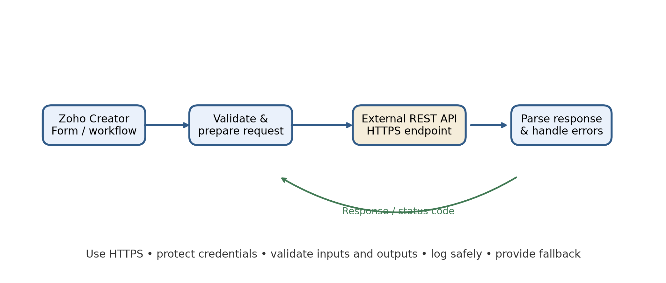
Implementation Steps
- Document the business requirement, data flows, data owner, and expected API behaviour. Obtain approval for the external provider and confirm contractual, privacy, and security requirements.
- Read the provider’s current API documentation. Identify the sandbox endpoint, authentication method, request schema, response schema, rate limits, and error codes.
- Create a small prototype using fictional data and a sandbox or mock endpoint. Do not use production credentials in classroom testing.
- Configure the integration through the current supported Creator mechanism. Store credentials in an approved secure facility and restrict access to administrators.
- Validate input before making a call. Use parameterised or safely encoded values and send the minimum necessary data over HTTPS.
- Parse the response defensively. Check status codes, required fields, expected types, and business validity before updating an application record.
- Add error messages, operational logging, and a manual alternative. Test service outages and malformed responses before deployment.
Example Request and Response (Illustrative)
Example only: an application sends a non-sensitive reference code to an approved sandbox endpoint and receives a JSON response such as {"status":"found","category":"standard"}. Actual endpoint paths, credentials, payload fields, and response formats must come from the provider’s official documentation. Never copy sample secrets or send real personal data without approval.
Testing and Validation
Test case | Expected result
Valid sandbox request | Expected response is received and mapped to the correct application fields
Missing required input | Validation stops the call and explains which input is needed
Invalid credentials | Call fails safely; secret is not shown to the end user or written to logs
Provider returns an error status | Application gives a useful message and preserves entered data
Timeout or service unavailable | User can retry appropriately or use documented manual fallback
Unexpected or malformed response | Response is rejected or flagged; no invalid data is silently saved
Repeated submission | Application avoids unintended duplicate external actions where applicable
Rate limit exceeded | System handles the response and avoids uncontrolled repeated calls
Security and Privacy Controls
- Use only an organisation-approved API provider and an authorised account. Apply least privilege to service credentials and keep keys out of public client-side code.
- Transmit data only when necessary. Review data location, retention, provider terms, and applicable privacy requirements.
- Use HTTPS and validate certificates through supported platform mechanisms. Never disable transport security to make an integration work.
- Sanitise and validate data received from the external service before displaying it or using it in business rules. Treat external content as untrusted.
- Limit logs to operational information; do not log authentication headers, secret values, or unnecessary personal data.
- Document credential ownership, rotation, revocation, and incident response procedures.
Reliability and Operational Considerations
- External services can be unavailable, slow, change their schema, or enforce quotas. Design the user experience so a dependency failure does not lose the original form submission.
- Use timeouts and bounded retries. Avoid retrying operations that could create duplicate records or payments unless an idempotency mechanism is documented.
- Monitor failed calls and usage against service limits. Define who investigates alerts and how manual processing is performed.
- Version and test integrations when the provider changes its API. Keep a record of endpoint, schema, and configuration ownership without exposing credentials.
Results
- API integration can extend a no-code application with approved external data or actions, reducing manual copy-and-paste between systems.
- A stable integration depends on documented schemas, secure credentials, careful response validation, and robust failure handling.
- A no-code interface does not eliminate API complexity, privacy obligations, or the need for technical ownership.
- Sandbox testing with fictional data and a manual fallback reduces risk before a production connection is considered.
Conclusion
Connecting Zoho Creator with an external service can make application workflows more useful, but an integration must be designed as a secure and managed dependency. Teams should define the use case, follow the provider’s current API documentation, protect credentials, minimise data, validate responses, and handle errors without losing user work. This conceptual exercise uses no live endpoint; any real deployment requires approved services, appropriate plan capabilities, security review, testing, and ongoing monitoring.

