Infosys Springboard Virtual Internship 7.0
Completion Report

Batch Number: 03
Start date: 14th August, 2026
Names:
- Tanavi T. Vadagole
- V. Priyadharshini
- Vismaya A.S.
- Veena Mallikarjun Jatti
- Rentala C S S S N Krishna Priya
- Vaishali B.
Internship Duration: 8 Weeks

1. Project Title
Smart Urban Mobility and Traffic Intelligence Dashboard

2. Project Objective
The project aimed to develop a Power BI-based decision-support dashboard for urban mobility and traffic intelligence. It focused on preparing and validating mobility data, building a reusable star-schema model, creating dynamic DAX measures, and analyzing traffic, congestion, route performance, geographic demand, transit reliability, mobility modes, environmental sensitivity, mobility access and demand trends. The project progressively extended from descriptive traffic monitoring to advanced analytical views including equity, forecasting and anomaly detection.

3. Project description in detail
The project was developed progressively across four documented milestones using Microsoft Power BI Desktop. Power Query was used for data cleaning, validation and transformation, while DAX was used for KPIs, reliability, demand, disruption, access and derived analytical indicators. The central FactMobilityTable was connected to Dim_Date, Dim_Location, Dim_Route, Dim_Vehicle and Dim_Weather using a star-schema structure with one-to-many, single-direction relationships. The documented dataset contained 300 mobility records.

Milestone 1 established the data foundation and baseline dashboard with KPI cards, slicers, traffic-volume analysis, congestion comparison, vehicle distribution, weather impact and route-performance details. Milestone 2 extended the same model into demand, geospatial, route and transit intelligence through passenger-demand maps, route performance, transit reliability, geographic

drill-down and supporting flow-map preparation. Milestone 3 added demand intelligence, estimated fare, congestion-based surge proxy, service-provider and mobility-mode analysis, weather/temperature sensitivity, regional availability proxy and demand trends. Milestone 4 added executive intelligence, a Mobility Access Index, mobility-equity analysis, demand forecasting and anomaly detection.

In real-world implementation, the dashboard can support transportation and mobility stakeholders in monitoring demand, identifying high-congestion or high-demand areas, comparing route and mode performance, examining accessibility and reliability, and exploring future demand patterns. Derived indicators such as estimated fare, surge, demographic groups and bike availability are analytical proxies and are not direct billed, survey or real-time measurements.

4. Timeline Overview
Week | Activities Planned | Activities Completed
Week 1 | Project understanding, dataset collection, requirement analysis | Reviewed project objectives, collected mobility dataset, identified KPIs
Week 2 | Data cleaning and preprocessing | Cleaned dataset, handled missing values, standardized fields
Week 3 | Data modeling and relationship creation | Built star schema, created fact and dimension tables
Week 4 | DAX measures and KPI development | Created Total Trips, Total Demand, Reliability and performance measures
Week 5 | Dashboard design and visualization | Developed Milestone 2 dashboard with demand and transit analysis
Week 6 | Advanced analytics and mobility insights | Built Milestone 3 dashboard with demand intelligence and mobility analytics
Week 7 | Executive dashboard and optimization | Developed Milestone 4 Executive Intelligence Dashboard
Week 8 | Testing, documentation and final submission | Validated dashboards, prepared documentation and presentation

5a. Key Milestones
Milestone | Description | Date Achieved
Project Kickoff | Project requirements analysis, objective definition and dataset understanding completed. | Week 1
Prototype/First Draft | Initial data model, relationships and dashboard wireframe developed. | Week 4
Mid-Term Review | Milestone 1 and Milestone 2 deliverables reviewed and validated. | Week 6
Final Submission | All dashboards, documentation and analytical insights finalized. | Week 8

5b. Project execution details
The project was executed using a systematic Business Intelligence and Data Analytics workflow in Microsoft Power BI. The objective was to convert raw urban mobility data into meaningful insights that support transportation planning, operational monitoring, and executive decision-making.

Phase 1: Data Collection and Understanding
The project began with the analysis of a transportation and urban mobility dataset containing 300 records. The dataset included information related to passenger demand, vehicle movement, route performance, travel time, congestion levels, transit reliability, weather conditions, and accessibility indicators.
A detailed understanding of the available attributes was carried out to identify relationships between transportation demand, operational efficiency, and mobility performance.

Phase 2: Data Preparation and Validation
Before performing any analysis, the dataset was reviewed for consistency and analytical readiness.
The following activities were completed:
- Verification of data types for all attributes.
- Validation of primary and foreign key relationships.
- Standardization of categorical values.
- Review of transportation metrics such as passenger count, vehicle count, travel time, delay minutes, and congestion indicators.
- Organization of data into analytical structures suitable for reporting and dashboard development.
This phase ensured that the dataset could support reliable business intelligence reporting.

Phase 3: Data Modeling
A dimensional data model based on the Star Schema approach was developed to improve reporting performance and simplify analysis.
The model consisted of:
- Fact Table
- FactMobilityTable
- Dimension Tables
- Dim_Date
- Dim_Location
- Dim_Route
- Dim_Vehicle
- Dim_Weather
One-to-many relationships were established between the fact table and dimension tables using unique keys. This structure enabled efficient filtering, drill-down analysis, and cross-functional reporting across multiple transportation dimensions.

Phase 4: KPI and DAX Development
To measure transportation performance, several analytical measures were created using DAX (Data Analysis Expressions).
Key performance indicators included:
- Total Trips
- Total Passengers
- Total Vehicles
- Average Delay
- Transit Reliability
- Mobility Access Index
- Average Fare
- Passenger Satisfaction
- Demand Metrics
- Route Performance Indicators
These measures formed the foundation for all dashboard calculations and visual analytics.

Phase 5: Dashboard Development – Demand & Transit Performance Analytics
The first analytical dashboard focused on monitoring transportation demand and service performance.
Key analyses performed included:
- Mobility demand trends over time.
- Passenger demand distribution across locations.
- Route-wise transportation performance.
- Travel time analysis by area.
- Transit reliability comparison across transport modes.
- Demand visualization using interactive geographic mapping.
- Interactive slicers and filters were implemented to allow users to analyze data based on location, transport mode, weather conditions, routes, and time periods.

Phase 6: Dashboard Development – Demand Intelligence Analytics
The second dashboard focused on identifying patterns in mobility demand and supporting strategic transportation planning.
This dashboard enabled:
- Analysis of historical demand behavior.
- Demand categorization and comparison.
- Identification of demand fluctuations.
- Monitoring of mobility utilization trends.
- Demand intelligence reporting through interactive visualizations.
The dashboard helped in understanding how transportation demand varied across different regions and operational conditions.

Phase 7: Dashboard Development – Executive Intelligence Analytics
The final dashboard was designed for decision-makers and management-level users.
This dashboard consolidated important transportation metrics into a single executive view and included:
- Mobility Access Index monitoring.
- Service reliability evaluation.
- Transport mode performance comparison.
- Travel efficiency analysis.
- Accessibility assessment across locations.
- Strategic KPI tracking for transportation planning.
The dashboard provided a high-level overview of operational performance while maintaining the ability to drill down into detailed information when required.

Phase 8: Testing and Validation
All dashboards were reviewed to ensure:
- Correct KPI calculations.
- Proper functioning of relationships.
- Accurate filter interactions.
- Consistent visual outputs.
- Reliable analytical results.
- Cross-validation was performed between dashboard values and source data to maintain reporting accuracy.

Phase 9: Final Reporting and Documentation
After validation, the dashboards were finalized and organized into a complete Business Intelligence solution. Documentation was prepared to explain the project objectives, data model, dashboard functionalities, analytical outcomes, and key findings.
The final solution successfully transformed transportation data into an interactive decision-support platform capable of supporting urban mobility analysis, operational monitoring, and data-driven transportation planning.

6. Snapshots / Screenshots
Selected dashboard snapshots from the project documentation are included below. They show the progression from baseline traffic monitoring through demand/geospatial intelligence and advanced analytics.

Figure 1. Milestone 1 – Baseline traffic and route-performance dashboard
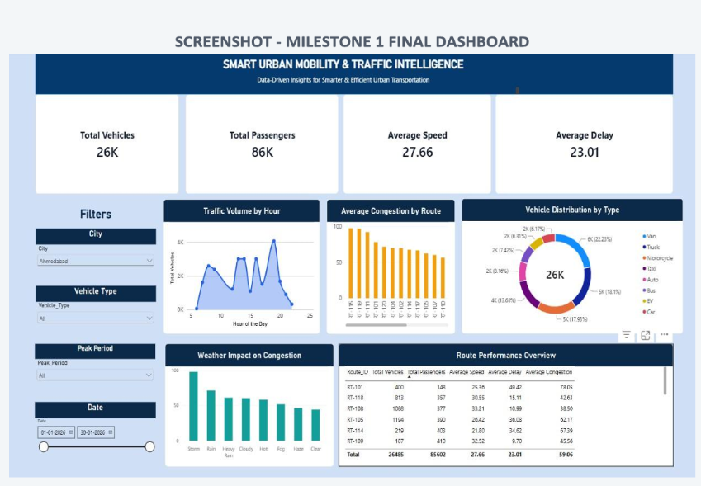.

Figure 2. Milestone 2 – Demand, geospatial and route-intelligence dashboard.
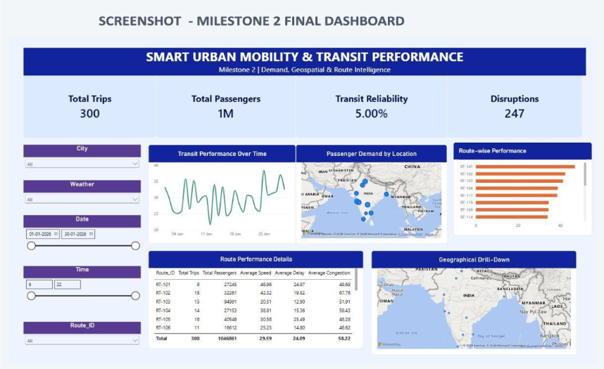

Figure 3. Milestone 3 – Demand and mobility-intelligence dashboard.
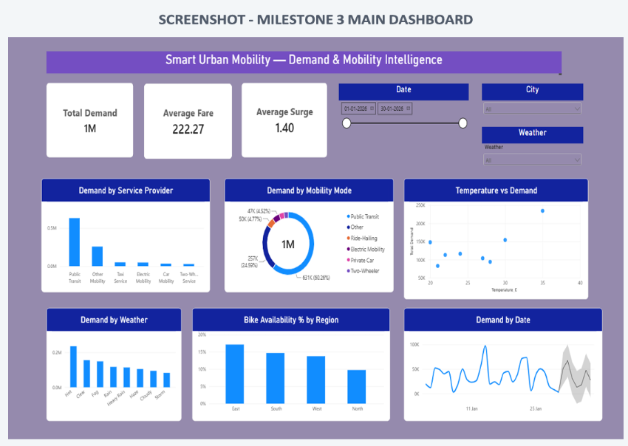

Figure 4. Milestone 4 – Executive intelligence dashboard.
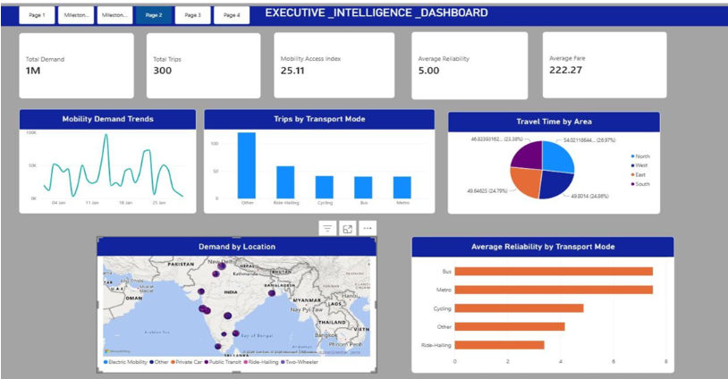

Figure 5. Milestone 4 – Mobility equity and access-index dashboard.
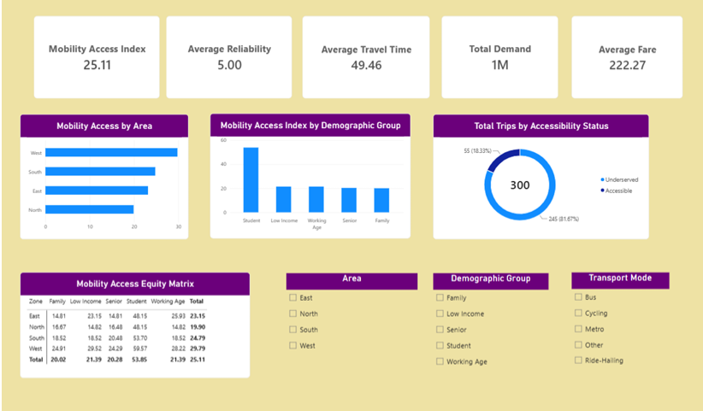

Figure 6. Milestone 4 – Demand forecasting and anomaly-detection dashboard.
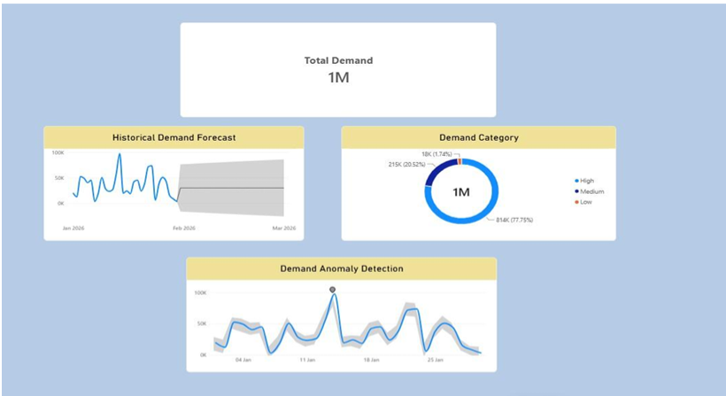

7. Challenges Faced
• Maintaining consistent relationships and filter propagation while extending the same star-schema model across multiple milestones.
• Preparing derived analytical fields when equivalent source fields were not directly available. These were documented as proxies rather than direct operational measurements.
• The Azure Maps flow-path visualization could not be displayed in the development environment because it required Microsoft sign-in; an ordered MobilityFlow support table was retained for later activation.
• Ensuring that forecasting and anomaly detection were applied to the historical demand series while retaining the required historical demand visual.

8. Learnings & Skills Acquired
• Power BI Desktop, Power Query and DAX for data preparation, modeling and analytics.
• Star-schema data modeling, one-to-many relationships and filter-context management.
• Interactive dashboard design using KPI cards, slicers, charts, maps, tables and drill-downs.
• Geospatial, route, transit, demand, mobility-mode and environmental analysis.
• Creation and transparent interpretation of derived analytical indicators.
• Forecasting exploration and anomaly detection in Power BI.
• Documentation, validation and communication of analytical assumptions and limitations.

9. Testimonials from team
The internship provided hands-on experience in converting mobility data into an interactive analytics solution. The team gained practical exposure to Power BI, data modeling, DAX, visualization, validation and advanced analytical techniques while progressively improving the project across multiple milestones.

10. Conclusion
The Smart Urban Mobility and Traffic Intelligence Dashboard evolved from a baseline traffic-monitoring solution into a richer decision-support dashboard. Across the milestones, the same Power BI semantic model was extended with demand intelligence, geospatial analysis, route and transit performance, mobility analytics, equity and access indicators, forecasting and anomaly detection. The project demonstrates how a structured data model and transparent analytical assumptions can support increasingly advanced mobility insights.

11. Acknowledgements
We sincerely thank Infosys Springboard and our project mentor Ms. Kalaiyarasi N .for providing the opportunity, guidance and structured milestone framework for this internship. We also thank all team members for their collaboration and contributions throughout the project development, validation, documentation and presentation.

