Week 11:

ROLL NO.:240801169

Name: Krishnapriyabala JS

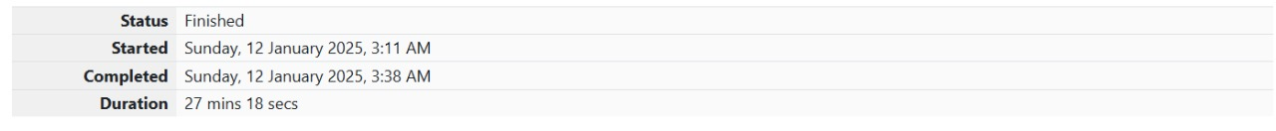

Q1) Two strings A and B comprising of lower-case English letters are compatible if they are

equal or can be made equal by following this step any number of times:

• Select a prefix from the string A (possibly empty), and increase the alphabetical

value of all the characters in the prefix by the same valid amount. For example, if

the string is xyz and we select the prefix xy then we can convert it to yx by

increasing the alphabetical value by 1. But if we select the prefix xyz then we

cannot increase the alphabetical value.

Your task is to determine if given strings A and B are compatible.

Input format

First line: String A

Next line: String B

Output format

For each test case, print YES if string A can be converted to string B, otherwise print NO.

Constraints

1 ≤ len(A) ≤ 1000000

1 ≤ len(B) ≤ 1000000

Sample Input

abaca

cdbda

Sample Output

YES

Explanation

The string abaca can be converted to bcbda in one move and to cdbda in the next move.

Code:

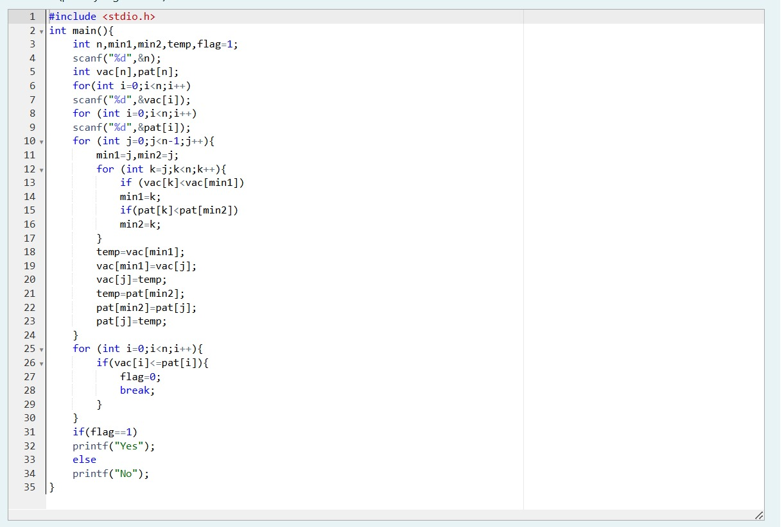

OUTPUT:

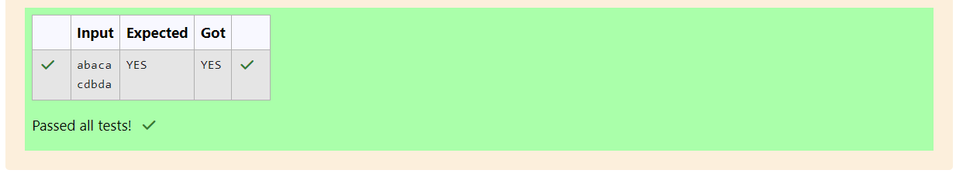

Q2) Danny has a possible list of passwords of Manny's facebook account. All passwords length

is odd. But Danny knows that Manny is a big fan of palindromes. So, his password and

reverse of his password both should be in the list.

You have to print the length of Manny's password and it's middle character.

Note: The solution will be unique.

Input Format

The first line of input contains the integer N, the number of possible passwords.

Each of the following N lines contains a single word, its length being an odd number

greater than 2 and lesser than 14. All characters are lowercase letters of the English

alphabet.

Output Format

The first and only line of output must contain the length of the correct password and its

central letter.

Constraints

1 ≤ N ≤ 100

Sample Input

4

abc

def

feg

cba

Sample Output

3 b

Code:

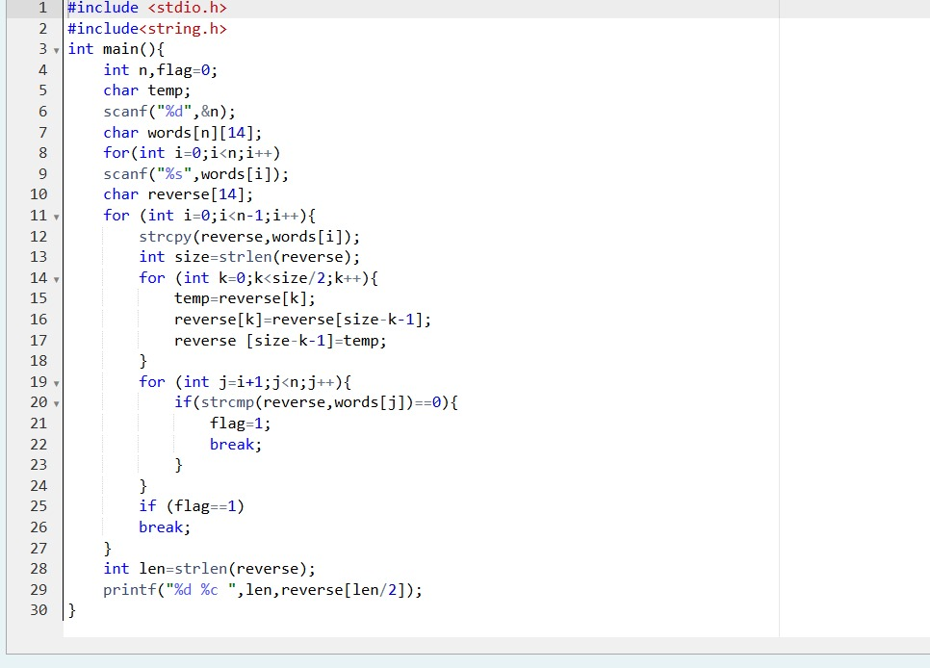

OUTPUT:

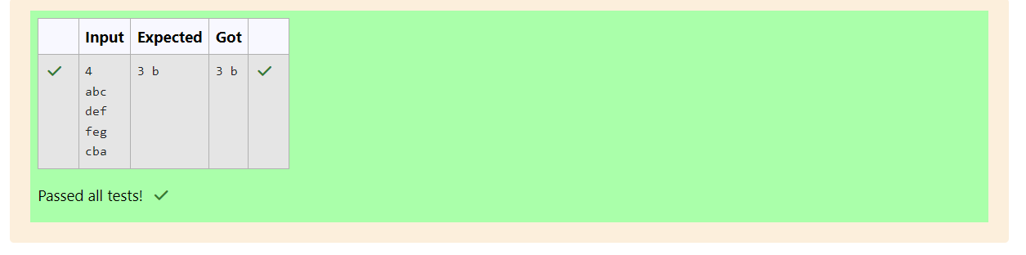

Q3) Joey loves to eat Pizza. But he is worried as the quality of pizza made by most of the

restaurants is deteriorating. The last few pizzas ordered by him did not taste good :(. Joey

is feeling extremely hungry and wants to eat pizza. But he is confused about the restaurant

from wherehe should order. As always he asks Chandler for help.

Chandler suggests that Joey should give each restaurant some points, and then choose the

restaurant having maximum points. If more than one restaurant has same points, Joey can

choose the one with lexicographically smallest name.

Joey has assigned points to all the restaurants, but can't figure out which restaurant satisfies

Chandler's criteria. Can you help him out?

Input Format:

First line has N, the total number of restaurants.

Next N lines contain Name of Restaurant and Points awarded by Joey, separated by a

space.

Restaurant name has no spaces, all lowercase letters and will not be more than 20

characters.

Output Format:

Print the name of the restaurant that Joey should choose.

Constraints:

1 <= N <= 105

1 <= Points <= 106

Sample Input

3

Pizzeria 108

Dominos 145

Pizzapizza 49

Sample Output

Dominos

Code:

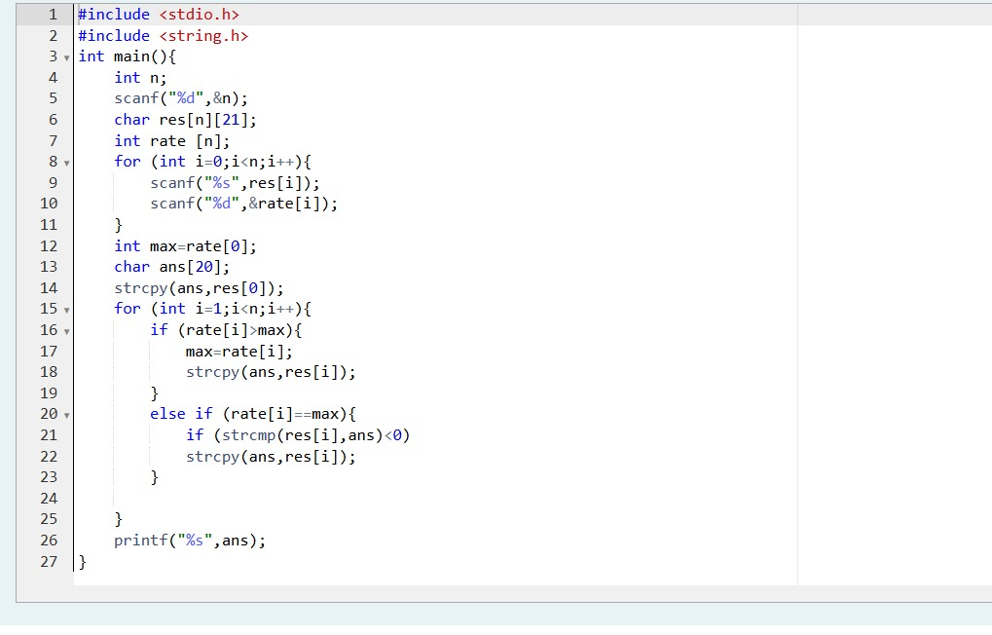

OUTPUT:

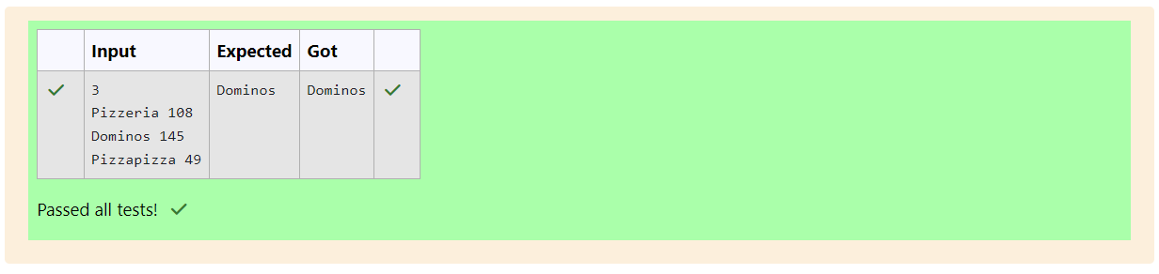

Q4) These days Bechan Chacha is depressed because his crush gave him list of mobile number

some of them are valid and some of them are invalid. Bechan Chacha has special power

that he can pick his crush number only if he has valid set of mobile numbers. Help him to

determine the valid numbers.

You are given a string "S" and you have to determine whether it is Valid mobile number

or not. Mobile number is valid only if it is of length 10 , consists of numeric values and it

shouldn't have prefix zeroes.

Input Format:

First line of input is T representing total number of test cases.

Next T line each representing "S" as described in in problem statement.

Output Format:

Print "YES" if it is valid mobile number else print "NO".

Note: Quotes are for clarity.

Constraints:

1<= T <= 103

sum of string length <= 105

Sample Input

3

1234567890

0123456789

0123456.87

Sample Output

YES

NO

NO

Code:

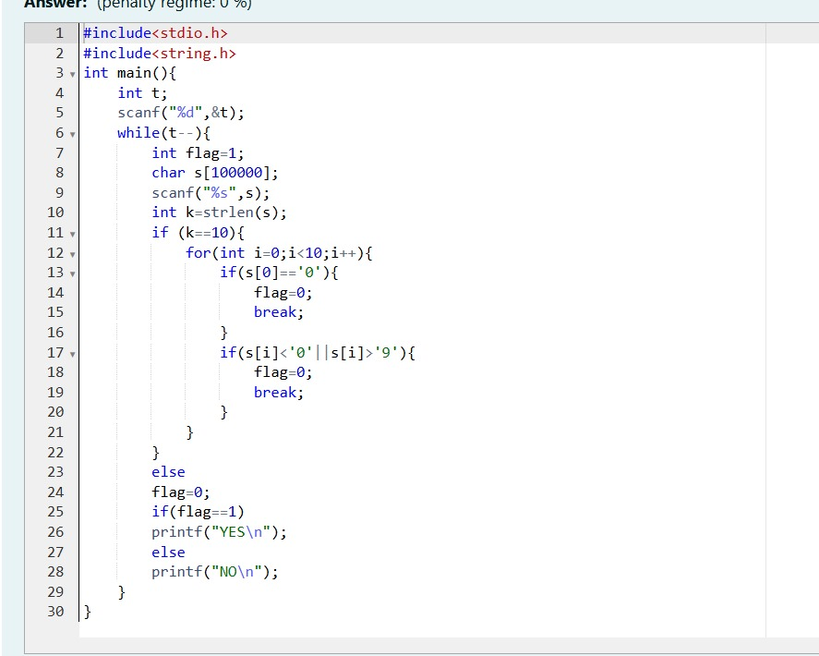

OUTPUT:

