1. swap

x=int(input("enter the first number:"))

y=int(input("enter the second number:"))

print("Before Swapping")

print("x=",x)

print("y=",y)

x=x+y

y=x-y

x=x-y

print("After Swapping")

print("x=",x)

print("y=",y)

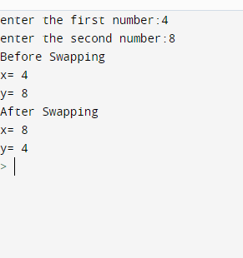

2.even or odd

num = int(input("Enter a number: "))

if (num % 2) == 0:

print("{0} is Even number".format(num))

else:

print("{0} is Odd number".format(num))

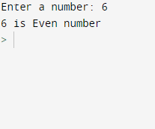

3.Leap year

year = int(input("Enter a year: "))

if (year % 4) == 0:

if (year % 100) == 0:

if (year % 400) == 0:

print("{0} is a leap year".format(year))

else:

print("{0} is not a leap year".format(year))

else:

print("{0} is a leap year".format(year))

else:

print("{0} is not a leap year".format(year))

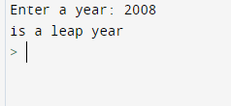

4.area of circle

import math

r = float(input('Enter the radius of the circle :'))

area = math.pi * r * r

print("Area of the circle is : %.2f" %area)

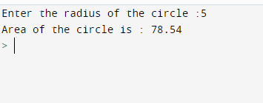

5.armstrong

def armstrong_check(num):

sum = 0

temp = num

while temp > 0:

digit = temp % 10

sum += digit ** 3

temp //= 10

if num == sum:

print(num,"is an Armstrong number")

else:

print(num,"is not an Armstrong number")

num = int(input("Enter a number: "))

armstrong_check(num)

